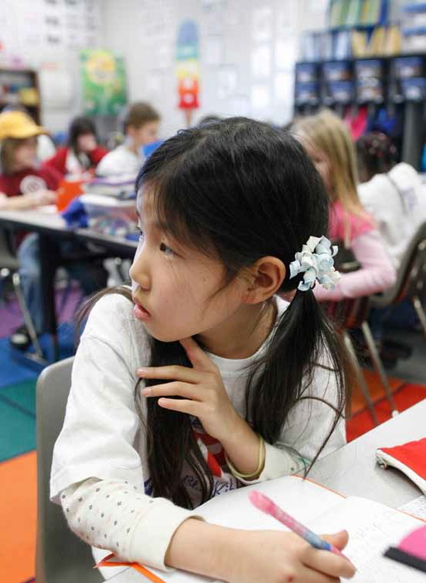
Our Future
Nurturing

A Parent’s Guide to Meeting the Needs of Kentucky’s Gifted and Talented Youth

A Publication of the State Advisory Council for Gifted
and Talented Education Kentucky Department of Education

Table of Contents
Nurturing Our Future

Who are the Gifted and Talented? 1
What does the gifted regulation require of districts? 2
What are service options and how are they determined? 4
Primary Talent Pool 6
The Gifted Student Services Plan 6
What is underachievement and how does it affect students? 7
How do I support my gifted child in and out of school? 9
Terms to know 12

Who are the Gifted and Talented?
Kentucky’s gifted and talented students include those who are identified as possessing demonstrated or potential ability to perform at exceptionally high levels in general intellectual ability, specific academic aptitude (e.g., mathematics, science, language arts), creativity, leadership skills, and/or the visual or performing arts.
704 KAR 3:285

While formal identification of gifted and talented students involves a combination of formal measures (tests), work samples, observations, checklists, and input from parents, teachers, and the student in order to match educational services to needs, parents will find student characteristics that require attention both in and out of the classroom.
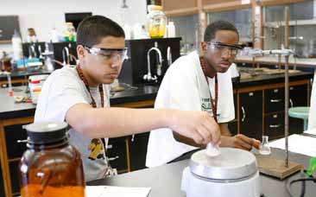
Gifted children are those who may demonstrate:
- Early and rapid learning
- Keen observation
- Efficient, high-capacity memory
- Intense curiosity, questioning
- Intense reactions
- Abstract thinking
- High activity level
- Strong verbal ability
- Ability to concentrate for long periods in area of interest
- Emotional sensitivity, excitability
- Wide range of interests
- Unusual depth and intensity of interest in topic

Gifted Children in Kentucky
Gifted children are found in all shapes and sizes, representing every race,
ethnicity, economic background, and many exceptionalities. Kentucky’s gifted children are urban, suburban, and rural youth from every part of the state and many nations.
The diversity of students who make up the gifted population, and the range of gifts and talents requiring attention in order to allow students to reach their full potential, create significant challenges to meeting student needs.
Kentucky’s Gifted Regulation 3:285 establishes the policies and procedures that guide gifted services at the local level. Each school district is required to pass local policies, procedures, and assurances that support appropriate gifted services for students in compliance with the Gifted Regulation. These policies and procedures guide school councils, school boards, and district level committees as decisions are made about educational policy and services that impact gifted students.

What does the gifted regulation require of districts?

What must each school district do for its Gifted and Talented Students?
Every district and every school wants its students to succeed. The Gifted Regulation (704 KY Administrative Regulation 3:285) establishes policies and procedures to guide districts, schools, teachers, and parents as they work together to design the most effective school experience for gifted stu- dents.
Every school must design articulated services K-12 matched to the needs of students diagnosed as demonstrating gifted and talented behaviors. To develop the curriculum for these students, schools shall differentiate, replace, supplement, or modify curricula to facilitate high level attainment of the learning goals established in KERA (Kentucky Education Reform Act) and to assist students’ development of individual interests, needs, and abilities.
Districts must identify and serve students in five categories:
- General Intellectual Ability: These are the students who are identified on the basis of an IQ score (9th stanine on a full scale comprehensive test of intellectual ability).
- Specific Academic Aptitude: These students are identified on the basis of a 9th stanine on an individual or group test of academic aptitude. (achievement test)
- Creativity: These students are identified on the basis of formal or informal measures — creativity tests, creative writing samples, obser- vations of creative problem-solving, or product creation.
- Leadership: These students are identified on the basis of informal measures that include demonstrated leadership roles, sociograms, observations of leadership, product/portfolio review, or self-reflec- tions.
- Visual/Performing Arts: These students are identified based on per- formance through observations of demonstrated arts ability, portfolio review, and/or audition.

Gifted Students are a Category of Exceptional Children
Gifted students are included as a category of exceptional children requiring accommodation in the Kentucky Education Reform Act. The purpose of identifying and serving gifted youth within schools is to ensure appropriate levels of instruction in order to maximize the potential of every child. Contrary to the myth, gifted children will not “make it on
their own.”

Minimum Requirements
According to 704 KY Administrative Regulation 3:285, districts shall provide articulated, primary through grade twelve (12) services for students diagnosed as possessing gifted characteristics.
These services must:
- Be qualitatively differentiated to meet individual needs
- Result in educational experiences commensurate with the student interests, needs, and abilities
- Facilitate the high level attainment of goals established in KRS 158.6451

Grouping for instructional purposes SHALL BE used.
There shall be multiple service delivery options, with no single service
option existing alone, district-wide, at a grade level.
An individualized educational plan (Gifted Student Services Plan — GSSP) shall be designed to meet the individual student’s needs. The GSSP will match student abilities, interests, and needs to differentiated service options and will establish accountability for meeting student instructional needs.
Teachers working with gifted students shall be prepared through appropri- ate professional development to address the individual needs, interests, and abilities of the students.

What are service options and how are they determined?

How Are Service Options Determined?
Once students are identified as Gifted and Talented, the gifted place- ment committee, composed of the Gifted Resource teacher, counselor, teachers, principal, and other appropriate personnel examine test and diagnostic data to develop the Gifted Student Services Plan (GSSP).
Keeping in mind that the objective of Gifted Services is the develop- ment of students to their maximum potential, the gifted committee works to identify services matched to the identified needs of the student. Gifted services should provide for continuous progress in students’ areas of strength and need.
Leadership services should be offered to ALL Gifted and Talented students, as they will each be expected to be leaders in their fields of expertise.
The Gifted Regulation requires that parents be informed about the service recommendations at least once during the school year. Services are identified, specific instructional goals for the student are identified, and the individual(s) responsible for documenting progress toward the instructional goals are named in the GSSP.
It is the responsibility of the school to report at least twice in each school year, the progress of the student toward the instructional goals identified in the GSSP.
Each district shall have a grievance policy in place to assist parents in addressing concerns regarding gifted services and placements.
educational experiences matched to the student’s needs, interests and abili- ties.
Resource services are services delivered in a pull-out classroom or other appropriate instructional setting to provide direct instruction by teachers trained in the unique needs of gifted students and to provide an intellectu- al peer group.
Independent study is the self-directed exploration of a topic or a course under the supervision of a teacher or college/university personnel.
Honors courses are classes designed to present students with higher levels of content, process, product, and pacing. Honors courses are not exclusively for gifted students, but gifted students may be clustered within an honors section, providing a higher level curriculum that can be further differentiat- ed.
Seminars are sessions on specific topics focusing on advanced content and high level process skills. Conducted by teachers, representatives of various professional fields, volunteers, or parents, seminars provide opportunity for students to come together while maintaining enrollment in their regular coursework.
Distance learning is a rapidly growing service option in which students use the Internet, television broadcasts, correspondence courses, and other technology to access courses and resources not available within the school. Kentucky Virtual High School offers many high level courses.

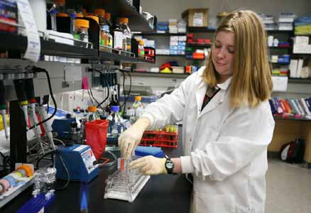
Service Options
Service options are to be matched to the identified strengths and needs of the gifted and talented students to be serviced. Service options are to be offered that are qualitatively differentiated to meet student needs, facilitating high level achievement of the KERA goals and mastery of the Kentucky Core Content for Achievement.
Districts shall use grouping for instructional purposes and multiple ser- vice delivery options. Student grouping format shall include grouping based on student interests, needs, and abilities, including social and emo- tional needs.
Cluster grouping is the grouping of a limited number of identified gifted stu- dents in a heterogenous setting with a teacher trained in the appropriate special needs of gifted students for the purpose of receiving differentiated

Primary Talent Pool
The Primary Talent Pool is intended to discover and nurture the gifts and talents of high potential students so that these students may truly thrive in a setting of con- tinuous progress.
Each school that serves students in primary grades will develop a group of students informally selected as having characteristics and behaviors of a high potential learner and will use a series of informal and formal measures to determine differentiated service delivery needs during their stay in the primary program.
Representing the five areas that districts are required to serve (general intellectual, specific academic aptitude, creativity, leadership, and visual and performing arts), the talent pool may be made up of approximately twenty- five percent of the primary population. These high potential learners are selected for participation in the talent pool through the use of assessment options (minimum of three) to assess the degree of demonstrated gifted characteristics and behaviors and to determine the level of need and most appropriate service interventions. Data from formal, normed measures may also be used to discover and include eligible students overlooked by infor- mal assessment, and to diagnose appropriate levels of service.

Services for Primary Students
Membership in a primary classroom shall not preclude the continued, appropriate use of resource services, acceleration options, or the other spe- cialized service options appropriate to the individual needs of primary high potential students.
With the exception of self-contained classrooms, all service delivery options that are available to grades 4-12 may be appropriate for students in the primary talent pool.
There shall be multiple service delivery options, with no single service option existing alone, districtwide, at any grade level P-12.

The Gifted Student Services Plan
For each student formally identified as gifted and talented (grades 4-12) an individualized Gifted Student Services Plan shall be developed. The GSSP is designed to match student interests, needs, and abilities to differ- entiated service options and serves as the communication vehicle between parents and school personnel.
While the format for the GSSP may be adapted to meet local district needs, the GSSP must include information about the strengths and needs
of the student, information about specific instructional strategies and interventions to meet student needs, goals for student growth, and identi- fication of the individual(s) responsible for providing services and the doc- umentation that will demonstrate progress toward the specified goals.
Parents should expect a progress report from the school at least once each semester that reflects the student’s progress toward the goals identified in the GSSP.
The district must have procedures in place that will allow parents to provide input and to make changes in the GSSP and services provided. These procedures will usually be part of board policy and assurances.
Information Gathering and Reporting
The Gifted Regulation requires that districts implement a procedure to gather information related to the interests, needs, and abilities of students from parents or guardians for use in determining appropriate services.
Parents or guardians of identified students shall be notified annual- ly of services included in the child’s GSSP and specific procedures to follow in requesting a change in services.

What is underachievement and how does it affect gifted students?

Underachievement
Underachievement is the significant gap between a student’s potential ability and demonstrated achievement to a degree that there is an overall diminished ability to achieve at the expected level of ability. Unfortunately, many cur- rent educational settings foster underachievement because students sit unchallenged and are expected to wait to learn new skills or content. As students associate success with school tasks that come easily (or that rep- resent skills/content already known), they face a diminished ability and willingness to attempt tasks that may represent an appropriate level of challenge.
Students who underachieve are often recognizable as the students who don’t seem to be working up to their potential. These may be students who demonstrated significant potential earlier in their school career, yet that high potential is not recognized in their current work.
Underachieving students may do well on tests, but fail to complete or turn in daily assignments. Underachieving students may withdraw from the

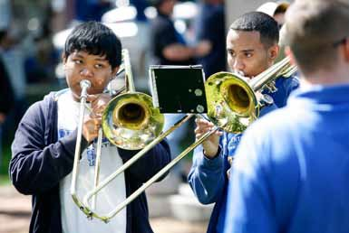
class by daydreaming, sleeping, or doodling; or they may begin to misbe- have and become behavior problems. Another group of underachieving students gets fairly good grades (maybe even A’s and B’s), but do so with no effort and are not given opportunities to show what they truly have the potential to do.
A consistent pattern of underachievement creates students who may lack cognitive skills, study skills, and task persistence that will allow them to succeed when faced by work at an appropriate level of challenge. It is important that steps be taken to improve underachievement whenever the pattern emerges in order to keep underachievement habits from becoming too deeply entrenched in student work habits.

Underachievement Interventions
Always pretest to find what students have mastered, then use results of pretesting
to design instruction. The pretest can be helpful to underachieving students by show- ing areas of mastery and by identifying needs. Validating what students know by excusing them from tasks that pretests show they have mastered has been shown to be a strong motivational tool.
Good diagnostic data on strengths and needs of underachieving students, as well as a profile of interests and passions is invaluable. Once this information is available, the preferences of underachievers can be used to design tasks just as diagnostic data can be used to provide instruction to eliminate skill gaps that interfere with the underachiever’s willingness to attempt tasks.
Compacting, acceleration, and contracting are all valuable strategies to use to reverse underachievement. Each of these strategies validates student mas- tery, provides opportunities for student choice, and provides practice with study skills, time management skills, and research skills so that underachiev- ers feel more empowered and feel greater ownership in their own education.
Keys to Reversing Underachievement:
  - Provide specific, diagnostic feedback.
  - Identify and recognize small improvements in underachiever’s work habits.
  - Make tasks meaningful and be able to justify what students are asked to do.
  - Provide opportunity for student choice.
  - Establish and communicate clear criteria for success.
  - Be patient. Underachievement patterns took time to become habits. It takes time to break habits.

How do I support my gifted child in and out of school?

Education Beyond the School
Provide opportunities for the students to explore and pursue interests. Exploration of a variety of experiences should be encouraged as students “try on” various activities to discover interests and strengths. Students must also be expected to honor commitments and follow through on tasks/activ- ities they signed on to do. Discussions and decisions about participation should include the degree of commitment expected and the realities of time management that go with each activity. Each child must be given the opportunity to discover and expand personal capacities for varied obliga- tions.
Provide/facilitate opportunities within the community. Community based activities may give gifted students opportunity to act on concerns and global awareness. (For example, students may be participants in a food drive or environmental project that can provide opportunity to develop leadership skills and see applications for skills in a real world setting.) Such activities may provide a peer group focused on a common purpose that is often absent in school activities.
Connect students with academic opportunities that are available outside of the school day. Weekend and summer enrichment programs, correspon- dence courses, mentors, Virtual High School courses, travel-study experi- ences, and talent/hobby pursuits can be invaluable in forging connections with an intellectual peer group and individuals who share a common pas- sion for learning. Those links can be important to gifted students providing experiences that may sustain their intellectual curiosity.
Encourage pursuits that support identified gifts. Provide lessons, team experiences, family travel, and resources that relate to student gifts. (For example, take a gifted leadership student to a political rally to observe the

process and discuss the characteristics of successful political leadership.) It is important to link the gifts and talents of the student to real world experi- ences and to guide the student to internalize the standards of excellence reflected in that talent area.

Strength in Numbers
Seek out parent support groups and materials through the Kentucky Association for Gifted Education (KAGE), the National Association for Gifted Education (NAGC), the Council for Exceptional Children (CEC), local PTA or PTO, and any other group focused on the unique needs of gifted students. Parenting a gifted child is a wonderful, challenging process, and learning about the experiences of others may be helpful.

Strengths Create Needs
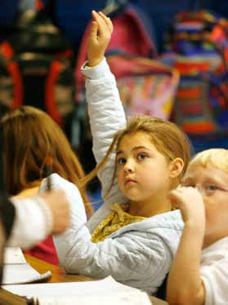
Remember that a gifted child’s strengths are part of the child, but do not entirely define the child. Giftedness is asynchronous development and the child may appear average or even “below average” in some settings on some types of activities. For a child with extremely high ability in one or more areas, age-appropriate responses may be characterized as “immature.” A
“childish” response — frustration with injustices, nonconformity, perfectionism, inappropriate comments — may result from cognitive skills and awareness beyond the child’s ability to act. Be aware of student strengths and needs and help to build coping strategies and skills — social, time-management, affective, and academic — that will be needed to allow the child’s experiences to keep pace with the strengths.
Advocacy and Communication
Paired with effective parenting strategies, communication between home and school is critical to designing the most effective educational environment for each student.
- Offer information, anecdotes, work samples, and other communication that can give educators insights into the child. Students often do what is expected, “rising” to the low level of expectation in the classroom, so that teachers truly do not have the opportunity to see the capabilities of the child. Educators need all of the information they can get in order to best serve children.
- Be aware that “Bored” is a code word for many student reactions. Work with the teacher to equip the student with strategies that will build independence, will ensure mastery of requisite skills, and will provide opportunity for continuous progress.
- Work to build awareness that students learn to underachieve by working in an environment that is not challenging and that does not celebrate excellence. Emphasis must be on personal growth, change, improvement, and personal standards rather than a grade or generic comment, such as “Very good” of “Do your best.” Gifted students must be helped to internalize standards of excellence for various tasks in varied fields, as they will be working independently more often and earlier than their peers.
- Ask about curriculum decisions and pre-testing. How is the level of instruction determined? How are student groupings determined? How are student needs addressed when pre-testing indicates that content is already mastered? How is instruction matched to the learning styles and characteristics of students?
- Remember parent/child roles. A precocious child does not have
the life experiences or wisdom to make the rules, yet may attempt to use strong verbal skills to argue or convince. Listen, but remain the adult.

Terms to Know

The 3 G’s of Gifted Education —
Gifted and Talented: Those students who are identified as having demonstrated or potential ability to perform at an exceptionally high level in general intellectual ability, specific academic aptitude (e.g., science, mathematics, language arts), creativity, leadership skills, and/or the visual or performing arts. These students require services or activities beyond those ordinarily offered by the school in order to reach their full potential. Gifted and Talented Student Services Plan (GSSP): The educational plan designed specifically to meet an individual gifted student’s needs. The GSSP matches student’s interests, needs, and abilities to differentiated service options and serves as the communication vehicle between parents and school personnel.
Grouping: The grouping of students for the purposes of addressing specific
continuous progress skill development, socio-emotional needs, and interests. Groups may be flexible to address the instructional needs, interests, and abilities of students. Instructional grouping is NOT tracking, in which student grouping is maintained for all learning activities and remains in place over extended periods of time without regard for the specific needs of students.
Acceleration: Allowing students to move through material at a pace faster

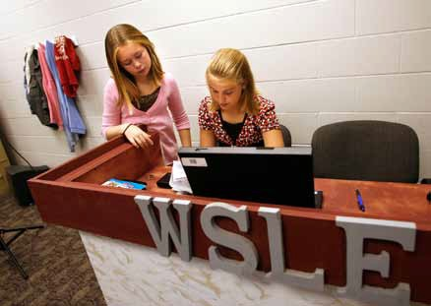
than their age mates and at a rate that is appropriate to their abilities. Examples of acceleration include curriculum compacting, higher level activities based on parallel content, subject level acceleration, grade skipping, and early exit from school.
Affective Domain: The domain of learning centered around attitudes, feelings, understanding of self and others. Gifted students have specific needs within the affective domain.
Advanced Placement (AP): A program of college level courses available to high school students. Completion of a core of AP courses with acceptable exam scores earns students a Kentucky Commonwealth Diploma.
Students who receive prescribed scores on AP exams may receive college
credit.
Cluster Grouping: The assignment of a small group of identified students with similar interests, needs, and abilities to a teacher trained in the appropriate instruction of gifted and talented students in order to provide differentiated instruction.
Compacting: Reducing the amount of time students spend in those areas of the curriculum where students demonstrate mastery. Compacting reduces repetition, promotes student engagement, and allows students to focus on content/skills not already mastered. Pre-testing and careful monitoring are important to compacting.Differentiation: Systematic changes in the pacing, the content (what is learned), the process (how it is learned), or the product (how learning is demonstrated) to meet the learning needs of students.
Distance Learning: Learning opportunities such as Kentucky Virtual High School and Kentucky Virtual University offered through the use of computer technology or satellite transmission.
Enrichment: Differentiated, academically-based activities that go beyond the core curriculum to offer in-depth exploration or opportunity to integrate learning across disciplines. Enrichment activities are intended to supplement and extend the student’s educational experience.
Heterogeneous Grouping: Students placed together in a classroom based on their age or grade levels.

High Potential Learners: Students in the top twenty-five percent of the primary student population who demonstrate gifted characteristics and behaviors. These students demonstrate need for differentiated instruction as a part of the Primary Talent Pool.
Homogeneous Grouping: Students placed together based on academic ability, special needs, interests, or other common characteristics relating to instruction.
Honors Courses: Courses designed to provide more challenging material through higher levels of content, process, product, and adjusted pacing.

Independent Study: A self-directed course or a study of a selected topic under the supervision of a teacher or college/university personnel.
Primary Talent Pool: The primary students selected as having characteristics and behaviors of high potential learners and diagnosed using a combination of informal and formal measures to determine differentiated service delivery needs throughout their primary experience.
Seminar: Sessions on specific topics focusing on advanced content and high level process skills.
Underachievement: A significant gap between a student’s potential ability and demonstrated achievement to a degree that there is an overall diminished ability to achieve at the expected level of performance.

Nurturing Our Future

Where Can I Get More Answers?

Kentucky Department of Education Kathie Anderson – Gifted Education Consultant
kathie.anderson@education.ky.gov Capital Tower Plaza 18th Floor Frankfort, KY 40601
502-564-4970
http://education.ky.gov/specialed/GT/Pages/default.aspx
Kentucky Association for Gifted Education (KAGE)
P.O. Box 9610 Bowling Green, KY 42102-9610
KAGE@wku.edu
Center for Gifted Studies Western Kentucky University Bowling Green, KY 42101 270-745-6323
Center for Gifted Studies Murray State University Murray, KY
270-762-2539
RESOURCES

704 KY Administrative Regulation 3:285.
Programs for Gifted and Talented

National Association for Gifted Children Parent Information Guide #4 Davis, G. A. & Rimm, S. B. (1998).
Education of the Gifted and Talented. Needham Heights, MA: Allyn & Bacon.
“What are You Doing to Develop My Child’s Talents?” — KAGE Brochure “Differentiation” — KAGE Brochure
A Publication of the Kentucky Advisory Council for Gifted and Talented Education
Created by Jan W. Lanham

