**Special Education**





Boyd County Schools have been working tirelessly during the COVID-19 event. We continue to feed our students each day of the week. Our cafeteria staff takes the time to write words of encouragement on the meals in hopes to brighten a student’s day. We have staff preparing meals and then our volunteers deliver meals along with our crew from the Transportation Department. We so appreciate our volunteers! Not just during this emergency but also throughout the school year.

We continue to deliver instruction via our Non Traditional Instruction (NTI) process. We have staff preparing materials and working pick-up stations at our schools. We distrubuted chromebooks to those students that needed them and increased our outside wi-fi access at our schools so parents can drive to the parking lots for their students to access wi-fi for on-line lessons (social distancing rules still apply of course). Our Technology Department have been working dilegently to make this happen for our students.

Our teachers continue to proivde quality Specially Designed Instrucion (SDI) to meet the individual needs of our students. Teachers use a varitety of virtual platforms and communication tools to reach our students and families. We are providing occupational and physical therapy and telehealth services for our students. Speech teachers are providing speech services and instruciton by various means as well. Our School Counselors are working to plan virtual transition meetings to include a virtual tour about what students can expect for their new school for our transiton grades.

We are focused heavily at this time on our seniors as well. We have signs to be placed in the yards of our seniors. We leave the ballfield lights on as a way to let our seniors know we are thinking about them. Our Pep Club recognizes our seniors with twitter shout outs. Our high school College and Career/Transition Counselor and College Coaches are keeping seniors up to date about events. Staff even hold a senior virtual session each Friday for students to join a Google Meet as a way to keep in touch.

We continue to work with our mental health community partners in an effort to provide information to our families for telehealth services. Boyd County Public Schools will continue to provide quality instruction and meet the needs of our students and families. All the while, looking ahead to when we all can be together again.

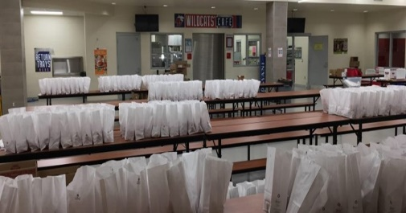 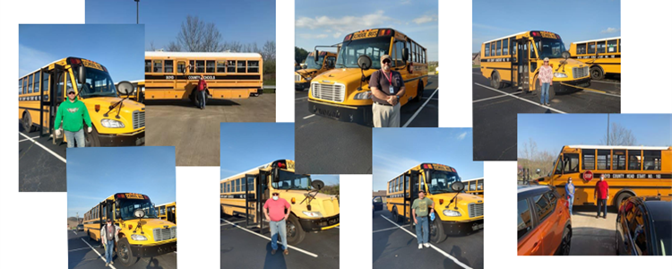

 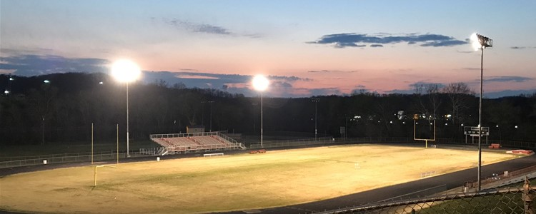

**Special Education Cooperatives**

[](https://www.ckec.org/)            [](https://www.grrec.org/)             [](https://sesccoop.org/)     [](https://www.kentuckyvalley.org/)       [](https://www.ovec.org/)       [](https://www.kyglec.org/)        [](http://www.kedc.org/)      [](http://www.wkec.org/)           [](https://www.nkces.org/)