**Special Education**





Owsley County is a veteran school district when it comes to Non-Traditional Instruction (NTI). When the call came to close their doors, the staff went right to work. Owsley County was in the first NTI pilot program in Kentucky nearly a decade ago. The district is already 1:1 for devices and students in grades 3 through 12 were already in the habit of taking their devices home. As a community, Owsley County is lucky to have high-speed internet service to over 90% of our students and Peoples Rural Telephone Coop (PRTC) joined the initiative by offering families without internet two months of free service. "It's been a full community effort to make sure our kids can still excel", says Owsley County Elementary School Principal, Sylvia Havicus. "We are grateful for everyone's time and energy to educate and feed the whole child.”

Assignments and instructional tools are housed in Google Classroom. Each grade level offers office hours online so students and parents can drop in with questions, on top of the twice-weekly class zoom meetings to keep everyone connected and on task. Owsley County High School (OCHS) teachers meet with students on Zoom daily. Teachers quickly put out tutorials for parents to use Zoom to build capacity and ensure parents can actively participate in this new challenge of educational partnership.

Counselors even provide services via Zoom for students who are anxious or already receiving services. “Our staff and students were well-prepared for this quick transition to online learning, due to our experience with NTI,” says OCHS Principal, Lincoln Spence. “I am very proud of our staff and students for making this transition quickly, while also keeping the quality of education and expectations high.”

Special education teachers and related services also have zoom sessions, Google Classroom, porch visits, and over the phone instruction. Owsley County Director of Special Education Tonya Spicer commends the relationship building that is going on between the school and families. “Prior to these NTI days, special education staff already worked closely with parents to develop Individualized Learning Plans (ILP) for students and that partnership has only been strengthened through these new NTI days.”

Principals and administrators are also able to use Zoom for weekly staff meetings and Professional Learning Community (PLC) meetings to discuss progress monitoring, identify pockets of students that need extra assistance and plan home visits for those out of reach of bus meal routes and without internet service. Certified and classified staff are engaged in on-going professional learning through online modules and Micro-credentials.

Owsley County Food Service fed over 13,000 meals in the first two weeks of NTI alone! Bus drivers and classified staff assist in the door-to-door delivery of food. Youth Service Center and Family Resource staff have also ridden on buses to take other supplies.

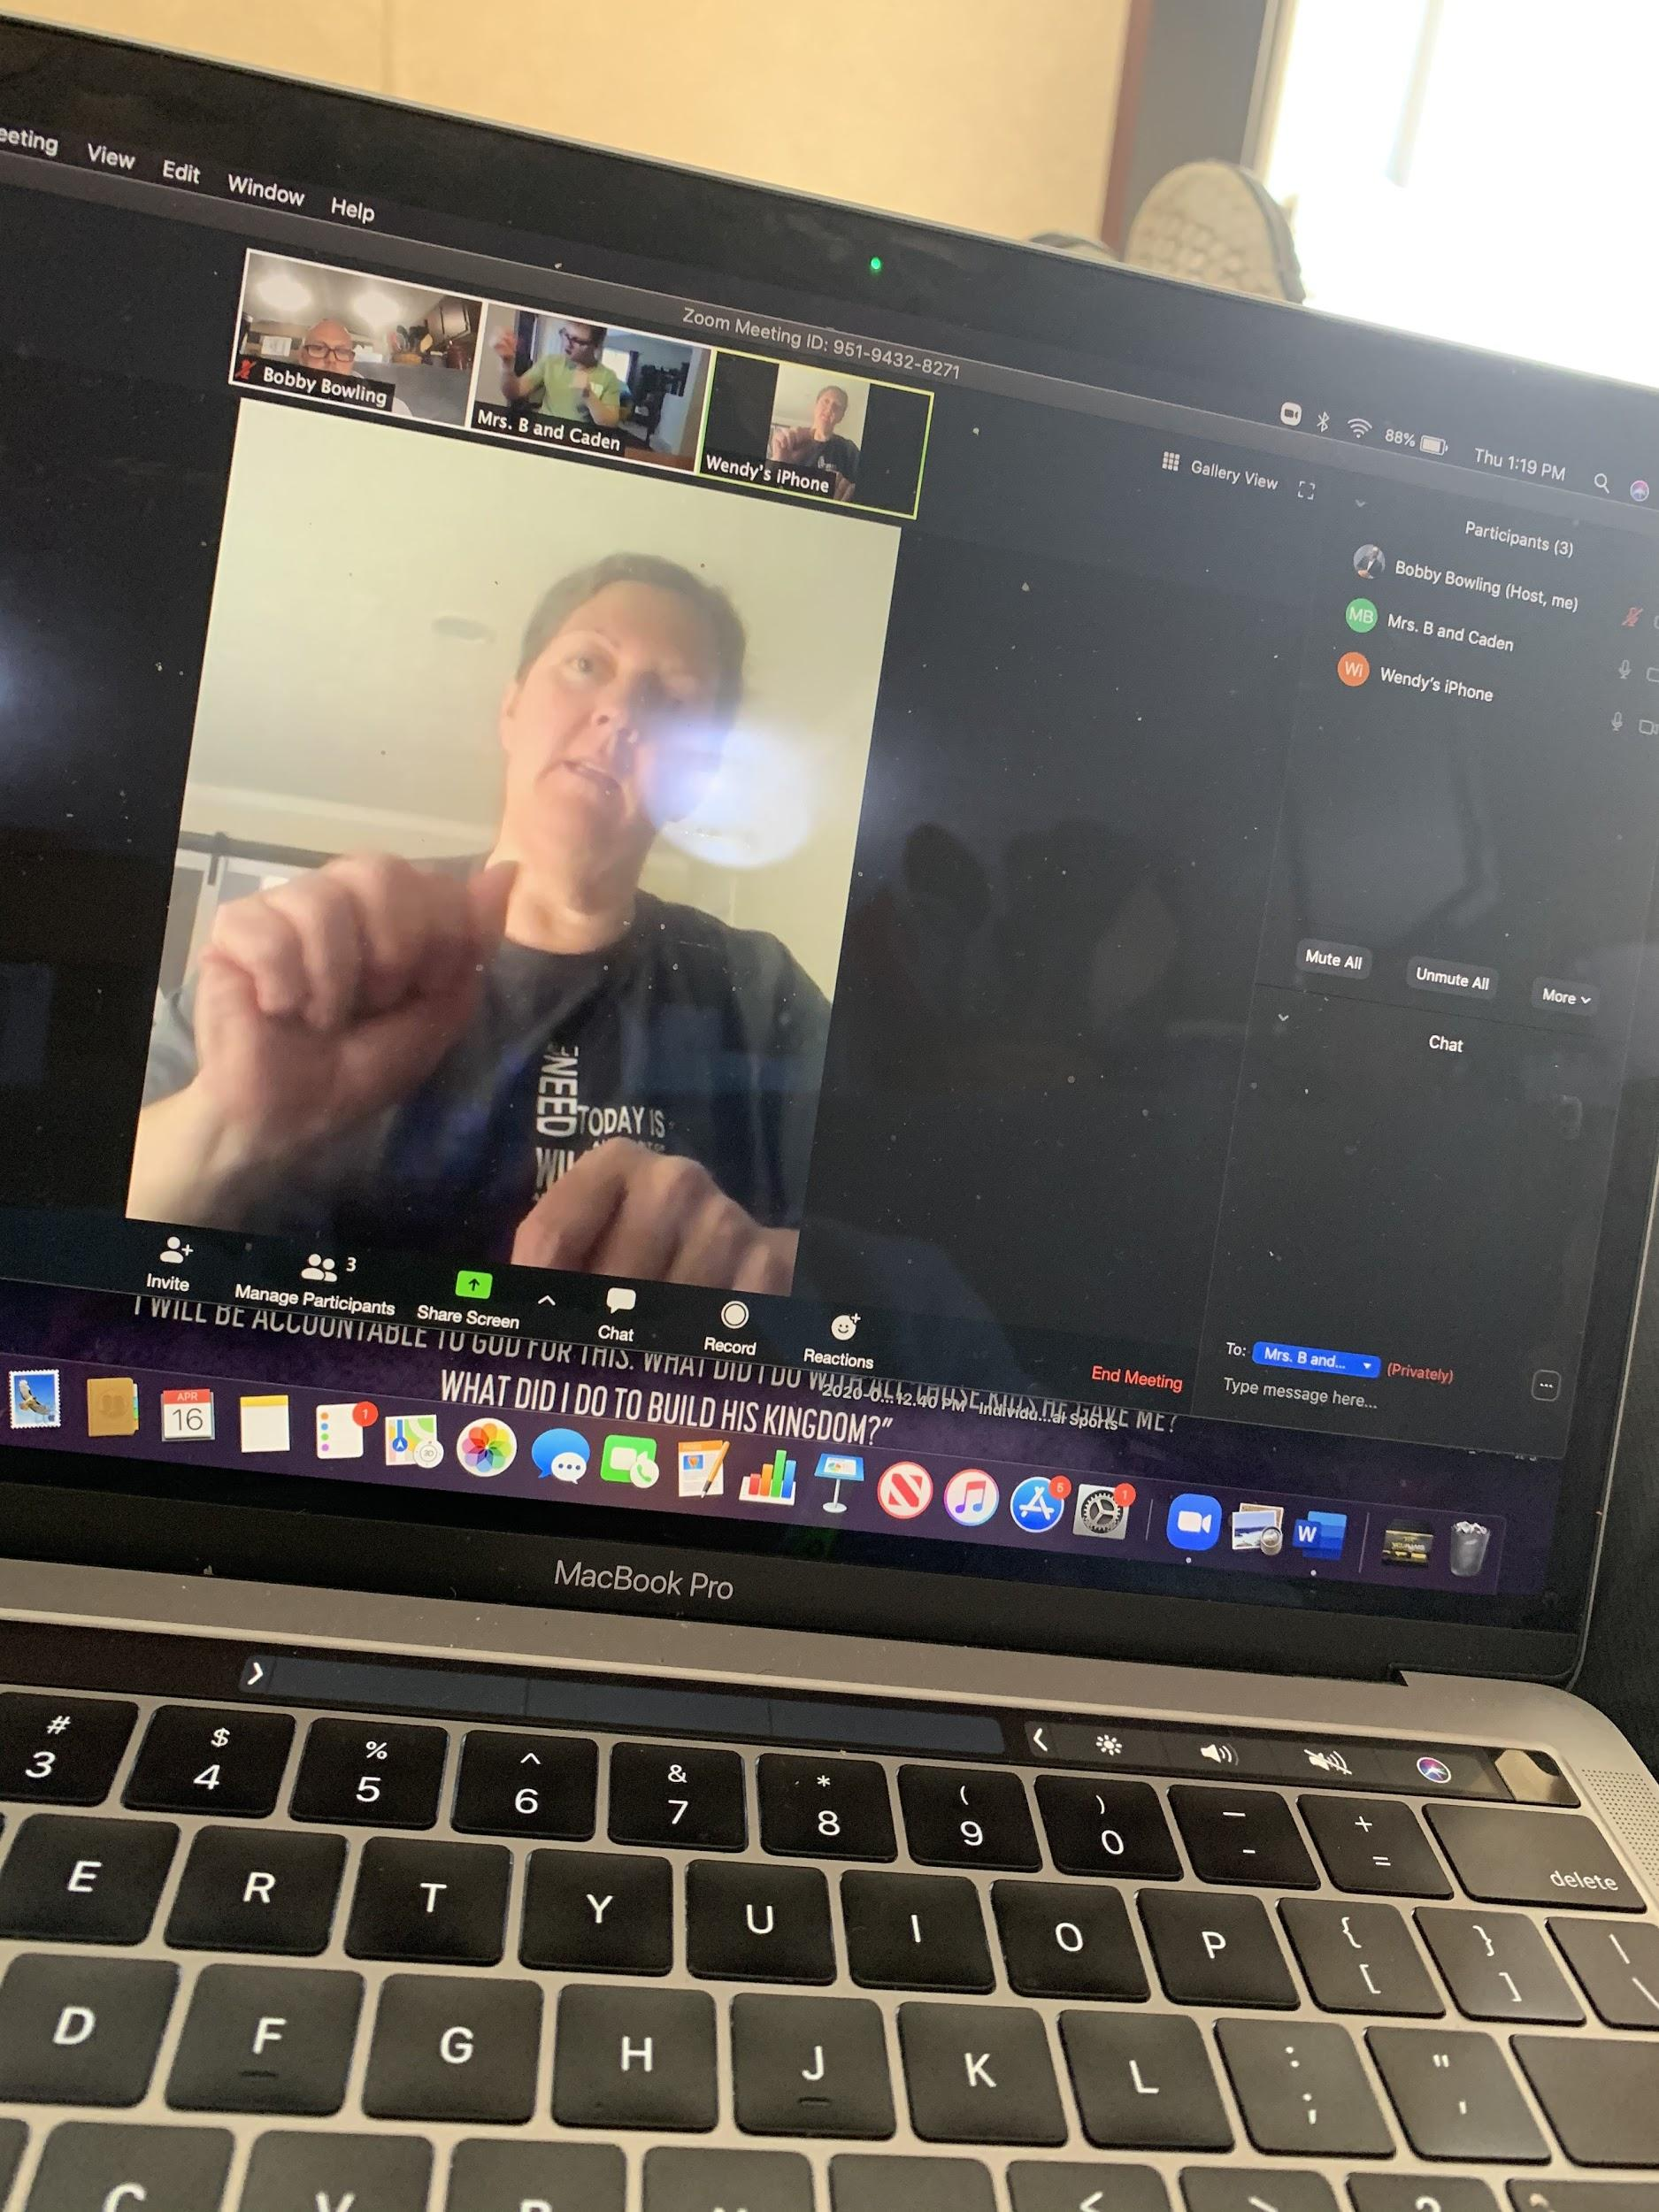 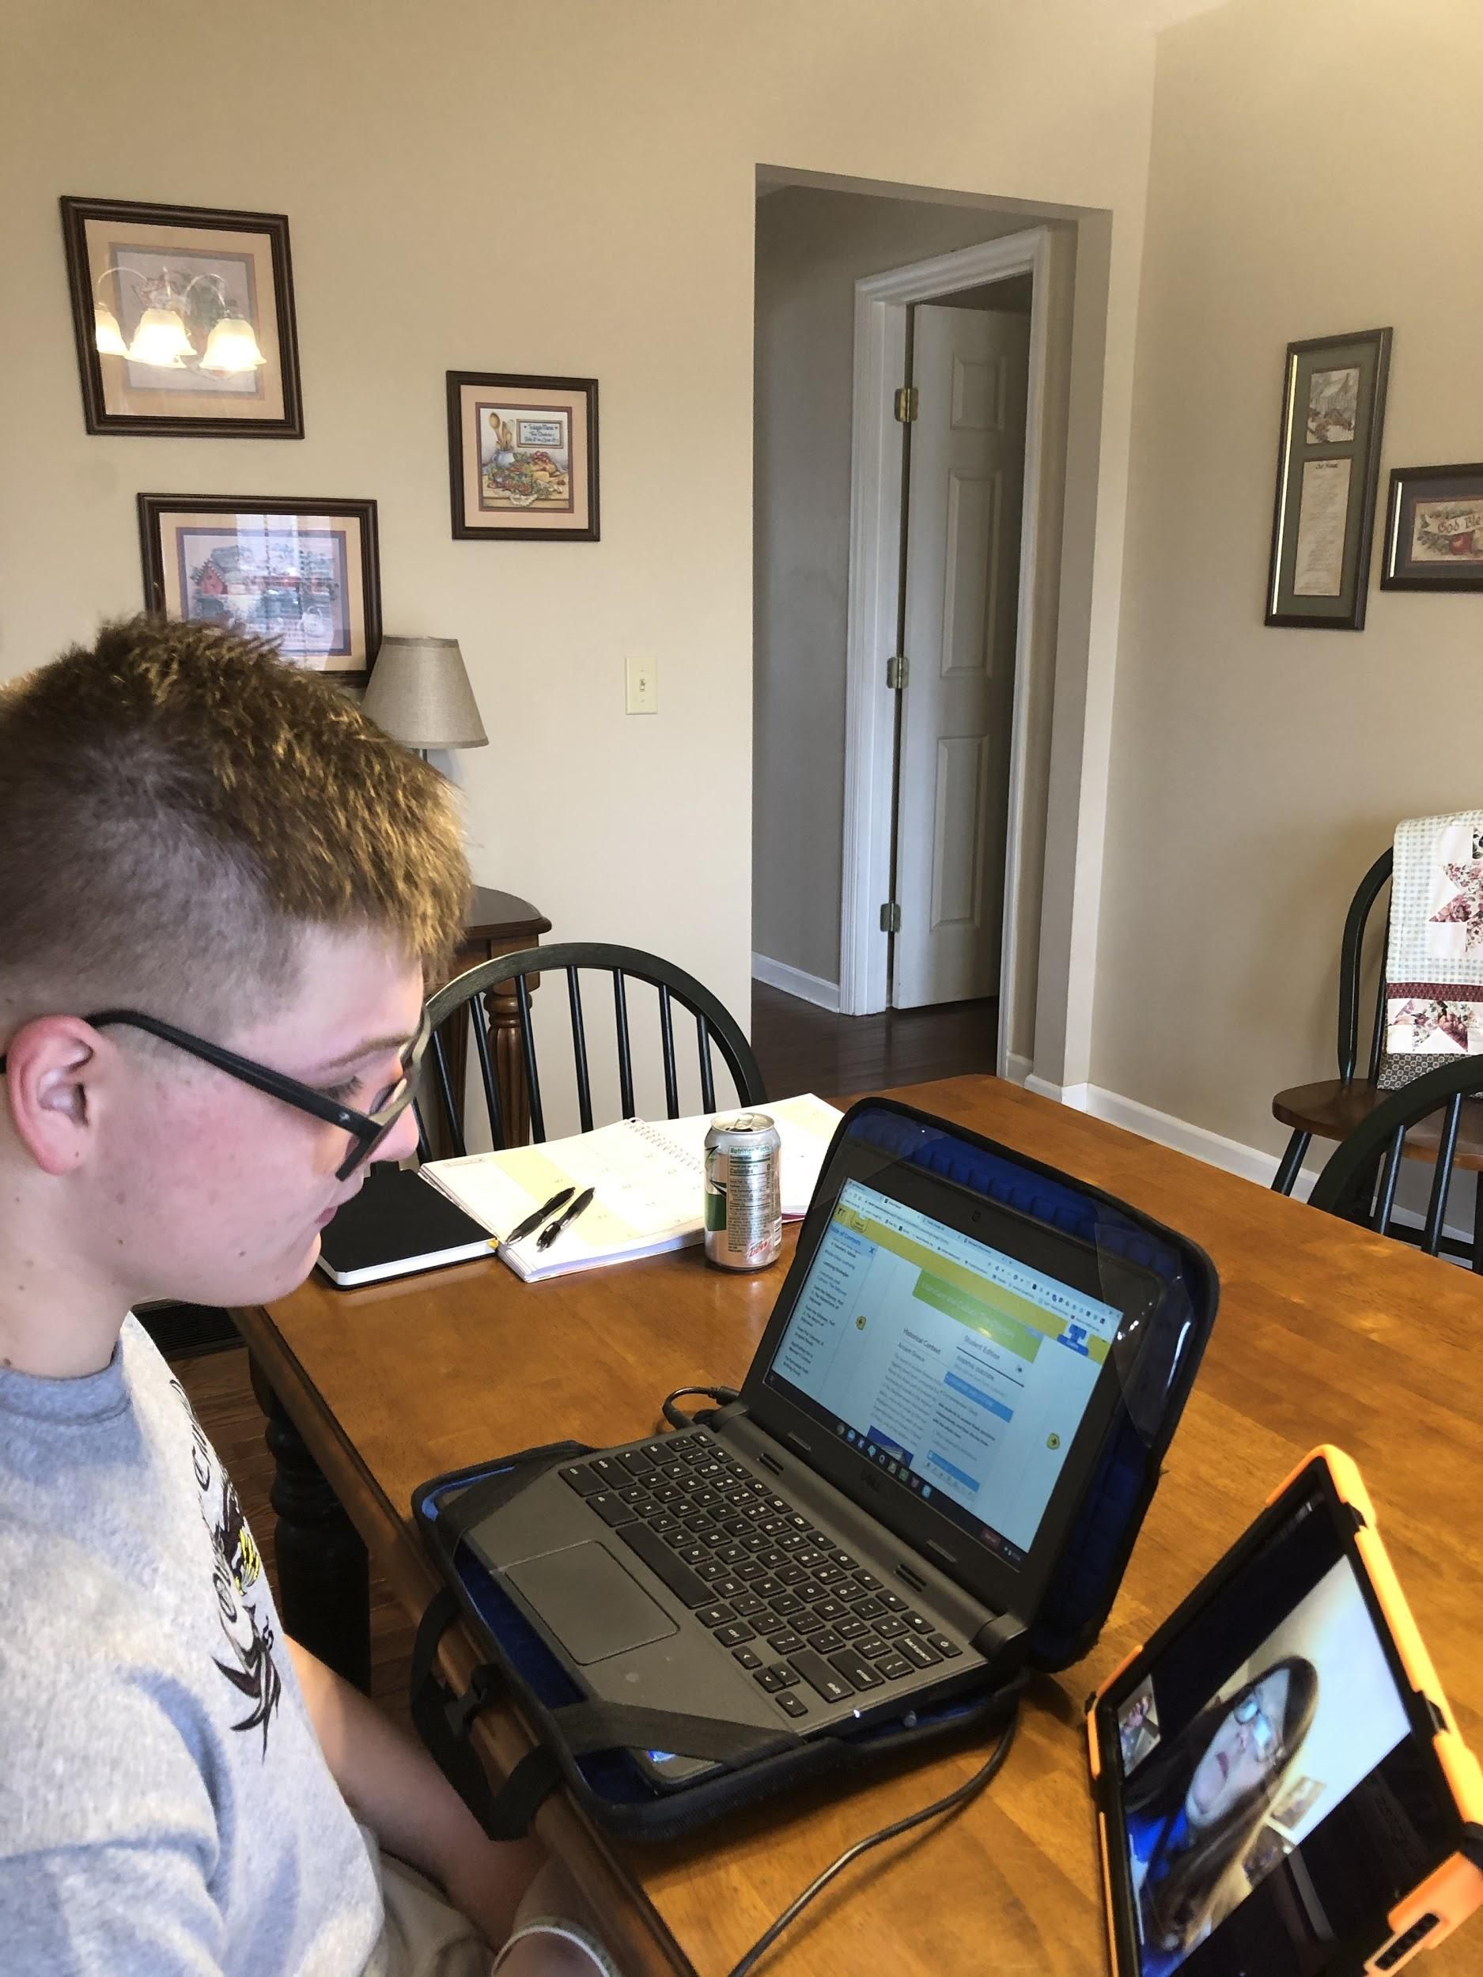

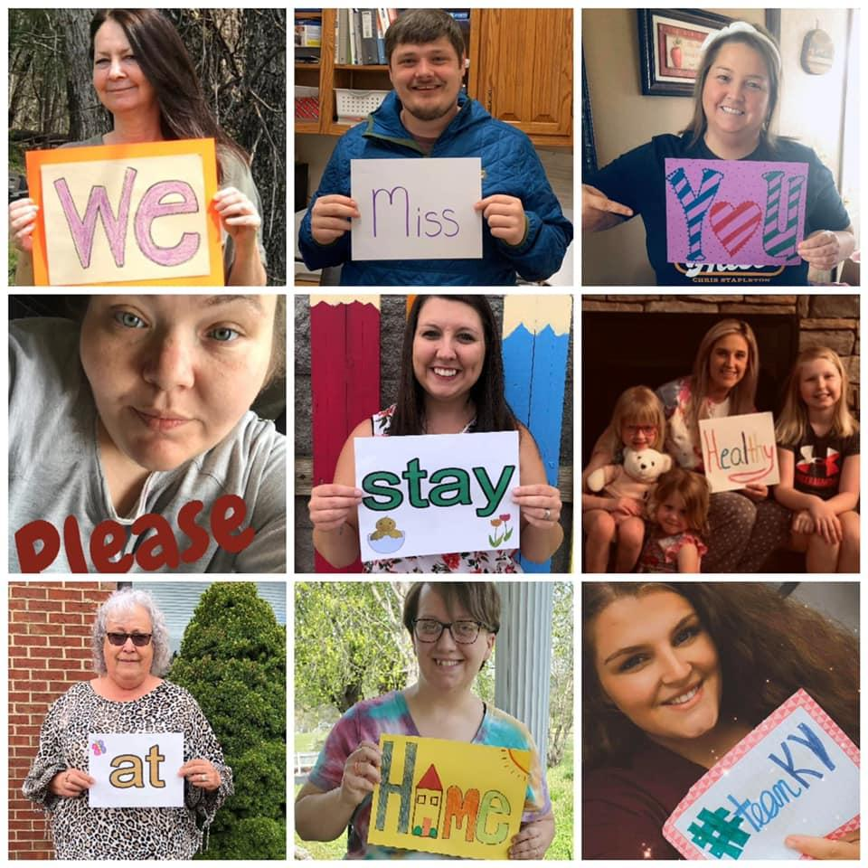 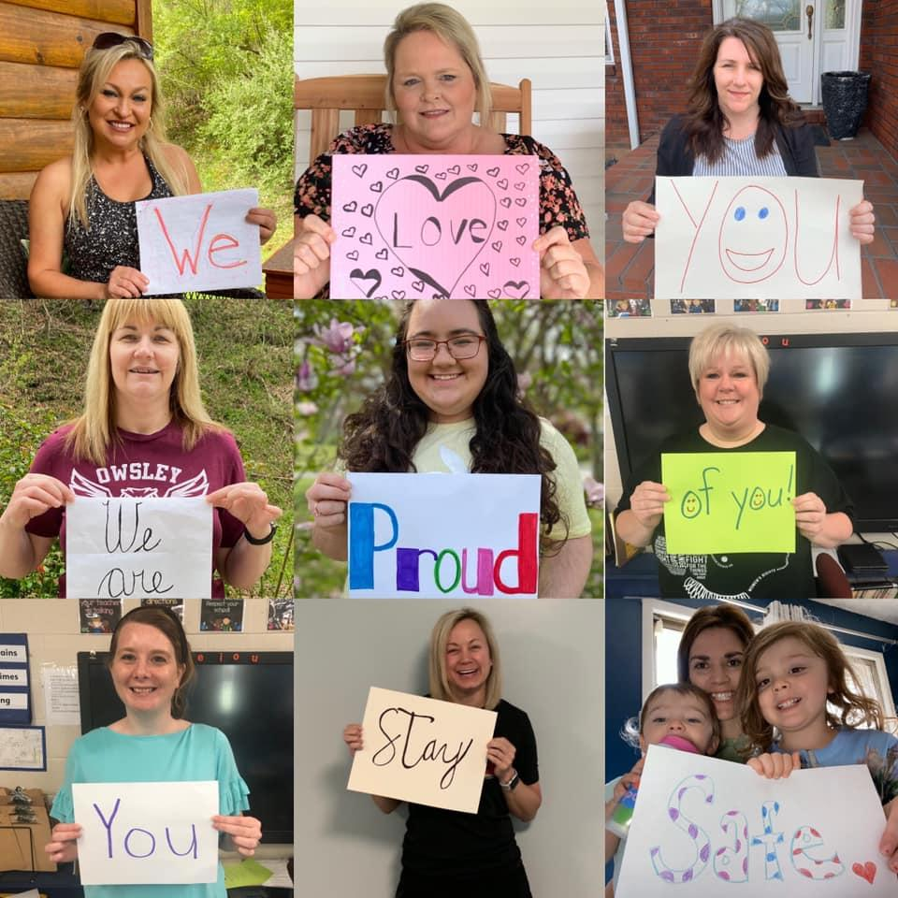

**Special Education Cooperatives**

[](https://www.ckec.org/)            [](https://www.grrec.org/)             [](https://sesccoop.org/)     [](https://www.kentuckyvalley.org/)       [](https://www.ovec.org/)       [](https://www.kyglec.org/)        [](http://www.kedc.org/)      [](http://www.wkec.org/)           [](https://www.nkces.org/)