**Special Education**





McLean County Schools have been very proactive in trying to meet the needs of their students during NTI, particularly in a county with limited Internet access. Through a district-wide collaborative effort, they have strategically planned to ensure equitable access for all students to participate in instructional activities.

All students in grades 2 through 14 were allowed to check out Chromebooks. The majority of teachers have provided their instruction and assignments through Google Classroom. To accommodate those students who don't have Internet access, the District Technology Coordinator set up wireless access points at each of their three elementary schools in locations that can be accessed from the parking lot. Parents are then able to drive up to connect to the Internet so that assignments from Google Classroom can be downloaded and/or uploaded. McLean County staff members are providing meals from these locations as well so it would be more convenient for parents to "one stop shop!”

One of their three elementary schools is already one-to-one with technology so grades K and 1 in that building are using the Chromebooks. The other two elementary schools provide instruction through Google Classroom for those K-1 students who might have access at home but also provide packets to accommodate those who do not.

Teachers across the district are trying new things every day to make instruction as accessible as possible. They are using Zoom, Google Meet, Facetime, Facebook Live, Facebook pages, Remind Text. They are also investigating and using Google extensions to make creative and/or interactive assignments such as Kami. Since many parents and/or students do have access to smartphones, teachers have used apps/tools that allow for using the phones camera to scan documents that can be uploaded to Google classroom or emailed directly to teachers.

Finally, one of the preschool classrooms has created a Facebook page to provide activities, videos, and information to their students and families. Check them out: [Livermore Head Start\Preschool](https://www.facebook.com/Livermore-Head-StartPreschool-696364837432620/)!

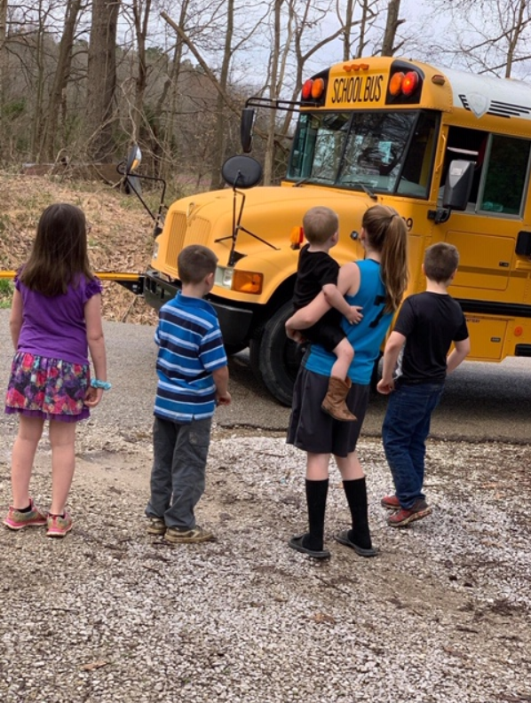 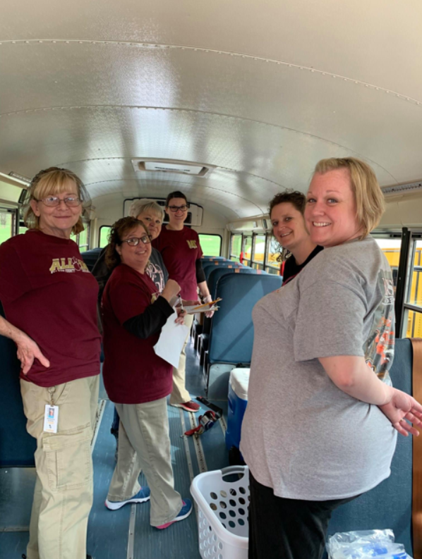 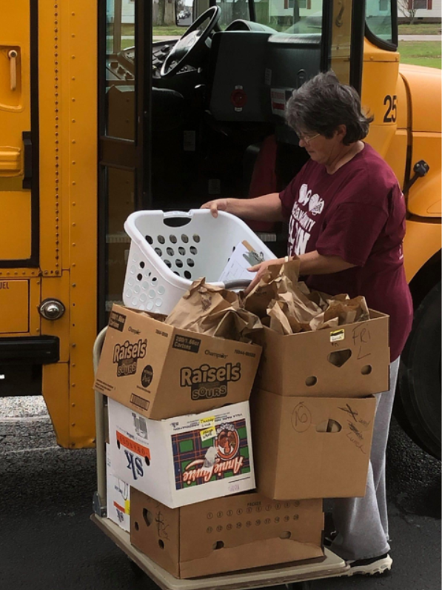 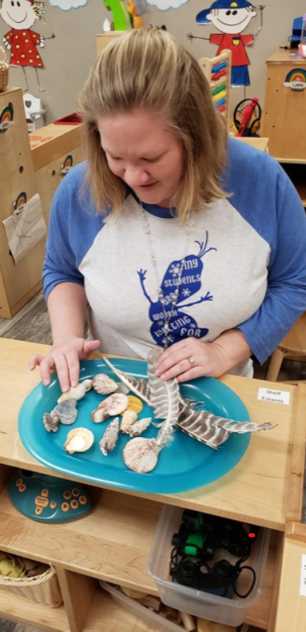

**Special Education Cooperatives**

[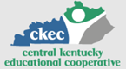](https://www.ckec.org/)            [](https://www.grrec.org/)             [](https://sesccoop.org/)     [](https://www.kentuckyvalley.org/)       [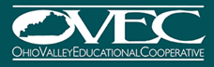](https://www.ovec.org/)       [](https://www.kyglec.org/)        [](http://www.kedc.org/)      [](http://www.wkec.org/)           [](https://www.nkces.org/)