Special Education
The Mayfield Independent School District has taken many creative approaches and strategies to ensure that the needs of all students are met during this unprecedented time. Mayfield has endured barriers that have attempted to cause difficulty for students and teachers to continue with serving specially designed instruction and instruction in general education. Collectively, they have worked as a district team to pull together and knock down those barriers so the students will continue to receive all they need to accomplish their tasks, stay nourished through meal delivery, and maintain social and emotional strength.
All students, Pre-K through grade 14, have teachers who are reaching out to them daily via phone calls, texts, Facetime, Google Meet, Microsoft Teams, Zoom, YouTube Channels, Facebook Live, Remind App, Google Extensions, and various other virtual avenues. A designated packet pick-up/drop-off has been put into place at each individual school so that hardcopies of work may be picked up and returned upon completion. Packets for students who receive special education services have individualized instruction that targets Individualized Education Program (IEP) goals.
The special education department is excelling in making certain they are documenting specially designed instruction minutes served, accommodations provided, methods used for delivery of services, and summaries of instruction delivered on a form created specifically for Non Traditional Instruction (NTI) days. Staff continue to maintain progress monitoring and logging parent contacts in Infinite Campus. All of Mayfield employees continue to meet together in Professional Learning Communities as departments to contribute new ideas, plan together, give instructional/virtual tips, and more.
Mayfield Independent faculty and staff are delivering meals to different locations within the school district, creating a simple way for parents/guardians to pick up their students’ breakfast and lunch. Mayfield has gone the extra mile to also provide meals on Saturdays and deliver weekend backpacks with meals for those who may need food through each Monday. This all started from the very top with Superintendent, Joe Henderson, leading the way. Not only has Mr. Henderson led his team by making tough decisions that are best for students and staff, but he has also delivered many meals himself. Mr. Henderson has made it clear: Mayfield’s top priorities are taking care of the mental/emotional health of Mayfield students and staff, exceeding the standards for the safety of physical health, and ensuring every step is taken to virtually meet the academic needs for all students.

Teachers, instructional assistants, transportation, custodial staff, food service, administrators, and technology consultants are all collaborating to establish and ensure the daily routine remains as consistent and fulfilling for students and families as possible. Whether it is a teacher-led virtual field trip or a parent/guardian poll concerning instructional delivery methods, Mayfield has proven it will go above and beyond to meet the needs of each student. Equity is key for Mayfield Cardinals, and all staff are committed to this mission.
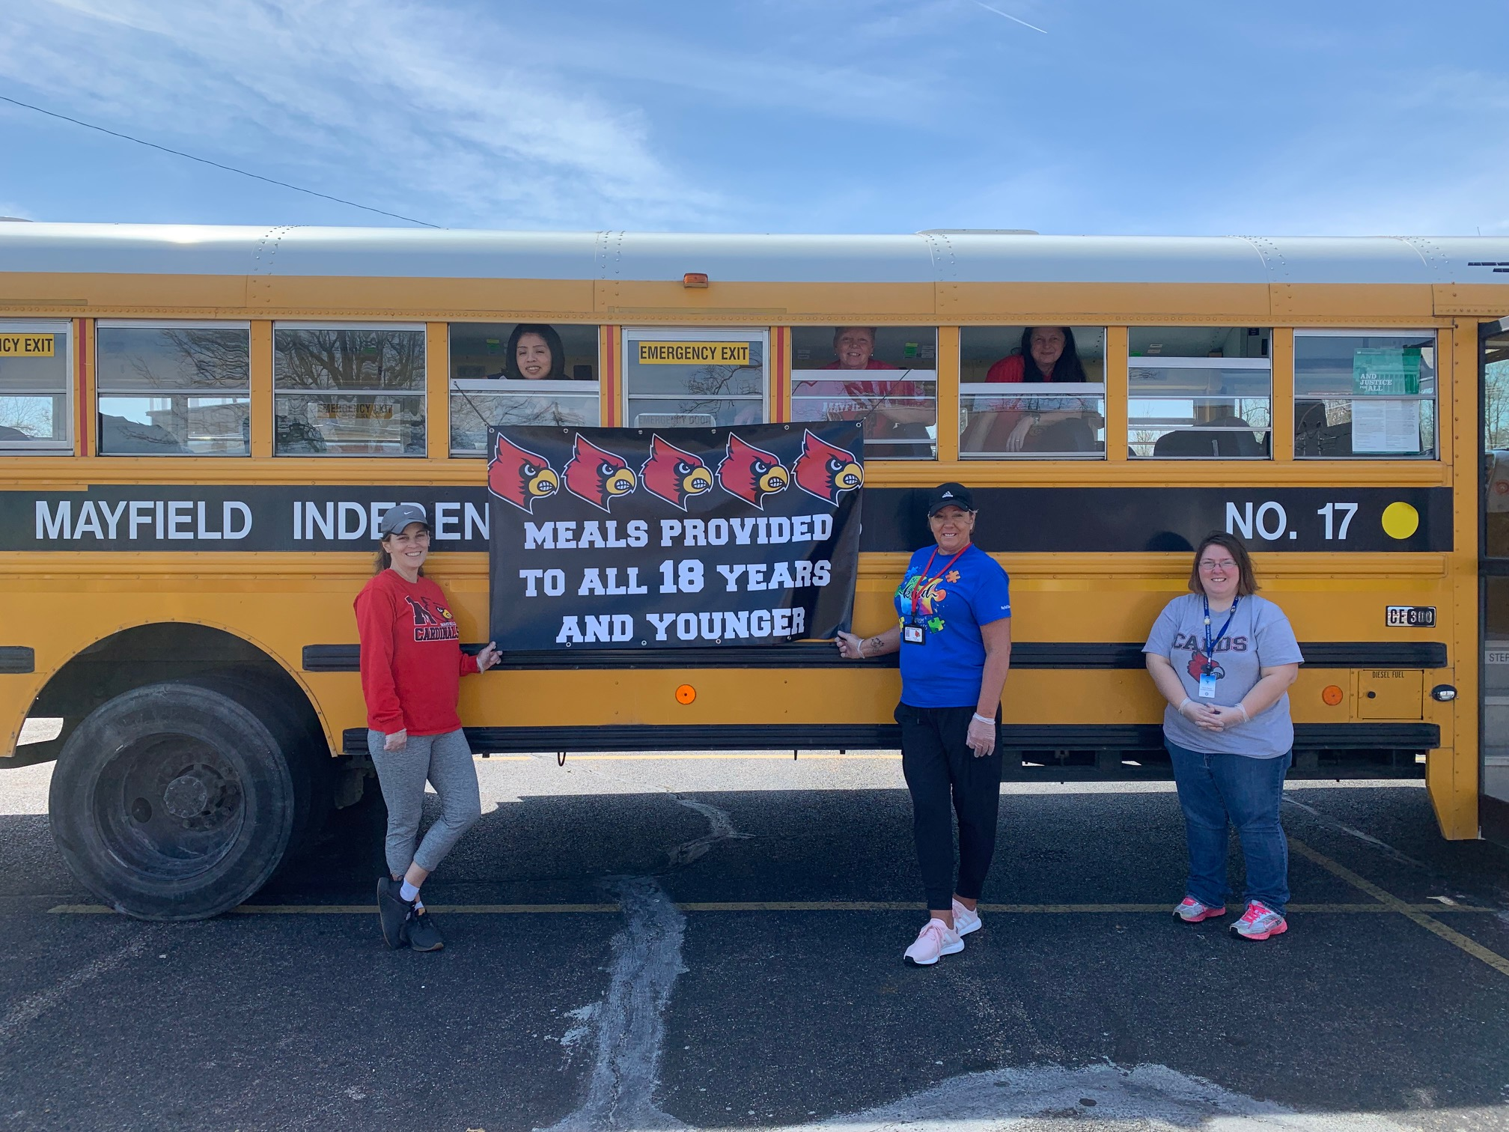
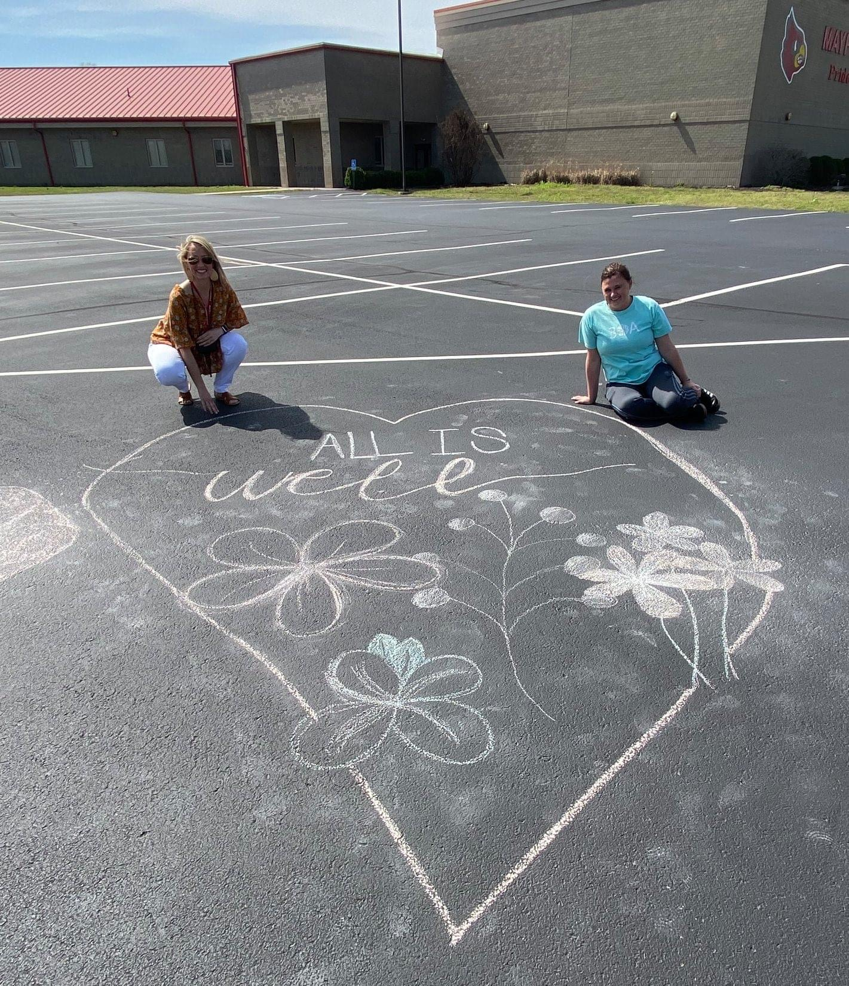
The Mayfield Independent School District is PROUD of the teamwork and support from staff, students, families, and community all working together!
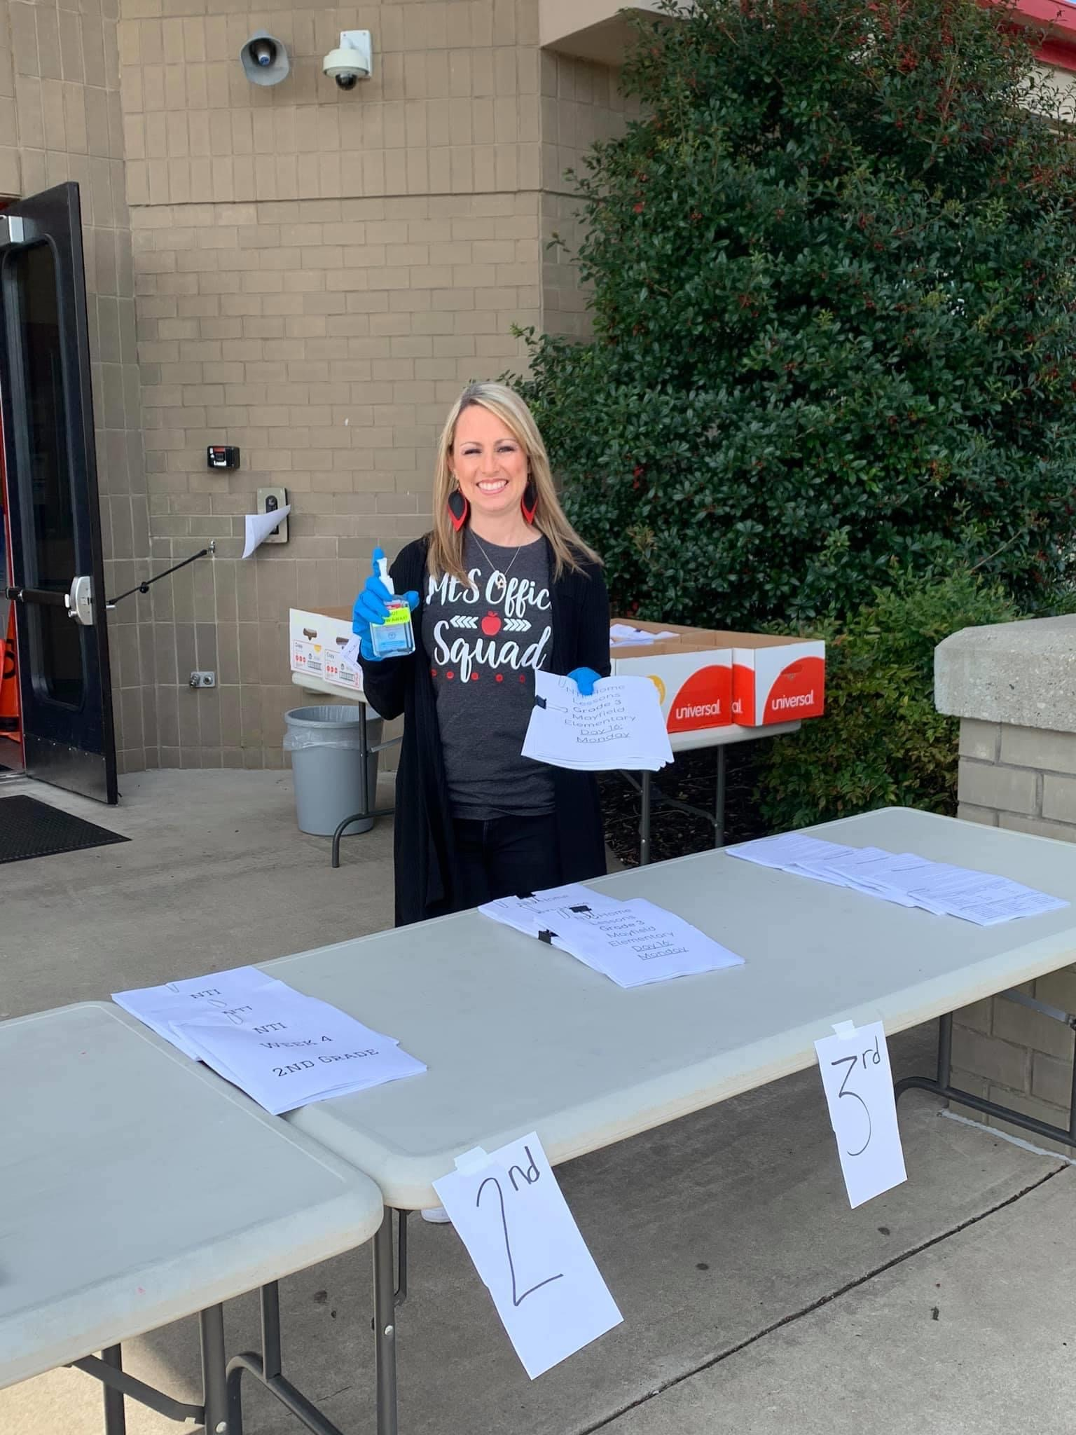
Special Education Cooperatives

