**Special Education**





Jefferson County Public Schools system was quick to respond with access for students with disabilities when the district transitioned to Non-Traditional Instruction (NTI). “When you plan for individualized and personalized pathways there is always student success that will follow. Students with special needs were at the forefront of the collective district leadership,” stated Kim Chevalier, Chief of Exceptional Child Education (ECE). Superintendent Marty Pollio and the ECE team operated on the premise that students' needs come first. Mrs. Chevalier’s comprehensive approach supported teachers and staff allowing them to concentrate on their best faith effort to provide equitable access, and a process for documenting their decision-making process for individual students.

The district implemented a comprehensive approach in ensuring families were provided with access to technology with Chromebooks and hotspots. Students with disabilities were given priority to implement their Individual Education Programs (IEP), and if needed, paper packets to continue their learning opportunities. Students with all disabilities continue to receive services using a variety of technology platforms. Students participate in live instruction on Google Meet with both ECE and general education teachers. They have access to and submit assignments via Google Classroom. In addition, students access instruction via YouTube and Screencastify videos developed by teachers. Students who are Deaf/Hard of Hearing access instruction through the use of live captioning and interpreters. District-based staff went to schools to sanitize equipment for students with visual impairments and made contactless home deliveries.

Additionally, JCPS district staff provided support and technical assistance for school staff. Through an awesome cross-departmental collaboration, ECE district staff provided live online professional learning through the JCPS Digital Learning Channel on YouTube. Throughout the month of April, the team presented daily training for teachers, school administrators, ARC chairs, and ECE Instructional Assistants on how to meet the needs of students with disabilities in the virtual environment. The district ECE team conducted weekly Zoom meetings with ECE teachers, ECE Implementation Coaches, and Related Services staff. ECE staff worked tirelessly to develop tools and supports for teachers and staff to provide reasonable, alternative access to the curriculum with comparable services in light of the current situation.



JCPS created an NTI Portal for educators, students, and parents ([JCPSNTISupport](https://sites.google.com/jefferson.kyschools.us/jcpsnti/home)**).** The ECE Department developed a compliance guidance document to address NTI specific issues which they updated daily. Additionally, the department offered live support with a school psychologist and ECE Supervisor through Google Meet for eight hours a day. District staff joined the meet to ask questions specific to supporting students with disabilities during NTI. JCPS personnel could also access support through a Google Form which the ECE department monitored. Supervisors in the ECE Department made themselves available for further guidance. District teams provided detailed content and soothed the nerves of adult learners who needed more support for their new virtual world.

JCPS Language Services offered support through phone and video conference interpreting. The Language Line service allowed district staff to communicate effectively with English Learners and their families in their native language. What a great opportunity to support communication for all.

Students with Visual Impairments continue to have access to learning: [Twitter video - VI Breck-Frank spotlight](https://twitter.com/i/status/1248385505735016448)

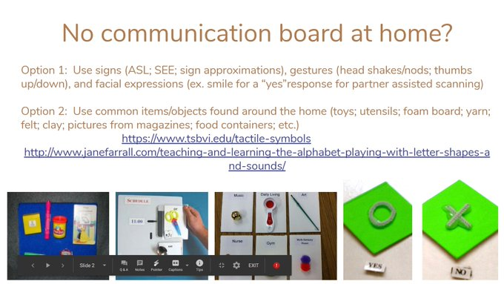

So thankful that my son can still receive speech services from home! Way to go [@JCPSKY](https://twitter.com/JCPSKY) [@SLPs_JCPS](https://twitter.com/SLPs_JCPS) [@WheelerElem](https://twitter.com/WheelerElem) [@CoachMeredith](https://twitter.com/CoachMeredith) [#JCPSNTI](https://twitter.com/hashtag/JCPSNTI?src=hashtag_click) [#WeAreJCPSAtHome](https://twitter.com/hashtag/WeAreJCPSAtHome?src=hashtag_click)  [@MyNTIky](https://twitter.com/MyNTIky) [#MyNTIKy](https://twitter.com/hashtag/MyNTIKy?src=hashtag_click)

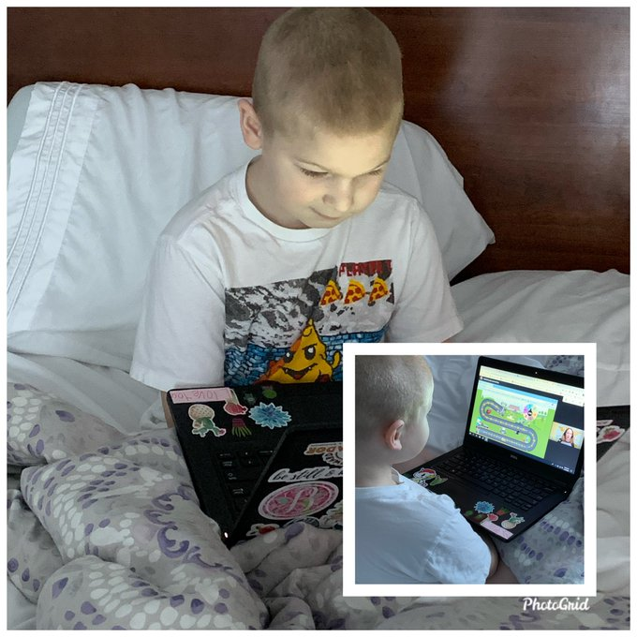

Students who receive special education services are general education students first! Non-traditional Instruction (NTI) may have posed initial unique challenges in regards to students with disabilities but it also allowed for more individualism, especially within the constructs of general education accessibility. Accessibility is the Key!

One teacher gave this advice, “Be flexible. Be patient. Listen to the student’s needs.

Let them help you make their schedule. Let students help you create a workspace. Set up Google hangout or video time for students to be in touch with their friends or loved ones. Explain what is going on in the world and listen to their feelings and reactions. Answer the “Why?” questions. If the day seems to be too much for them, let them take a break and start fresh.”

For students who have the ability to engage in instruction digitally, this time allows them to use needed accommodations, like text readers, and predictive writing programs without feeling embarrassed or singled out. The tools were available and used by all students, not just students with disabilities. One teacher reported some students are doing better in this environment and they are able to work at a pace that reduces the feeling of being rushed, or overwhelmed.

JCPS is in the midst of developing an NTI plan that will provide ongoing support should NTI be needed for the future. The newest shared resources are saved and accessible from JCPS Live Support, now recorded digital training and resources.

**JCPS will use NTI through May 27, 2020**

[**Parent Letter**](https://www.jefferson.kyschools.us/departments/communications/monday-memo/non-traditional-instruction-nti-announcement)**,** [**School Portals**](https://docs.google.com/spreadsheets/d/e/2PACX-1vTf8bBWvPPvQTypm_rWA8UKSC25Y48XHuf5VFmkWJwwuQUvOapEA940ukjauTLR4SsiUWXGMEoUZAnC/pubhtml)**,** [**NTI Packets**](https://apps.jefferson.kyschools.us/orchard/PracticePackets)**, &** [**Food Sites**](https://www.jefferson.kyschools.us/sites/default/files/Emergency%20Feeding%20Sites.pdf)

Together we can! We are fortunate to have the support and partnership of the Greater Louisville Education Cooperative (GLEC) who provides us with additional resources, tools, and virtual professional development. Thank you to all staff in Jefferson County Public Schools for their teamwork!

**Special Education Cooperatives**

[](https://www.ckec.org/)            [](https://www.grrec.org/)             [](https://sesccoop.org/)     [](https://www.kentuckyvalley.org/)       [](https://www.ovec.org/)       [](https://www.kyglec.org/)        [](http://www.kedc.org/)      [](http://www.wkec.org/)           [](https://www.nkces.org/)