**Special Education**

Sp



Harrison County was the first to roll out Non-Traditional Instruction (NTI) in a quick manner due to the Covid-19 pandemic. Harrison County made an extra effort to connect with families and students virtually, send instructional activities home with students, and connect with parents to share examples for how they might help their children with school work.

Harrison County Special Education and Preschool staff have been rock stars! Having been impacted from the beginning of the COVID-19 outbreak, the entire special education program has united to support the entire community.  Brad Yearsley, Director of Special Education, has served as a mentor to all special education directors throughout the CKEC region on how to implement specially designed instruction (SDI) and related services, as well as just giving advice on day-to-day operations.

Whitney Fowler, Preschool Director, is also an amazing example of how to implement preschool services during NTI.  The school district staff exhibit strong teamwork strategies of support such as utilizing zoom and google hangouts for specially designed instruction and related services.

We salute the Harrison County special education program for their steadfast commitment to meet the needs of students with disabilities!  Thank you!

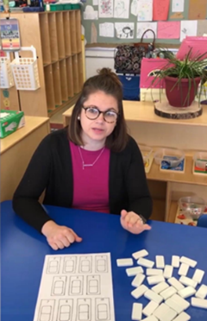 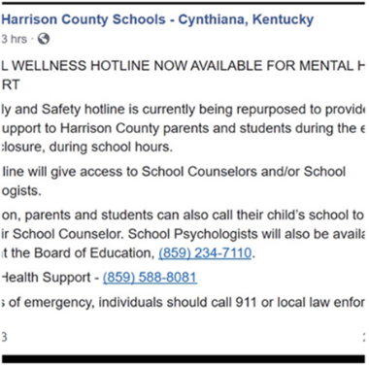 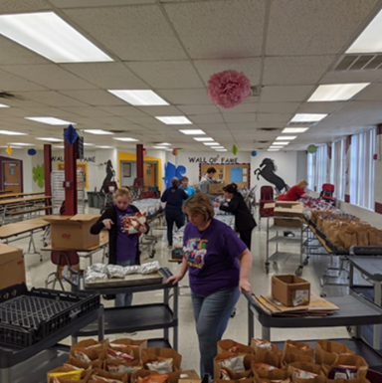 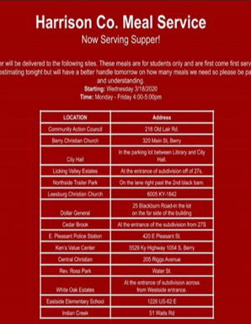

**Special Education Cooperatives**

   

   