**Special Education**

Special Education Spotlight




Boone County Schools Special Education Staff did not miss a beat as they moved into Non-tradition Instruction (NTI) on March 13, 2020.  All special education staff (teachers, Occupational Therapists, Physical Therapists, Speech and Language Pathologists, Para-educators, Interpreters, job coaches, etc.) have been working cooperatively with the regular education staff and they have rose to the challenge of discovering new ways to positively impact the lives of each student and their families.  At the start of NTI, each teacher began the journey by reaching out to each student and their families to develop a learning plan through numerous virtual tools.

Instruction for all learners regardless of disability continues through creative methods including the use of Google classrooms, Facebook live streaming and pre-recorded instructional videos with the use of YouTube and Screencastify.  Some students are benefiting from hands on learning by utilizing manipulatives, games, virtual community based instruction, video modeling, sign language, paraeducator-support and conferencing to teach content.

Our instruction was not limited to academics.  For example, social and emotional learning instruction around emotions, growth mindset, and social awareness continues to benefit students while working at home. Staff utilize a variety of motivators including show and tell, scavenger hunts, surprise guests in google meets and group online games. Therapy teams are also working hard with our students to address communication, life skills, fine and gross motor skills and sensory needs.  They are providing therapy equipment, sharing handouts, utilizing social media to post daily play activities that support development as well as joining teachers in their virtual classrooms. Speech Therapists are also providing direct instruction through tele-therapy sessions.  NTI has also provided the therapists the opportunity to coach parents on ways they can reinforce skills taught during the therapy sessions.

In addition to ensuring the students are getting the support they need, we work to ensure we are there for each other.   On a weekly basis we hold District, School and Disability level Professional Learning Communities where we take time to celebrate our successes, answer questions, problem solve individual issues and share ideas and resources with each other.  We ensure every staff member has access to materials, tools and information by posting on our [Special Education NTI website](https://sites.google.com/boone.kyschools.us/specialeducation/nti-resources).  We are also blessed to have the support from the Northern Kentucky Cooperative for Educational Services (NKCES) who provides us with additional resources, tools and virtual professional development.  Thank you to all staff in Boone County Schools for their work!

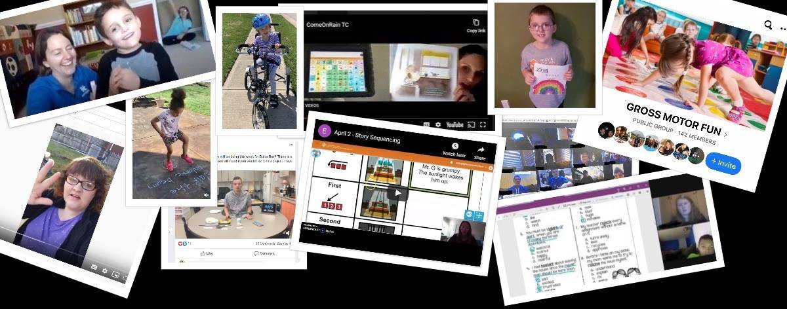

**Special Education Cooperatives**

[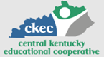](https://www.ckec.org/)            [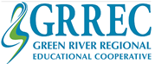](https://www.grrec.org/)             [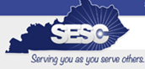](https://sesccoop.org/)     [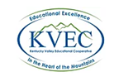](https://www.kentuckyvalley.org/)       [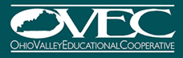](https://www.ovec.org/)       [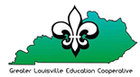](https://www.kyglec.org/)        [](http://www.kedc.org/)      [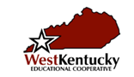](http://www.wkec.org/)           [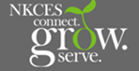](https://www.nkces.org/)