**Special Education**



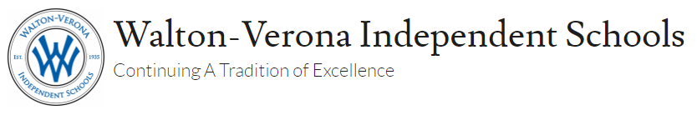

School School School School

The Walton-Verona Independent School District’s mission is to prepare our students for life through academics, extracurricular activities, and community engagement while continuing our tradition of excellence.

Throughout this school year, our special education staff has overcome many barriers using our core values of honesty, integrity, excellence, accountability, respect, and teamwork to ensure our students were still receiving the education they had come to know and expect.

This year more than ever, we were forced to balance our tradition with innovation.  As a district, we launched a 1:1 initiative that provided every middle and high school student with a school-owned Chromebook. Additionally, we provided a Chromebook to any elementary school student who needed one for at-home use. We received a donation from the Walton City Council to purchase additional Chromebooks to further the 1:1 initiative at our elementary school. Additionally, we were able to partner with Cincinnati Bell and the United Way to provide discounted home internet connections for families who needed it.

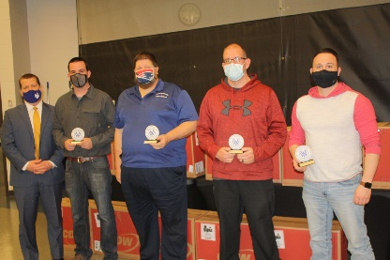 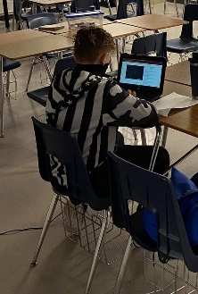 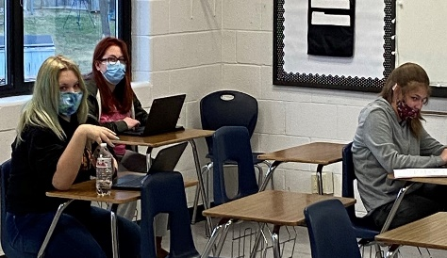

In our Early Childhood Center, the team developed healthy and safe ways to complete preschool screenings.  Once school started, the teachers utilized a mix of video lessons and recordings of books while utilizing the seesaw online learning platform for student engagement.  Teachers created folders for parents to pick up each week full of activities and manipulatives for the week’s learning.  As soon as we were able, the WVECC returned to in-person instruction as we felt like this was the best for our kids.  Following the Healthy at School Guidelines, the students and parents were excited to begin the preschool school year.  We have remained in session for most of the school year and have seen growth across the board for our preschool students.

In our elementary, middle, and high schools, our special education staff quickly helped students learn to navigate google classrooms, google meets, and other communicative tools.  As collaborative teachers in the google classrooms, the teachers were able to continue their co-teaching work. Teachers communicated with students daily and came up with creative ways to contact families and to stay connected.  Across the district, our teachers and therapists utilized targeted services to get students into the buildings for services and supports in a safe manner.  This allowed students in-person interaction with teachers and therapists and was an extremely valuable part of their learning.

Our MSD teachers were busy creating videos, picture schedules, behavior instruction, and working with the parents on strategies to help with the non-traditional instruction.  They also utilized the targeted services, which greatly aided in the transition to hybrid and in-person instruction.  Students were able to learn some classroom routines and procedures before starting back to school.

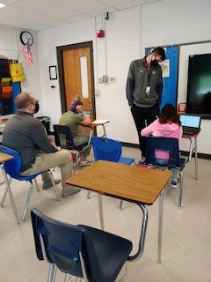 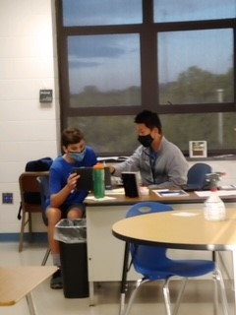 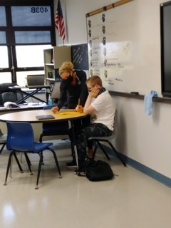

Once a hybrid model of instruction was adopted, the special education staff was still forced to balance online learning with in-person instruction but were able to manage both and create successful learning environments in each capacity. Across the district, our teachers continued to utilize targeted services to get students into the building for services and supports.  Our district helped to provided transportation for these targeted services.

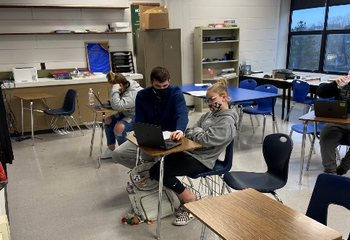 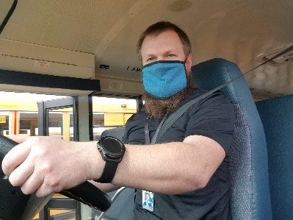 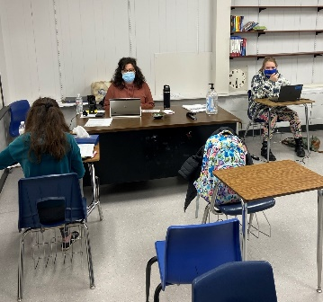

The WVISD continued to focus on the social-emotional learning needs of all of our students.  One unique way we were able to address these needs was through a partnership with New Day Farm in Verona, Kentucky.  Selected students were able to participate in their therapeutic program.

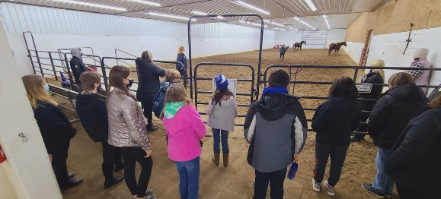 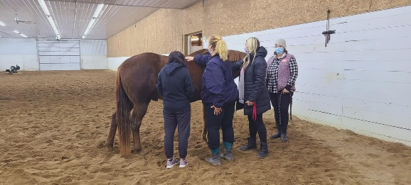

The program focuses on the fact that some students may not be able to express how they are feeling, why they are upset, or what they need, especially throughout this pandemic. This makes living with trauma, grief, behavioral disorders, or anxiety even more stressful. However, when it comes to horses, not having the right words is okay! Horses have a different way of communicating, and by teaching students to listen like they do, they help students recognize their emotions, learn new coping mechanisms, and gain the confidence to move forward.  New Day’s therapeutic programs include a variety of equine-based techniques. Some exercises involve riding horses. Others focus on leading them while tackling other challenges. Because they are customized to fit the student’s individual goals, no two programs are the same. However, each is built on a foundation of tried-and-true techniques designed to improve interpersonal connections, conquer fears, and rediscover our strength within.

During the time that our students were missing the culture of the school, staff worked hard in conjunction with PTSA and other organizations to provide fun student and parent involvement activities, including reverse parades, a family Christmas light scavenger hunt, and a drive-in movie night. Parents and students were also able to recognize teachers and staff members who have gone above and beyond during the pandemic. This is tradition that our district plans to adopt and continue in the future.

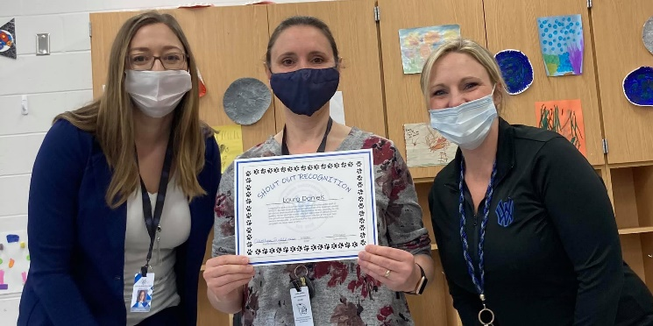

As a district, we have risen to the challenge of educating our students throughout this unprecedented time. Every member of our staff has contributed to this effort, from food service and transportation, custodial staff to our teachers; everyone has played an essential role in the success of our students. We are so proud to be Bearcats!

Special Education Cooperatives

[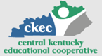](https://www.ckec.org/) [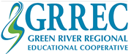](https://www.grrec.org/) [](https://sesccoop.org/)

[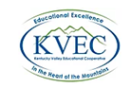](https://www.kentuckyvalley.org/) [](https://www.ovec.org/) [](https://www.kyglec.org/)

[](http://www.kedc.org/) [](http://www.wkec.org/) 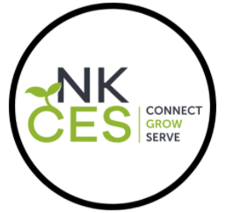

Early Childhood Regional Training Centers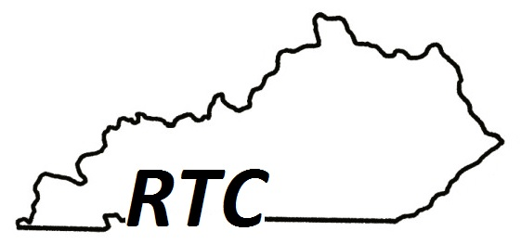

Ashland RTC

Anderson County RTC

Berea RTC

Calloway County RTC

Simpson County RTC