**Special Education**

 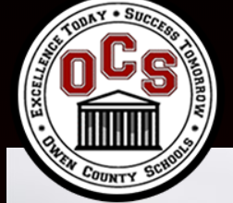



Owen County’s Student Technology and Leadership Program (STLP) students are making use of technology in order to apply what they know, solve problems, and empower others. This is also evident particularly with students with disabilities struggling at home during non-traditional instruction. Owen County staff and students have been determined to meet the definition of empowered learners. For example, STLP students Jacob Lilly, Janelle Aguazul and Alli Gill took on the project of creating YouTube videos of the grade level NTI packets to accommodate students with disabilities. These students read the directions, lengthy passages, provided examples and explanations, offered learning strategies and voiced encouragement to those students who may have needed it the most during this difficult time of social distancing. The purpose was not to take the place of what teachers were doing but rather to enhance it. An example of this work is located in the links below.

The mission of Owen County Schools is to provide opportunities and resources where ALL students will develop perseverance and a passion for life-long learning in a safe, *supportive*, educational environment.The vision for Owen County students is that they will **R**espect others, **E**xperience learning, **B**uild relationships, **E**xpect excellence, **L**ead, and **S**eek opportunities. Director of Special Education, Donna Combs, shared that, “These model students exhibited every characteristic of the vision statement with this project. Alli, Janelle, and Jacob are demonstrating a servant’s heart and that is why we are honored to recognize their REBEL spirit. Even when school is not in session in the traditional sense, personalized learning for our students with disabilities should never stop. Isn’t it ideal that their peers are providing an additional layer of support in order to connect outside of the classroom walls?”

Example NTI Support from Owen County STLP students:

<https://www.youtube.com/watch?v=2sCXyWeD32Y&feature=youtu.be>

Jacob Lilly, student

<https://www.youtube.com/watch?v=M_9kBl_1dOA&feature=youtu.be>

Alli Gil, student

<https://www.youtube.com/watch?v=5neTuHXwoPE&feature=youtu.be>

Janelle Aguazul, student

**Special Education Cooperatives**

[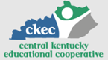](https://www.ckec.org/)            [](https://www.grrec.org/)             [](https://sesccoop.org/)     [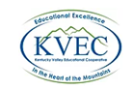](https://www.kentuckyvalley.org/)       [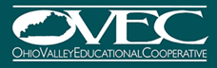](https://www.ovec.org/)       [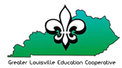](https://www.kyglec.org/)        [](http://www.kedc.org/)      [](http://www.wkec.org/)           [](https://www.nkces.org/)