Special Education

This team of special educators have really stepped up their pace during Non-Traditional Instruction. They have made numerous contacts with parents via telephone, letter writing, and video conferencing. They have learned where students live, what barriers they have to learning, and how important education is to their students’ families.

Several special educators provided assistance in gathering and disseminating food to families and have provided resources to families as they relate to financial assistance, free internet, free online educational resources and games, and mental health resources. Our school psychologists have listened and worked through emotional issues with families and have also provided community resources for them to seek additional professional assistance.

This team of special educators have taken their students on virtual historical tours of Ohio County! They have read to students virtually and over the phone. They have conducted virtual math lessons with students on their own refrigerator doors and home walls! They have provided visual schedules for families to use at home and have provided virtual sign language instruction to both students and their families and friends.

As a team, we hold Special Education Advisory Team (SEAT) meetings monthly in the district. During the pandemic, we have held these meetings virtually with most everyone in attendance (see attached photo of our April 2020 meeting). Some teachers are walking in their backyards while they participate, some are by their pools, some are in their living rooms or kitchens or bedrooms of their homes, and others are in their actual classrooms while they participate. We have learned lots during the pandemic and much of what we’ve learned is going to be seen as options for the future education of Ohio County students.

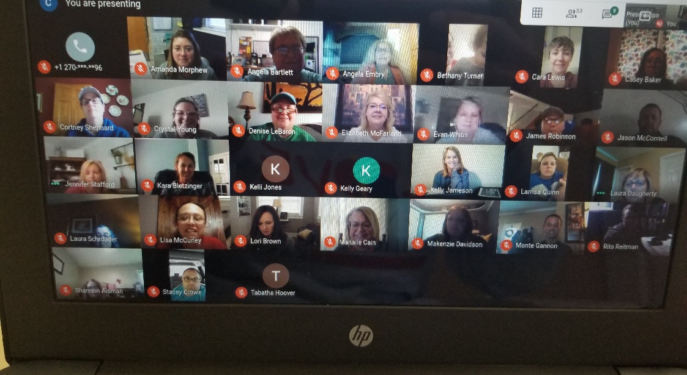

Special Education Cooperatives
G SESC

