**Special Education**



**Madison County- Person First Academy (PFA)**

Person First Academy (PFA) is a Madison County initiative to help improve post-school outcomes for students with moderate to severe disabilities. Since 2019, a team of Madison County teachers have committed to bring together a hands-on learning project that incorporates transition into careers and community, while also allowing students to pursue higher education avenues as well.

The PFA consists of four career areas. Each area is designed around the career interest inventory and career clusters that match with student skills and abilities.

The PFA blends a unique collaboration with higher education and skills training attainment facilities such as Bluegrass Community Technical School with their Comprehensive Transition Program (CTP) and The Carl D Perkins Vocational Rehabilitation Institute (CDP). These programs give our students a chance to earn valuable career certificates and college credits (Audit or Regular) in a variety of different career settings. Thus increasing employability and career placement matching before leaving high school. We are able to offer these opportunities utilizing a relationship between higher education and our very own Madison County Area Technology Center. Below are the areas of certification available through the PFA:

* Landscape/ custodial: Within Madison County Schools a partnership with our Agricultural Department and custodial staff will give valuable hands-on training to learn the techniques and jobs related to these different areas.

* Food Service: Students in this area will be able to pursue numerous opportunities learning in an industrial kitchen set up and designed by Madison County Schools. This unique opportunity will allow our students to gain hands-on experience while earning their food handler cards, several certificates offered through Madison County Schools, and learn different techniques and skills adapted to area eating establishments within Richmond.

* Office Management: This area will allow our students to learn what skills are necessary to work in an office setting, such as answering the phone, serving others through hospitality, or taking orders to complete copies for teachers. This area will allow partnerships to gain the aforementioned college credits in Office Support and technical college classes that partner between BCTC and our ATC schools.

* Retail: This area will allow students to learn what it takes to work in different areas of a retail department store. With the help and collaboration of JCPENNY of Richmond, a unique area is being designed and constructed within the PFA transition area to replicate an area with the department store giant.

All these career areas will supplement certificates earned from the CDP center in the Job Readiness Training area, each student will have the opportunity to complete this certificate before they graduate or age out of school. The PFA spaces will offer familiarity and security to allow students with different abilities to learn tasks that are in demand around us but at a pace they feel comfortable and grow in confidence before they display their skills in a real-world setting.

Below is the space Madison County Schools offered at one of the two high schools. A special word of thanks goes out to the teachers responsible for bringing the work ethic and knowledge to this initiative to make it real. Alexis Patterson and Jeanine Mosher deserve all the credit for what PFA is and will become. Also, Madison Central High School principal, Brandon Fritz deserves a huge shout out. He has been able to see the potential of this program and what it can offer students who through data, struggle to find and maintain positive post-school outcomes. Without the vision of our Director of Special Education, Shanna Reeder, and our Superintendent Dr. David Gilliam these opportunities would not be available. So, thanks go out to them and their trust in a dream.

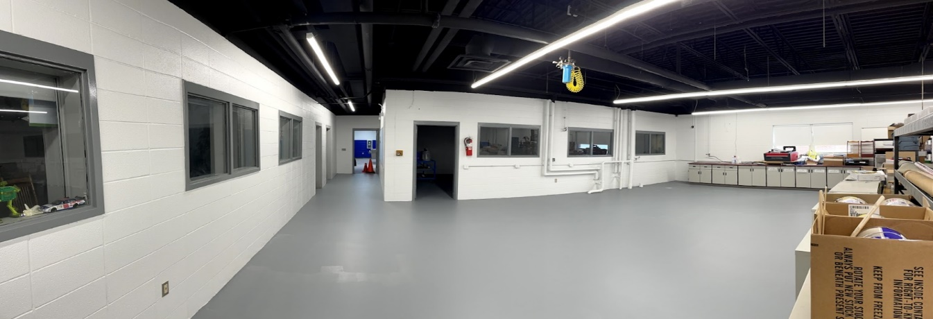

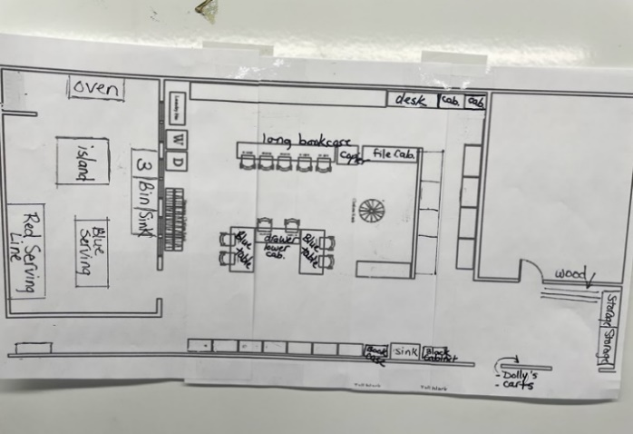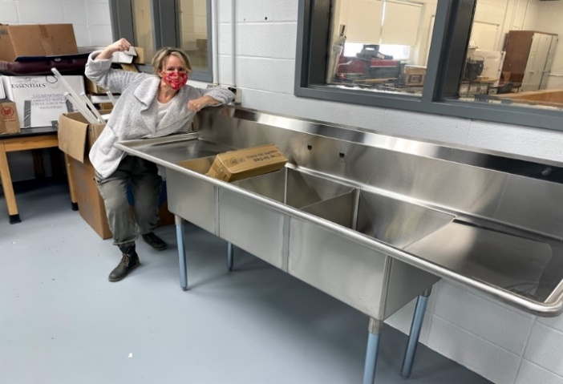

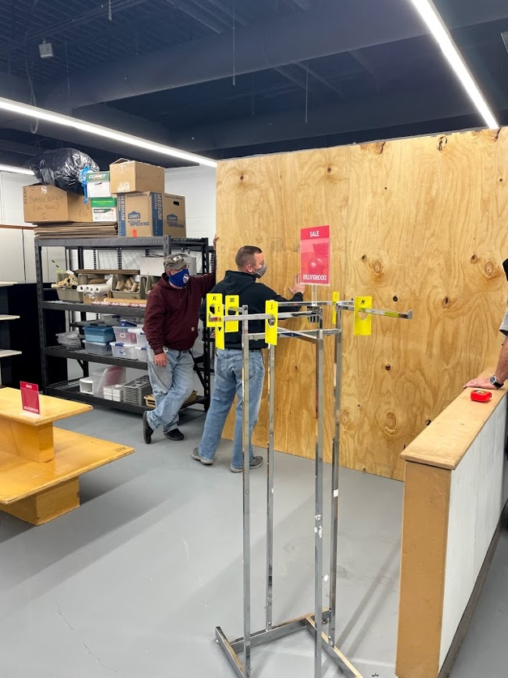

Special Education Cooperatives

[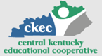](https://www.ckec.org/) [](https://www.grrec.org/) [](https://sesccoop.org/)

[](https://www.kentuckyvalley.org/) [](https://www.ovec.org/) [](https://www.kyglec.org/)

[](http://www.kedc.org/) [](http://www.wkec.org/) 

Early Childhood Regional Training Centers