**Special Education**





Letcher County’s motto is “Learner Today, Leaders Tomorrow!” Helping students learn during a pandemic can be difficult, so now, even more than ever, our staff have become avid learners.

Our Special Education Teachers, Therapists and Support Staff have adapted and met the needs of our students. When we moved to a complete virtual platform, our staff jumped into action. Special Education teachers, Therapists, and others began to learn new online methods of instruction with one-on-one instruction via Zoom, Google Meets and/or Microsoft Teams.

Many of our teachers and all of our Instructional Assistants began assisting in meal preparation and delivery. This summer Whitney Cooper, a Letcher Elementary Special Education teacher, Donna Mason a Reading Specialist, and Mattie Collins, a Letcher Elementary Instructional Assistant, volunteered in the kitchen daily, as did so many of our other Special Education staff. Whitney and Mattie even came on days they could work from home, because they wanted to make sure all their kids had a hot meal.

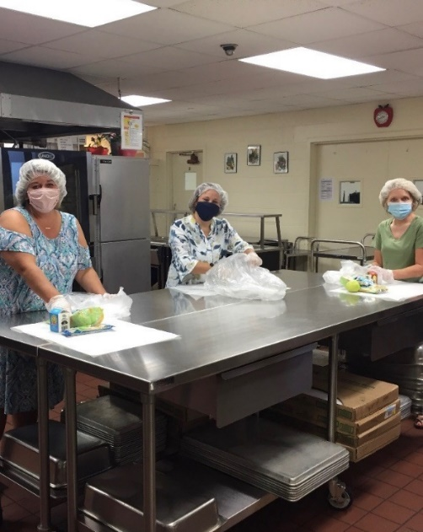

Last week our MSD and Autism units began bringing students in one at a time, for a short in-person session. Our Special Education teachers and Instructional Assistants have all commented that it finally feels somewhat normal. One of our students, like many across the state, struggled with online learning. “He has always been difficult to motivate when it comes to doing classwork and last spring impossible online.” Shellie Williams, his Special Education teacher at West Whitesburg elementary, was elated last week. This young man came for an in-person session and performed all academic tasks willingly!

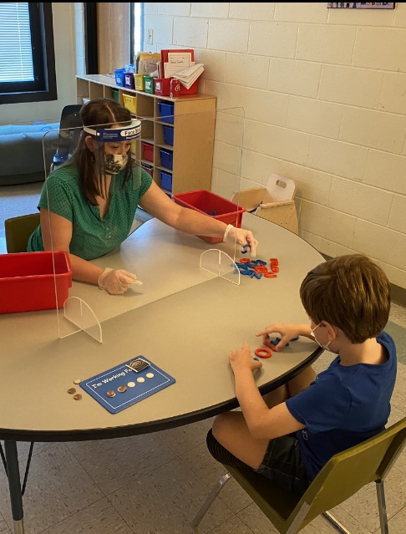

Our district, like many rural districts, have areas without the availability of internet. Some cannot afford internet even if it is available and/or do not have transportation to drive to one of the many hotspots in our county that offers free wi-fi. Joey Kincer, a Special Education teacher at Letcher County Central High School, had difficulty finding one of his students. He utilized all virtual methods to reach him, and then finally jumped in his truck and drove through our county until he found the student at a relative’s home. He even took Roddy Craft, one of our LCCHS Principals with him!

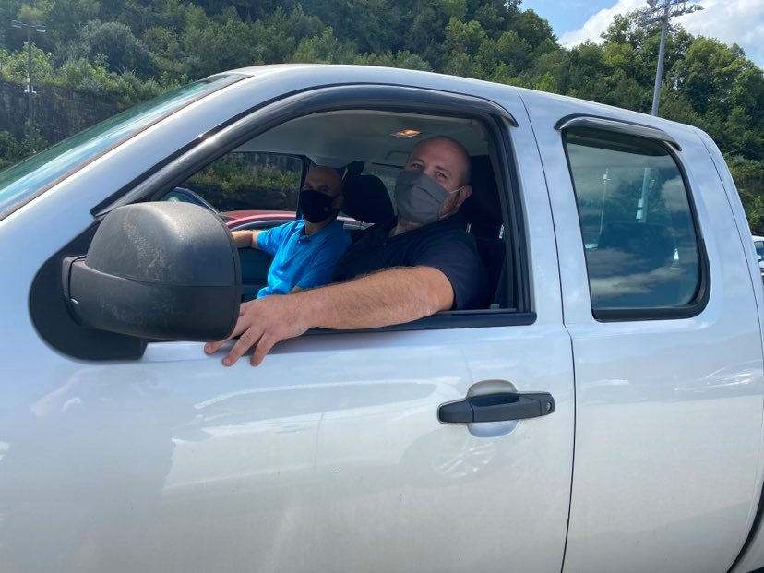

We realize that what we are doing today is not what we anticipated having to do to meet the needs of our students, but we are resilient. We will come through this much stronger and smarter than before, and our students will benefit from what we are learning. We truly are learning today so that we can shape leaders for tomorrow.

**Special Education Cooperatives**

[](https://www.ckec.org/) [](https://www.grrec.org/) [](https://sesccoop.org/)

[](https://www.kentuckyvalley.org/) [](https://www.ovec.org/) [](https://www.kyglec.org/)

[](http://www.kedc.org/) [](http://www.wkec.org/) [](https://www.nkces.org/)