Special Education
Special Educators in the Lee County School District are working harder than ever to ensure that student needs are being met. The district is using Microsoft Teams to conduct Professional Learning Communities and team meetings. Teachers are using Google Hangouts and Facebook videos to deliver instruction. They are making multiple contacts to students weekly using multiple means of communication.
One innovative teacher, Dr. Julia Bishop, is going live every day on Facebook at 10am. Julia teaches Functional Mental Disability at Lee County Middle High School. Her students tune in to get clues for the word of the week. She is also continuing her daily read aloud to students and plans a daily craft or snack to go along with the book of the week. This week she is reading CLEMINTINE by Sarah Pennypacker. In the picture, you can see her reading the book. This chapter in the book talked about lentils, so Mrs. Bishop made a craft using lentils on a flower. Mrs. Bishop’s students have loved the daily lessons. She has a big following including some former students.
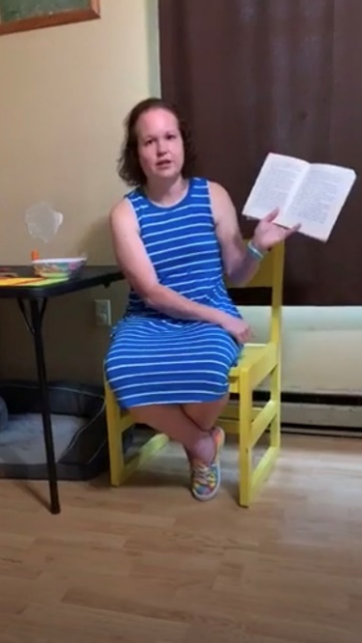
All teachers across the district and state are working hard. This is definitely a historic time for everyone. Teachers and all school staff continue to provide support in many ways and they continue to prove their love and dedication to all students! #TeamLeeCountyBobcats
Special Education Cooperatives
