Special Education
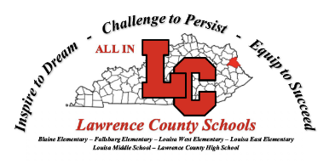
Lawrence County Schools

Lawrence County School District was able to transition IDEA and preschool instruction to a distance learning format very effectively during the pandemic because of previous years of providing high-quality non-traditional instruction. Lawrence Count IDEA and preschool staff supported students and families in overcoming barriers by being flexible and creative with delivery methods so that all students were provided access to services. Moreover, we are blessed to have high quality learning and behavior disorder, moderate and severe disabilities, visually and hearing impaired, and interdisciplinary early childhood certified teachers on staff. We employ our own school psychologist and related service providers. Full-service staffing allowed us to transition from on campus classroom instruction to distance learning without interruption of services.
Our IDEA and preschool staff were also able to connect with students and provide instruction in multiple ways including digital online instructional opportunities, video lessons and assignments, social media interactions, online classes, as well as interactive instructional packets. Specially designed instructional opportunities were individualized for each learner by their case managers, and IDEA requirements were always considered including FAPE and access to general education. We are very intentional to guard the confidentiality of our students and to meet their academic and functional needs.
Additional district supports enhance our opportunity to reach students including one-to-one technology at the middle and high school levels. Several students who did not have technology at home were provided Chromebooks by Louisa Middle School or Lawrence County High School. Our district also delivered meals to students on our bus routes which gave us access to younger students who did not have technology. We were able to provide interactive packets between school and home by coordinating deliveries between parents and teachers to meet the needs of all learners.
In addition to these supports, Lawrence County Schools provide curriculum and instructional resources that are designed to be digitally interactive. The district purchases curriculum resources such as Go Math, Benchmark Reading, IXL, Apex, Fountas and Pinnell, and Edmark instructional programs. Both our general education and special education teachers use Google Classroom to facilitate online interaction and delivery of instruction.
Although we had not anticipated the pandemic, we were prepared with the knowledge and skills to deliver instruction and continue due process. Our ARC chairpersons carried on with ARC meetings using online meeting platforms. We adapted what was adaptable and used KDE and OSEP guidance to make decisions and changes as needed. While we are saddened by the pandemic and limited in our face to face interactions, we are not limited in our dedication to students and their services and to what lengths we will go to overcome barriers so that we can do our jobs and do them well.

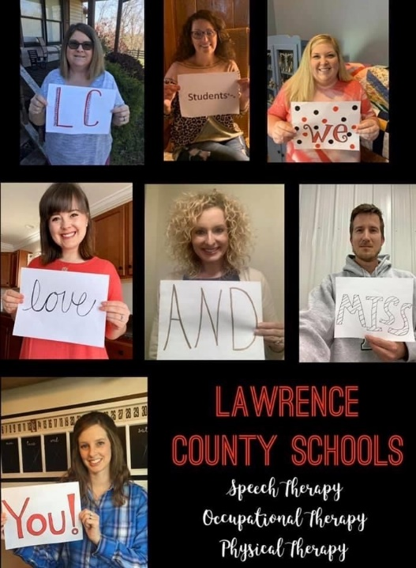
Special Education Cooperatives
G SESC

