**Special Education**



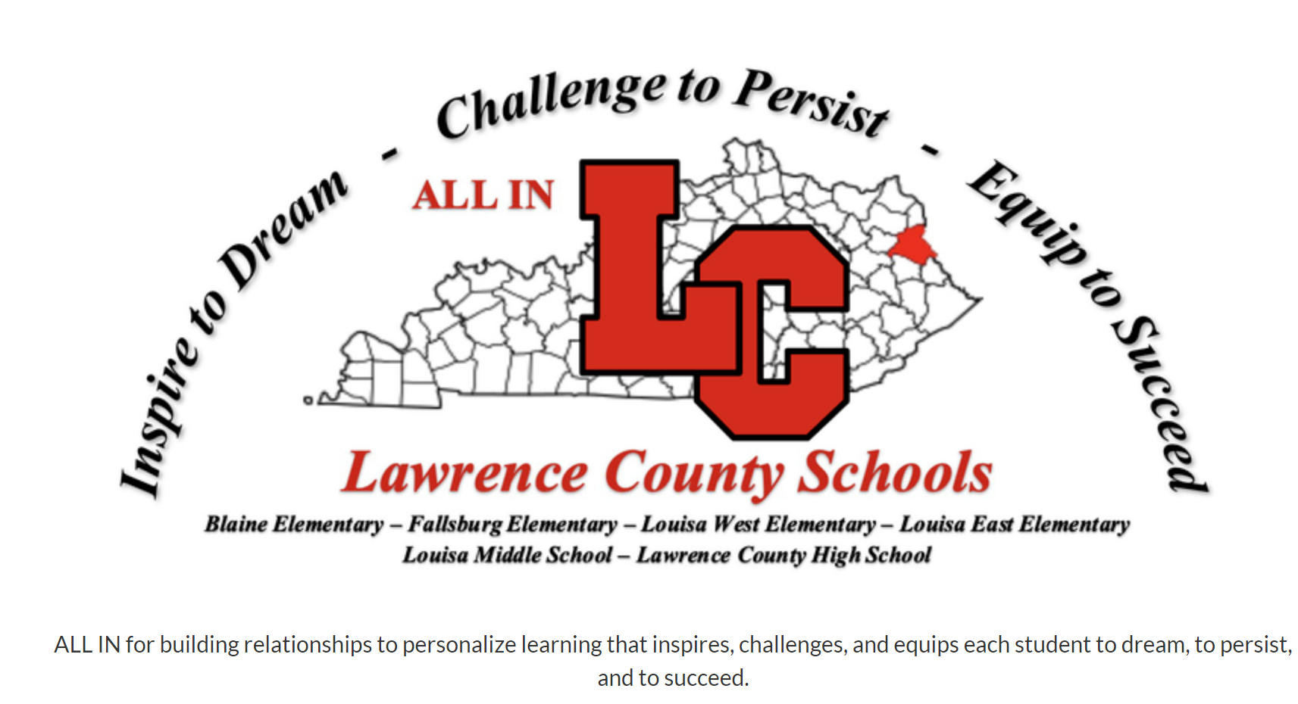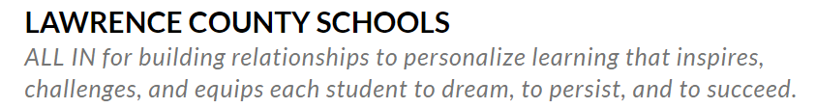

Lawrence County Schools started the school year with a flexible plan for students to choose to access general education and special education instruction from three different access points including at school, at home and/or through virtual learning (vendor-provided).  Of course, students with disabilities were offered the same options as non-disabled peers.  Lawrence County Special Education teams were determined to ensure that every student had access to general education instruction and received IEP Specially Designed Instruction within their individually chosen format. For the first month, everyone was at home or learning through virtual due to the pandemic.   Our teachers and ARC teams used Universal Design for Learning (UDL) strategies to make sure students had the necessary tools and resources they needed to overcome barriers and receive high-quality instruction.

Here are some of the barriers we faced in Lawrence County Schools and how we overcame them:

* ***We overcame*** connectivity issues by offering students drive-in Internet access points, provided Chromebooks or other devices, and offered flash drives with weekly lessons and assignments.
* ***We overcame*** moderate and severe disability challenges by offering face-to-face appointments/sessions with teachers and service providers on campus.
* ***We overcame*** barriers to meeting face-to-face by providing Personal Protective Equipment (PPE) and extra precautions such as trifold Plexiglas petitions.
* ***We overcame*** distance learning issues by providing Google Classroom access to all students and teachers.
* ***We overcame*** co-teaching barriers by teaming up and co-teaching in Google Classroom settings.
* ***We overcame*** barriers to receiving related services by designing in-district Teletherapy services.
* ***We overcame*** evaluation challenges by setting up safe environments for testing by appointment.
* ***We overcame*** ARC meeting barriers by conducting virtual and teleconference team meetings.
* ***We overcame*** independent practice barriers by providing research-based online resources such as IXL, TeachTown and Edmark.
* ***We overcame*** legal barriers by developing new protocols and procedures.
* ***We overcame*** proximity barriers that separated us from each other by using online platforms for virtual face-to-face meetings such as Skype, Google Meet, Microsoft Teams and Zoom.
* ***We overcame*** teaming barriers by having online PLC’s and trainings.
* ***We overcame*** physical, hearing and visual challenges for online learners by purchasing and implementing specialized equipment and devices.
* ***We overcame*** barriers to screening for preschool enrollment by designing a rotation of healthy and safe screening centers.

Through this process we have discovered that we are tougher than we thought and we are outstanding problem-solvers.  Moreover, we have always empowered others to succeed at Lawrence County Schools and we intend to continue to grow professionally so that we can equip our learners to be overcomers as well.

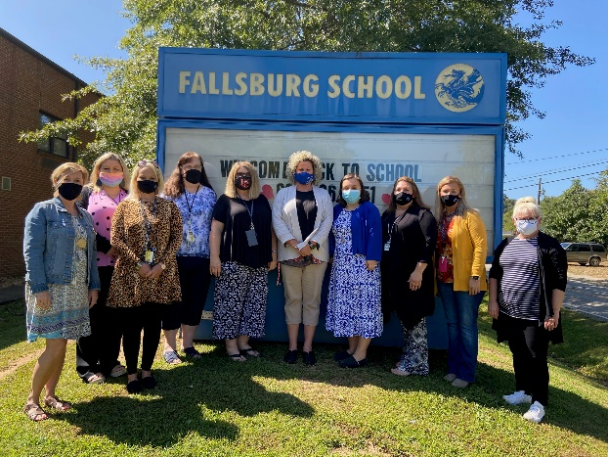 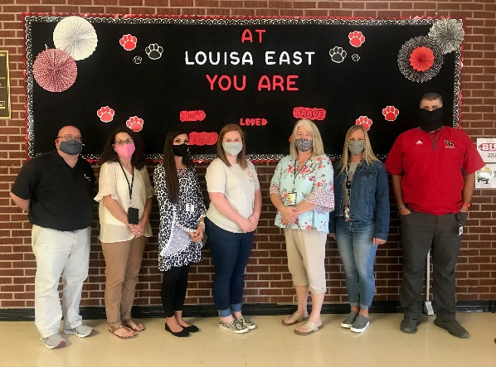

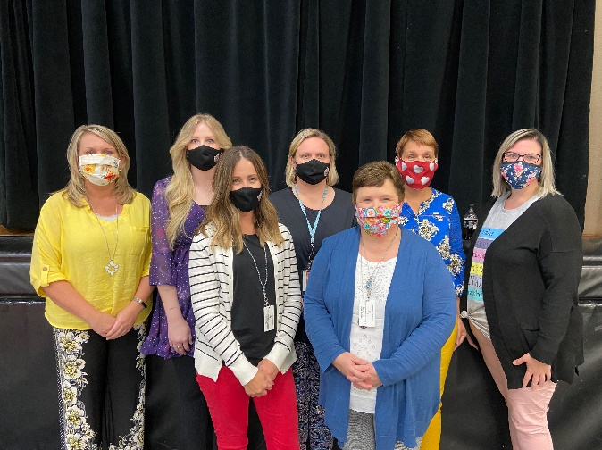 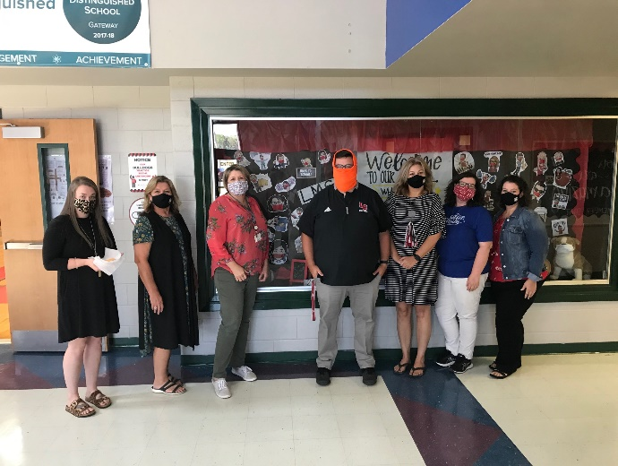

**Special Education Cooperatives**

[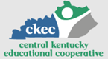](https://www.ckec.org/) [](https://www.grrec.org/) [](https://sesccoop.org/)

[](https://www.kentuckyvalley.org/) [](https://www.ovec.org/) [](https://www.kyglec.org/)

[](http://www.kedc.org/) [](http://www.wkec.org/) [](https://www.nkces.org/)