**Special Education** 



**FMD AND SPEECH PROJECT BASED COLLABORATION ZOOM SESSIONS**

The following project is an example activity. Project 1:  How to Catch the Easter Bunny

Part I: Families were invited to participate in Zoom meetings.  Ms. Parker read the book, “*How to Catch the Easter Bunny*” and Ms. Goodin asked students questions targeting their IEP goals and objectives (yes/no questions, turn taking, why questions, details from the story).  The students were then asked to either draw a picture or create their own trap to catch the Easter Bunny.  Parents were instructed to film or send pictures to Ms. Parker.

Part II: The activity the following day includes Ms. Parker demonstrating how to make Bunny Bait to catch the Easter Bunny. Students will then video their versions of Bunny Bait.

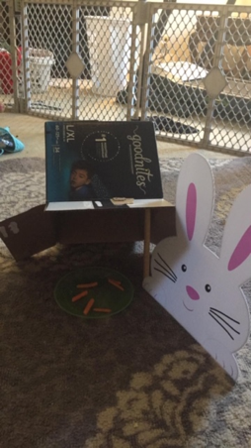 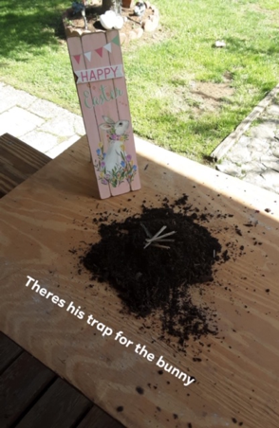

**Special Education Cooperatives**

 G SESC 

   

