Special Education

During the Covid-19 Pandemic, Hickman County School District has been true to our motto, “Every child, every chance, everyday.” Together, the school district and community have rallied to meet the needs of our children while keeping them safe. Meals, supplies and lessons were been delivered to the far edges of our county. Texts, calls, Google and Facebook Messaging were conducted at all hours of the day to keep connected to the students. While it has been stressful at times, most teachers, staff, parents and students would say it has brought us closer together.
Here are what a few staff members have stated about the NTI days:
I, like many other food service directors and their staff were entering uncharted waters when the pandemic occurred. We were unsure of ourselves and our choices for our community. However, I quickly was awed and so proud of our district employees from food service staff, bus drivers, aides, and other staff stepping in and stepping up to fulfill any request and task. I already was proud of my district but in tough times, seeing people pull together is the most beautiful and encouraging thing. My spirits are lifted every time I see a happy child enjoying their meals. We are so thankful to be operating and still have job security, but most importantly are so blessed to be able to serve the community and do god’s work. – Megan Adams FSD Hickman County Schools
Teaching during the pandemic has been a brand new experience for me. It has been very challenging at times but it has also shown me that there are many untapped resources I can be using. It has also shown me why I became a teacher in the first place: my students.-Tyler Burgess, LBD teacher
Teaching during this pandemic has been challenging, adventurous yet regenerating. The adventure comes from the challenges of continuing to teach my students from a distance while meeting their needs. It has allowed me to regenerate the connections to parents and even improve those connections during this time. Having those one on one conversations with the parents on a regular basis has developed into an even more trusting relationship which improves the relationship of the parents with the school as well. The parents realize at the depths that take place on an everyday basis for their child, in turn, respect and trust is given. I am proud of how my students and parents have responded to this pandemic. –Lisa Britton, FMD teacher
Distance learning has challenged me to think outside the box and find creative ways to communicate with parents. I actually feel closer with families than I have in years past. I have a unique opportunity to directly connect with families and help their children meet their goals. –Kayla Redden, SLP
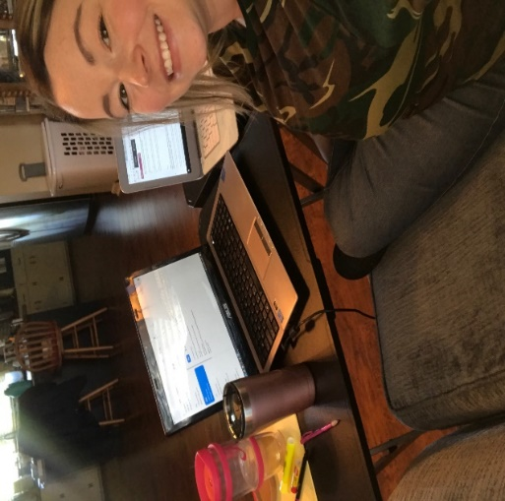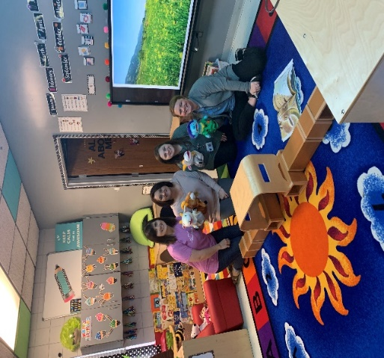
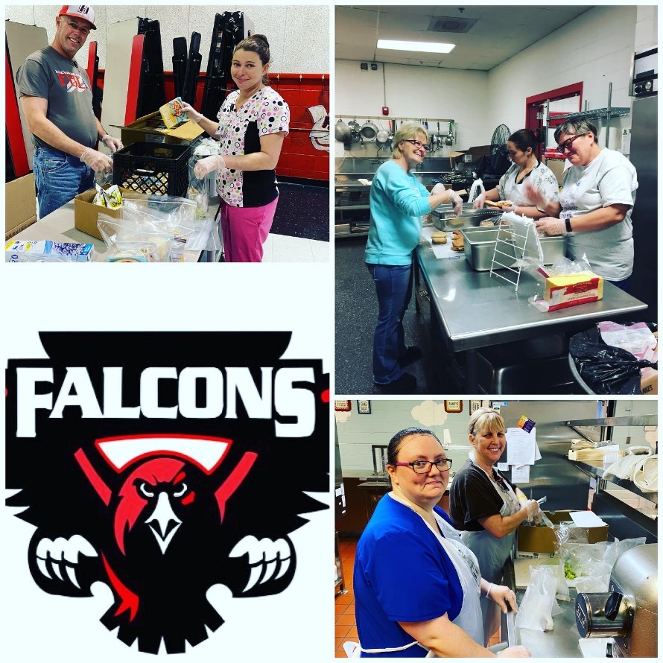

Special Education Cooperatives
