**Special Education**



|  |
| --- |
| Graves County Schools  ***Striving for Excellence, No Exceptions, No Excuses*** |
|  |

In Kentucky, 72.18% of high school students on the alternate assessment track leave high school with symbolic communication. That means that 27.82%, are at a level that makes functional communication difficult. Functional communication is the ability of a person to effectively communicate their wants and needs to a variety of communication partners for a variety of reasons. In Graves County, we want all of our high school students to exit at the symbolic level. Therefore, we developed a plan to enhance the communication abilities for our students with complex communication needs at all levels.

In preparation for the school year, our special education teachers, SLPs, assistants, and other support staff attended various trainings designed around building functional communication. Our educators have worked with the amazing staff at West Kentucky Educational Cooperative on building our capacity as aided-language models, becoming effective collaborators during push-in treatments, developing efficiency at designing communication opportunities in our classrooms, and learning about programs, such as BoardMaker Online, TAALC, Core Communication, and Snap+Core First that will help us in our mission.

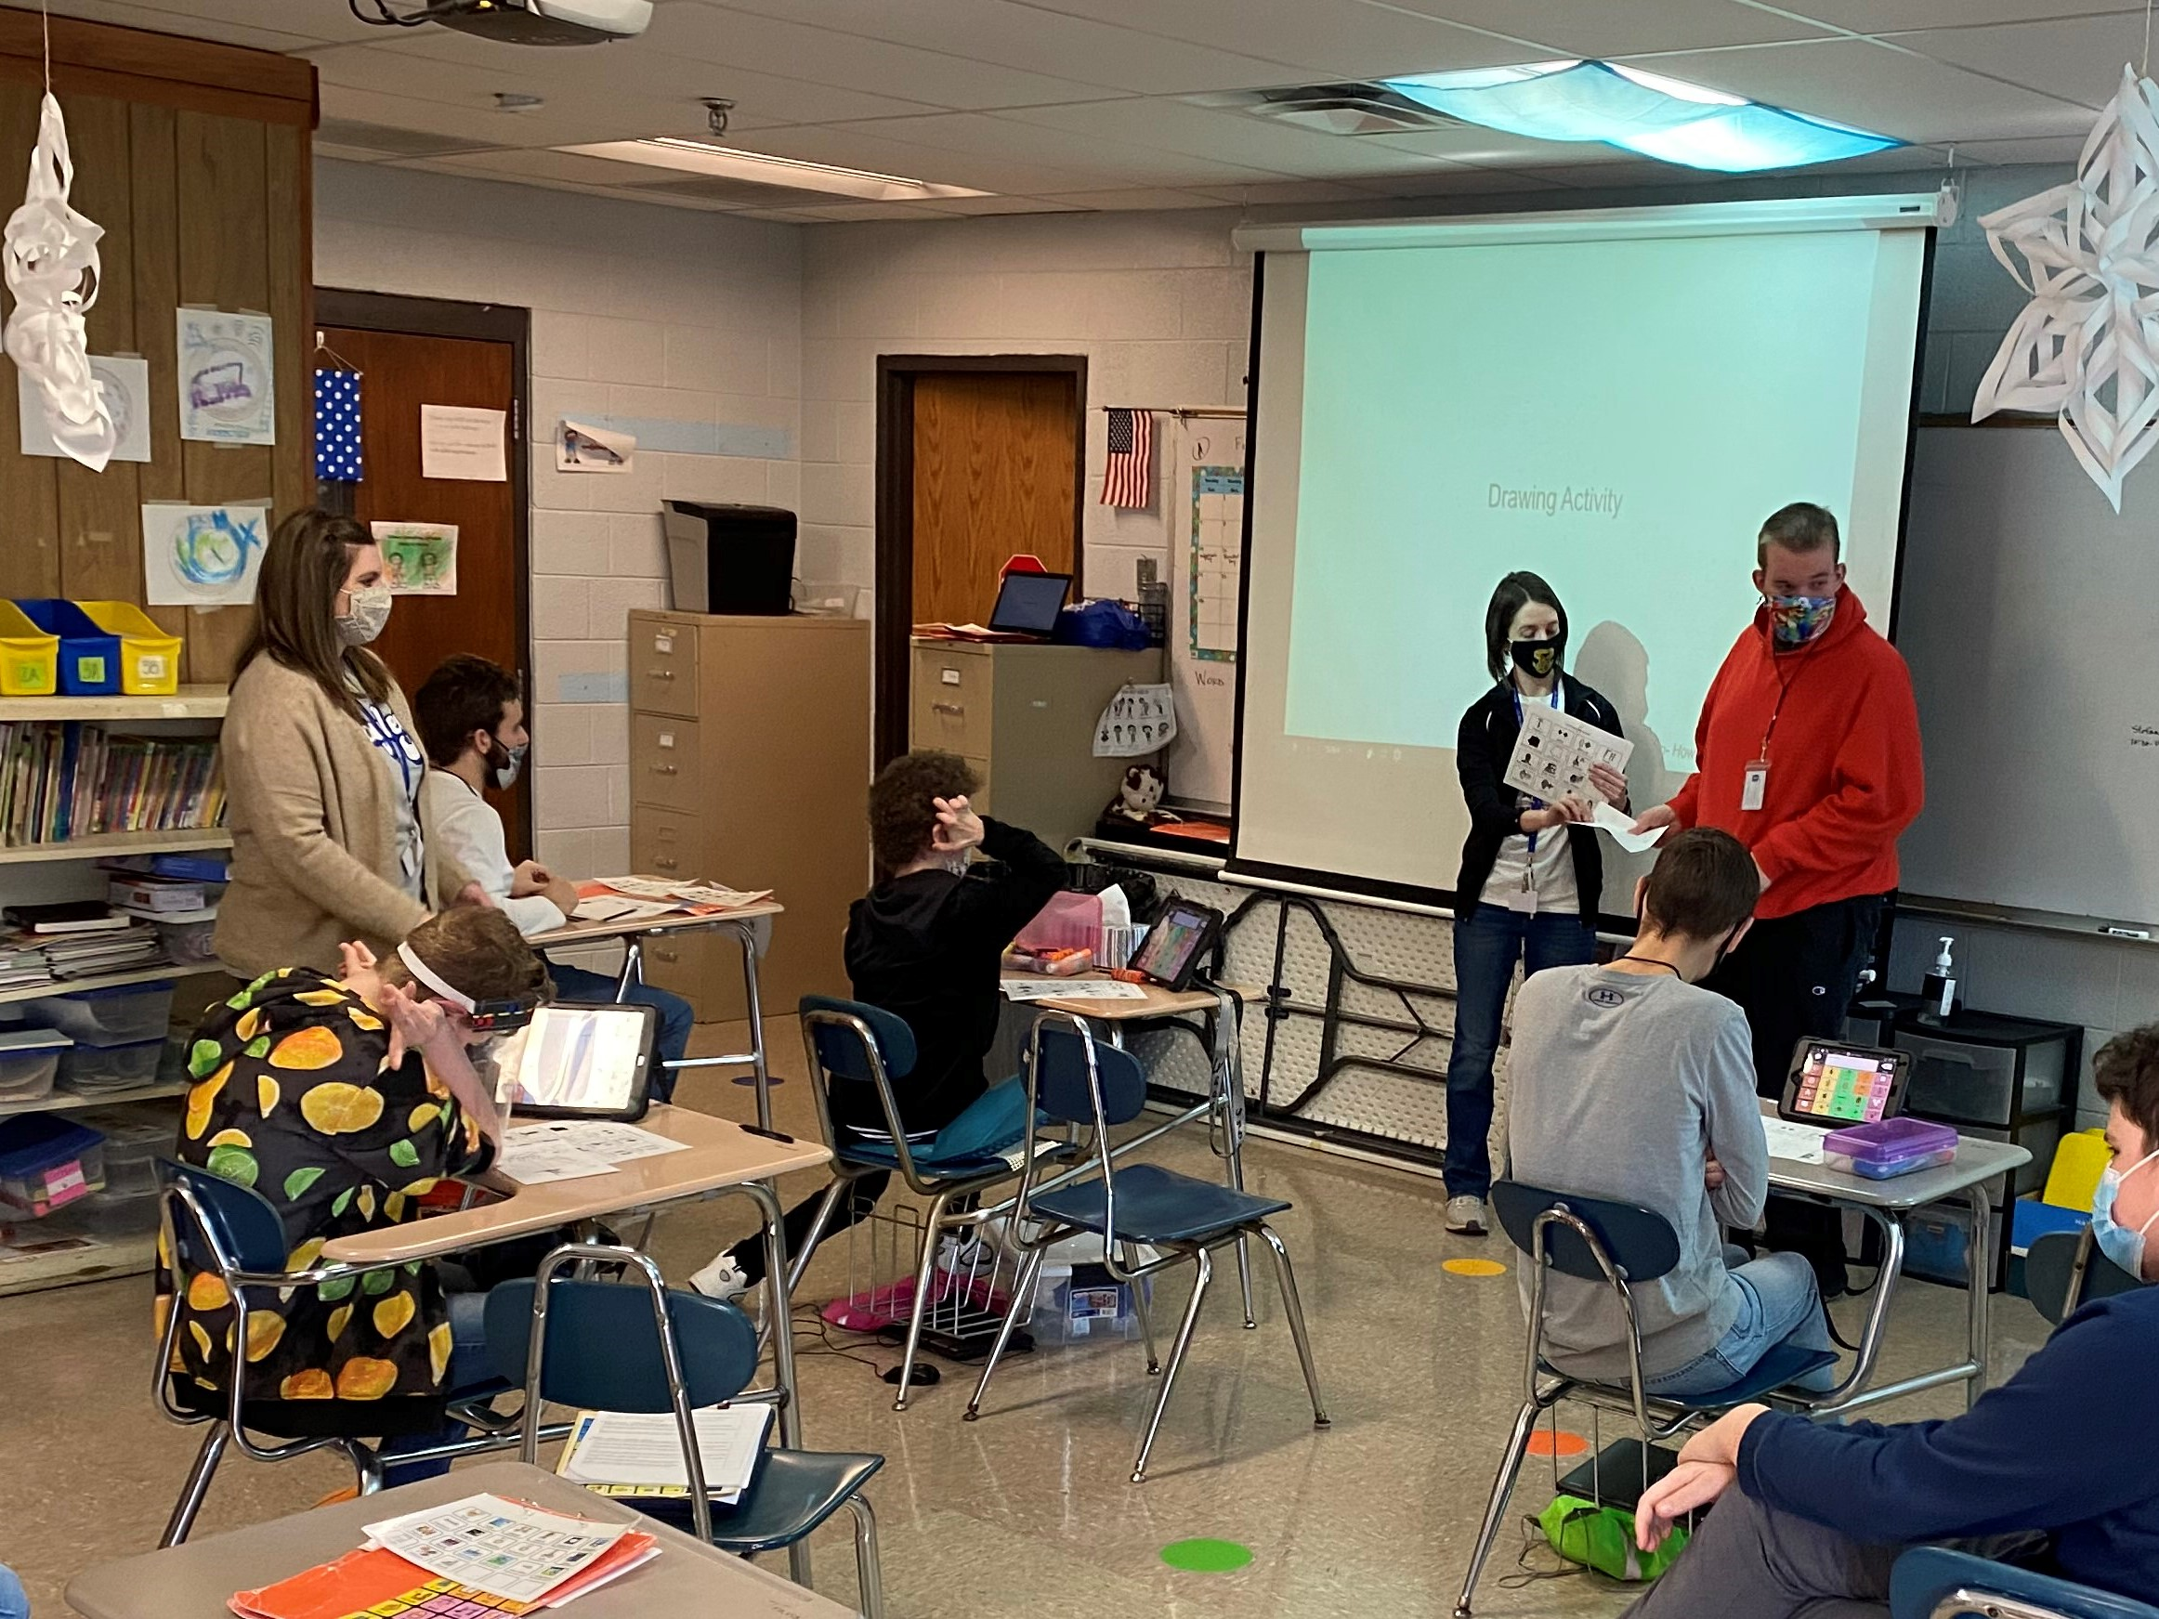

In our classrooms, you will find our teachers, SLPs, and assistants working together to engage students in as many communication opportunities as they can. Our teachers have worked hard to design lessons with targeted vocabulary that is presented to the students in modes of a fringe communication board, core communication board, or through the student’s AAC. Our SLPs and assistants are actively involved in the lesson planning and lesson execution to give every student in the classroom an opportunity to communicate. Our SLPs and teachers are scripting lesson plans to ensure every communicative opportunity is given and responded to by the students and staff throughout the day. Students are building their communication abilities through structured lessons, scripted social situations, and by playing games. Students are receiving highly motivating items to encourage and reward their communicative efforts.

|  |  |
| --- | --- |
|  |  |

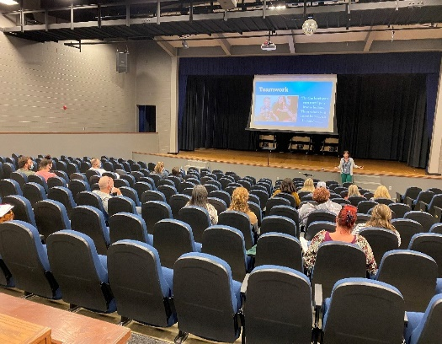In Graves County, we recognized that a critical member of the

team to reach functional communication status is the parent

of our students with complex communication needs. Our

staff worked with Laura Miller from WKEC to design and

conduct a parent functional communication training. We had

15 out of 19 targeted families attend this event. As a result

of this event, we had parents who became more accepting of

the idea of AAC devices and allowed staff to start sending the

devices home for use. We also had 15 out of the 15 families

in attendance request additional training opportunities.

Thinking beyond the typical trainings that we provide our teachers and assistants in these situations; it was decided to extend the training for functional communication to our administrative leaders in each building and at the district level. We felt like all good things flow and are sustainable with the support of the administration. Laura Miller and Sherida Gentry from WKEC, along with, Michelle Antle from KATC, provided a training for our administrators on what AAC may look like in their buildings, how they can support their staff, and how they can engage with their students at all communication levels. We received positive feedback from the administrators following the meeting, with some, requesting additional information. Since the training, you will find, in some of our buildings, core communication boards in the office, cafeteria, bathrooms, and on the playgrounds.

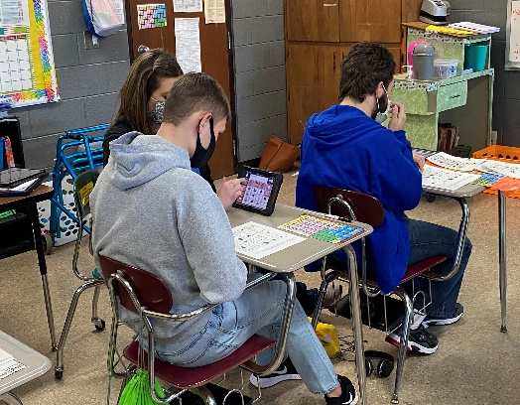

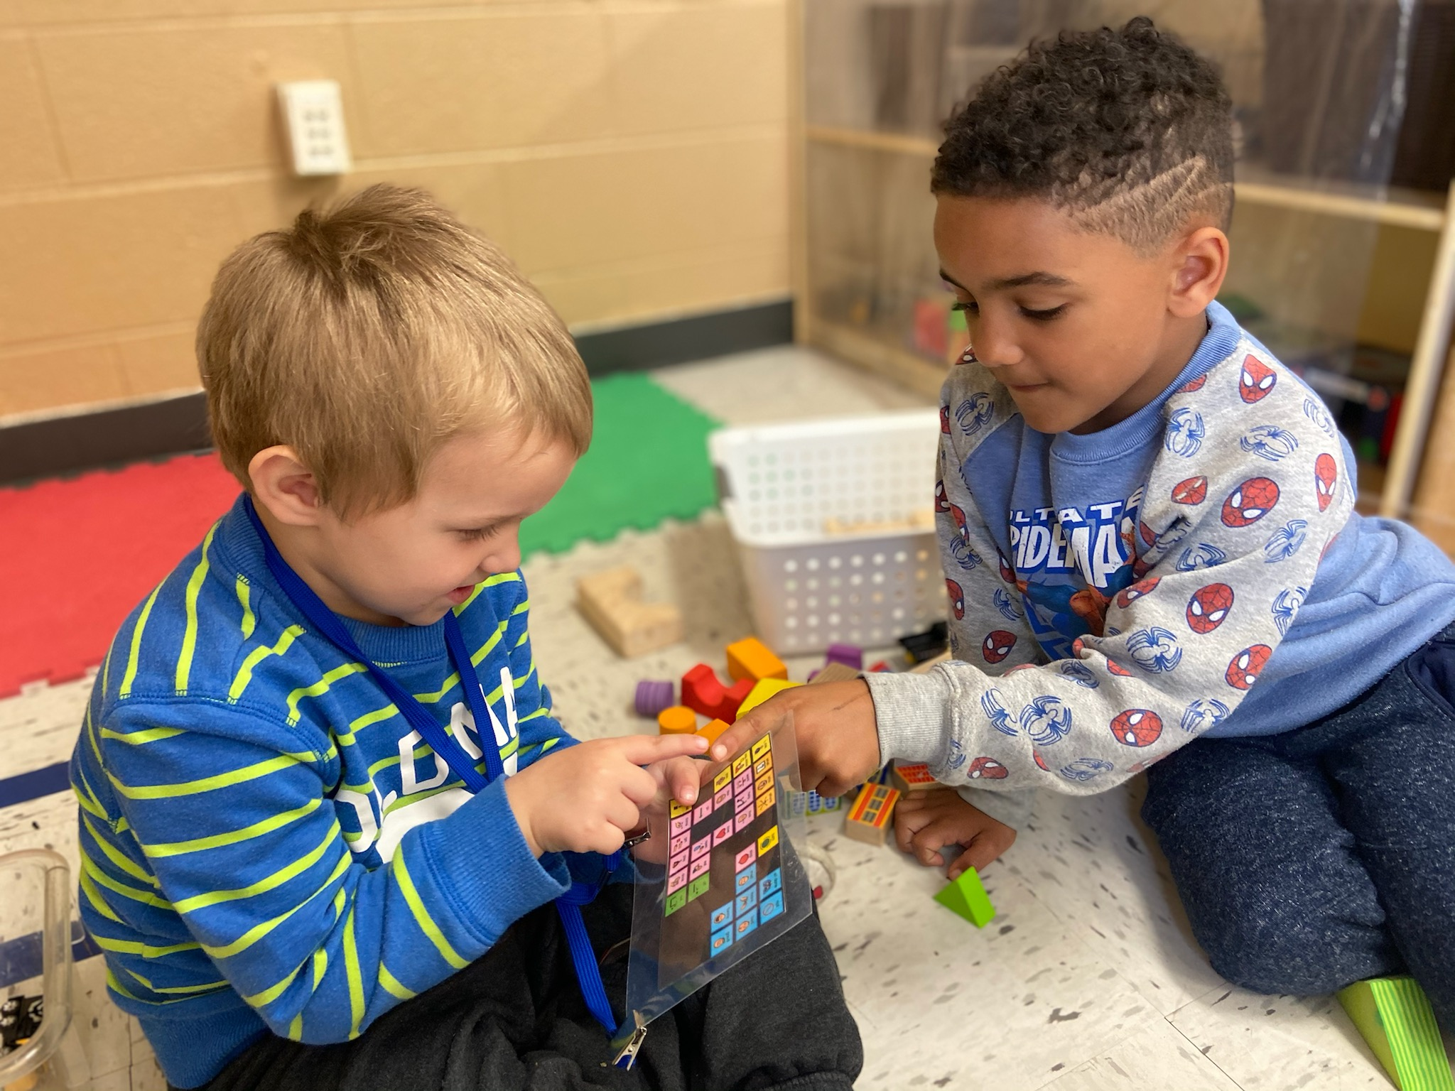

In Graves County, we don’t consider this a mission that will ever fully be completed. Each year we gain new students at all grade levels with varying communication abilities. Our mission will remain the same. We will continue to do whatever is needed to help all students become functional communicators. We will continue to attend trainings to further our knowledge and enhance our practices. We will continue to be collaborative among our staff to give the best communication instruction. We will continue to provide opportunities to model, aide, and stimulate communication at all levels.

**WE WILL CONTINUE…**

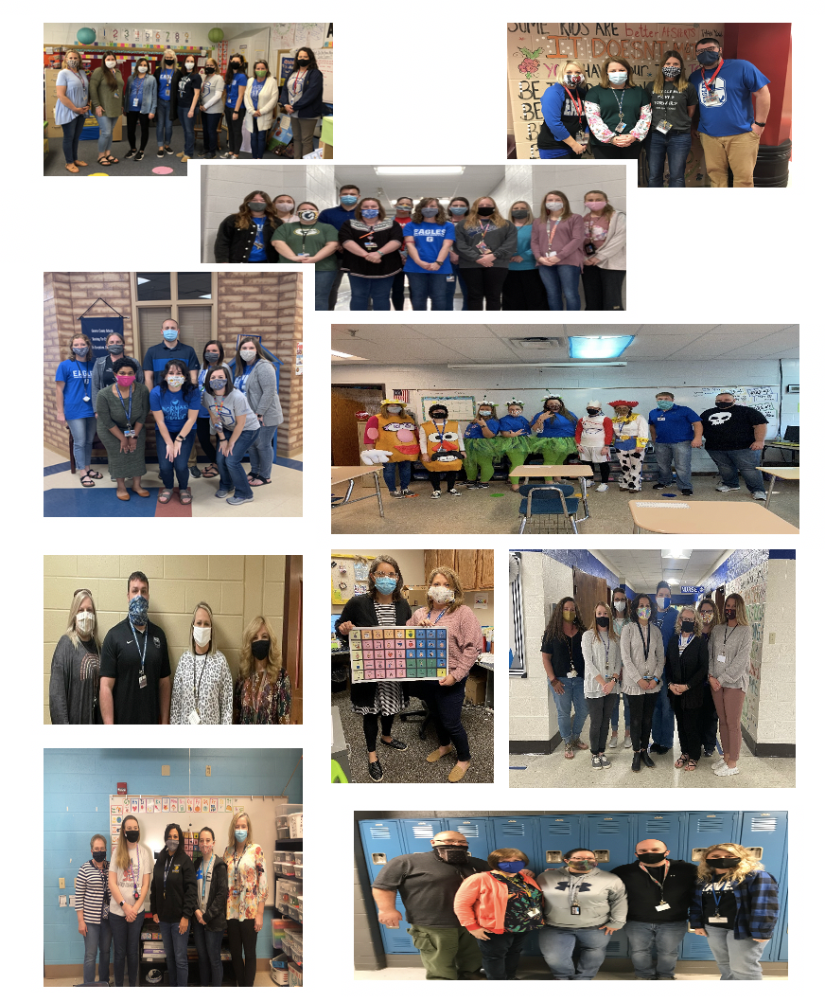

Special Education Cooperatives

[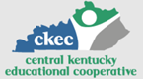](https://www.ckec.org/) [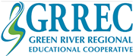](https://www.grrec.org/) [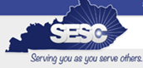](https://sesccoop.org/)

[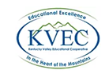](https://www.kentuckyvalley.org/) [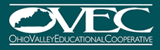](https://www.ovec.org/) [](https://www.kyglec.org/)

[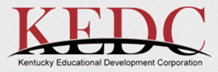](http://www.kedc.org/) [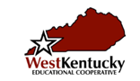](http://www.wkec.org/) 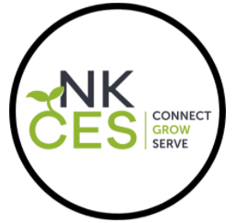

Early Childhood Regional Training Centers