Special Education
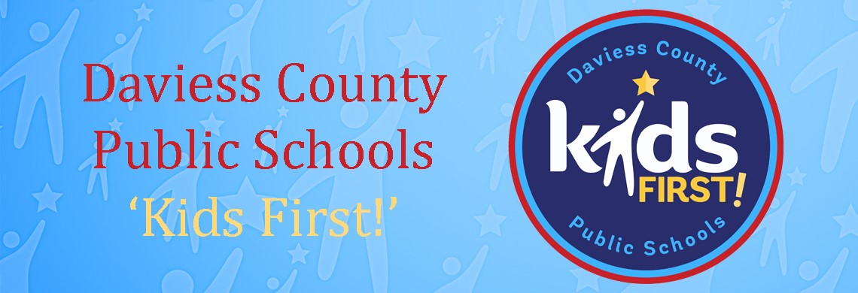

The Teachers of the Deaf/Hard-of-Hearing and Educational Interpreters of the Daviess County Public Schools worked diligently during the NTI days to meet the needs of their students. Technology was key for this success. For the youngest students who need access to signing peers and adults to grow their skills, the Google Meet platform was used as featured in the picture where Madison Koller, interpreter, led some signing time with families. When Google meetings were held between teachers and students, interpreters would join to ensure equal access to the lesson for the DHH students. Interpreters also provided one-on-one sessions daily for students so that ASL could be provided as necessary.

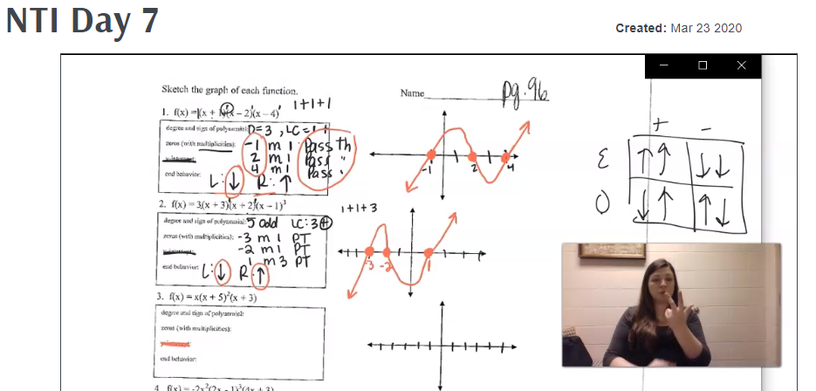
Screencastify was another program that was used heavily to provide American Sign Language to students. Teachers would share prepared instructional videos with voice-over so that the interpreters could add an ASL video. Two math examples appear below; Megan Hunt providing interpreting during an Algebra lesson at the high school level while Carrie Stelmach interprets a middle school math lesson.
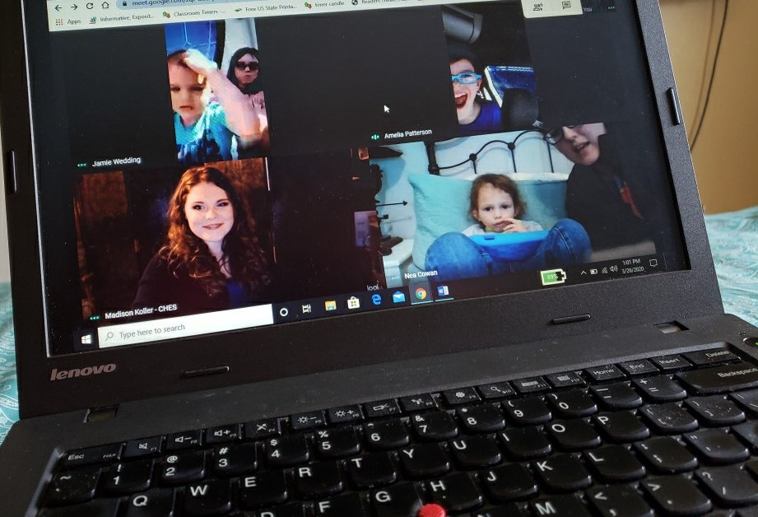
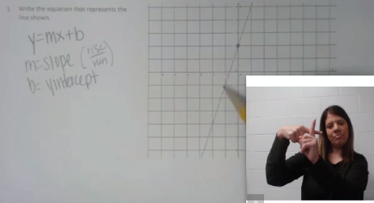
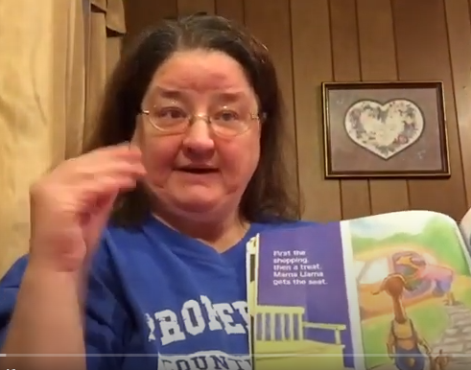
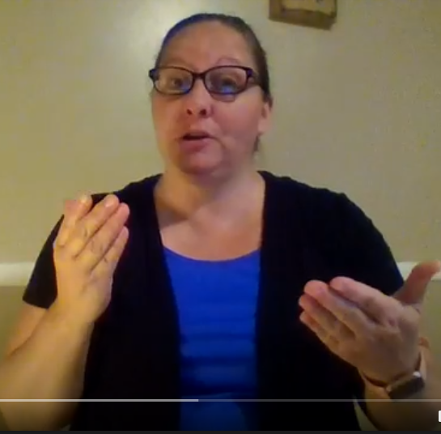
Videos including sign language were also used for literature activities across the grade levels. Mandi McCann, interpreter, created signed summaries of chapters from the class novel at the middle school level and emailed them directly to students’ accounts. Lisa Howe, who is a Deaf language model for elementary students, also created read aloud videos using ASL for the younger students which were then uploaded to YouTube for families to view together.

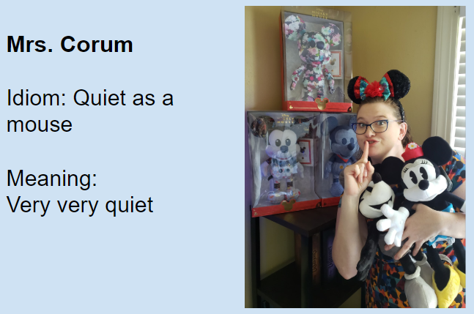
Crystal Corum, teacher of the Deaf and Hard-of-Hearing, utilized slide presentations to bring her lessons to life in her Google classroom.

Over the course of the NTI days, there were even some instances when students and staff came together using necessary precautions to prevent the spread of COVID-19. Denise Lautenschleger, interpreter, participated in a video project, masked in an open environment and 6-feet away from the student. Maranda Maurer, teacher of the Deaf and Hard-of-Hearing, provided direct instruction in ASL to one of her Deaf high school students who lacked a home internet connection. The porch featured the perfect partition for open signed communication through the closed storm door. These are just a handful of examples to highlight how the DHH team came together to provide opportunities of success for their students.

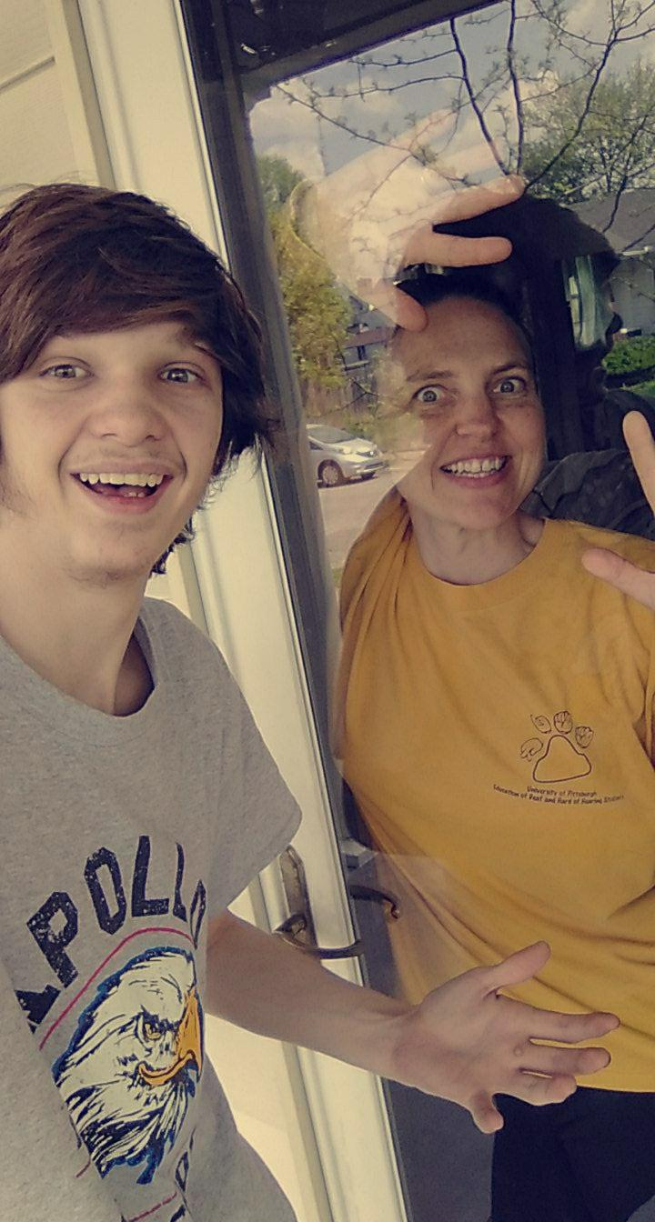
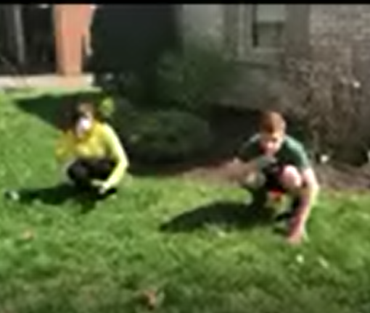
S

Special Education Cooperatives
