**Special Education**





**Breathitt County Schools**

**Graduates Prepared for College, Career, and Community**

The mission of the**Special Education Staff at Breathitt County Schools**is to educate students in appropriate learning environments through specially designed instruction so students will successfully demonstrate their fullest potential as well as the knowledge and skills essential for life-long learning, social well-being, and responsible behaviors. Through the partnership with our regional cooperative, KVEC, special education teachers can implement and improve the quality of education for students with disabilities in the district.

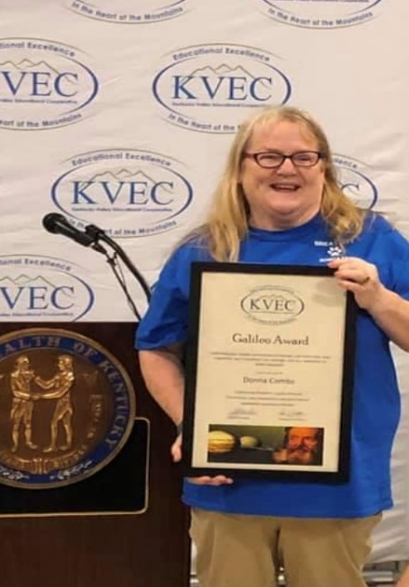Ms. Donna Combs has been an employee for the Breathitt County School system for 32 years. She works tirelessly to provide to students with learning experiences that are beneficial in their everyday lives. When ask about her 32 years of experience, Ms. Combs stated, “I've had many memories and enjoyed the opportunity to make a difference in the lives of young adults.”

Ms. Combs was a recipient of the 2020 Kentucky Valley Educational Cooperative Galileo Award. Her commitment to learners and the community is inspiring. Over the last several years, Ms. Combs has written and been awarded several Appalachian Renaissance Initiative (ARI) grants.

Even during the pandemic and the constant changing learning environments because of COVID-19 guidelines, students at Breathitt High School with the supervision of Ms. Combs completed two ARI grants, Raised Gardens for the Nursing Home and Lap Quits for Hospice. Ms. Combs stated, “When we work together to help others, we help ourselves.”

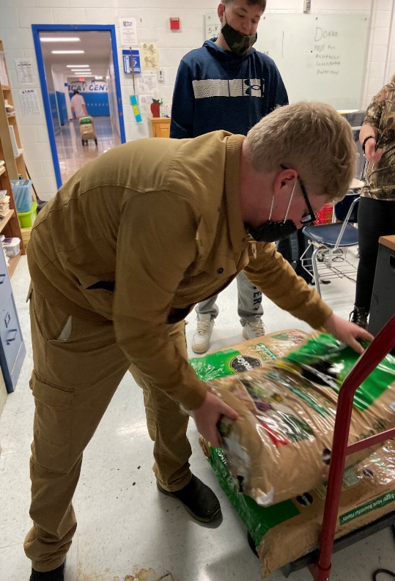Below are pictures of students creating, loading, and delivering the finished products.

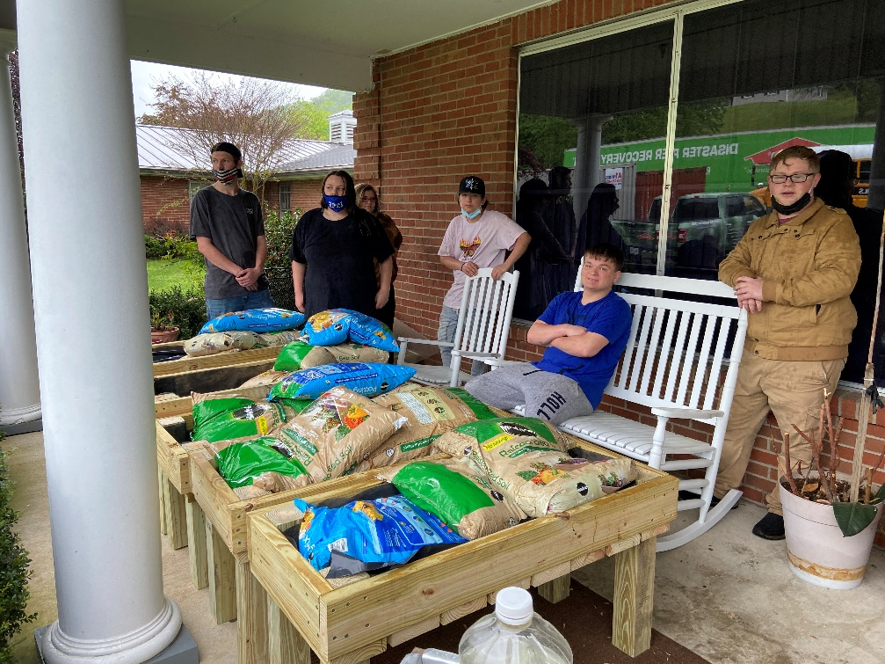

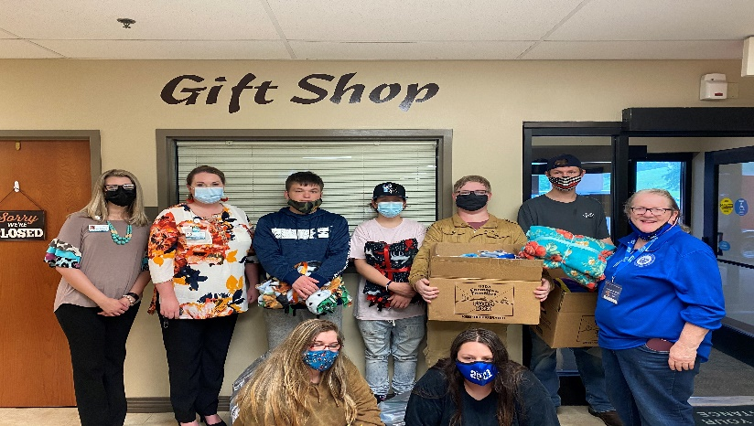

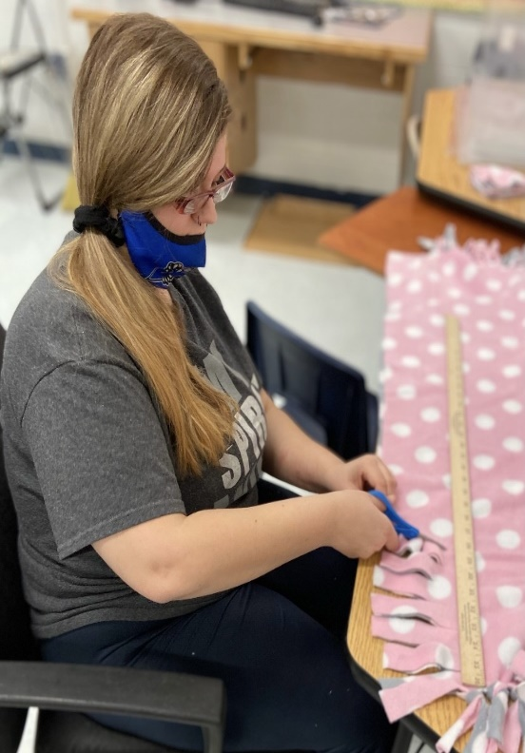

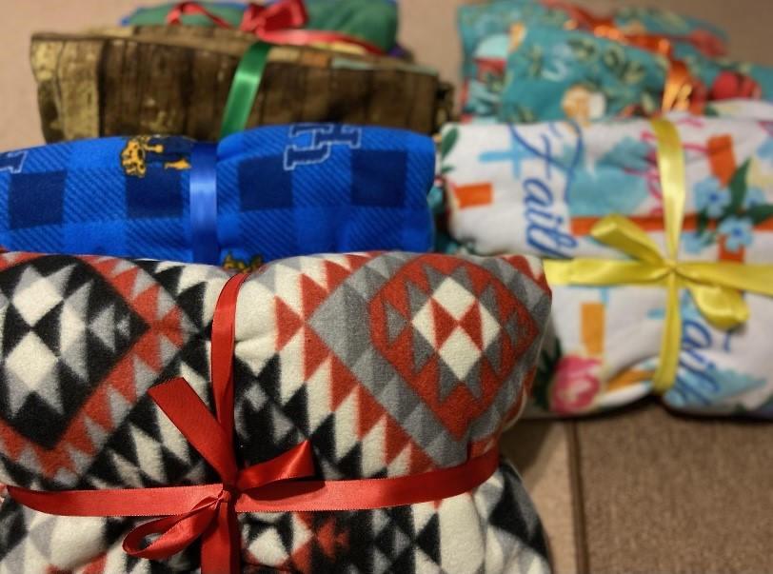

Other Special Education teachers within the district also completed micro-credential presentations this year. These presentations demonstrate competency in virtual or hybrid instruction using evidence-based strategies to enhance instruction for students with disabilities. Micro-credentials are beneficial and increase the educational outcomes of teachers and, by extension, their students.

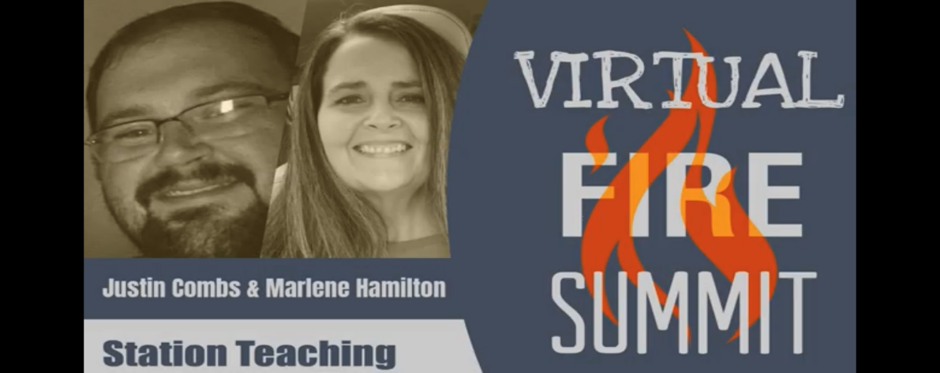Special Education teachers, Marlene Hamilton and Justin Combs’ micro-credential focused on Using Station Teaching for Students with Disabilities. When asked about the presentation Mrs. Hamilton explained, “Our micro-credential presentation demonstrated how station teaching can benefit both the regular and the special education teacher’s ability to improve student instruction through the virtual and regular classroom.”

[Station Teaching](https://summit.theholler.org/speaker/justin-combs-3/)

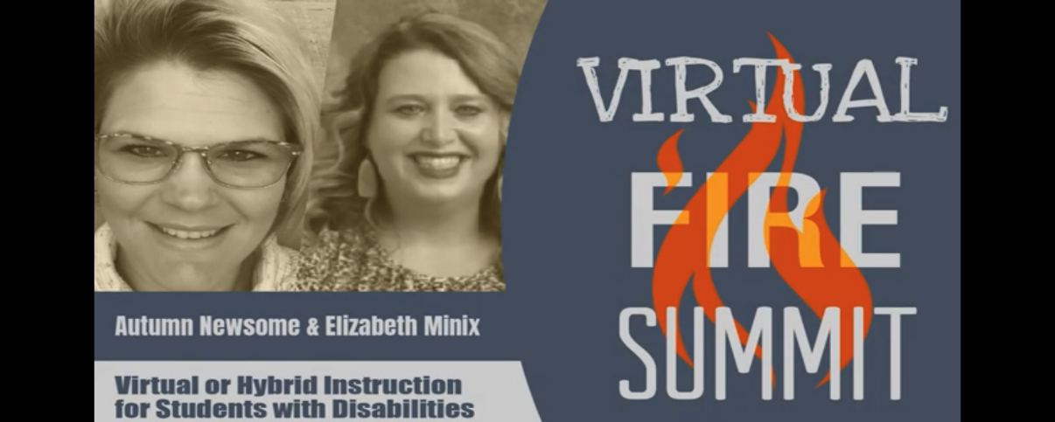Elizabeth Minix, Hearing Impaired teacher for the district, micro-credential presentation focused on implementing high leverage instructional strategies that fosters rigorous learning and removes barriers for deaf and hard of hearing students in a virtual setting.

[Virtual or Hybrid Instruction for Students with Disabilities](https://summit.theholler.org/speaker/elizabeth-minix-2/)

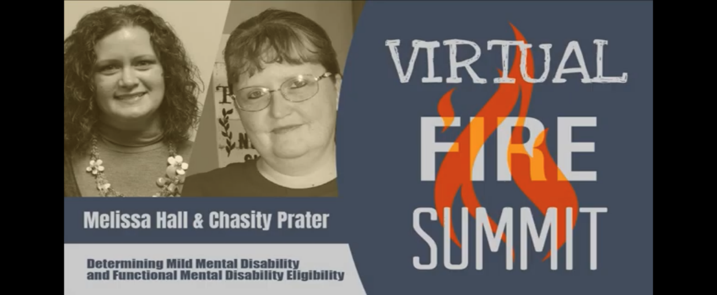Melissa Hall, Special Education teacher at Highland Turner Elementary also co-created a micro-credential that focused on understanding and interpreting data to make eligibility determinations for students with disabilities. “My partner and I have developed a micro-credential to determine eligibility for MMD or FMD by analyzing evaluation data and creating the present levels section of an IEP.  This micro-credential will provide an opportunity to hone data analyzation skills and put them to use when creating the present levels section of an IEP,” stated Melissa Hall when asked about her presentation.

[Understanding Data for Eligibility Determination](https://summit.theholler.org/speaker/melissa-hall-3/)

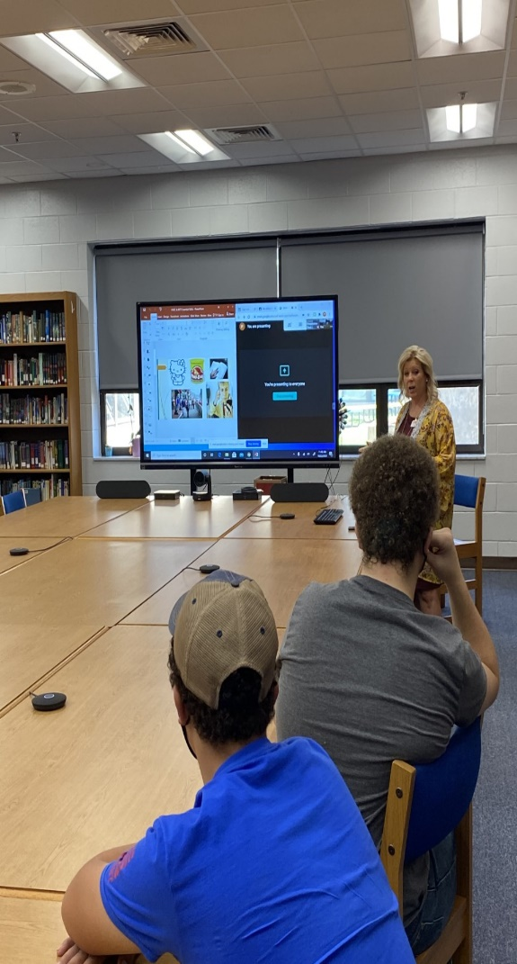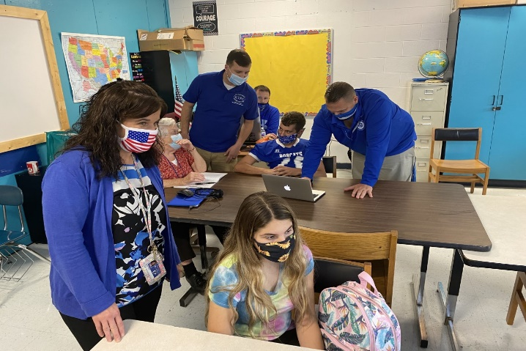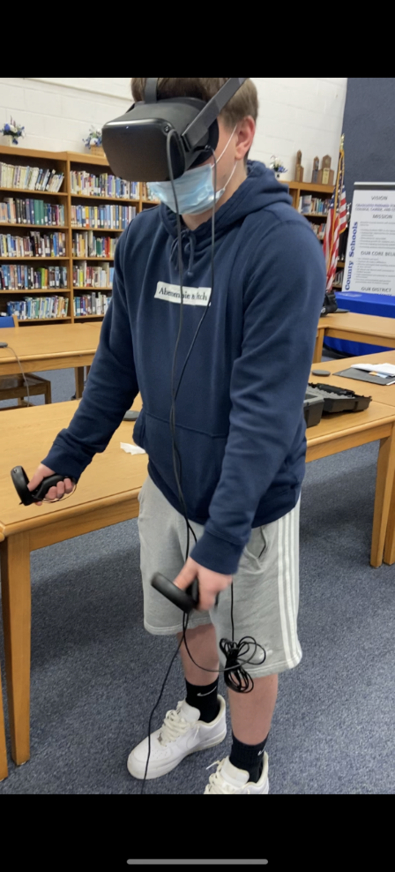Students at Breathitt High School also participated in Post-Secondary Transition Workshops throughout the school year.

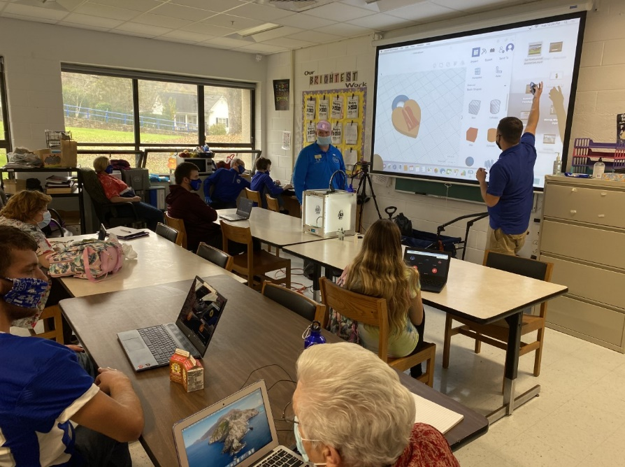

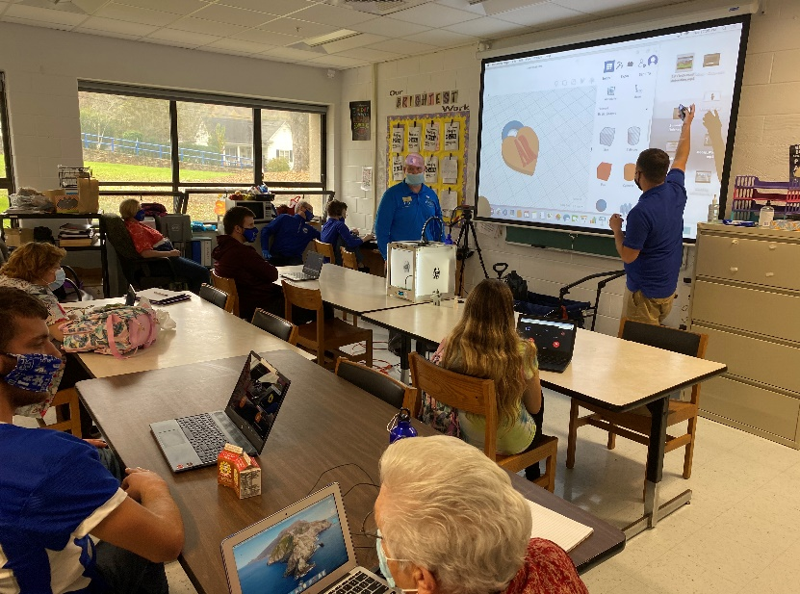

**Special Education Cooperatives**

[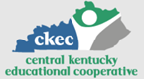](https://www.ckec.org/) [](https://www.grrec.org/) [](https://sesccoop.org/)

[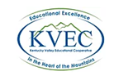](https://www.kentuckyvalley.org/) [](https://www.ovec.org/) [](https://www.kyglec.org/)

[](http://www.kedc.org/) [](http://www.wkec.org/) 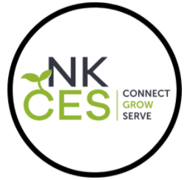

**Early Childhood Regional Training Centers**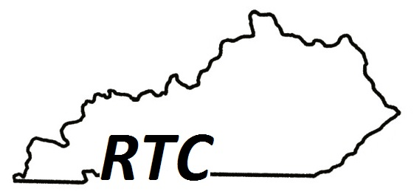

Ashland RTC

Anderson County RTC

Berea RTC

Calloway County RTC

Simpson County RTC