Special Education
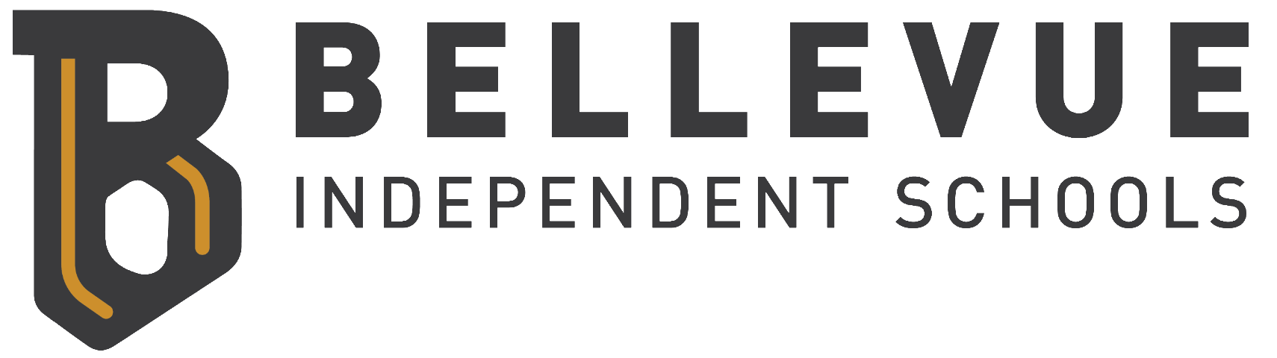
From the onset of the Covid-19 pandemic, Bellevue Independent Schools has embodied our vision of partnering with every student and family in the relentless pursuit of lasting fulfillment. Our staff rose to meet the challenges of non-traditional instruction by providing each student with a creative and personalized framework to confidently achieve their highest potential, a commitment to our mission that is second to none.
Both Grandview Elementary and Bellevue Middle/High School supplied each student with the necessary technology to complete work at home and facilitated internet connections for any family in need. Teachers created opportunities to engage students on a daily basis through virtual platforms like Google Meets, Microsoft Teams, and SeeSaw, while also meeting the needs of any student who required paper copies of assignments. Our food service staff not only converted all breakfast and lunch plans into convenient and healthy Grab & Go options, they also delivered meals, groceries, and hygiene items to the doorsteps of families.
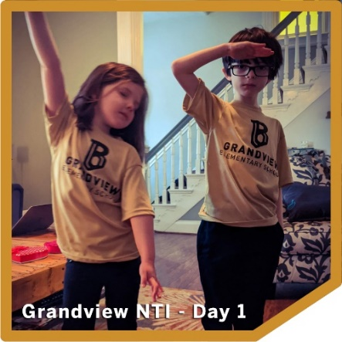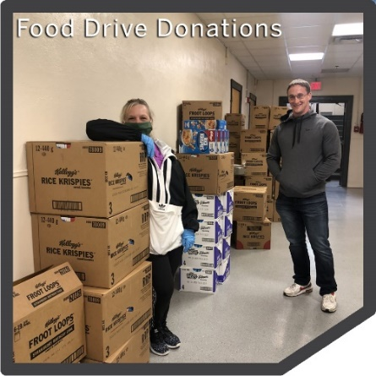
Bellevue Preschool continued to provide a five-star early childhood experience by converting daily lessons into engaging new formats that could be easily accessed from home. The most popular method of instruction came in the form of the new Bellevue Preschool YouTube channel, delivering top-notch lessons for our youngest Tigers (https://www.youtube.com/channel/UC57TpU6f2abMKttaMSrQyEQ/videos). In conjunction with these daily video lessons, our dedicated preschool staff arranged for multiple home deliveries that provided each child with the necessary supplies to keep skill development at the forefront of the preschool NTI experience.
The exceptional children staff at both schools went above and beyond, quickly learning new technologies to create unique, interactive forms of instruction and outreach to families. The staff made daily contact with each child through a multitude of outlets, meeting each student’s individual needs for instruction. Through a combination of funny videos clips, text and phone support, and video chats, instructors were available around the clock to ensure that our students with disabilities had every available support needed for successful NTI. When it came time for ARC meetings, Bellevue staff spent countless hours teaching parents how to access video conferencing software for meaningful participation in the process of serving students with disabilities.
Adjusting to a new way of life and learning in the midst of a global pandemic presented many new challenges and unknowns, and the Bellevue community answered the call to serve our students without hesitation. It has been nothing less than awe-inspiring to watch members of our community and schools work together to meet the needs of every student, every family, every day. We are better together and stronger than ever.
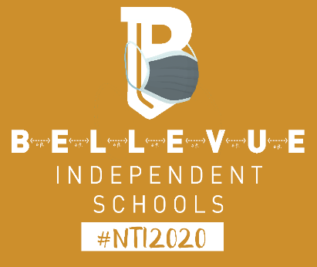
Special Education Cooperatives
