**Special Education**



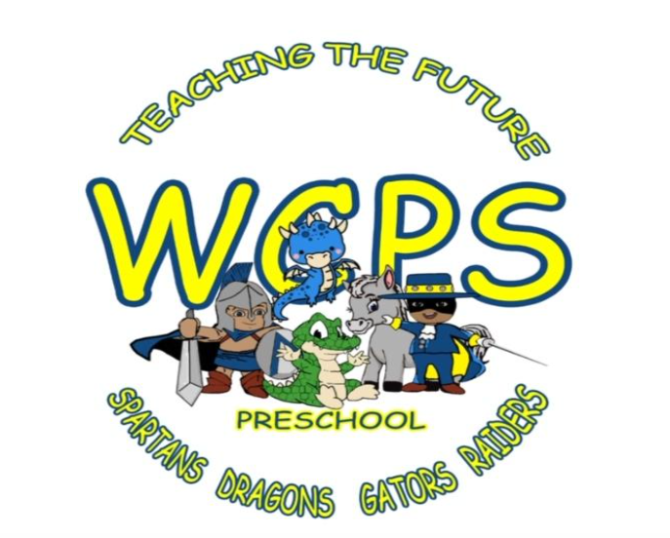**Warren County**

In order to better serve children and their families, Warren County Public Schools has developed a district wide screening process to identify preschool aged children for targeted interventions (KSI) and the potential need for special education services. Child Find notices are shared with the community on a regular basis, providing families with a link to request a preschool screening. Screenings are scheduled on a monthly basis at a central location within the district. With social distancing and sanitation measures in place, in-person screening can be implemented safely and appropriately. Utilizing a central location has also allowed for the distribution of books and educational materials to all families who come for screening, with a representative from Warren County Public Library assisting.

WCPS has established a district screening team which consists of two preschool school psychologists, two preschool consultants, a preschool parent facilitator, a speech consultant, and two district speech therapists who assist with screenings on a rotating basis. WCPS speech therapists follow a model of three weeks of direct services and one week of indirect services per month. By scheduling district screenings during indirect service weeks, speech therapists are available to conduct speech screenings with interrupting direct service time to current students.

Donna Williams and Christina Sanders, preschool consultants, screen each child with the Brigance developmental screener. Speech, hearing, and vision screenings are also conducted.

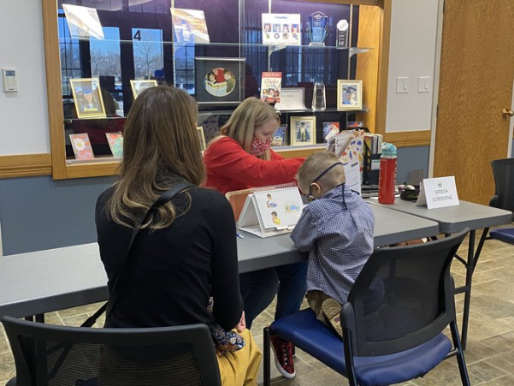Students



If interventions are recommended, the family is provided with appropriate materials to implement and monitor interventions at home. These families receive individualized weekly check-ins with the WCPS preschool parent facilitator, Paige Hargett. They are also integrated into Mrs. Hargett’s Little Learners mobile classroom program, which is currently meeting virtually, but is scheduled to resume in person sessions this summer. This allows the opportunity for children to participate in group instruction as part of their interventions without being formally enrolled in the preschool program.

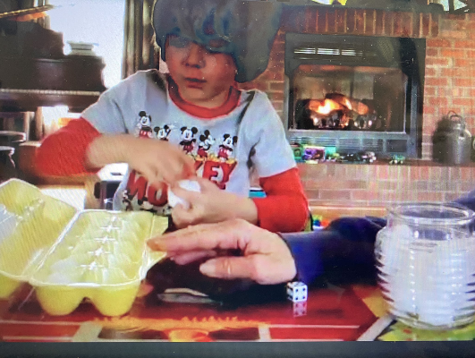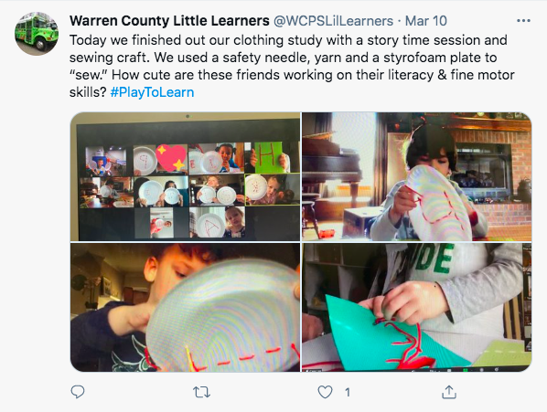

Progress is evaluated by Karin Holland and Ashley McGinnis, preschool school psychologists, at the midway and completion point of interventions. The screening team works collaboratively to make data informed decisions about which children need to continue on to the referral process. Children who show adequate progress and are not referred for special education services are given information to support continued development at home and encouraged to continue their participation in the Little Learners program.

While this new process is a work in progress with adjustments being made along the way, the benefits have already been seen. One notable impact of moving to a scheduled district-wide screening model is that it has relieved classroom teachers and school speech therapists of much of the responsibility of screening. Most importantly, this shift has provided more consistency in screening and intervention results and created family centered options for interventions, strengthening families and resulting in greater outcomes for children.

Special Education Cooperatives

[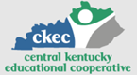](https://www.ckec.org/) [](https://www.grrec.org/) [](https://sesccoop.org/)

[](https://www.kentuckyvalley.org/) [](https://www.ovec.org/) [](https://www.kyglec.org/)

[](http://www.kedc.org/) [](http://www.wkec.org/) 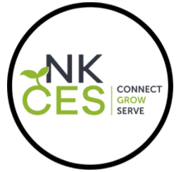

Early Childhood Regional Training Centers

