Dear Parents and Guardians,

Ensuring the safety and wellbeing of our students is one of the many responsibilities that we have as a school district. Senate Bill (SB) 73[1], related to sexual extortion, was recently passed by the legislature and requires the district to provide the following information about sexual extortion to help ensure that parents/guardians have the resources they need to support their student(s) and protect them from being victimized (KRS 531.125).

Sexual extortion, also known as sextortion, occurs when someone threatens another person – through violence, harm to reputation, or distribution of explicit material – with the intent to coerce them into unwanted actions. These actions may include engaging in sexual conduct, providing explicit content, providing money or valuables, or complying with demands against the victims’ will. These situations can cause significant emotional distress and place victims in dangerous situations. Many victims feel forced to comply because they fear the repercussions. Below is the exact language in SB 73/KRS 531.125, followed by resources provided to support you and your student.

**Sexual Extortion is defined as:**

1. **A person is guilty of sexual extortion when he or she communicates, through any means, a threat to:**

**(a) Injure the property or reputation of another person or commit violence against another person with the intent to coerce that person to:**

* 1. **Engage in sexual conduct; or**
  2. **Produce, provide, or distribute any matter depicting that person engaging in sexual conduct or in a state of nudity or semi nudity; or**

**(b) Distribute any matter depicting another person engaged in sexual conduct or in a state of nudity or semi nudity with the intent to coerce that person to:**

1. **Engage in sexual conduct;**
2. **Produce, provide, or distribute any matter depicting that person engaging in sexual conduct or in a state of nudity or semi nudity;**
3. **Provide the payment of money, property, services, or any other thing of value to the perpetrator; or**
4. **Do any act or refrain from doing any act against his or her will.**

Schools are required to display posters with resources to help young people report and seek support if they believe they or someone they know are victims of sextortion. One of the most effective ways to protect youth is by encouraging open communication with trusted adults.

Parents and guardians play a key role in keeping their student(s)safe by discussing healthy relationships and by respecting boundaries. Together, we can help ensure these children understand that sexual extortion is NEVER their fault, and that there is always someone out there to help them navigate these situations if they find that they have fallen victim to these predators. Offenders often manipulate, groom, or trick young people into sharing images and scare them into submission. To support families, the National Center for Missing & Exploited Children (NCMEC) provides resources to help parents talk with their student(s) about these risks and take steps to remove harmful images from the internet.

**What Parents Should Know About Sextortion:** <https://www.missingkids.org/content/dam/netsmartz/downloadable/tipsheets/sextortion-what-parents-should-know.pdf>

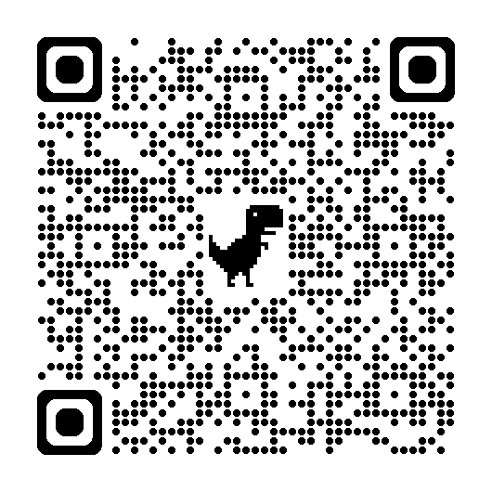

Even if an explicit image or video has been shared, there are ways to have it removed. Parents and guardians can help young people by using NCMEC’s Take It Down tool and reporting the content to the platform or app where it was posted. For more information, visit these resources:

**Take It Down – Remove Explicit Images:** <https://takeitdown.ncmec.org/>

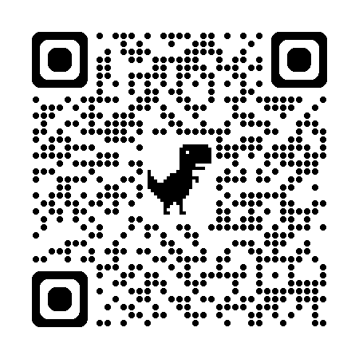

Our district is committed to helping you keep your students safe from sexual extortion. Please do not hesitate to contact school or district staff with any questions or concerns related to this critical issue.

1. The full text of SB 73 is available at <https://apps.legislature.ky.gov/recorddocuments/bill/25RS/sb73/bill.pdf> and becomes effective June 27, 2025. SB 73 creates a new statute, KRS 531.125, and is available at <https://apps.legislature.ky.gov/law/statutes/statute.aspx?id=56088>.