August 2024

Dear Superintendents and Principals,

The Kentucky Department of Education (KDE) is launching a statewide campaign to address chronic absenteeism in our schools, and we need your support to make it a success.

As you know, a student who misses 10% of the school year—or approximately **two days** per month—for any reason is considered chronically absent. Alarmingly, this affects nearly **30%** of our students across the Commonwealth each year. When students miss school, they miss out on learning, meaningful relationships and countless other opportunities that are crucial for their development and future success.

To combat this issue, we're introducing the "Attendance Matters” campaign to raise awareness about the importance of regular school attendance and provide resources to schools and districts to help reduce chronic absenteeism across the state.

As part of this campaign, KDE will be providing:

1. TV, radio, and streaming advertising in English and Spanish in August and September, and again in January, March and April

2. Billboards, social media posts and advertising

3. Updated “[Chronic Absenteeism](https://www.education.ky.gov/school/Pages/Chronic-Absenteeism.aspx)” webpage with many best practice resources

4. Informational sheets for schools to use and share with their communities

5. Letter templates for use in your districts

We believe that it takes everyone—schools, families and communities—to reduce the chronic absenteeism statistics in Kentucky. After all, we miss our students when they're absent, and we want to see them reach their full potential.

We encourage you to utilize these resources in your districts. Let us know if there are other resources or materials that could help you in improving attendance in your district. Together, we can make a significant impact on attendance rates and, ultimately, on the educational outcomes of Kentucky's children.

You'll receive more detailed information soon about the campaign and how to access and implement the provided materials. If you have any questions or need additional support, please don't hesitate to contact Florence Chang, Division of Student Success, [florence.chang@education.ky.gov](mailto:florence.chang@education.ky.gov).

Thank you for your dedication to Kentucky's students. Let's work together to ensure every child has the opportunity to succeed because we are #AllinKY.

Sincerely,

Dr. Robbie Fletcher

Commissioner of Education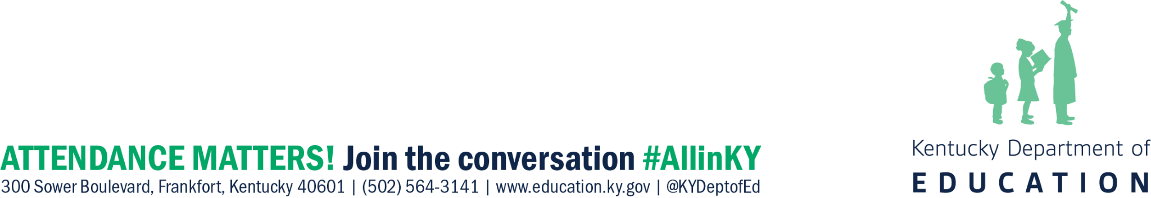

Kentucky Department of Education