Consolidated Expenditure Report - (CDIP)
The Consolidated Expenditure Report provides data for all district planning and reporting requirements on a single report in printed form and a spreadsheet import file format.
Navigate to MTD Project Budget Report:
Financials > General Ledger Menu > Project Accounting > Projects within General Ledger > MTD Project Budget Report
- Select Consolidated and the following screen displays:
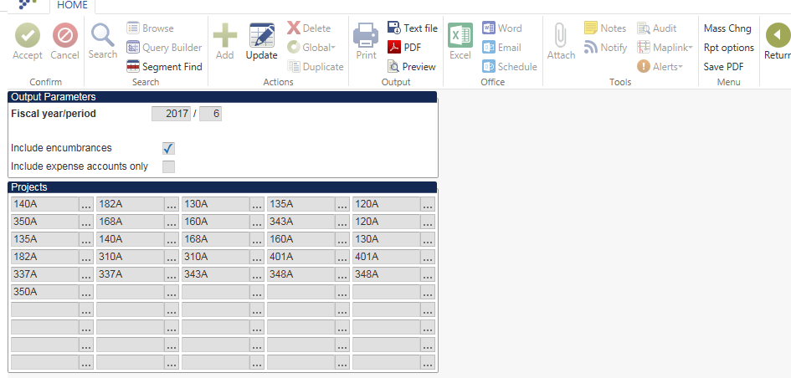
- The reported projects may already appear from a previously generated report. Project numbers can be updated by selecting Update.
- User can also select Mass Chng to change the last digit of the project codes.
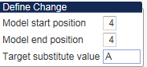
Select Define, enter 4 as the starting and ending position of the project code and enter the character that represents the year. In the example above the 4th position of each project will be changed to an A to reflect fiscal year 2015 projects.
- Select Accept and then Process after project codes have been added and/or updated.
Note: There are 50 fields available for project codes. However, if there are not enough fields for your district’s projects, please submit one file with current year projects and a separate file containing prior year projects.
- Select Rpt Options and verify that Life-to-date is chosen in the Multiyear view field:
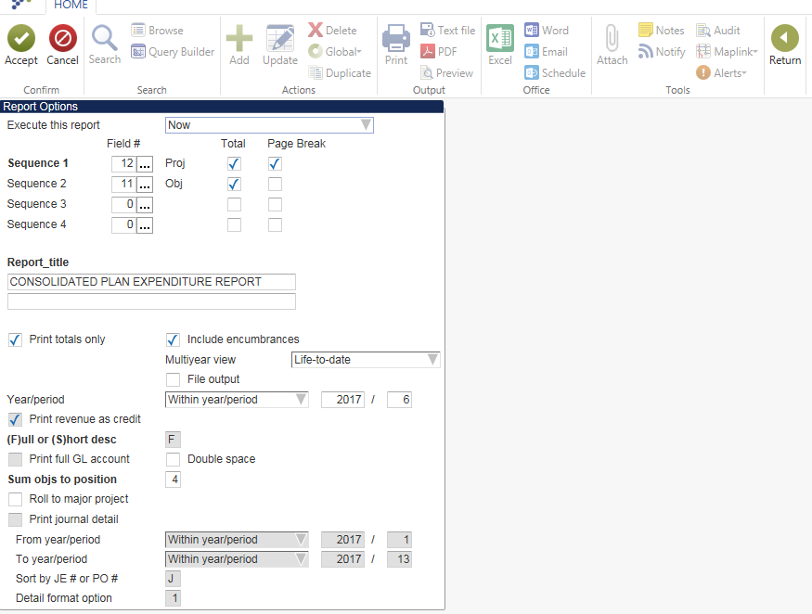
Note: Change the Summ objs to position field to 5 if you have any projects that have object codes consisting of five digits.

- Update the Fiscal year/period.
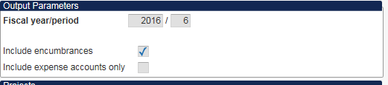
- Note: It is necessary under the No Child Left Behind Act of 2001 to include Revenue totals on this report. Please be sure the Include expense account only box is left blank.
8. Select Save PDF to save the report to your saved report directory or select the PDF icon to create the report in PDF format and save locally. The file that is submitted to KDE is created with a name of PSBddd####.pdf. The ddd represents your District Number and the last four digits (####) reflects the number of times the report has been generated.

TRANSFERRING FILES TO KDE
Files should be submitted via email to the KDE CDIP Reports email account (kdecdipreports@education.ky.gov). Please include the district name in the subject line of the email and the quarter for which you are reporting. For example:
Subject: Sample Co, 3rd Quarter 2015

SUBMITTING REPLACEMENT ELECTRONIC FILES
Each electronic file must have a unique file name if the Consolidated Plan Expenditure Report is submitted more than once to KDE. Therefore, each time the Consolidated Plan Expenditure Report spreadsheet files are generated, the last four digits of the file name are automatically incremented by 1. Repeat the processes described above to submit replacement electronic files.

