**COVID-19**

**Office of Finance and Operations Division of District Support**

**Student Tracking and Data Branch**



Kevin C. Brown, Interim Commissioner Kentucky Department of Education

Office of Finance and Operations

Division of District Support

March 24, 2020

# KDE Contacts

Jessica Carlton – Division of District Support: (502)564-5279 x2468

[Jessica.carlton@education.ky.gov](mailto:Jessica.carlton@education.ky.gov)

Ronda Devine – Division of District Support: (502)-564-5279 x4450

[Ronda.Devine@education.ky.gov](mailto:Ronda.Devine@education.ky.gov)

Josh Whitlow - Division of District Support: (502)-564-5279 x4444

[Josh.Whitlow@education.ky.gov](mailto:Josh.Whitlow@education.ky.gov)

Brad Kennedy – Division of District Support: (502)564-5279 x4417

[Brad.kennedy@education.ky.gov](mailto:Brad.kennedy@education.ky.gov)

Laura Loman – Division of District Support: (502)564-5279 x4485

[Laura.loman@education.ky.gov](mailto:Laura.loman@education.ky.gov)

Rodney Bennett – Division of District Support: (502)564-5279 x4449

[Rodney.bennett@education.ky.gov](mailto:Rodney.bennett@education.ky.gov)

Angie McDonald - Division of District Support: (502)564-5279 x4430

[Angela.mcdonald@education.ky.gov](mailto:Angela.mcdonald@education.ky.gov)

Samantha Engstrom - Division of District Support: (502)564-5279 x4434

[Samantha.engstrom@education.ky.gov](mailto:Samantha.engstrom@education.ky.gov)

# KDE Field Staff

Sheila Harned: Division of District Support: (270)-705-9158

[Sheila.Harned@education.ky.gov](mailto:Sheila.Harned@education.ky.gov)

Scott Rose: Division of District Support: (606)-776-0798

[Scott.Rose@education.ky.gov](mailto:Scott.Rose@education.ky.gov)

Ruth Wilkes: Division of District Support: (859)-516-1673

[Ruth.Wilkes@education.ky.gov](mailto:Ruth.Wilkes@education.ky.gov)

Table of Contents

KDE Contacts 2

KDE Field Staff 2

DASCR 4

FRAM 5

SAAR 7

NTI Days 7

Home Hospital 9

School Calendars 10

# DASCR

Q: What is District and School Collection Repository (DASCR), and how do I request change(s) to school demographic data?

A: Please see link: <https://education.ky.gov/districts/data/Pages/School-Change-Requests.aspx>

Q: Where should staff go to setup a new user to access the DASCR system, Person Role Manager system, register for a KDE Web Application user account or retrieve their username/password if they have forgotten user name and/or password?

A:   <https://applications.education.ky.gov/Login/SelfRegistration>

Q: When will new schools for 2020-2021 Calendar year be active in DASCR and IC?

A:  Effective - July 1, 2020 (7/1/20)

Q: What is the deadline for school districts to validate school demographic information.

A:  August 15, 2020 (8/15/20)

# FRAM

Q: What households need a Household Income Form(HIF)?

A: Full CEP Households, Mixed CEP Households (Partial CEP Only) and Direct Certified (DC) students who do not pull in on the DC list.

Q: What is the difference between the application date and the effective date on the HIF?

A: The application date is the date the application was signed by the parent or guardian and the effective date is the date the application is entered into Infinite Campus (IC).

Q: When does the DC need to be uploaded into IC?

A: The DC list is uploaded monthly.

Q: What if a HIF is not returned?

A: Make attempts to reach out to the household with the missing HIF. If not successful, move on and manually mark the student as “paid” and “did not apply”.

Q: How do I upload DC file into Infinite Campus?

A: Follow this link to obtain your DC list <https://applications.education.ky.gov/login> and then follow the directions in the DC web download tool manual found [here](https://education.ky.gov/districts/Pages/Community-Eligibility-Provision-(CEP).aspx).

Q: How do I setup the default expiration date for household income applications?

A: Default expirations date is setup under FRAM Preferences. Path: FRAM/FRAMS Preferences

Q: How do I enter a household income form for a split CEP household family?

A: You will remove the student who is in the Non-CEP school and process the application for only the student in the CEP school.

Q: Can household income forms be electronic with online registration?

A: No, as of right now we are unable to accept online signatures for household income forms.

Q: How long do we need to keep household income forms?

A: The retention rate is 10 years.

Q: Do I need to enter a HIF if a student is on the DC list?

A: If a student is on the DC list you do not need to enter a HIF. When you pull up the student it will show “Free, direct” and you can document that on the form and move to the next student.

Q: If a student pulls in on the DC list and they already have a HIF entered, will the DC status override the HIF?

A: Yes. DC pulls in monthly and will override a form entered manually.

Q: What is the deadline goal for entering HIF’s into IC?

A: October 1 is the goal for funding purposes.

# SAAR

## NTI Days

Q: How do I add an NTI day?

A:  **Path *System Administration>Calendar>Calendar> Days***

Uncheck the “Attendance” box and choose N: Non-traditional Instruction as the event type. The boxes for “School day” and “Instruction” should be checked.

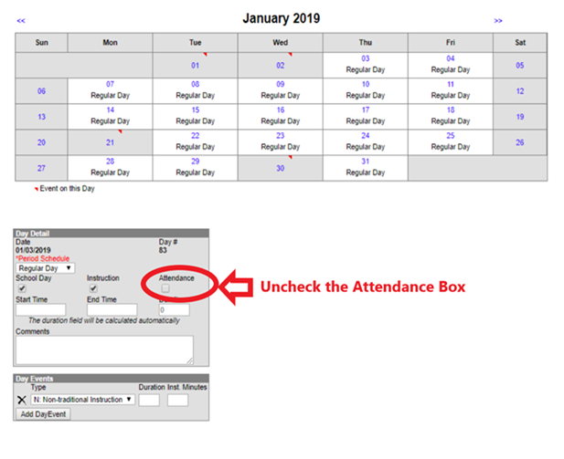

Q: How is transportation calculated on a NTI day?

A:  There is no transportation calculated on a NTI day since students were not transported.

Q: Where do I see NTI days on the SAAR?

A:  In Infinite Campus when creating the SAAR, you will see the NTI days listed under Record N. You can also see the days on your pdf copy of the SAAR.

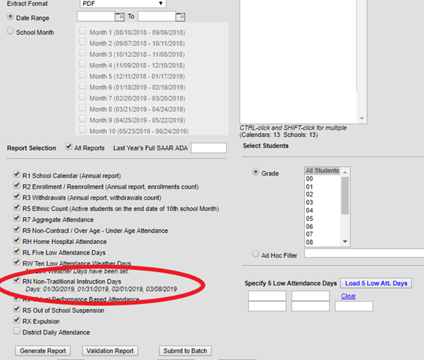

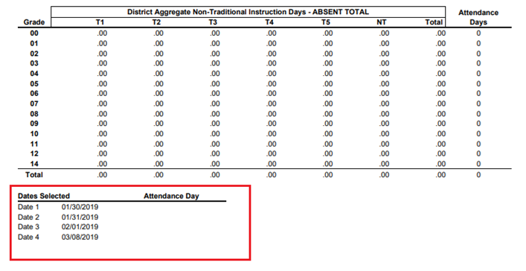

## Home Hospital

Q: How should handle the requirement that students who are educated via Home and Hospital instruction must have two hours of face-to-face instruction each week?

A: Following the governor's recommendation that telework be allowed whenever possible during this crisis, districts may fulfill the face-to-face requirement remotely using available technology.  The contact may be a simple as a phone call or something more elaborate like a video chat. Verbal contact with the student is the goal so email does not satisfy the face-to-face requirement.  An in-home visit is not prohibited but appropriate social distancing must be practiced. If materials need to be hand delivered to the student, staff should make appropriate drop-off arrangements with the parent/guardian. The district still needs to log the "visit" per their specific policy and procedures.

During this time NTI packets may be assigned to home hospital students but KDE recommends contact with these students through telephone or electronic means during this time.

If you have questions regarding a special education student on home hospital, please reach out to the Office of Special Education and Early Learning (OSEEL) to determine how to properly provide services for students with IEP’s. OSEEL has issued the attached guidance on NTI for students with IEPs.

**NTI Guidance for Students with an IEP**

## School Calendars

Q: When school is cancelled for Coronavirus and NTI day is not being used, how do districts code their calendar in?

A: KDE recommends when school is closed for Coronavirus and NTI day is not being used that districts use code “I: Closed Due to Illness”. All checkboxes, School Day, Instruction, Attendance should all be unchecked.

**Path: *System Administration | Calendar | Calendar | Days***

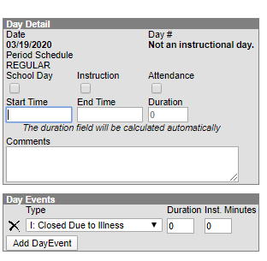

Q: When school has decided to take NTI day for the Coronavirus, how do we mark this in Infinite Campus?

A: When school is taking an NTI for Coronavirus, Day Event should be “N: Non-traditional Instruction”. School Day and Instruction should be checked

**Path: *System Administration | Calendar | Calendar | Days***

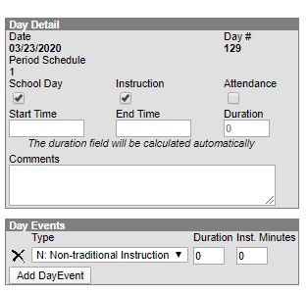

Q: How do we print/store monthly attendance reports during the last months of the 19-20 school year?

A: The register report and ADM/ADA report will not return data when a school month has only NTI days. Due to COVID-19 and the transition from in-person instruction in Kentucky, these reports will not be available to reconcile or archive for a few months of the 2019-20 school year. KDE will not audit or ask for these reports. If your district would like to continue to print, sign and archive the reports, please add the following statement:

Due to COVID-19 and the transition to NTI days, this report would not return attendance data for a month with only NTI days. Daily attendance was not used for attendance funding during this month of the 2019-20 school year.