Summer School

Calendar Setup Guide

Jason Glass, Commissioner
Kentucky Department of Education

Office of Finance and Operations
Division of District Support
April 2021

Table of Contents
KDE Contacts 2
Summer School Calendar Setup 3
Calendar Wizard 3
Calendar Tab 4
Resources 4

KDE Contacts

Josh Whitlow: 502-564-5279
Josh.Whitlow@education.ky.gov

KDE Field Staff

Sheila Harned: 270-705-9158

Sheila.Harned@education.ky.gov

Scott Rose: 606-776-0798
Scott.Rose@education.ky.gov

Ruth Wilkes: 859-516-1673
Ruth.Wilkes@education.ky.gov

Summer School Calendar Setup

Calendar Wizard

Path: System Administration |Calendar |Calendar Wizard

The Calendar Wizard has three modes that can be selected by the user.
  - Create new blank calendars: will create a calendar with start and end dates, but the grade levels, terms, periods, and days of the calendar will need to be manually defined.
  - Year: 2020-2021
  - Name Template: SUM (Summer School)
  - Number: 999 (will send Sumer School calendar to the bottom of dropdown)
  - Start Date: First day of Summer School (Example 05/26/2021)
  - End Date: Last day of Summer School (Example 06/18/2021)

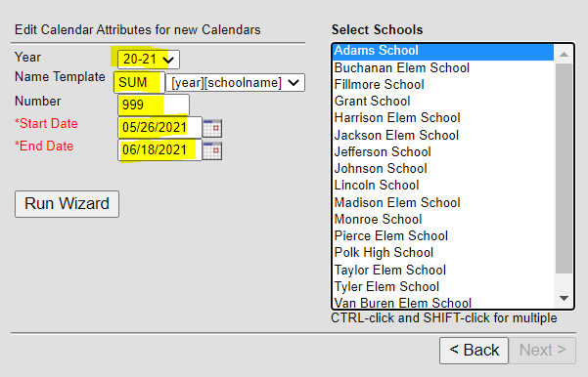

Note – If Summer School continues through July, you do not have to create two Summer School calendars.

Calendar Tab
This first tab, Calendar houses user-defined fields that set how the calendar will work for attendance and state reporting.
- The Start and End Date are bookends that define the range of days in which all instructional days for a summer school will occur (Example Start Date 05/26/2021, End Date 06/18/2021).
- Check Summer School if the calendar includes a summer school term.
- Check Exclude for all Summer School Calendars.
- Comments are seen on this screen only. The system will append the timestamp of when the calendar was created in this field by default.
- When finished making changes, select Save.

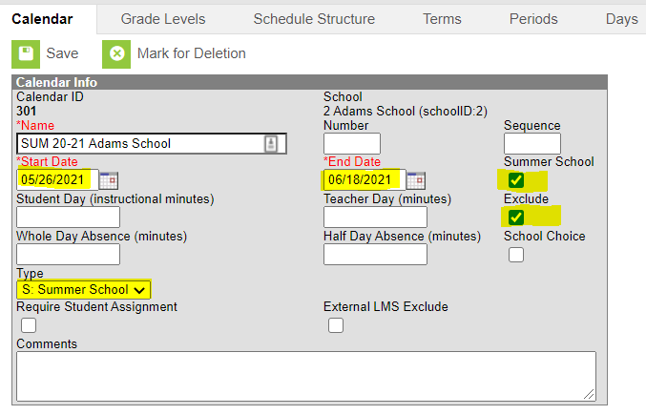

Tracking of attendance and course data is not required for summer school calendars, but districts may decide to setup and maintain tracking of attendance and courses in a summer school calendar.

Resources
Calendar Setup Guide & Using Calendar Wizard

