How to Set Up and Document Narcan in Infinite Campus Health Office Visits

How to Set Up in Infinite Campus:

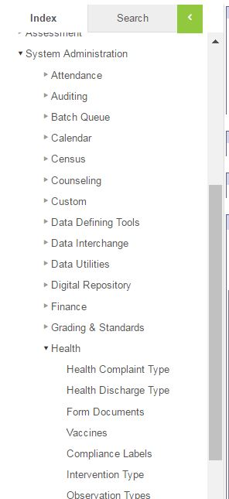
- Go to Index
- System Administration
- Health
- Intervention Type

Oval ar

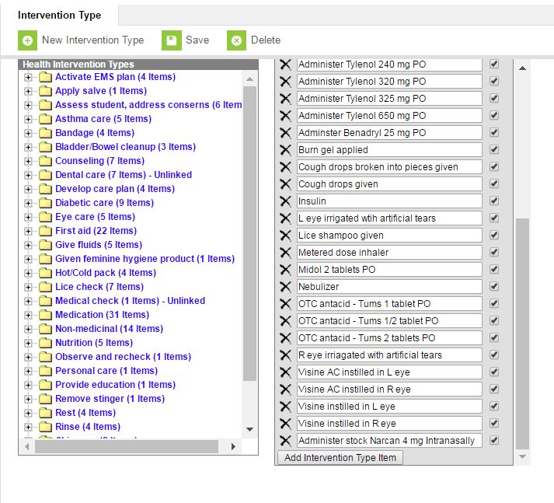
- Click on Medication
- Click on Add Intervention Type Item
- Enter Narcan, dosage and route as Intervention Type Item
- Check active box so it will appear as a choice in the drop down box
- Click “Save”

Oval
o

Example of How to Correctly Document Narcan Administration in Infinite Campus
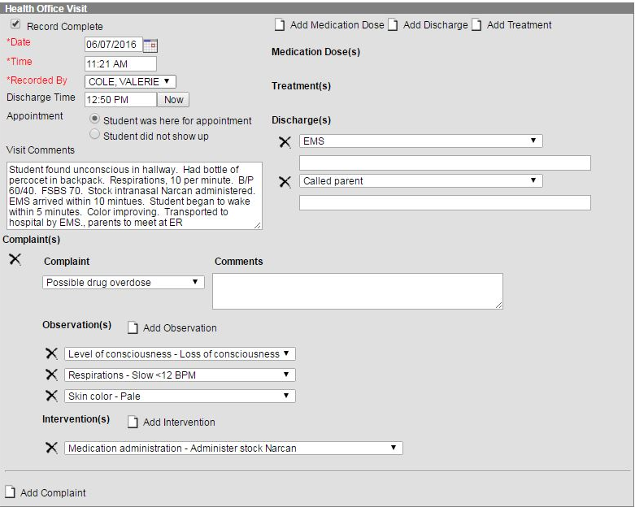

KDE Contact
For questions or assistance with entering or setting up Narcan in health office visits, contact Angie McDonald via email at angela.mcdonald@education.ky.gov or via 502-564-5279, ext. 4430.

