Data Standard Health

Rev. 8/20/2026

Ownership and History

  - Standard prepared by:

Tonia Hickman

  - Data steward(s)
Tonia Hickman, (502) 564-5279 ext. 4062
Angela McDonald, (502) 564-5279, ext. 4430
  - Office(s)
Office of Finance and Operations
  - Revision history
8/20/2026
Update for 2026-2027 school year

8/19/2026
Updated Section D – changed title to District Assignments for District Hired Health
Staff
Updated Section E – District Health Service Providers (For use with contract providers)

8/26/2025
Updated AED information to include new tool that launched in 2025

8/23/2024
Updated dates for AED reporting

7/1/2024
Updated for New Look/Tool Search

8/4/2023
Added Section G – Tracking of Portable Automated External Defibrillators (AED)

7/3/2023
Update for 2023-24 school year

4/10/2023
Added Titer to the Immunization exception list

Contents
Ownership and History 1
Overview 3
Section A – Health Office Visits Conditions and Alerts 4
Section B – Immunizations 5
Section C – Screenings 8
Section D – District Assignments for District Hired Health Staff 12
Section E – District Health Service Providers (For use with contract providers) 16
Section F - Tracking of Portable Automated External Defibrillators (AED) 18

Overview
  - Description
Health services delivered to students while they are in school are recorded in the health module.
  - Regulation citation(s)
- KRS 156.502 describes health services to be the provision of direct health care including the administration of medication, the operation, maintenance, or health care through the use of medical equipment or the administration of clinical procedures. To facilitate reducing barriers to learning (KRS 158.6451 (1)(e), all chronic health conditions documented by a medical provider and noted on the student’s health information card should be entered.
- KRS 158.037, 902 KAR 2:055, and 902 KAR 2:060 - Immunizations
- 702 KAR 1:160– Vision Examination and Screening and Hearing Screening
  - Data use
- The Kentucky Department of Education collects annual data on current immunizations, health conditions, physical exams, dental screenings/exams, vision exams, hearing and vision, health screening, health office visits and discharges, district nurse/student ratio (nurse counts) and use of stock emergency medications (Narcan, Epinephrine and Rescue Inhaler)
- Data Sharing between systems – P20
- School Report Card reporting – Number of district nurses
  - Related ad-hoc filters and reports
Health Condition Alerts
Student Health Immunization
KY Student Health Screening
KY Health Office Visit
Stock Rescue Inhaler Report

Health Audit Grade 00 w/No Dental Record
Health Audit Grade 00 with no Physical Exam
Health Audit Grade 00 with no Vision Exam
Health Audit Grade 06 w/No Physical Exam
Health Codes with ICD-9 Code Set
Health – HOV Missing Discharges
Health Students without Hepatitis A vaccine
Health 16-year-olds without Meningitis Booster
  - Training
Guidance - Health Data Entry
  - Entering Health Data into Infinite Campus PowerPoints

Section A – Health Office Visits Conditions and Alerts

Tool Search: Health Conditions
Main Menu > Student Information > Health > Conditions
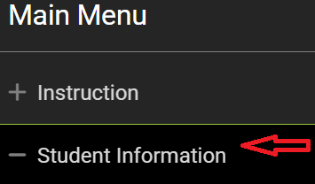
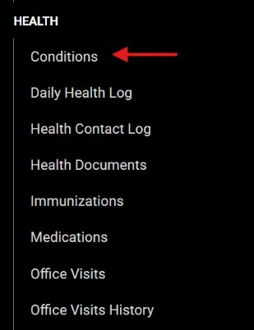
Health Conditions
Enter all students with a documented chronic disease under the appropriate health condition code. Use the Description Search to locate the Health Condition/ICD-10 Code. After searching, choose the Health Condition for the student from the drop-down menu. ‘Other’ should not be chosen. KDE does not require standardized health conditions. A list of KDE recommended ICD-10 codes to be used when choosing health conditions can be found here.

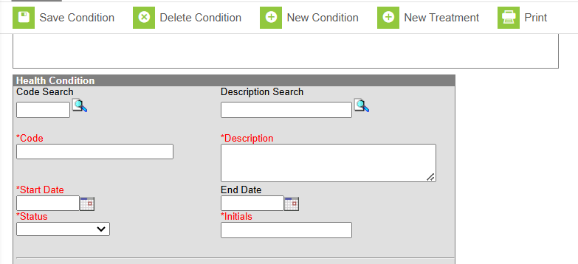

Start Date: Enter start date in which student was diagnosed with this condition.

Status: Select the status of the condition:
- Not Resolved
- Resolved
- Unknown
Initials: Enter initials of user entering condition

Referring Provider’s Information: Name, Phone, Credential Suffix
Additional Information (if known) NPI number, Enumeration, Taxonomy Number

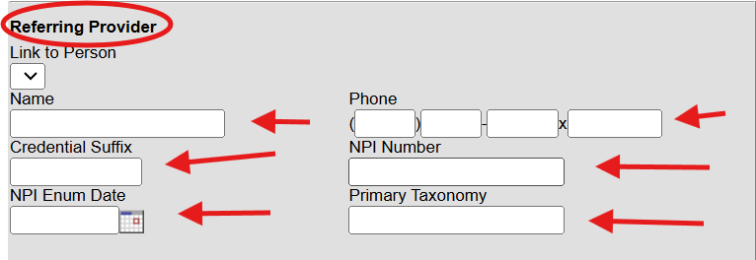

Flag:
Check this box for medical conditions that will require an emergency action if a condition occurs. These conditions would be seen as life threatening and need immediate attention, i.e., Glucagon for a student with diabetes receiving insulin experiencing very low blood sugar. Checking the box will create this flag on student’s screen:
User Warning:
Enter brief emergency information relating to the student’s health condition and treatment that will display when user hovers over alert symbol. (Example: Glucagon kept in nurse’s office)

Instructions:
Enter further details regarding emergency treatment procedures required and locations of medication. (Example: Administer medication and call parent). These instructions will be visible in a popup box when clicking on the alert symbol.

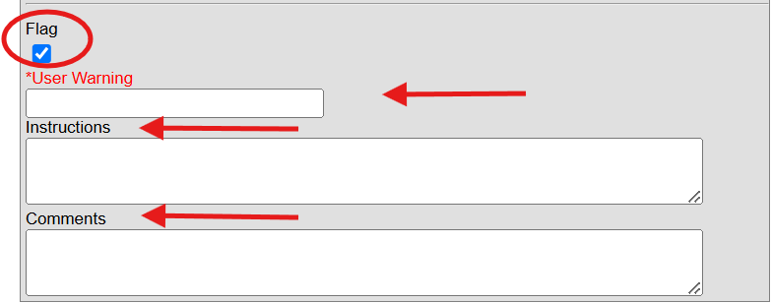

Section B – Immunizations

Tool Search: Immunizations
Main Menu > Student Information > Health > Immunizations

*Required by KDE for grades K, 7 and 11.
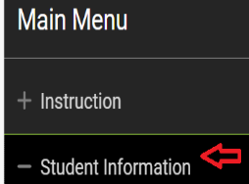
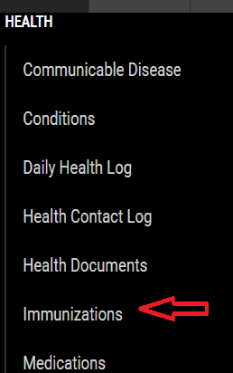

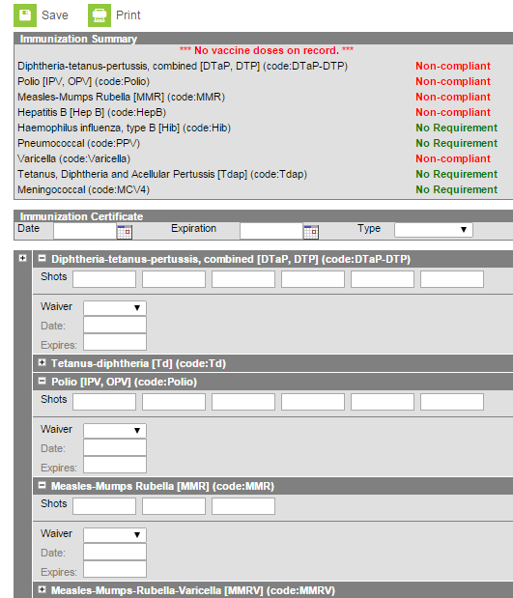

Date: Enter the date the certificate was signed by local health care provider. If there is a waiver, enter the date of the waiver.

Expiration: Enter the expiration date of the certificate submitted. If medical or religious exemption is checked, no expiration date is required.

Type: Select from the dropdown menu the type of certificate provided:
- Provisional
- Standard
- Medical
- Religious
Note: If Medical or Religious is chosen, user must also choose Medical or Religious waiver in the dropdown under each immunization for which the waiver is applicable and enter the waiver date. If a Titer Immune certificate is presented the waiver must be added to the immunization and a waiver date must be entered as well.
NOT required by KDE:
KDE does not require the entry of individual shot dates. You are not required to address invalid vaccination doses. KDE is only concerned that:
- A student has a certificate on file.
- The certificate type (Regular, Religious, or Medical Exemptions).
- The certificate is not expired.
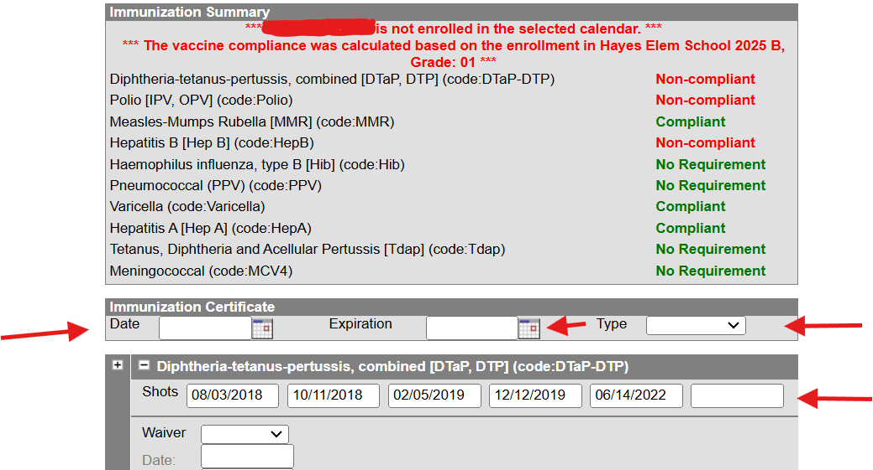

Note: If you have an immunization that is considered Non-compliant, double check the entry dates to make sure that the immunization dates were entered correctly. If the immunization was given at the incorrect interval, it will show Non-compliant as well.

Exemptions: In the event of a medical or religious exemption, enter type of exemption in the waiver box. List the certificate date in the box, click save.
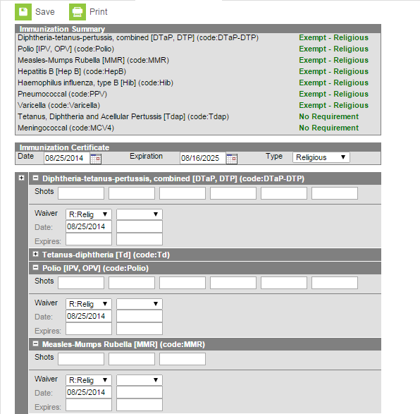
Other considerations: All Kentucky schools will be asked to complete an immunization survey through their local health department each year as required by the Kentucky Department of Public Health (KRS 158.037 and 902 KAR 2:055). To assist with completing this survey, schools may enter the data for the immunizations. Instructions for entering immunizations can be found on Campus Community.

Section C – Screenings

Tool Search: Health Screenings
Main Menu > Student Information Health > Screenings
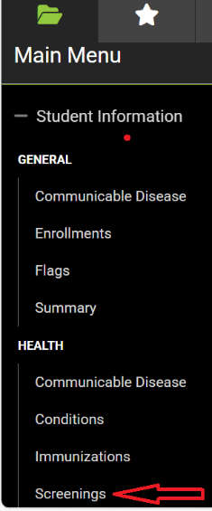
Select the Screening Type
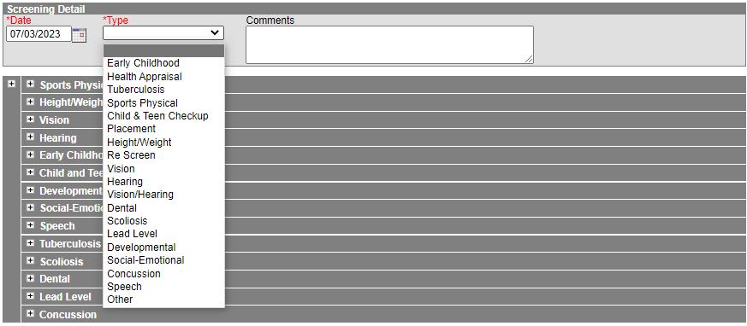
Date: Enter date of screening

Type: Select the required KY screening:

- Child and Teen Checkup (Physical Exam)
- Vision (Exam and Screening)
- Hearing
- Dental (Exam or Screening)

Guidance for each Screening Type

Child and Teen Checkup (Physical Exam) - Required for Initial Entry and 6th Grade

NOTE: Multiple sections will open but data entry is only required in this section.
Date of Exam: Enter the date on the student’s form. If a student is entering kindergarten with a preschool or Head Start physical, that initial screening date may be used, even if more than one year prior to kindergarten enrollment.

Type: Select from drop down menu:
- I: Initial Entry
- 6: 6th Grader
- 9: 9th Grader (optional in Kentucky)
Status: Select from drop down menu:
● Normal
● Referred
● Known condition

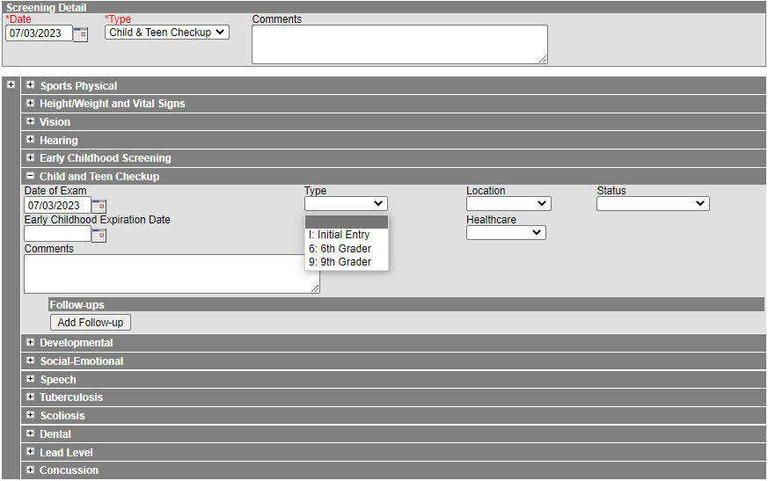

Vision Exam – Required for students three, four, five or six for Initial Entry to school, must be completed before January 1 of the current school year.

Date: Enter the Vision Exam date

Vision Check Type: Select Vision Exam from the drop-down menu
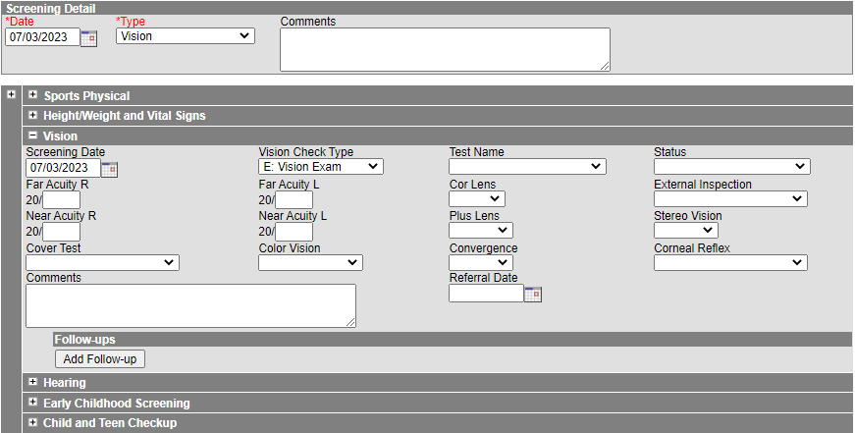

Vision Screening – For students after Initial Entry. Districts determine which grades will be screened per 702 KAR 1:160.
Status: Select results of Vision Screening from drop down menu:
- P: Passed
- F: Failed
- C: Cannot test
- R: Refused
- RE: Referred
- RC: Referral Complete

Referral Date: Enter the date a referral was sent home to the parent/guardian, if needed

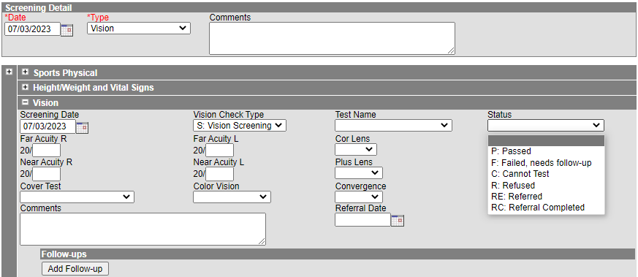

Hearing Screening – Required for students. Districts determine which grades will be screened per 702 KAR 1:160.

Date: Enter the Hearing Screening date

Type: Select Original from drop down menu

Status: Select results of hearing screening from drop down menu:
- P: Passed
- F: Failed
- C: Cannot test
- R: Refused
- RE: Referred
- RC: Referral Completed
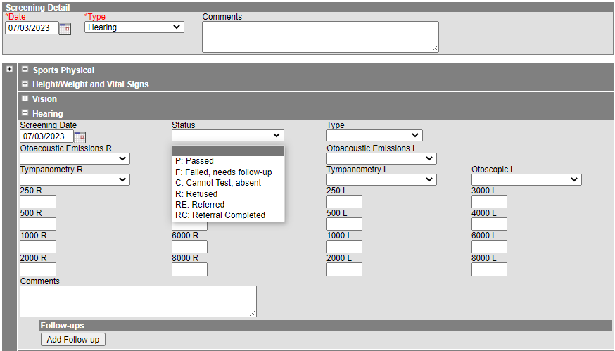

Note: There is no Referral date in the Hearing Screening. If a referral is made, two screenings must be entered. One with the actual status of the screening and a second with the referral.

Dental Screening or Exam – Required for students aged five or six who enroll in a public school. Proof of a dental screening or exam is required within the calendar year of the initial enrollment

Date: Enter the date of the dental screening or exam

Test Type: Select Dental Exam or Dental Screening from drop down menu

Referral Date: Enter the date a referral was sent home to the parent/guardian, if needed.
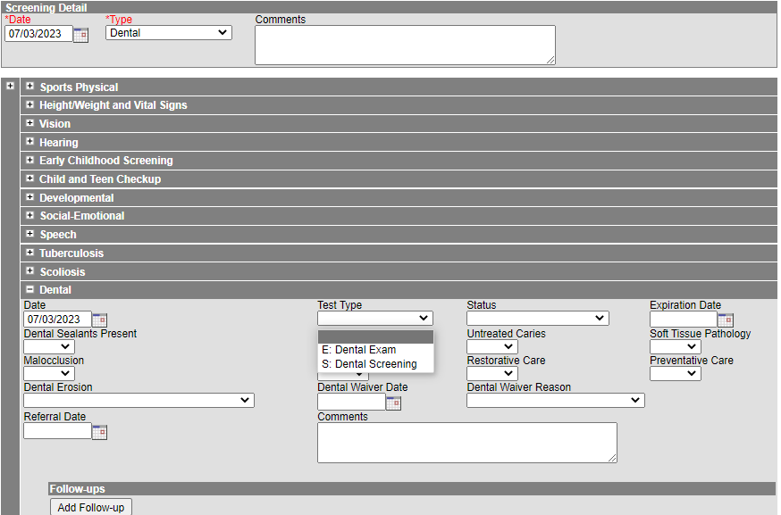

Section D – District Assignments for District Hired Health Staff
All district-hired school health staff should be entered under the District Assignments tab. The information will sync to State Edition and be available for retrieval by KDE. The service providers tracked in this tab will have District Employment Records.

Tool Search: District Assignments
Main Menu > Census > Staff > District Assignments
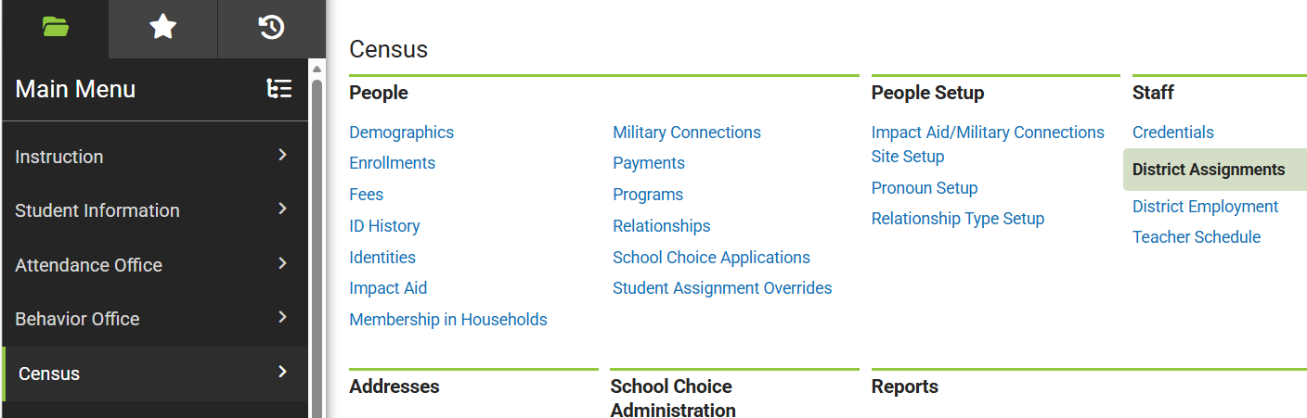

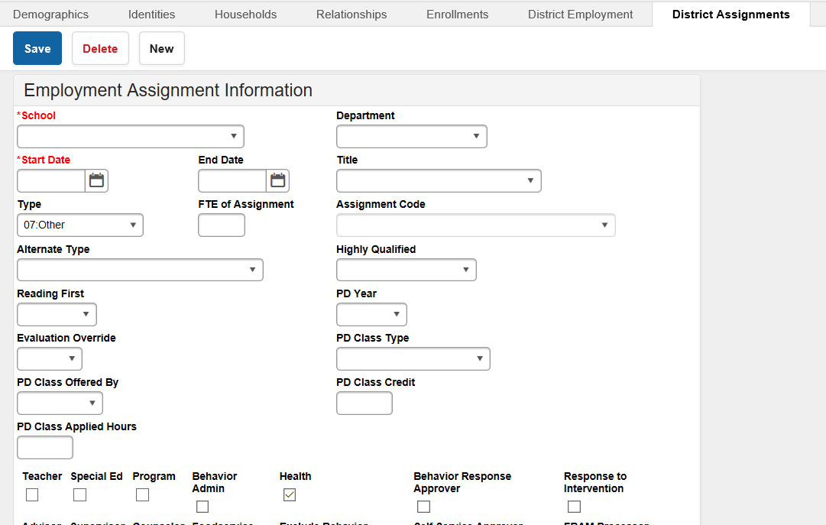

School Name: Choose school name from drop down box.

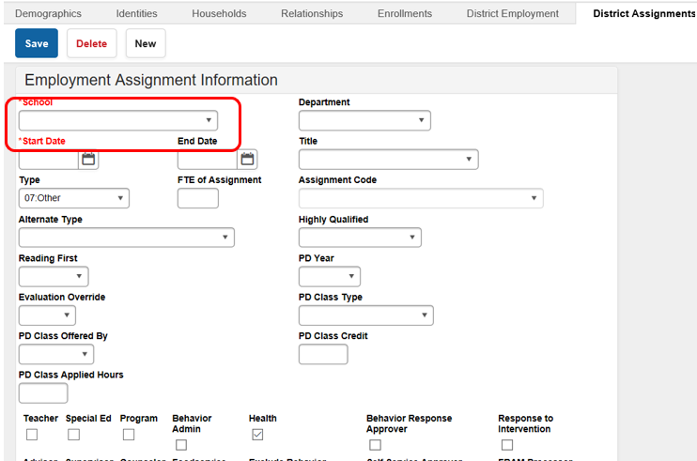

Date: Add employee hire date.
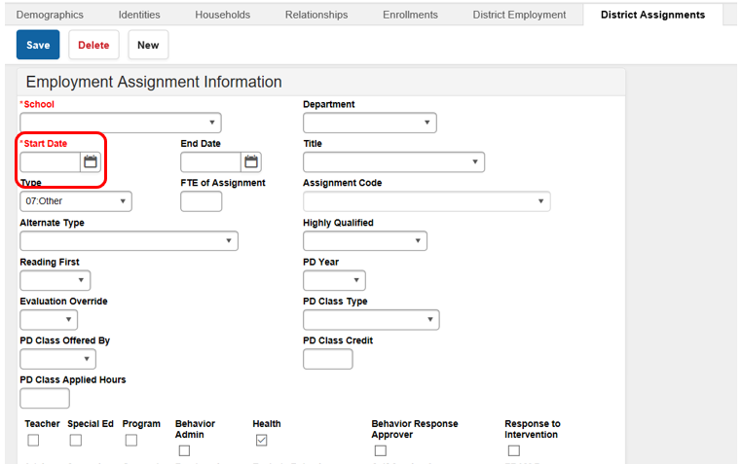

Type: Select “07: Other”

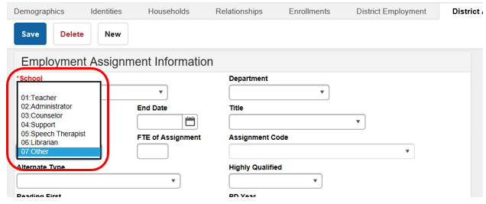

Alternate Type: Choose the correct type of license from the drop-down box.
- LPN: Licensed Practical Nurse
- RN: Registered Nurse/Advanced Practice RN

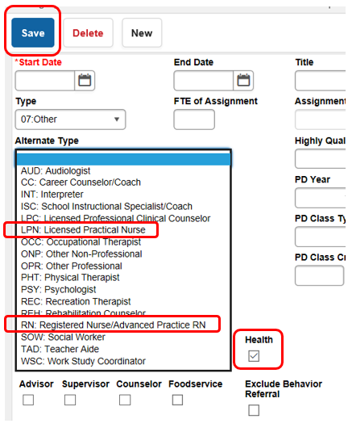
Check the Health box and then Save.

Section E – District Health Service Providers (For use with contract providers)
The District Service Providers tab tracks contract health service providers in each district by school year based on contract start and end dates. Contracted service providers can be more than one school year in duration. The information will sync to State Edition and be available for retrieval by KDE. The service providers tracked in this tab will not have District Employment records. This tab is for nurses that are board hired – District Health Service Providers.
Tool Search: District Health Service Providers
Main Menu>School & District Settings > District Health Service Providers
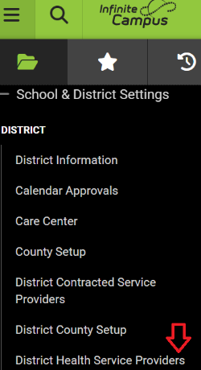

School Year: Enter correct school year
Note: This information must be entered yearly even if the contract is longer than a one-year period.

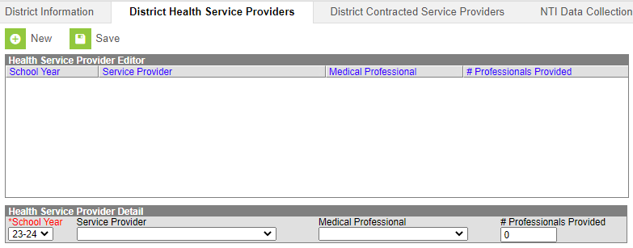

Service Provider: Choose type of service provider from the drop-down menu.
- 01. Health Department
- 02. Hospital
- 03. Staffing Agency
- 04. Federally Qualified Health Care Center

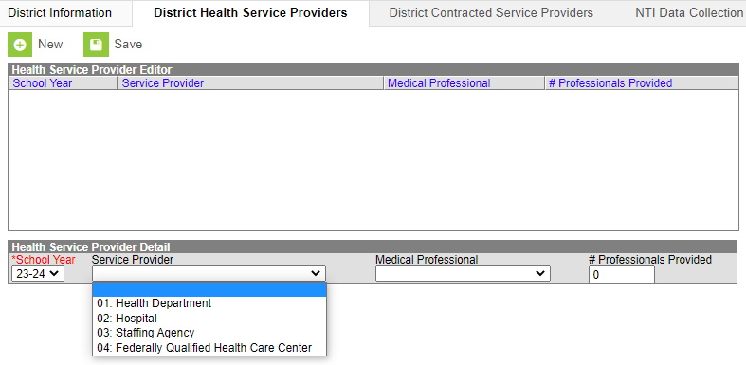
Medical Professional: Choose type of medical professional from drop down menu
- PA: Physician’s Assistant
- APRN: Advanced Practice RN
- RN: Registered Nurse
- LPN: Licensed Practical Nurse
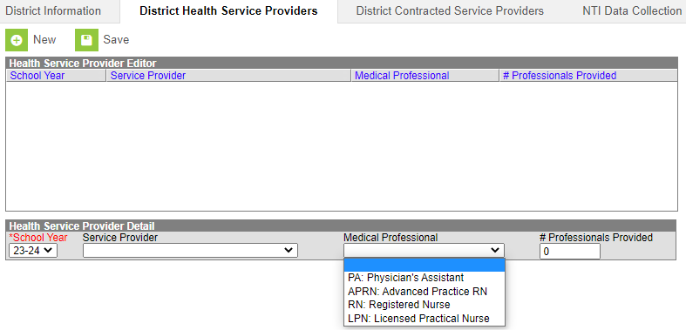
Number Professionals Provided: Enter number of health provider staff

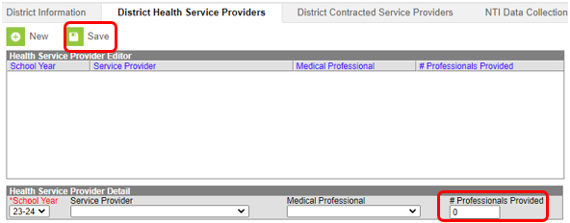
Click Save

Individuals who are hired to provide health services by contract are entered through this tab.
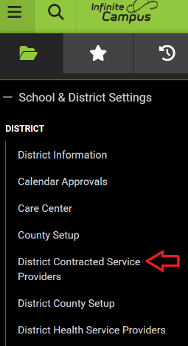

Section F - Tracking of Portable Automated External Defibrillators (AED)
KDE has transitioned to a new reporting application. This data should be entered into the AED Tracking Web Application. All AED-related data should be entered into the new AED Tracking Web Application and NOT into Infinite Campus. Contact your KDE School Health Branch regional field staff for more information on tool accessibility.

KRS 158.1621 requires school districts to report to the Kentucky Department of Education the number of portable automated external defibrillators (as of July1) at each school within the district annually by August 1. Using this information, KDE will publish a report on the number of portable AEDs in Kentucky public schools by school and school district to the department’s website. Additionally, KRS 158.162 requires annual reporting of AED-trained individuals, including all coaches, individuals, their training date and the progress being made on adding more units to cover all school-sanctioned athletic practices and competitions. This must be completed annually no later than November 1 in the AED Tracking Web Application. The tracking period should span October 2 through the following October 1.

If the district has additional AEDs that are not stored at individual schools, for example AEDs that are used at sporting events, district events or located at board offices/transportation offices/etc., please enter those AEDs at the “District Office”. Each AED owned by the district should only be counted at one location.

