YTD Budget Report Sample for Capital Funds Request
The screenshots below show an example of a YTD Budget Report for Fund 310 and Fund 320. Directions for generating a YTD Budget Report can be found in the General Ledger Statewide Reports section of the KDE Munis Support & Guides webpage.

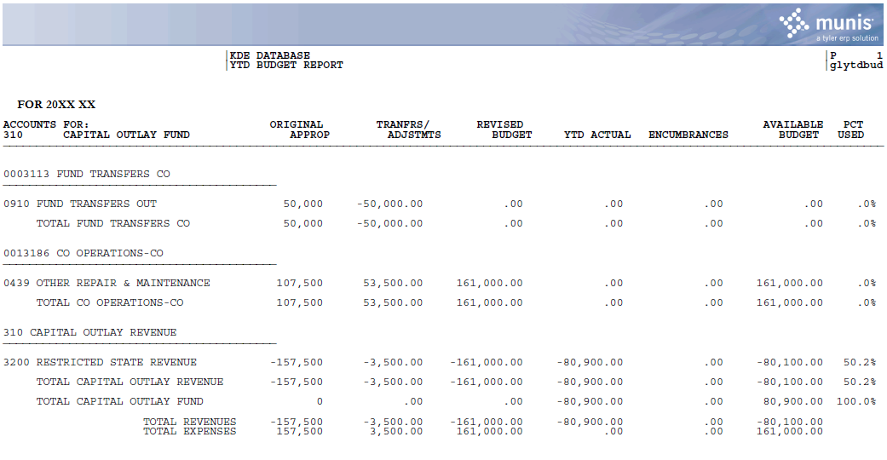

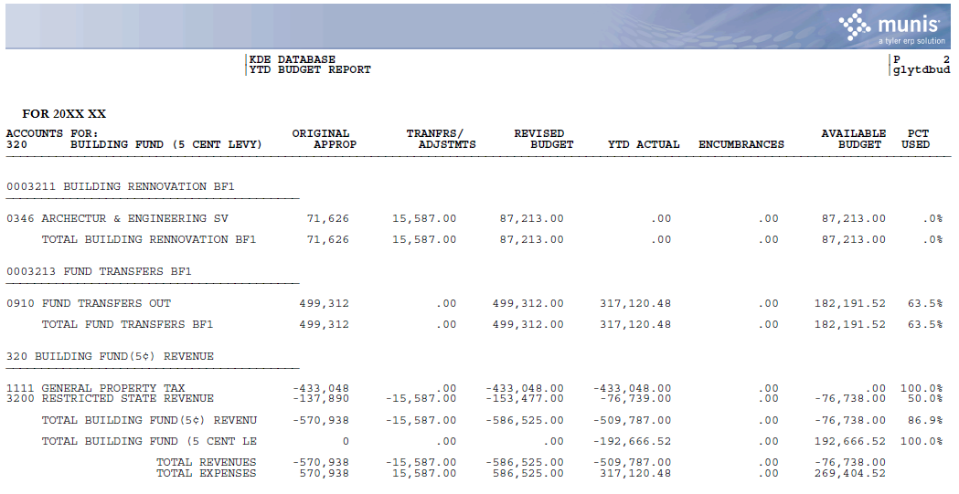

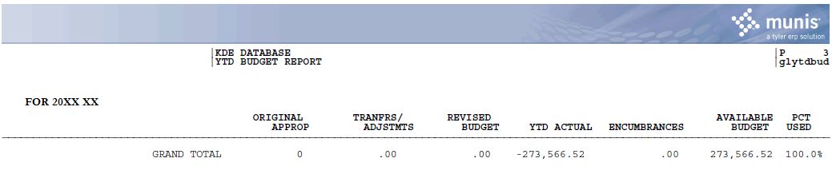

Project Budget Report Sample for Capital Funds Request
The screenshot below shows an example of a Project Budget Report for a Fund 360 project. Directions for generating a Project Budget Report can be found in the General Ledger Statewide Reports section of the KDE Munis Support & Guides webpage.

