Guidance on How to use the Kentucky.gov ACH Pay Application

Kentucky Department of Education Office of Finance and Operations Division of District Support
District Financial Management Branch

Dated: 6/22/26

Table of Contents
ACH Pay SETUP 3
TO MAKE A PAYMENT 5
TO CHANGE OR UPDATE ACCOUNT 6
FREQUENTLY ASKED QUESTION’S (FAQs) 7
CONTACT 7

Kentucky.Gov ACH Pay Application
To access the Kentucky.Gov ACH Pay application all NEW users will need to get registered. To get started go to the below website and GET REGISTERED. Follow the steps to create a username and password and answer the personal security questions. If possible, please provide a primary user and 2 backups. NOTE: Every user should have their own login credentials.

Registration Link: https://secure2.kentucky.gov/Identity/Account/Register

ACH Pay SETUP
Step 1: Provide the following information. NOTE: Each district user will need register with their own information.
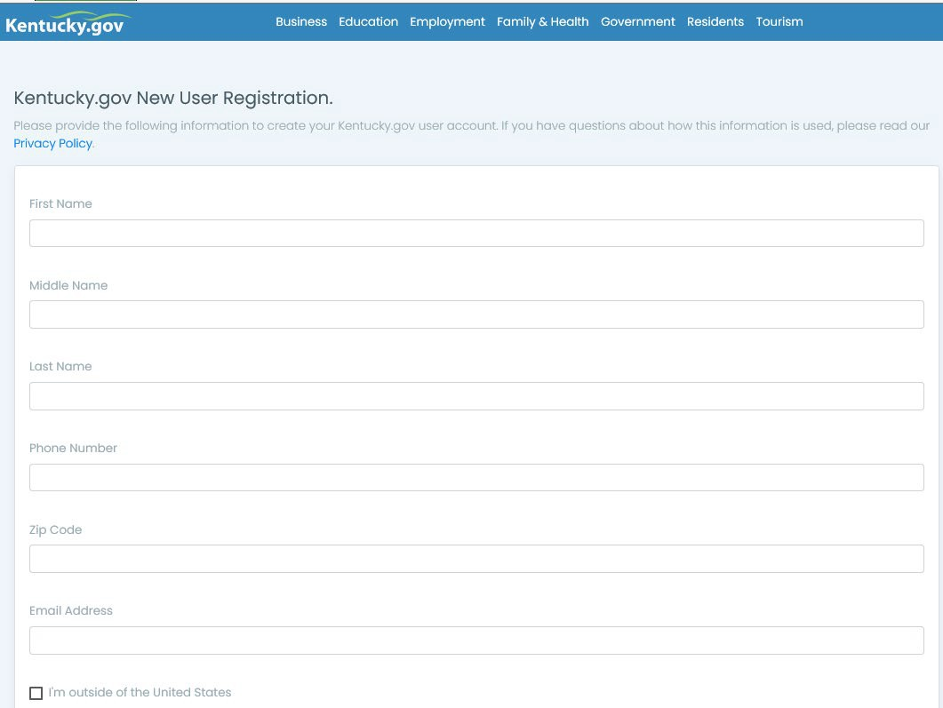
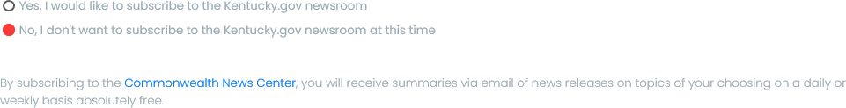

Step 2: Decide on a “Username”. Click on the “Username requirements” to see requirements. NOTE:
Each district user will need to register with their own username
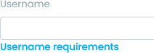
Step 3: Decide on a “Password”. Click on the “Password requirements” to see requirements. NOTE:
There should be a different password for each registered user in your district.
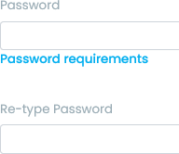
Step 4: Choose your Security Questions and Answers.
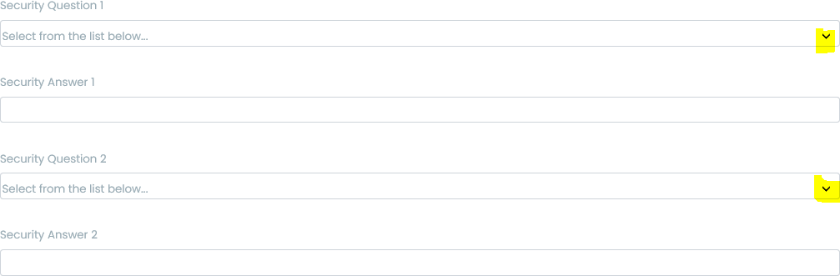
Step 5: Check the box.
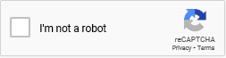
Last Step: Be sure to PRINT this page so that you will have all the information that you entered for your records. Click on the “Complete registration” button. You are now done registering.


NOTE: All users must be GRANTED ACCESS before they are able to submit a payment. (See “To Change or Update Account” or “FAQs” for more information)

TO MAKE A PAYMENT
Once the new user has been given access to the ACH Pay application, they may then go to the ACH Pay link (below) to log in and make a payment. (Add this link to your favorites!)
ACH Pay application: https://secure.kentucky.gov/achpay
Once logged in, there will be displayed the five (5) most recent payments made. To create a payment, click on the link titled “Add New Payment Item”.
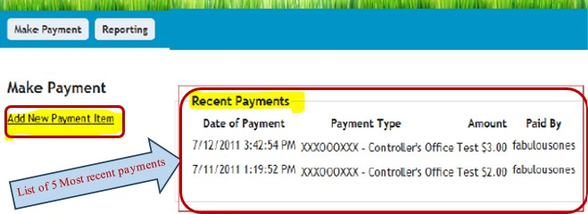
On the Create Payment Item page enter amount of payment and click CREATE. *Note: If you have multiple payment types be sure to choose the proper payment type from the dropdown menu for your agency.
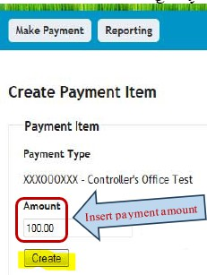
The Make Payment screen allows users to review payments that have been created or delete items, if necessary. After reviewing payment information (amount and last four digits of bank account number), click Submit Payment to process payment. *Note: Only click Submit Payment once. The transaction may take a few seconds to process.
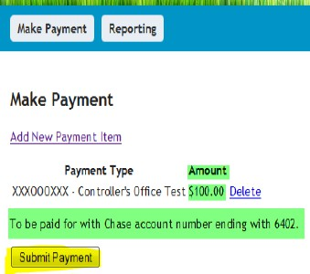

Next is the payment confirmation page. If you see the message “Your Payment Confirmation
number is…” that means your payment was successful. From this page you can click on the link titled
Print Receipt to print out a receipt of the transaction. Click FINISH to return to home page.
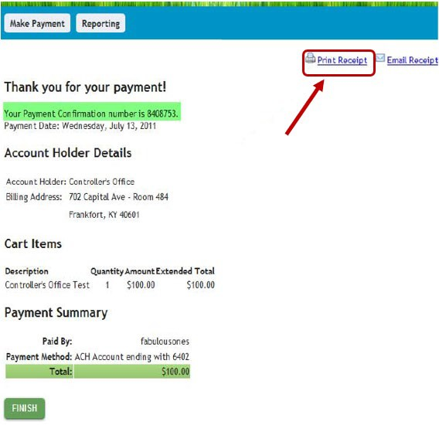
You can click on the “Reporting” link at the top of the screen and this page will list all payments that have been made. From this page you can view the payment receipt for each payment.
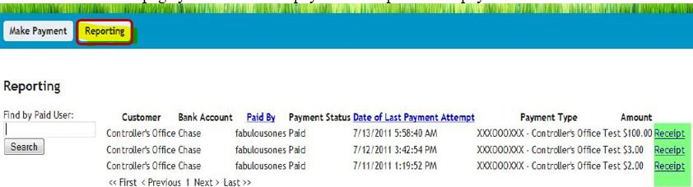

TO CHANGE OR UPDATE ACCOUNT
To make a change to the account/customer setup (i.e., add/remove user access to account, change banking information, contact information, etc.) click on the “ACH Change Form” link below.
ACH Change Form: https://secure.kentucky.gov/formservices/ACHPay/Request
NOTE: This link with prompt you to sign into the Kentucky.gov website, only an active user can use this feature. Once logged in scroll to the bottom of the screen then choose the “Request Type” and follow the prompts. Please NOTE, if there is no active user in your district/coop then you will need to send an email with your “User ID” to Bethany Crockett at the Finance Controller’s Office to request access.

FREQUENTLY ASKED QUESTION’S (FAQs)
Q. How do you get access to the account to make the payment?
A. If there is an active user in your district then they can use the “ACH Change Form” to make the request. If there is not an active user in your district/coop, then you will need send an email with your “User ID” to the Bethany Crockett at the Finance Controller’s Office to request access.
Q. What is the URL to access the Kentucky.Gov ACH Pay application?
A. https://secure.kentucky.gov/achpay
Q. What is the URL to reset my Kentucky.Gov password (if I don’t know it)?
A. https://secure.kentucky.gov/g2p/KII.G2P.Portal.Web.Pages.SSO/ForgotPassword.aspx
Q. What is the cutoff time for making my payment?
A. Payments made by 4:00 p.m. EST will be processed that day. Transactions take two business days to process with your bank account.
Q. Can I “void/cancel” a payment in the ACH Pay application?
A. Once a payment is successful (Confirmation # provided) it cannot be voided from within the ACH Pay application. To void a payment, you must contact the Finance Controller’s Office that same day. A payment made prior to 4:00 p.m. EST Monday - Thursday must be voided by 4:00 p.m. on the same day or it will be processed.

CONTACT
If you have any problems or issues with the Kentucky.gov ACH Pay Application, please contact Bethany Crockett with the Finance Controller’s Office at Bethany.Crockett@ky.gov or (502) 564-6690.

NOTE: These instructions were drawn up by the Financial Management Branch by using the information provided by the Finance Controller’s Office to assist the local school districts.

KDE USE: F:\audits_trans\DFMB Branch SOP's\Federal Reimbursement SOP's\District Use\ACH Pay Application

