Federal Reimbursement

ID Setup for

Federal Reimbursement File Submission Web Form

Kentucky Department of Education
Office of Finance and Operations
Division of District Support
District Financial Management Branch

Dated 8/14/18

FEDERAL REIMBURSEMENT ID SETUP
In order to utilize the Federal Reimbursement File Submission (FRFS) web form, the district users who provides the data to KDE must have a KDE Web Applications account and associated permissions. The login ID and password is the same ID and password utilized to submit SEEK data and Staff data to KDE so you may already have an account and will only need to be granted permissions to utilize FRFS.

In order to gain permission to utilize FRFS please follow one of the following three options that pertain to you:

- You do NOT have a KDE Web Applications login ID, then you will need to get registered.
- To register for a new account go to the following website KDE Web Applications - https://applications.education.ky.gov/Login/ and click on the link at the top of the website.
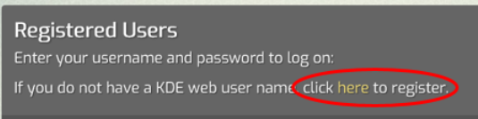
- The following screen will walk you through the steps to get registered. Once registered go to step # 6.
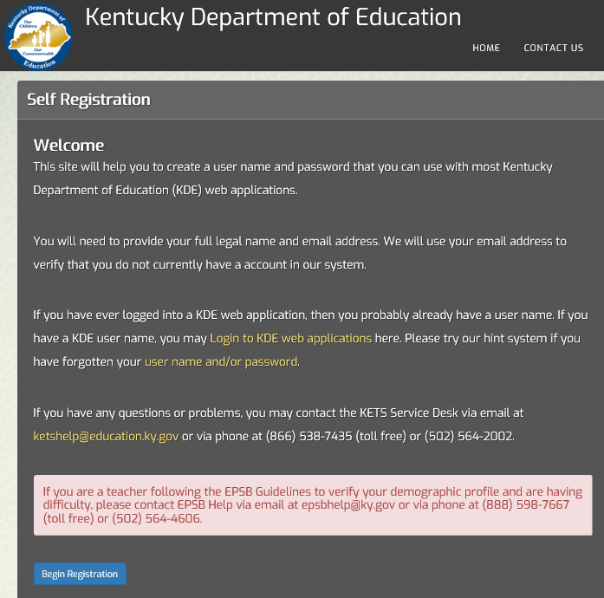
- If you already have a KDE Web Applications login ID and know your password, then go to step # 6.
- If you have a KDE Web Applications login ID, but you have forgotten your password and/or ID, then click on the link at the bottom of the login page on the KDE Web Applications - https://applications.education.ky.gov/Login/ and it will guide you through the steps to reset your password. If you still need assistance then contact your WAAPOC.
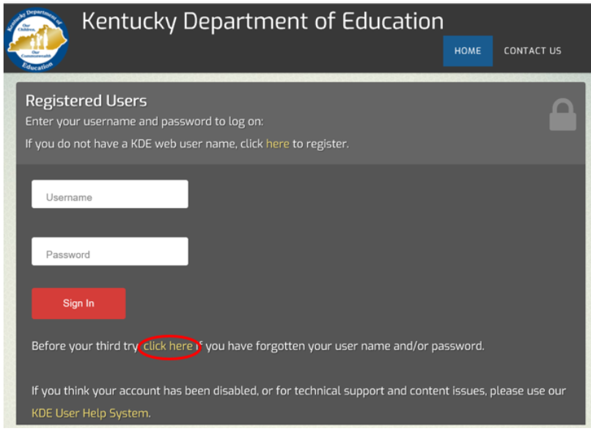
- Now that your account has been setup and verified you will need to be granted permissions to the Federal Reimbursement application. Contact your Web Apps Admin Point Of Contact (WAAPOC). If you do not know who your WAAPOC is go to this link KDE Other Roles Information - http://applications.education.ky.gov/sdci/Other.aspx. Click on the dropdown and go to “Web Apps Admin Point Of Contact-WAAPOC” and then find your district. You can also contact KETS Service Desk at ketshelp@education.ky.gov or call (866) 538-7435 (toll free) or (502) 564-2002. You will need to request to be added to the Federal Reimbursements application group as a District User for your District. NOTE: Have the WAAPOC deactivate any users that are no longer valid for this role before activating you.

- Once you are all setup you are ready to go to the Federal Reimbursement File Submission - http://opsupport.education.ky.gov/frs/Default.aspx web form to upload your file.
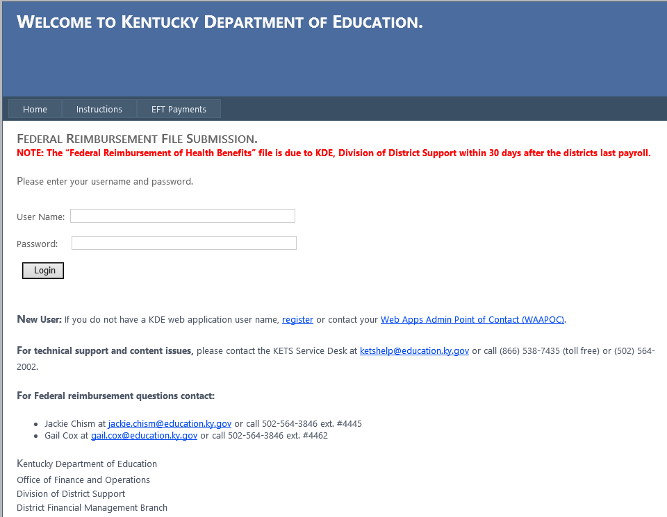
If you need further assistance, please call 502-564-3846 for Gail Cox at extension # 4462 or Gail.Cox@education.ky.gov or Jackie Chism at extension # 4445 or jackie.chism@education.ky.gov.

KDE USE: F:\audits_trans\Audit Branch SOP's\Federal Reimbursement SOP's

