# Federal Reimbursement SharePoint Submission Instructions for the Coops

**(Not on EERP)**

Kentucky Department of Education Office of Finance and Operations Division of District Support

District Financial Management Branch

Dated 3/4/25

**Federal Reimbursement Submission Process**

**(For Coops not on EERP)**

The Kentucky Department of Education (KDE), District Financial Management Branch (DFMB) has changed the process on how the Cooperatives not on EERP, submit their information for the Federal Reimbursement of Health Benefits. With this process, the Coops (not on EERP) will be required to fill out a verification form and submit the form along with an excel or other type of report used to determine who, and how much to reimburse. Below are the details on the verification form and how to upload the documents to the KDE SharePoint site each month. **PLEASE NOTE:** This process is separate from the payment process. The payment process has NOT changed.

Please refer to the “[Federal Reimbursement of Health Benefits](https://education.ky.gov/districts/FinRept/Pages/Federal-Reimbursement-of-Health-Benefits.aspx)” website document titled “*Guidance on ACH Pay Application*” for more information.

## STEPS TO FILL OUT THE VERIFICATION FORM

1. The verification form is located on the [Federal Reimbursement of Health Benefits - Kentucky](https://education.ky.gov/districts/FinRept/Pages/Federal-Reimbursement-of-Health-Benefits.aspx) [Department of Education](https://education.ky.gov/districts/FinRept/Pages/Federal-Reimbursement-of-Health-Benefits.aspx) website title “*Verification Form for Coops*”. You will need to download this form and save it to use every month.
2. Each month after you make the determination of who and how much will be reimbursed, you will need to complete the verification form.
3. Select from a dropdown box the “**Billing Month**” and “**Billing Year**” of the information that you are reimbursing for.



1. From the dropdown box, you will need to select the “**Name of Cooperative**”.



1. Under “**Amount Remitted**” you will need to enter the amount that was paid for that billing month and billing year.

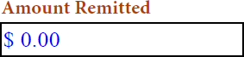

1. Under “**Please Sign Below**” enter your name. **NOTE:** This form must be completed every month and signed by the Director of Finance, or equivalent.

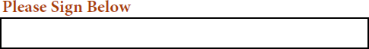

1. Under “**Date Signed**” choose or type the date that you are completing the form.

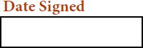

1. Be sure to **check the box** beside the statement.



1. Once the form is completed, signed, dated, and the box checked, please **SAVE** the form on your computer/server as “**Verification Form for (Coop Name)**”. You are now ready to upload the Verification Form into SharePoint. **NOTE:** It is important that you include your coop’s name in the file name. When uploading the document with the same file name as another coop, it will overwrite their file.
2. KDE requests that the Coops not on EERP, also upload a document they used in making their determination of who should be reimbursed and how much to reimburse. This could be a PDF or Excel document. **NOTE:** Do NOT submit any documents that contain SSN’s.
3. The report that you choose to submit as backup documentation for the payment, must contain the following information.
   * Employee number (**No SSN’s**)
   * Employees name
   * Billing Month
   * Billing Year
   * Federal Earnings (suggested not required)
   * Federal Percent (suggested not required)
   * Category (0297-HRA, 0296-Admin Fee, 0295-Life Ins., and 0294-Health Ins.)
   * Amount for each category
4. Below is a screenshot example of the report information. (The documentation does not have to be in this format or order. This is just an example.)

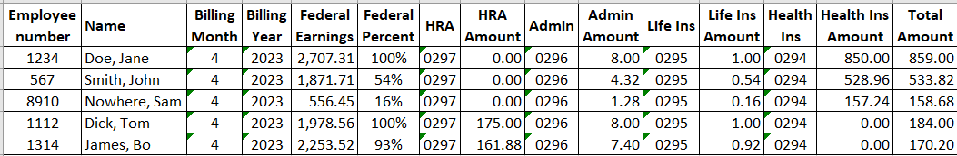

1. Before uploading the additional document, please follow the naming convention below to rename your file accordingly. This naming convention helps to prevent files from being overwritten. **Failure to follow these steps could cause the loss of critical data for another district/coop.**

* For the original file add “ORG” to the file name **Example** FRMMYYNNNorg.
* For a revised file add “REV” to the file name **Example** FRMMYYNNNrev.

**Breakdown of the File Name:**

* + FR – Federal Reimbursement
  + MM – 2-digit Billing Month (01-Jan, 02-Feb, 03-March, etc.) this is the calendar month
  + YY – 2-digit Billing Year (23 = 2023) this is the calendar year
  + NNN – Your District/Coop’s 3-digit Number ([refer to the “List of District & Coop numbers”](https://education.ky.gov/districts/FinRept/Pages/Federal-Reimbursement-of-Health-Benefits.aspx) [posted on the website](https://education.ky.gov/districts/FinRept/Pages/Federal-Reimbursement-of-Health-Benefits.aspx))
  + Org, or Rev – Original file, or Revised file for that Billing Month & Billing Year.

## STEPS TO SUBMIT THE DOCUMENTS IN SHAREPOINT

### NOTE: Do NOT submit any documents that contain employee social security numbers. Any document that is submitted with SSN’s will NOT be accepted.

1. To submit the **Verification Form and Other Documents** to KDE, click on the following SharePoint link: <https://staffkyschools.sharepoint.com/sites/dsapps/fedreimburse/SitePages/Home.aspx>. **NOTE:** Please note that SharePoint works better in a modern web browser like “Microsoft Edge” or “Google Chrome”.
2. If prompted, enter your appropriate Microsoft Credentials. **NOTE:** Please make sure the email address used is [employee.name@coopname.org](mailto:employee.name@coopname.org) or you will not be able to gain access to the program. If you continue to have problems logging in, please send an email to [finance.reports@education.ky.gov](mailto:finance.reports@education.ky.gov) with “Federal Reimbursement access issue – (coop name)” in the subject line.

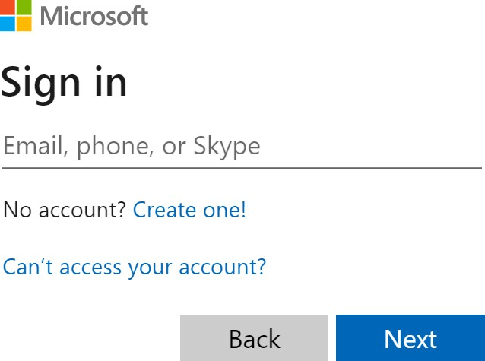

1. Once logged in, you will see the webpage screen below. To submit a report, click on the “**Upload**” button. **NOTE:** There is a link to the left that will take you to the most recent “User Instructions” located on the website.

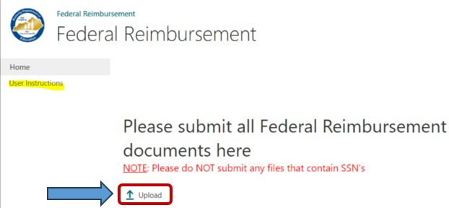

1. A dialog box will appear, click on the “**Choose File**” button to upload the specific report. In the box beside the **Version Comments** please provide a **comment** that indicates if this file is the original file or a revised file. Also provide the billing month, and billing year that the file corresponds to, then click the “**OK**” button. **NOTE:** The checkbox should always be checked.

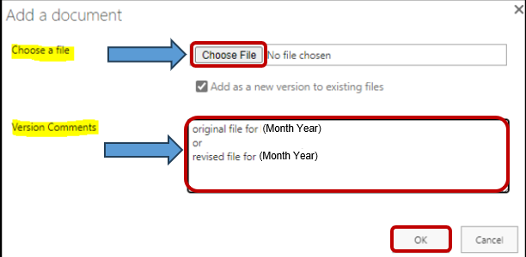

1. In the second dialog box, the “**Name**” field will be prepopulated. This is the name of the file that you have chosen in the previous dialog box. Next, click on the dropdown box beside each item and select the corresponding **District/Coop**, **Billing Month**, and **Billing Year**, then click either of the “**Check In**” boxes to finish. Please **note** at the top of this dialog box, it indicates that the document was **uploaded successfully**. *See example screenshot below*.

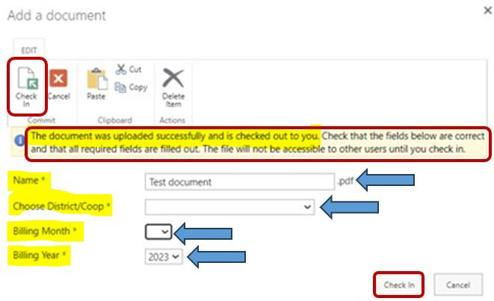

1. Once the file has been **Checked In,** you will receive a confirmation email the file has been received. If you do not get a confirmation email, please let our office know.

### KDE requests that the Federal Reimbursement file and payment be submitted to KDE within 30 days of the last payroll for the month.

If you have questions or a problem with the SharePoint submission process, please contact the Financial Management Branch Staff at 502-564-3846:

* + Jackie Chism extension #4445 or [jackie.chism@education.ky.gov](mailto:jackie.chism@education.ky.gov)
  + Kelli Young extension #4417 or [kelli.young@education.ky.gov](mailto:kelli.young@education.ky.gov)

**NOTE:** To add or remove a User from the **Federal Reimbursement of Health Benefits process,** please send an email to [finance.reports@education.ky.gov](mailto:finance.reports@education.ky.gov) with “Federal Reimbursement user change – (district name)” in the subject line.

**KDE USE:** F:\audits_trans\Audit Branch SOP's\Federal Reimbursement SOP's\District Use