Grade 1 Learning Experience Example: 1.H.CH.1

Introduction
The following learning experience was developed by the Kentucky Historical Society to demonstrate an implementation example aligned to the Kentucky Academic Standards (KAS) for Social Studies 1.H.CH.1.
It is important to note that the assignment(s), indicated throughout these Teacher Notes, and related resource(s) represent one example. This example is not a requirement nor a suggestion for school curriculum. While the Kentucky Department of Education (KDE) is responsible for the development of high-quality academic standards, state law assigns each local district the authority to develop the school’s curriculum and determine appropriate instructional resources based on language found in Kentucky Revised Statute (KRS) 160.345. It is under the discretion of the superintendent to determine the local curriculum, including the evaluation and selection of instructional resources. The KDE does not adopt, select or recommend specific curricula for coursework. Per KRS 160.345(g), “the local superintendent shall determine which curriculum, textbooks, instructional materials, and student support services shall be provided in the school after consulting with the local board of education, the school principal, and the school council and after a reasonable review and response period for stakeholders in accordance with local board of education policy.”

Kentucky Academic Standards (KAS) for Social Studies alignment:
1.H.CH.1 Describe how events, people and innovation of the past affect their present lives, community and state.
Educators may have to engage students with a standard multiple times throughout a year in order to meet the full intent of the standard. As a result, the following assignment example may not encompass the entire scope of the standards identified.

Overview:
Students will analyze a good invented by a Kentuckian in the early 20th century to determine the community impact.

Compelling Question: How can an individual impact their community?

Supporting Question: How does Garrett Morgan’s breathing device impact your community?

Teacher Notes

Vocabulary
A patent is a government license to give the inventor the sole right to produce and sell their creation.
A good is a tangible item that can be seen, touched, and owned by a consumer or customer.

Introduce Garrett Morgan:
Garrett A. Morgan, an African American, was born in Claysville, Kentucky on March 4, 1877. At the age of 14, he started working as a handyman and later opened his own repair shop. This experience taught Morgan how things worked and were made, which inspired him to become an inventor.

Morgan also repaired and sold sewing machines. He used his skills to sew a hood that could be worn as a breathing device that would prevent the inhalation of smoke. Morgan sold this device to firefighters. To prevent others from stealing his design, he had to register a patent with the United States Patent and Trademark Office.

Sources
- United States Patent and Trademark Office. (1914, October 13). Breathing Device Patent. https://image-ppubs.uspto.gov/dirsearch-public/print/downloadPdf/1113675
- Smithsonian National Museum of African American History and Culture. (2019, May 16). Making A Way, Garrett Morgan [image].
This image has been used with the permission of the Smithsonian for use in the classroom. Image has been added to the Appendix.
- Western Reserve Historical Society. (1914). Garrett A. Morgan papers: Through Smoke and Fumes with Safety [image]. https://wrhs.saas.dgicloud.com/islandora/object/wrhs%3A9036
- Fisher Scientific. (n.d.). Scott Safety™ Air-Pak™ X3 SCBA. https://www.fishersci.com/shop/products/air-pak-x3-scba/15499132?ef_id=Cj0KCQjwuZGnBhD1ARIsACxbAViWbuGU1Ww1NuKIxHPQ5RXEVSl2exndPUWjE2VlKtEvMOcSPfU255gaAp00EALw_wcB:G:s&ppc_id=PLA_goog_2086145686_75666498134_15499132__375381481656_15961253220516167431&ev_chn=shop&s_kwcid=AL!4428!3!375381481656!!!g!296279732133!&gad=1&gclid=Cj0KCQjwuZGnBhD1ARIsACxbAViWbuGU1Ww1NuKIxHPQ5RXEVSl2exndPUWjE2VlKtEvMOcSPfU255gaAp00EALw_wcB
- Case Western Reserve University. (1916, July). Garrett Morgan rescues a victim of the Waterworks Tunnel Disaster, July 1916. https://case.edu/ech/media/1046

Define a patent. Pull up the first page of the patent (Source 1) for the Breathing Device for the class to see. Start an inquiry discussion, posing the following questions:

- What is going on in this image?
- What do you see that makes you say that?
- What more can you find?

Show the class the fire hood (Source 2, found in Appendix). Explain what a prototype is and how they are improved over time based on design, material, manufacturing, and usage.

Examine another primary source from the Fire Hood Pamphlet (Source 3). The text below is an excerpt from the source and is adapted for Grade 1 students:

The purposes of the fire hoods are to allow the person wearing it to enter a room that is filled with dangerous smokes and gases. This will help them save lives, stop whatever is causing the smoke and gases, and put out fires.

Have the students investigate it to find the purpose of fire protectors, an estimated price, and the date. Start an inquiry discussion:

- Do you think the design has changed?
- Do you think the material has changed?
- Do you think they are cheaper or more expensive today?

Pull up the current day Air Pack (Source 4). Discuss what is the same about the modern day air pack and Morgan’s breathing device, ending with the same community impact (i.e. saving lives, protecting firefighters and stopping fires to prevent more damage).

Then, pull up the photograph (Source 5) of the Waterworks Tunnel disaster rescue for the full class to see. Start an inquiry discussion by acting like a historian:

- What is going on in this image?
- What do you see that makes you say that?
- What more can you find?

Explain how Morgan wore his safety hood to enter a tunnel under Lake Erie to rescue workers that were in an explosion at Cleveland Waterworks in 1916. Discuss the importance of firefighters in the community.

Task Aligned to the Supporting Question
Quick Write:

How does Garrett Morgan’s invention of the firefighter breathing device impact your community? In your response, use evidence from two or more sources.

Extension Activity:
In pairs, engage in a Turn and Talk to construct a response to the following:

Think about the world you live in. Think about your home, your school, and the community. What could be improved or created to help people or animals complete a task? What would the product be made of? How much would it cost?

Bring back the class's attention to have a brainstorming discussion on their ideas. Have students drawn their idea as a patent. Label the parts of the invention. On the back, create an advertisement with a product name and price. They can present their idea to the class as a salesperson. An additional activity can be to build their invention out of paper or recyclables.
Supporting Sources:
- Public Broadcasting Service (PBS). (n.d.). Garrett Augustus Morgan. https://www.pbs.org/wgbh/theymadeamerica/whomade/morgan_hi.html
- Blitz, Mark. (2016, September 13). The Untold Story of the Man Who Called Himself the "Black Edison". Popular Mechanics. https://www.popularmechanics.com/technology/design/a22802/garrett-morgan-inventor/

Additional Morgan invention to explore with the same inquiry discussion leading to community impact:
- United States Patent and Trademark Office. (1922, February 27). Traffic Signal Patent. https://image-ppubs.uspto.gov/dirsearch-public/print/downloadPdf/1475024

Appendix
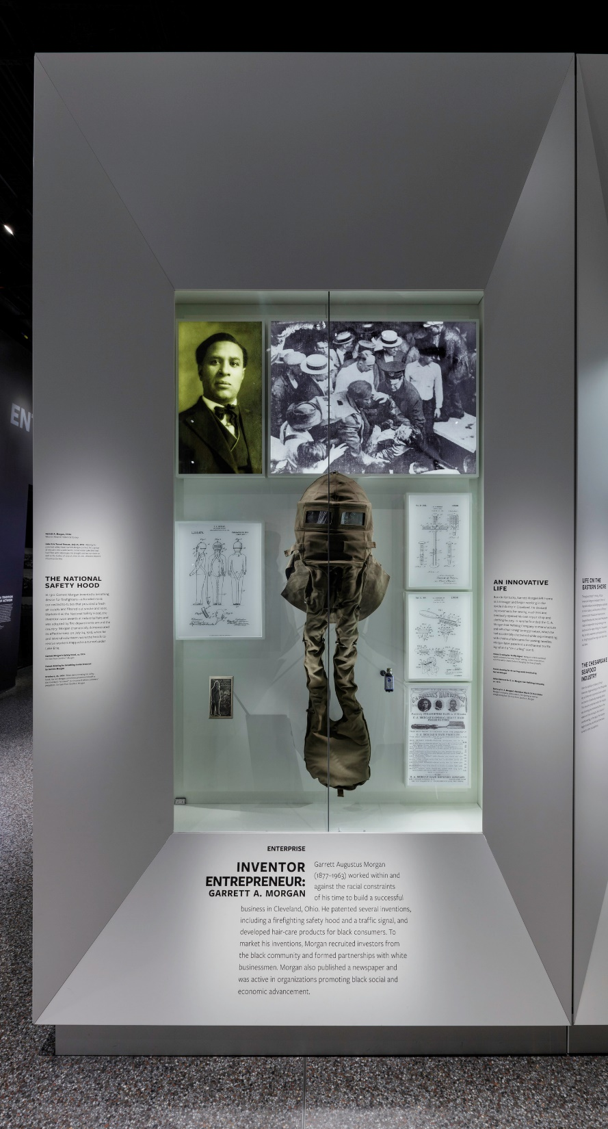
Courtesy of the Smithsonian National Museum of African American History and Culture, Photograph by Josh Weilepp.

