Grade 3 Learning Experience Example: 3.E.KE.1

Introduction
The following learning experience was developed by the Belle of Louisville to demonstrate implementation examples aligned to the Kentucky Academic Standards (KAS) for Social Studies 3.E.KE.1.
It is important to note that the assignment(s), indicated throughout these Teacher Notes, and related resource(s) represent one example. This example is not a requirement nor a suggestion for school curriculum. While the Kentucky Department of Education (KDE) is responsible for the development of high-quality academic standards, state law assigns each local district the authority to develop the school’s curriculum and determine appropriate instructional resources based on language found in Kentucky Revised Statute (KRS) 160.345. It is under the discretion of the superintendent to determine the local curriculum, including the evaluation and selection of instructional resources. The KDE does not adopt or select specific curricula for coursework. Per KRS 160.345(g), “the local superintendent shall determine which curriculum, textbooks, instructional materials, and student support services shall be provided in the school after consulting with the local board of education, the school principal, and the school council and after a reasonable review and response period for stakeholders in accordance with local board of education policy.”

Kentucky Academic Standards (KAS) for Social Studies alignment:
3.E.KE.1 Explain how trade between people and groups can benefit Kentucky.
Educators may have to engage students with a standard multiple times throughout a year in order to meet the full intent of the standard. As a result, the following assignment example may not encompass the entire scope of the standards identified.

Overview:
Students will investigate how the steamboat industry changed the lives of Kentuckians by examining the history of travel and trade on the Ohio River systems.

Compelling Question: How have innovations in river watercraft impacted the lives of Americans?

Supporting Question: How have steamboats expanded travel and trade to benefit Kentucky?

Teacher Notes
Introduce the supporting question to students by providing additional context regarding steamboats. Explain that steamboats are any watercraft propelled by steam. To give students more context about steamboats, show a video clip (from start to the 3 minute mark) of Main Street- Belle of Louisville. Ask students to pay attention to what a steamboat looks like and how it functions as they watch.

Share the following information about steamboats with students:

The first successful trial of a steamboat was in 1786-1787 by John Fitch. However, it wasn’t until 1811 that the first steamboat was built to travel the lower Mississippi river. The oldest example of a still operating Mississippi River-Style steamboat is the Belle of Louisville, launched in 1914 (originally named the Idlewild).

For more information about the history of steamboats, visit Steamboat or Steam Engine.

Explain that the steamboat has evolved over time. Provide the two images below side-by-side for students to compare. Inform students that the first image is an illustration of an early steamboat in 1787 and the second one is a photograph of the Belle of Louisville.
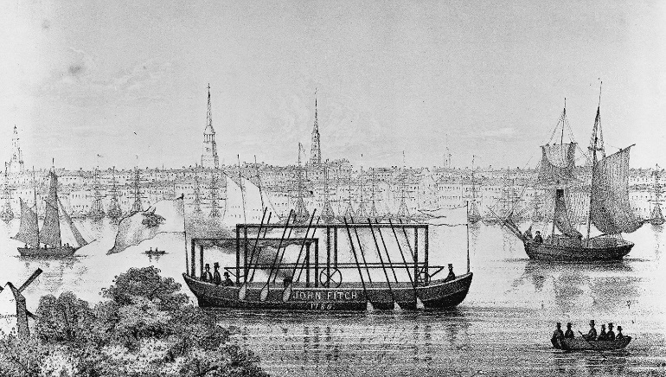
Library of Congress. (n.d.). John Fitch’s steamboat. Encyclopedia Britannica. https://www.britannica.com/technology/steamboat#/media/1/564552/101915

Str. Belle of Louisville – Belle of Louisville Archive 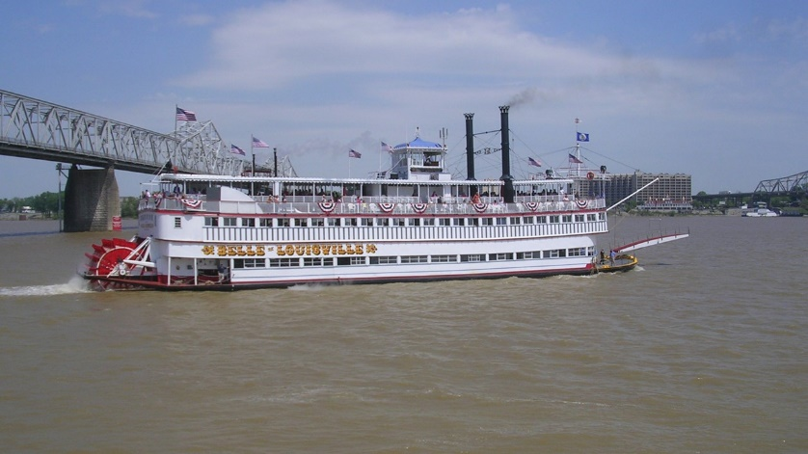

Ask students to do a Turn and Talk to discuss the following questions to help guide their thinking about how steamboats have improved over time:

- How are these boats similar?
- How are they different?
- What advantages might the Belle of Louisville have compared to the original steamboat?

Once students have discussed these questions with a partner, conduct a whole group discussion where students share their responses. As students are answering these questions, have them cite evidence from the images to support their response.

Inform students that they will now learn more about rivers and their connection with steamboats.

Part 2: Map of the Ohio River
Have students examine the following map, either individually, in partners or in a whole group using the Analyze a Map tool from the National Archives. For the purposes of this examination, students should only complete the “Meet the map” and the “Observe its parts” sections.
Rivers
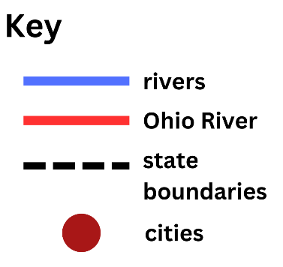
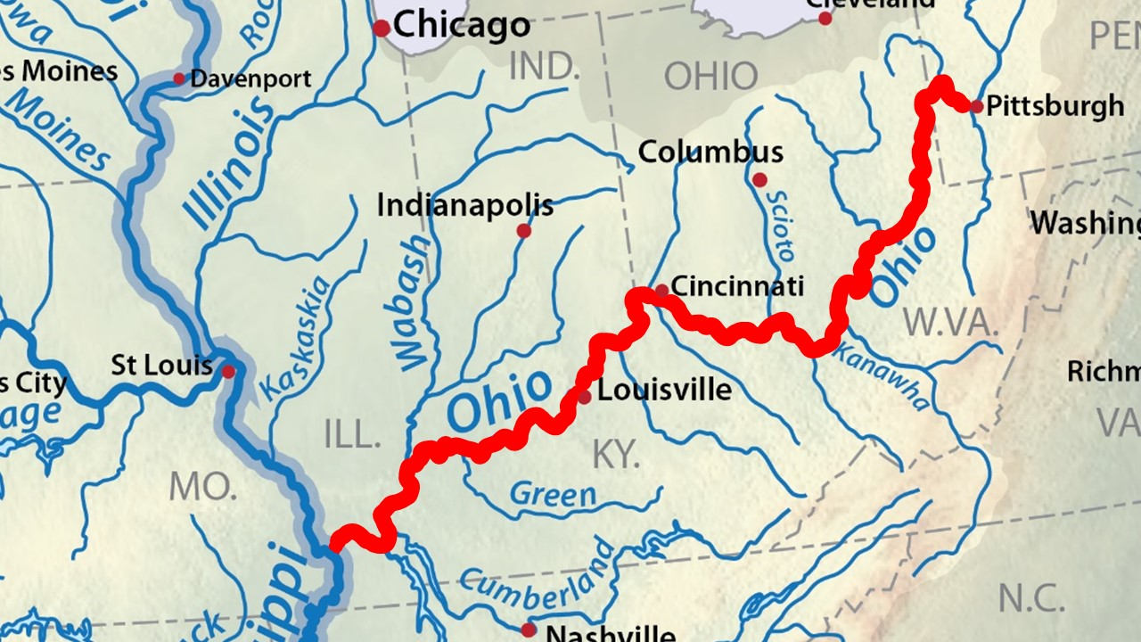
Modified from:
Shannon1. (2016, February 26). Mississippiriver-new-01 [map]. https://en.wikipedia.org/wiki/List_of_longest_rivers_of_the_United_States_%28by_main_stem%29#/media/File:Mississippiriver-new-01.png

In a whole group discussion, ask the following questions. Have students cite evidence from the map in their responses.
- How many different rivers are shown on this map that connect to the Ohio River?
- Why might people benefit from living near rivers?
- What questions do you have about the map?

Once students have answered these questions, share the following information about the Ohio River.
The Ohio (highlighted in red) is 981 miles long. Stretching from Pittsburgh, Pennsylvania to Cairo, Illinois. The river passes through six states (Pennsylvania, West Virginia, Ohio, KY, Indiana, Illinois) before emptying into the Mississippi River. 981 miles is a long distance and is hard to imagine. If a person walked all day (32 miles) it would take roughly a month to walk the whole length of the Ohio River. Traveling by steamboat was much easier and faster than walking. The Str. Belle of Louisville could make the same journey in a week or less. For more information, visit Rivers.

Once you have shared this information, have students complete a quick write on the following question:

How did the steamboat improve travel? Cite evidence from what you have learned to support your answer.

Facilitate a class discussion about this question to check for understanding. Visit Leading Discussions for more information on how to conduct whole group discussions.

Next, inform students that they are going to learn about the Western River System and its connection to steamboats, travel and trade.

Part 3: The Western River System
Share the following information with students. Use the following maps to illustrate the concepts provided in the text.
The Ohio River is part of the Western River System, which includes the Ohio, Mississippi and Missouri Rivers (shown in Image C). As well as many, many more. Rivers connect people and places. All the rivers flow south towards the Gulf of Mexico (shown in Image D). Steamboats can travel up and down the river with little difficulty in either direction. This was a huge advantage over other watercraft like flat boats and rafts. Before steamboats, you would use the current to help propel your boat “down” the river. Heading back or “up” the river was very difficult. It was possible but took a lot of effort because you had to fight against the flow of water the entire way. Steamboats being able to freely travel up and down the rivers essentially doubled a boat owner’s options for travel and trade. New Orleans was in an ideal location to take advantage of all of this river traffic. The maps show how many smaller and larger rivers throughout the country eventually flow into New Orleans, and it was also situated next to the Gulf of Mexico. As a result, this city became a massive trading hub for domestic and foreign commerce.

Map A
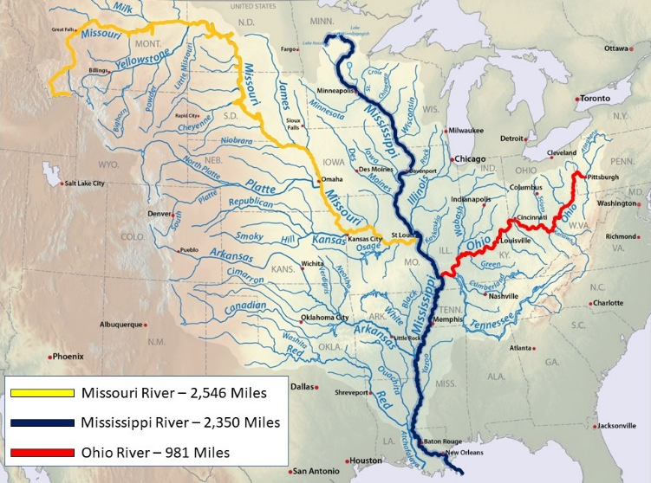
Modified from:
Shannon1. (2016, February 26). Mississippiriver-new-01 [map]. https://en.wikipedia.org/wiki/List_of_longest_rivers_of_the_United_States_%28by_main_stem%29#/media/File:Mississippiriver-new-01.png

Map B
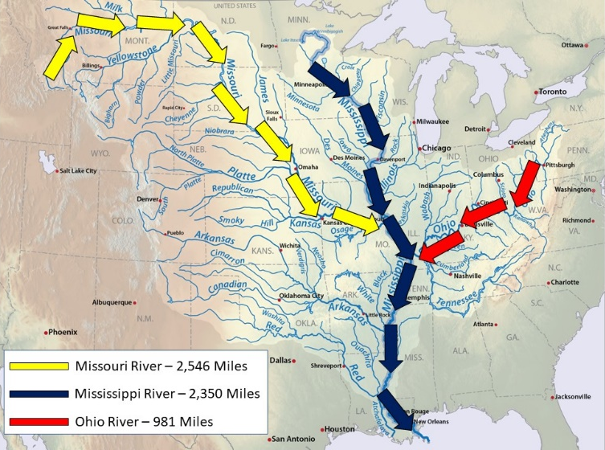
Modified from:
Shannon1. (2016, February 26). Mississippiriver-new-01 [map]. https://en.wikipedia.org/wiki/List_of_longest_rivers_of_the_United_States_%28by_main_stem%29#/media/File:Mississippiriver-new-01.png

Once you have shared this information, discuss the following questions in a Think Write Pair Share:
Why did steamboats have an advantage over other types of watercraft? Use evidence in your response.

Facilitate a class discussion about this question to check for understanding. Visit Leading Discussions for more information on how to conduct whole group discussions.
Part 4: Steamboats and Kentucky
Share the following information with students. Use the images below to illustrate the concepts provided in the text so students can see some of the items that have been transported to and from Kentucky.
Kentucky benefited from all the opportunities steamboats provided. Kentucky goods were transported down the Western River System to New Orleans to be traded with merchants from Europe and the Caribbean. Goods from these foreign merchants then made their way back upriver to Kentucky. For example, a farmer in Kentucky could bring their crops to Louisville to sell their seeds and grain to a steamboat that was heading downriver. While in town the same farmer could then buy goods from other steamboats that had traveled upriver laden with cargo from around the world. Individuals now had easier access to things like molasses and sugar from the Caribbean, European goods like fine textiles, clothes, and the latest fancy buttons from France.

To illustrate how far goods traveled when going to and from Kentucky, New Orleans, the Caribbean and Europe, show students the world map below while highlighting these locations.
World Map
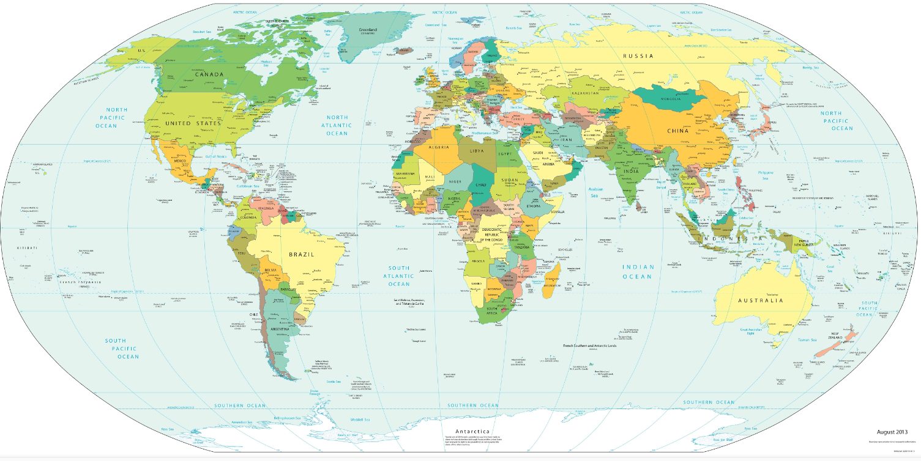
Worldometer. (n.d.). World Map. https://www.worldometers.info/world-map/#google_vignette
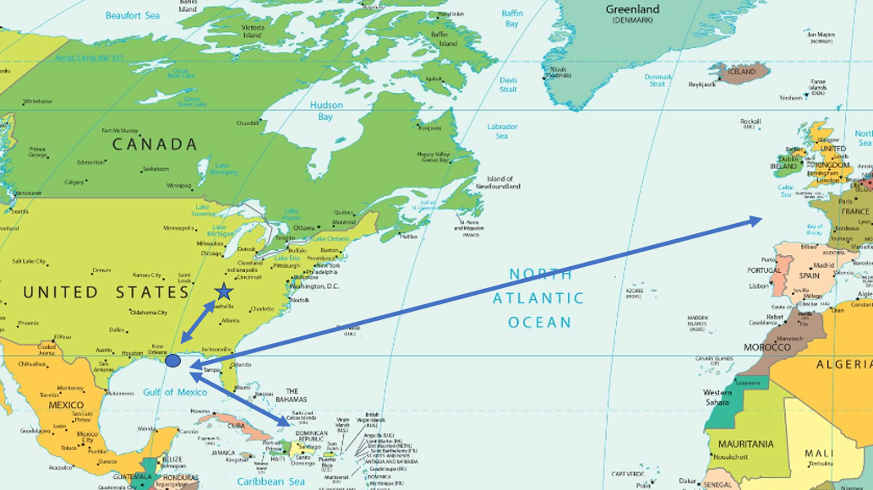
Modified from:
Worldometer. (n.d.). World Map. https://www.worldometers.info/world-map/#google_vignette

Goods that were traded
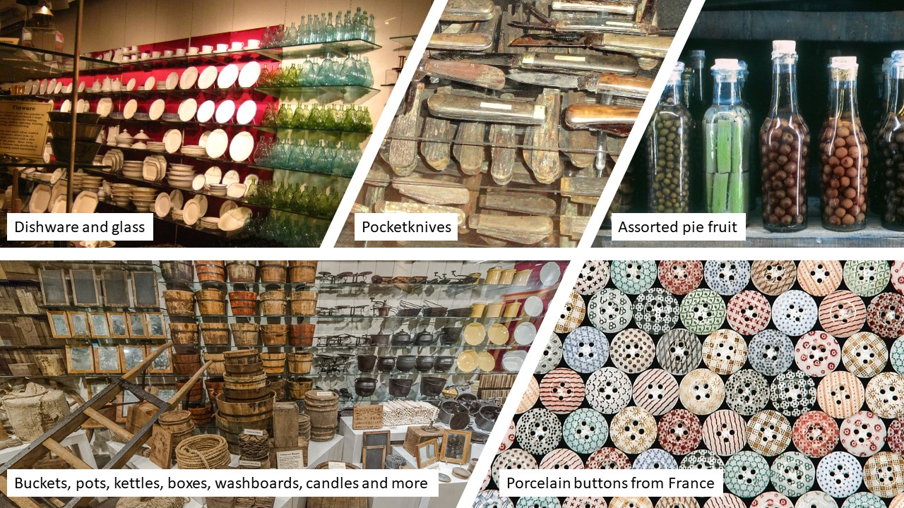
The Arabia Steamboat Museum. (n.d.). The Arabia Steamboat Museum [webpage]. http://www.1865.com

To support students in understanding the benefits of trade to Kentucky, have them complete the See, Think, Wonder thinking strategy based on the goods they see in the images.
- What do you see?
- What do you think about that?
- What does it make you wonder?

Once students have concluded the See, Think, Wonder thinking strategy, have them complete the “Try to make sense of it” section of the National Archives’ Analyze an Artifact or Object tool on one artifact seen in the images. Pose the questions below that are adapted from the Analyze an Artifact or Object tool:
- What do you think the artifact was used for?
- Who do you think would have used the object?
- Why do you think these items were traded?
- What does the object tell us about the time period when it was made and used?
- Do we still use this object today? If so, how it is different?

Once students have completed their discussion, have them complete the Claim, Support, Question thinking strategy to answer the question: How did Kentucky benefit from the opportunities steamboats provided?
- Write a claim that answers this question: How did Kentucky benefit from the opportunities steamboats provided?
- Identify evidence from the sources to support your claim.
- Ask a question related to your claim or the supports. What isn’t explained?

Trade Today
Share the following information with students to introduce modern river craft. Use the following images to illustrate the concepts provided in the text.

The trade systems established by the steamboat area are still used today. But instead of steamboats, trade on our rivers is done by tows and barges. A 15-barge tow can carry almost the same amount of cargo as 800 trucks on our roads. Over 125 million tons of cargo is shipped every year on the Ohio river alone.

Once students have been introduced to barges, ask them to examine the following images depicting trade today using the “Meet the photo” and the “Observe its parts” sections of the Analyze a Photograph Tool from the National Archives. As they examine the images, students should notice how the boats used to trade along waterways have evolved from the steamboat in the past to the barges used today.
Image A
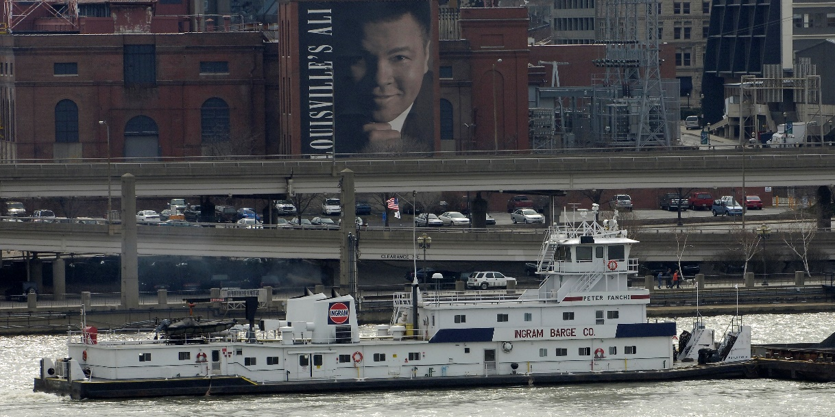
Peter Fanchi. (2006, February 25). The towboat Peter Fanchi down-bound on the Ohio river at Louisville, Kentucky. https://en.m.wikipedia.org/wiki/File:PeterFanchi.jpg

Image B
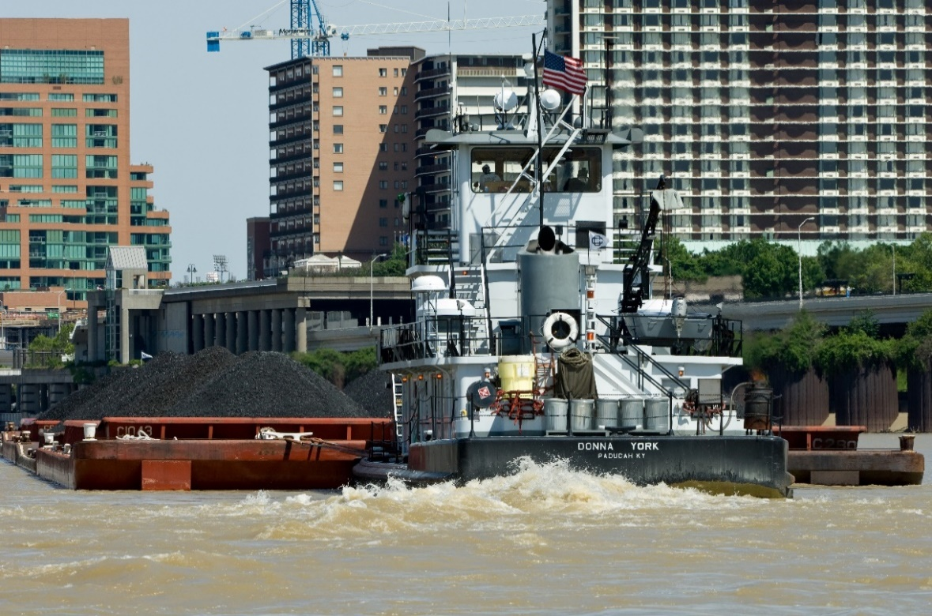
Schneid, Joe. (2009, May 24). The Donna York pushing barges of coal up the Ohio River at Louisville, Kentucky. https://en.wikipedia.org/wiki/Pusher_(boat)#/media/File:Donna_York.jpg

Once students have examined the images, facilitate a class discussion to answer the following question:
How have the trade systems we use today changed over time?

Visit Leading Discussions for more information on how to conduct whole group discussions.
Next, have students use the evidence they have examined to complete the task aligned to the supporting question below.

Task Aligned to the Supporting Question:
Answer the supporting question: How have steamboats expanded travel and trade to benefit Kentucky? In your response, provide evidence from at least two different sources you investigated.

