Student Work Annotations

Based upon the Science ERQ Rubric

Deer Population

Grade Level:
Middle School

Designed and revised by Kentucky Department of Education staff
in collaboration with teachers from Kentucky schools and districts.

This work is licensed under a Creative Commons Attribution-NonCommercial-NoDerivatives 4.0 International License.

Background Information About the Task

Task Overview

Students will analyze data with a graphic organizer and interpret the data for patterns in order to construct an argument as to why the deer population in Colorado is changing.

Disciplinary Core Idea (DCI)
- LS2.A Interdependent Relationship in Ecosystems
  - Organisms, and populations of organisms, are dependent on their environmental interactions both with other living things and with nonliving things.
  - Growth of organisms and population increases are limited by access to resources.

Science and Engineering Practice (SEP)
- Analyzing and Interpreting Data
  - Distinguish between causal and correlational relationships in data.
- Engaging in Argument from Evidence
  - Construct a written argument supported by empirical evidence and scientific reasoning to support an explanation for a phenomenon.

Crosscutting Concepts (CCC)
- Patterns
  - Patterns can be used to identify cause and effect relationships.
- Cause and Effect
  - Relationships can be classified as causal or correlational, and correlation does not necessarily imply causation.

Performance Expectations (PE) to which task is correlated
- 06-LS2-1
  - Analyze and interpret data to provide evidence for the effects of resource availability on organisms and populations of organisms in an ecosystem.

The original version of this Life Science middle school task may be found at: https://snapgse.stanford.edu/snap-assessments/short-performance-assessments
Deer Population

Deer Population in Colorado
People in Colorado have noticed a big change in the number of deer in their state over the last decade. Changes in deer affect the whole ecosystem, so scientists are trying to figure out what is causing this change.

Number of Deer in Colorado from 2005 to 2013
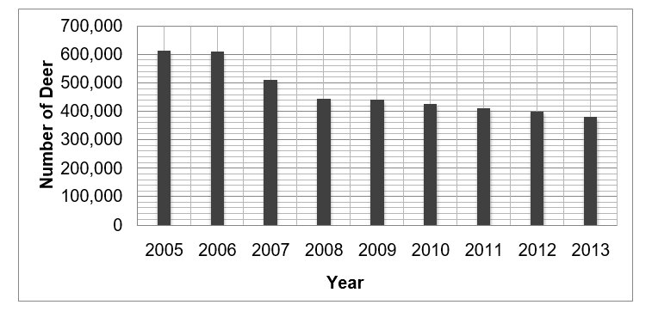
1. Describe what is happening to the deer population.

Scientists have collected a lot of data to figure out what could be causing the change in the number of deer in Colorado. Some of the data the scientists collected is on the next 3 pages. Study all of the data provided. Then, come back to this page to fill in the table below.

- In the table:
  - Describe the patterns you saw in each of the figures (graphs and tables).
  - Interpret the patterns that you described – what do the patterns tell you about the change in deer population? What could be causing the change?

Be sure to include data from the graphs and tables to support your answers.
Data | a. What patterns do you see? | b. What do the patterns tell you about the change in deer population?
Figure 1: Number of Deer and Elk
Figure 2: Amounts of Two Types of Grasses
Figure 3: Causes of Fawn (Baby Deer) Deaths
Figure 4: Yearly Rainfall

Deer and Elk
Scientists investigated other animals in Colorado to see if their populations showed similar patterns.
Deer and elk occupy similar niches in the same ecosystem. Scientists gathered data to compare the numbers of each type of animal across many years and made the graph below.
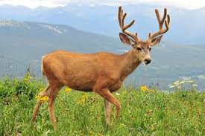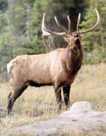
Deer (male) Elk (male)

Figure 1: Comparison of Number of Deer and Elk in Colorado from 2005 to 2013
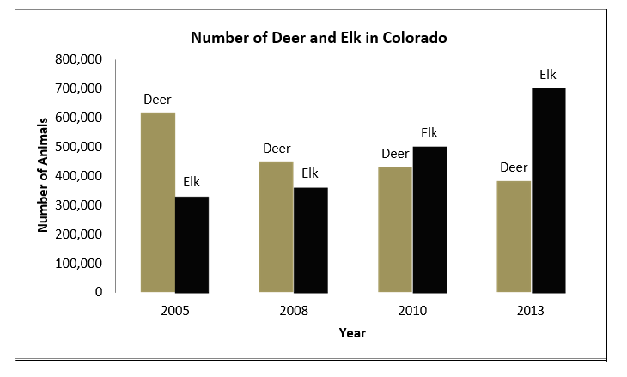
In the first row in the table on page 3, add a description and interpretation of the patterns that you see in the data. Use evidence to support your ideas.

Grasses
Scientists investigated what deer eat and found:
- Deer can only eat a native grass called Sagebrush. Sagebrush has always grown in Colorado.
- Elk can eat Sagebrush and Cheatgrass. Cheatgrass is an invasive species.
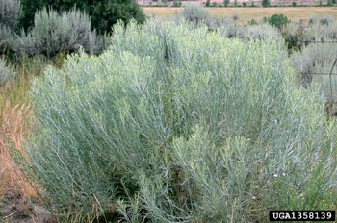
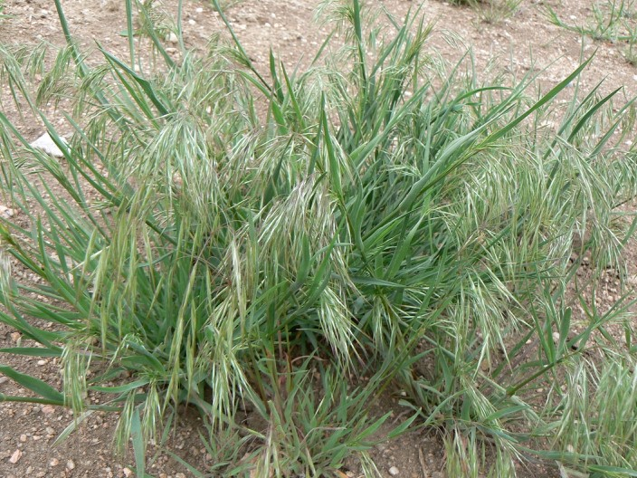
Sagebrush Cheatgrass

Scientist measured the amount of two types of grasses and made the following chart.

Figure 2: Amounts of Two Types of Grasses in Colorado

Type of Grasses | Year 2005 (square miles) | Year 2008 (square miles) | Year 2010 (square miles) | Year 2013 (square miles)
Cheatgrass | 41,000 | 52,000 | 61,000 | 66,000
Sagebrush | 185,000 | 140,000 | 110,000 | 100,000

In the second row in the table on page 3, add a description and interpretation of the patterns that you see in the data. Use evidence to support your ideas.

Figure 3: Percentage of fawns that died in Colorado 2005-2013 and causes of deaths.
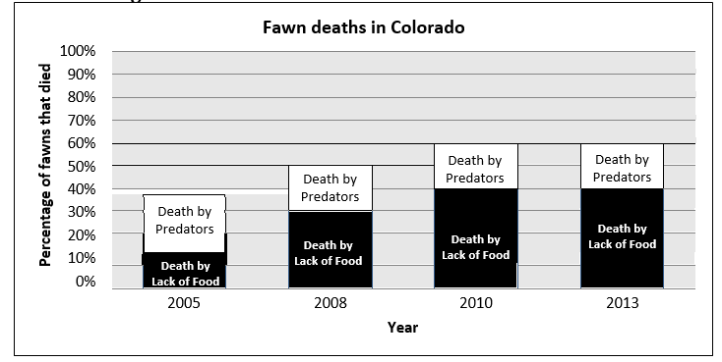

Rainfall
They also collected data on environmental that might affect the deer, including the amount of rainfall each year.

Figure 4: Yearly Rainfall in Colorado from 2003 - 2012
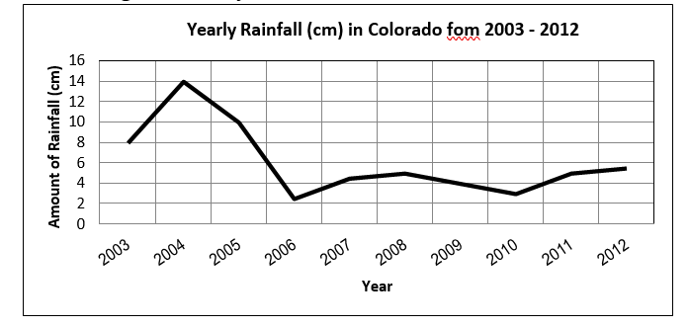

- Once you have filled in the whole table on page 3, analyze the patterns to help you decide why the number of deer in Colorado was changing.
- Write a claim for the most likely cause or causes for the change in the number of deer.
- Support your claim with patterns in the data and what you know about ecosystems.
- Sometimes patterns in data look like they are showing what caused the change you are investigating, but are really just correlated to the change.
What additional data would you want to see to help you decide if your answer to question 4 really is a cause, not a correlation? Explain how the data would help you.

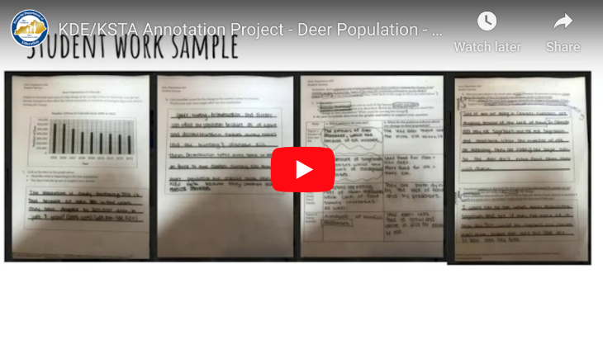
Deer Population
A video recording of the teacher discussing the annotation can be found at: https://youtu.be/qeBTyn_H9ww

Annotated Task

Student Sample 1
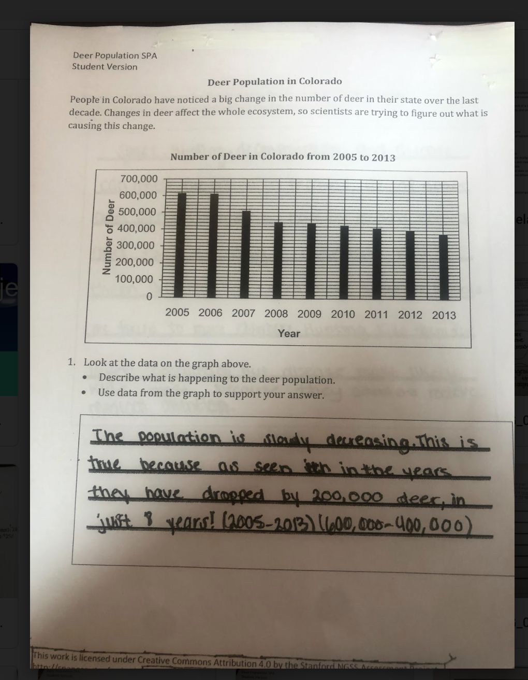

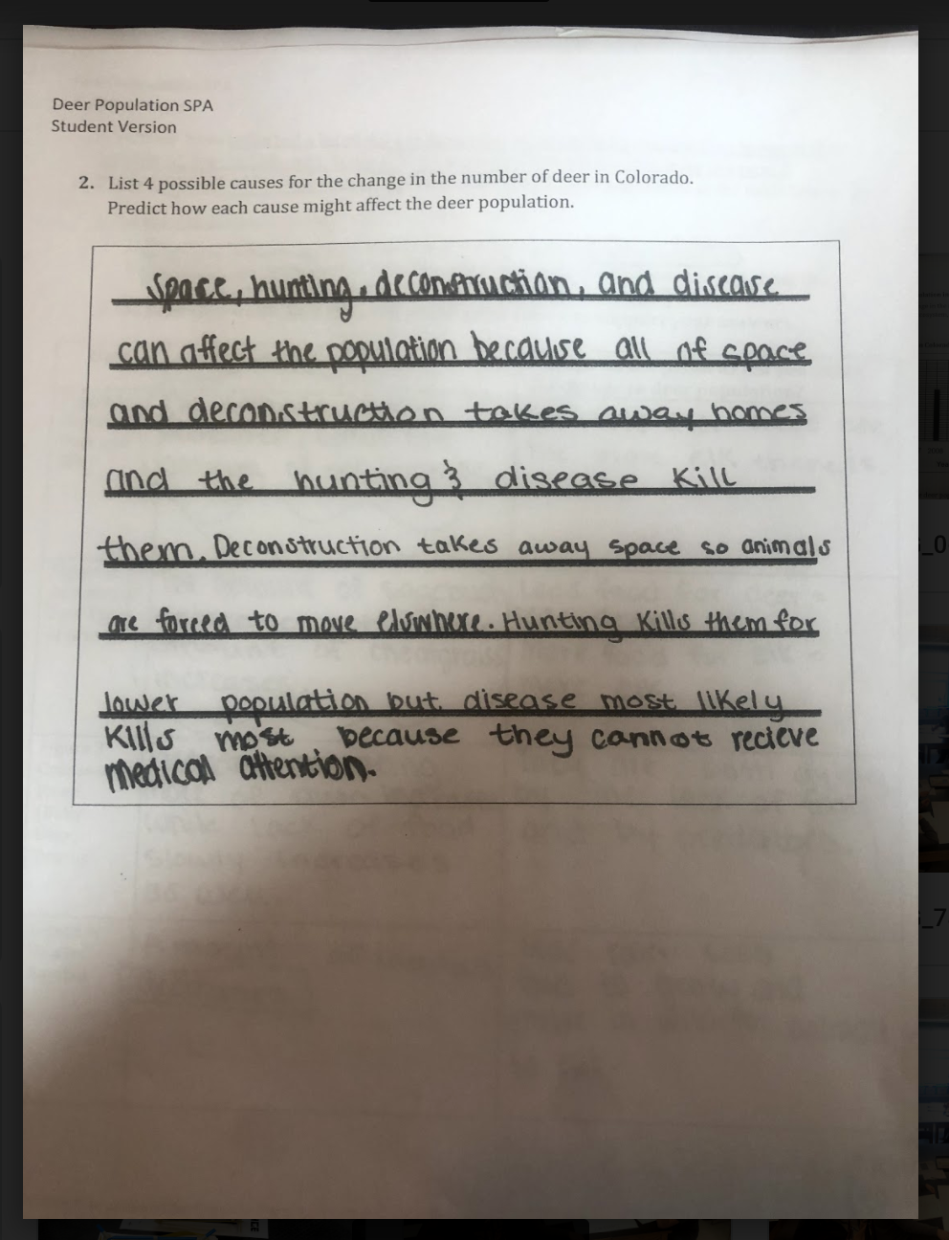

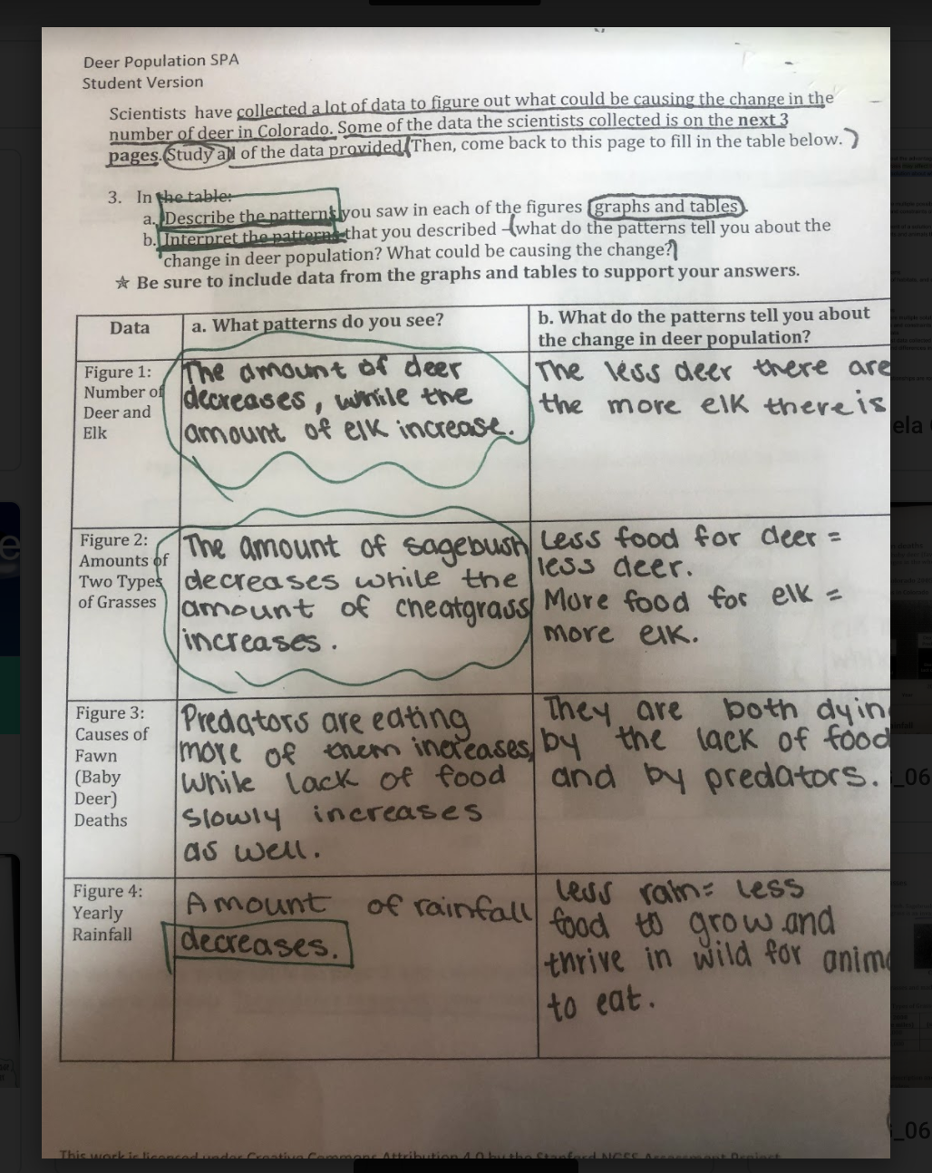

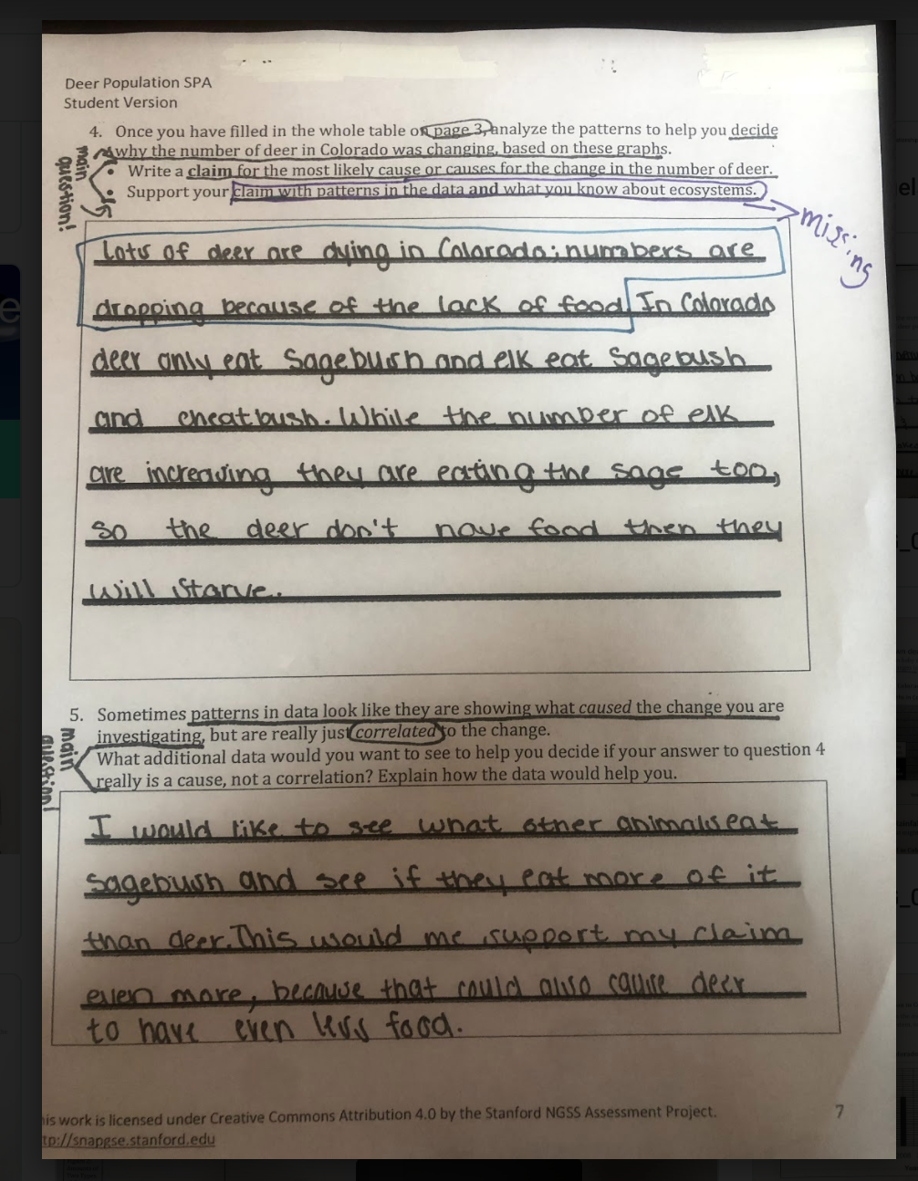
Student Sample 1:
The student demonstrates synthesis of the information presented in the task. The student relates the data about food sources and populations in a meaningful way.
The student understands multidimensionality, although incomplete. While the student’s argument (SEP) uses data to support the argument, it is unclear as to how the student used patterns to determine cause of deer population changes (CCC).
The student’s argument, however, is developed in a logical way.

Student Sample 2

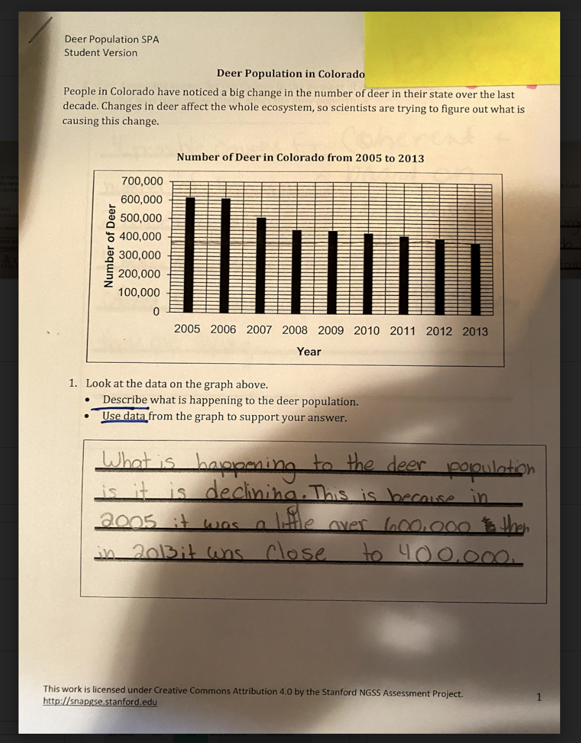

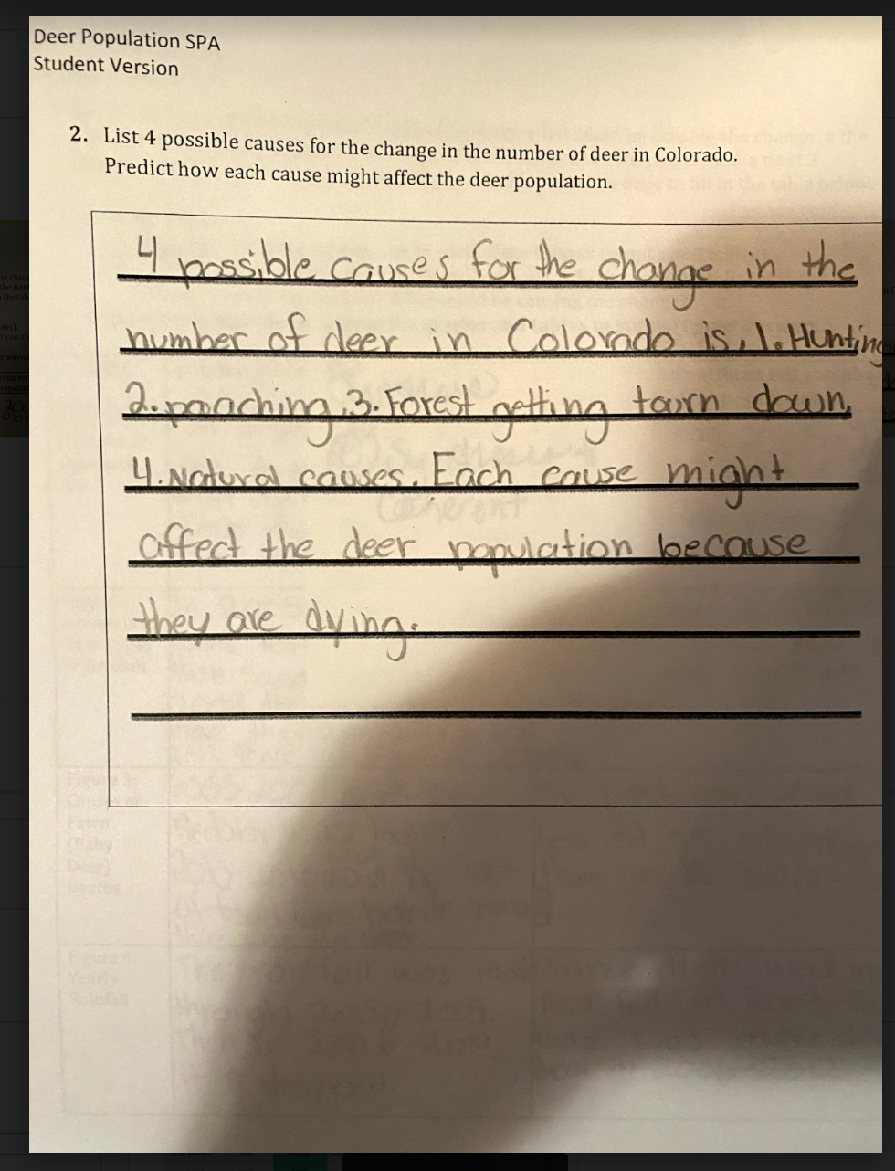

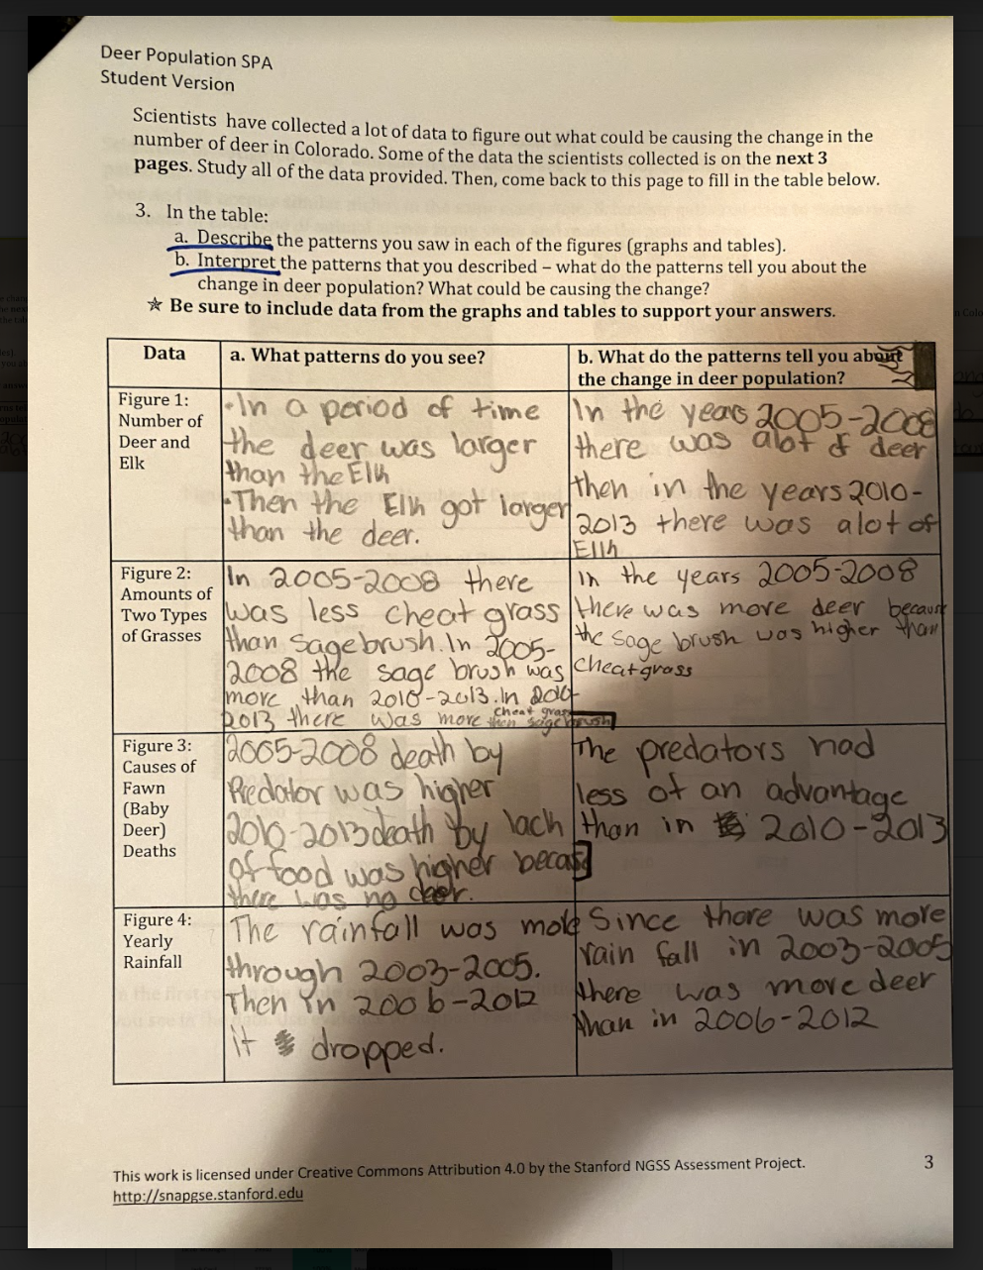

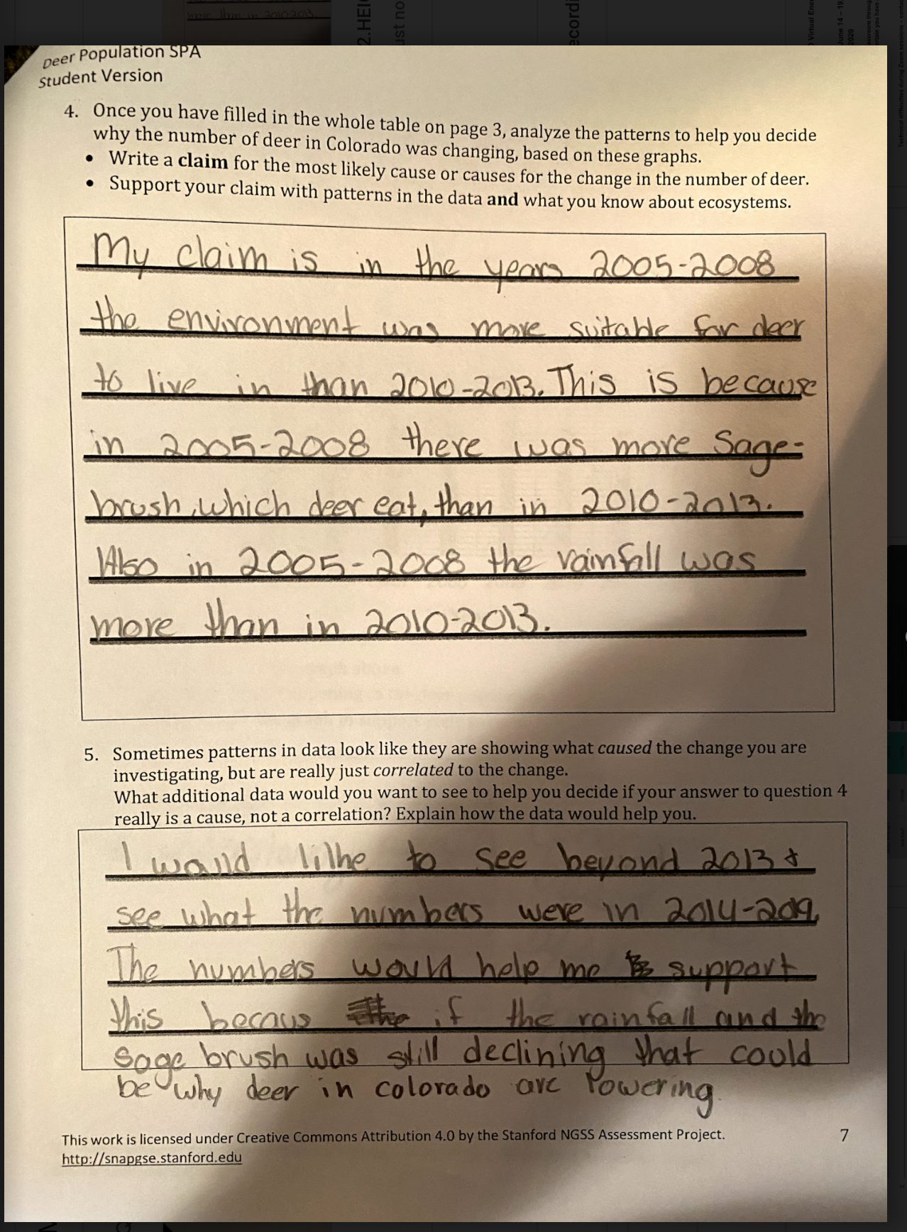

Student Sample 2
Student demonstrates some synthesis of the information presented in the task. The student interpreted the data presented to the environment in which the deer lived. However, the student used limited data in support of the claim.
The student’s response demonstrates multidimensionality, although incomplete. While the student’s argument uses data in support of the claim, it is unclear how the student used patterns to determine that the suitability of the environment was the cause of the deer population change.

There is evidence of some flaw in the logical thinking of this student. While the student does make use of data to support the claim, there is a lack of reasoning. In addition, the student’s thoughts are incomplete (“Also in 2005-2008 the rainfall was more than 2010-2013”).

