Grade 8 Assignment
This assignment is strongly aligned to the standards.

Teacher Notes

Introduction
This Teacher Notes document provides instructional support for implementing the strongly aligned assignments to the KAS for Social Studies. To examine why this assignment is strongly aligned to the KAS for Social Studies, engage with the Grade 8 Assignment Review Protocol for this assignment.

It is important to note that the assignment(s), indicated throughout the Teacher Notes with shaded boxes, and related resource(s) represent one example. It is not a requirement nor a suggestion for school curriculum. While the Kentucky Department of Education (KDE) is responsible for the development of high-quality academic standards, state law assigns each local district the authority to develop the school’s curriculum and determine appropriate instructional resources based on language found in Kentucky Revised Statute (KRS) 160.345. It is under the discretion of the superintendent to determine the local curriculum, including the evaluation and selection of instructional resources. The KDE does not adopt or select specific curricula for coursework. Per KRS 160.345(g), “the local superintendent shall determine which curriculum, textbooks, instructional materials, and student support services shall be provided in the school after consulting with the local board of education, the school principal, and the school council and after a reasonable review and response period for stakeholders in accordance with local board of education policy.”

KAS for Social Studies alignment:
- 8.I.Q.1 Develop compelling questions related to the development of the United States between 1600-1877.
- 8.I.Q.2 Generate supporting questions, using the disciplines of social studies, to help answer compelling questions in U.S. history between 1600-1877.
- 8.H.CO.2 Describe the conflicts and compromises that shaped the development of the U.S. government between 1783-1877.
- 8.C.KGO.1 Examine the role of Kentucky and Kentuckians within national politics between 1792-1877.
- 8.I.UE.1 Use multiple sources to develop claims in response to compelling and supporting questions.
- 8.I.CC.3 Evaluate how individuals and groups address local, regional and global problems concerning the development of the United States.
- 8.I.CC.4 Apply a range of deliberative and democratic procedures to make decisions about ways to take action on current local, regional and global issues.

Overview:
In this learning experience, students will learn about compromise, polarization and how the conflict surrounding the expansion of the institution of slavery in the 1800’s resulted in the Missouri Compromise. Students will investigate the Missouri Compromise and the role of Henry Clay in its drafting. Additionally, students will construct an explanation to a supporting question that asks them to evaluate how the Missouri Compromise temporarily saved the union. This knowledge, along with investigating other supporting questions, will support students in answering the compelling question: “How does a government compromise amidst polarization?”

Setting the Stage: Compelling Question

8.I.Q.1 Develop compelling questions related to the development of the United States between 1600-1877.

Compelling Question: How does a government compromise amidst polarization?

It is important to note that while this assignment provides a compelling question to demonstrate alignment, student development of compelling questions is a critical part of the inquiry process. Since 8.I.Q.1 states “develop compelling questions,” teachers should provide opportunities for students to develop their own compelling questions related to the development of the United States between 1600-1877. For more information on compelling questions, visit Section B: “What are Compelling Questions and how do students ask them?” from the Inquiry Practices of the KAS for Social Studies module

Introduce the compelling question to students by building a common understanding of “compromise” and “polarization.” First, ensure that students understand the term “compromise” by having them consider this word using the 3-2-1 Bridge thinking routine:

Think about the word compromise. Next, compose the following about compromise:
- 3 thoughts/ideas
- 2 questions
- 1 metaphor or simile

Next, share a definition of compromise:
Compromise: to come to agreement by mutual concession.

Merriam-Webster: https://www.merriam-webster.com/dictionary/compromise

If students need support in understanding concession, Merriam-Webster states concession is “something done or agreed to usually grudgingly in order to reach an agreement or improve a situation.” https://www.merriam-webster.com/dictionary/concession

Once students have reviewed the definition of compromise, have them revisit their initial thoughts/ideas, questions and metaphors. Ask the following:
Is there anything you would like to add or change for your 3, 2,1 responses? If so, how does your revised response connect to your initial response?

Once students understand compromise, transition to focusing on polarization. In this transition, explain that while compromise means coming to an agreement, some may view the definition of polarization and think that it would imply that compromise is not possible. To initially explore the term “polarization,” have students read the definition and clarify any unknown words. Consider creating a simplified definition together.

Polarization: a state in which the opinions, beliefs, or interests of a group or society no longer range along a continuum but become concentrated at opposing extremes.
- Merriam-Webster Dictionary
https://www.merriam-webster.com/dictionary/polarization

Once students understand the definition of polarization, introduce the two area charts below. Share with students that these area charts are from the Pew Research Center and “...illustrat[e] the shift in the American public’s political values over the past two decades…” Using the What Makes You Say That thinking strategy, have students explore these images.

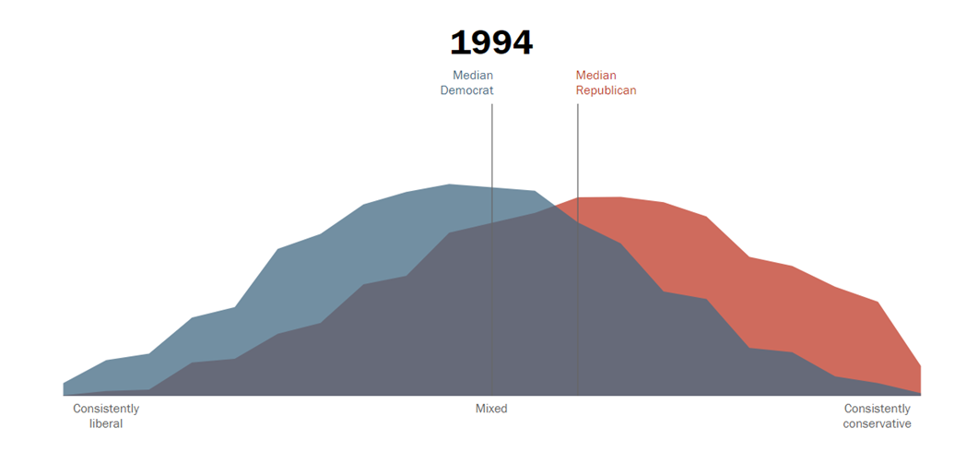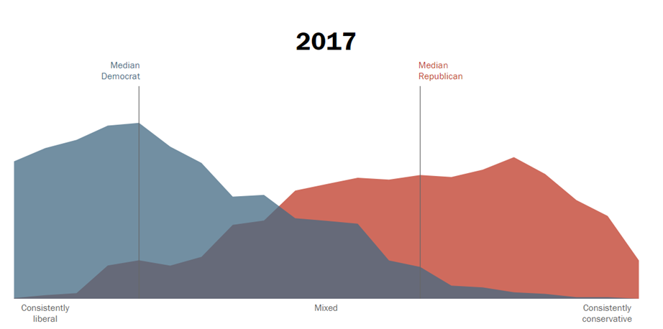
1. What’s going on?
2. What do you see that makes you say that?

The Pew Research Center. The Shift in the American public’s political values. The Pew Research Center. https://www.pewresearch.org/politics/interactives/political-polarization-1994-2017/

As students are sharing what they see, take the opportunity to provide more information on the graph to support students’ understanding of the area charts. Once students demonstrate an understanding of the area charts, have them answer the following question in a turn and talk with their partner:
How do the area charts below illustrate polarization? Cite information from the charts you examined in your response.

Once students have completed the turn and talk, facilitate a classroom talk session where students share their responses to the question while citing evidence from the graphs. Address any misconceptions in student responses as they arise.

Next, have students apply what they have learned about polarization to students younger than them by posing this question:
Are adults the only ones who are polarized?

Support students in considering this question by exploring how polarization impacts America’s youth by assigning students excerpts from the following resource:

Hutchins, Rachel. (January/February 2024). The Political Polarization of Pre-Adolescents: Affective Polarization in America’s Youth. Social Education. https://www.socialstudies.org/social-education/88/1/political-polarization-pre-adolescents-affective-polarization-americas-youth

In pairs, have students read the two excerpts that follow. As students are reading, have them annotate the sources by underlining, highlighting, etc. any words or phrases that answer the question: “Are adults the only ones who are polarized?”

Excerpt One:
“Children may not yet understand political issues or be engaged in politics, but identification with social groups emerges early; indeed, nearly a third of first-graders report identification with a political party.”

Excerpt Two:
“... fifth-graders demonstrated the same level of polarization as ninth-graders. This was also visible in participants’ responses to open-ended questions about their scores, such as the fifth-grader who wrote, “Democrats are ruining the country.” Similarly, when asked what it means to be a Republican, a ninth-grader wrote, “Liars and thieves.” Such animosity aligns with very recent research, suggesting that affective polarization develops at younger ages than previously expected.”

As students are annotating their excerpts in pairs, have them discuss why the annotated word or phrase answers the question “Are adults the only ones who are polarized?” Once students have read their excerpts and have discussed what they annotated, have them engage in a whole class classroom talk session where students share their responses to the question. As students are sharing their responses, have students cite evidence from their annotations. Address any misconceptions in student responses as they arise.

Next, support students in considering whether or not polarization occurred in the past. Since compelling questions are open-ended, enduring and center on significant unresolved issues, it is important to help students see how concepts that impact their lives existed in the past. To provide students with more information on how polarization is enduring, have students explore the following sources (one through four) while completing the following evidence log with a partner. These sources can be found from the following resources:

- First Amendment Museum. (n.d.). Political Cartoons, Part 1: 1720-1800. https://firstamendmentmuseum.org/exhibits/virtual-exhibits/art-politics-300-years-of-political-cartoons/political-cartoons-part-1-1720-1800/
- GBH Education. (n.d.). The Rise of Political Division in Early America. https://lsintspl3.wgbh.org/en-us/lesson/ush22-il-politicalparties/1?as_guest=True

Source Title | What claims does the author make? | What evidence does the author use? | What language (words, phrases, images, symbols) does the author use to persuade the document's audience? | How does the document's language indicate the author's perspective?
Source One:
Join, or Die
Source Two:
The Looking Glass for 1787
Source Three:
Jefferson Quote
Source Four:
Congressional Pugilists

Source One:
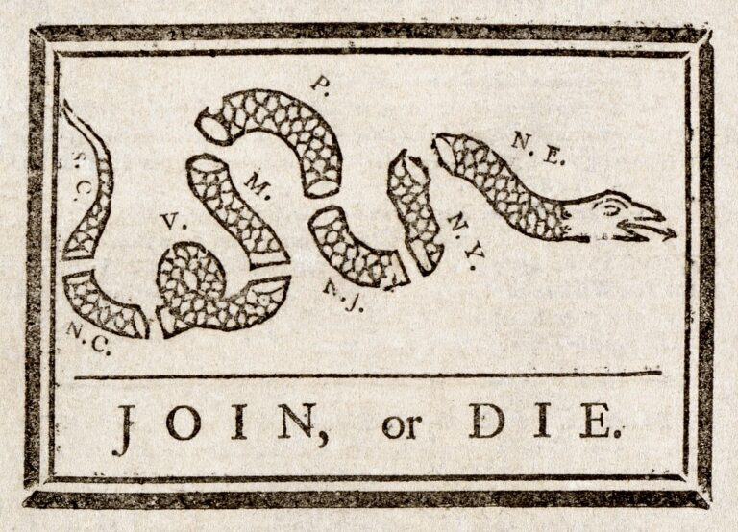
Title: Join, or Die
Artist: Benjamin Franklin
Date: 1754
Location: Pennsylvania, British Empire for the Pennsylvania Gazette
Framing: “One of the earliest and most famous examples of American political cartoons is this woodcut showing a snake cut into eighths, with each segment labeled with the initials of one of the American colonies or regions. The cartoon, which first appeared in the Pennsylvania Gazette in May of 1754, became a symbol of the need for organized action against the threat posed by the French and their native allies during the Seven Years’ War. It has been an enduring American symbol ever since.”

Source Two:
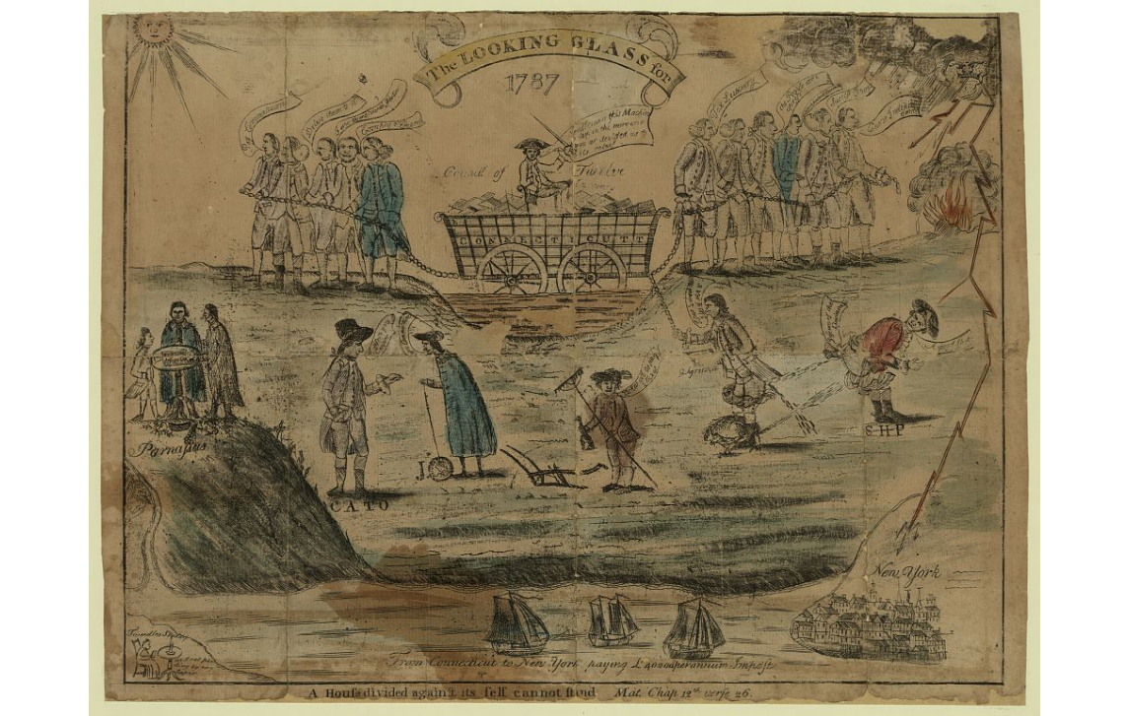
Title: The Looking Glass for 1787
Artist: Amos Doolittle
Date: 1787
Location: New Haven, Connecticut
Framing: “Two rival factions are lampooned here – the Federalists, who were in favor of the Constitution, and the Anti-Federalists, who were skeptical of the Constitution. In this cartoon, both sides tug on a wagon representing Connecticut on the eve of the ratification of the Constitution.”

Source Three:
“Men who have been [friendly] all their lives cross the streets to avoid meeting, and turn their heads another way, lest they should be obliged to [greet each other].”
—Thomas Jefferson, observing the bitter rivalry between Democratic-Republicans and Federalists, 1797

Source Four:
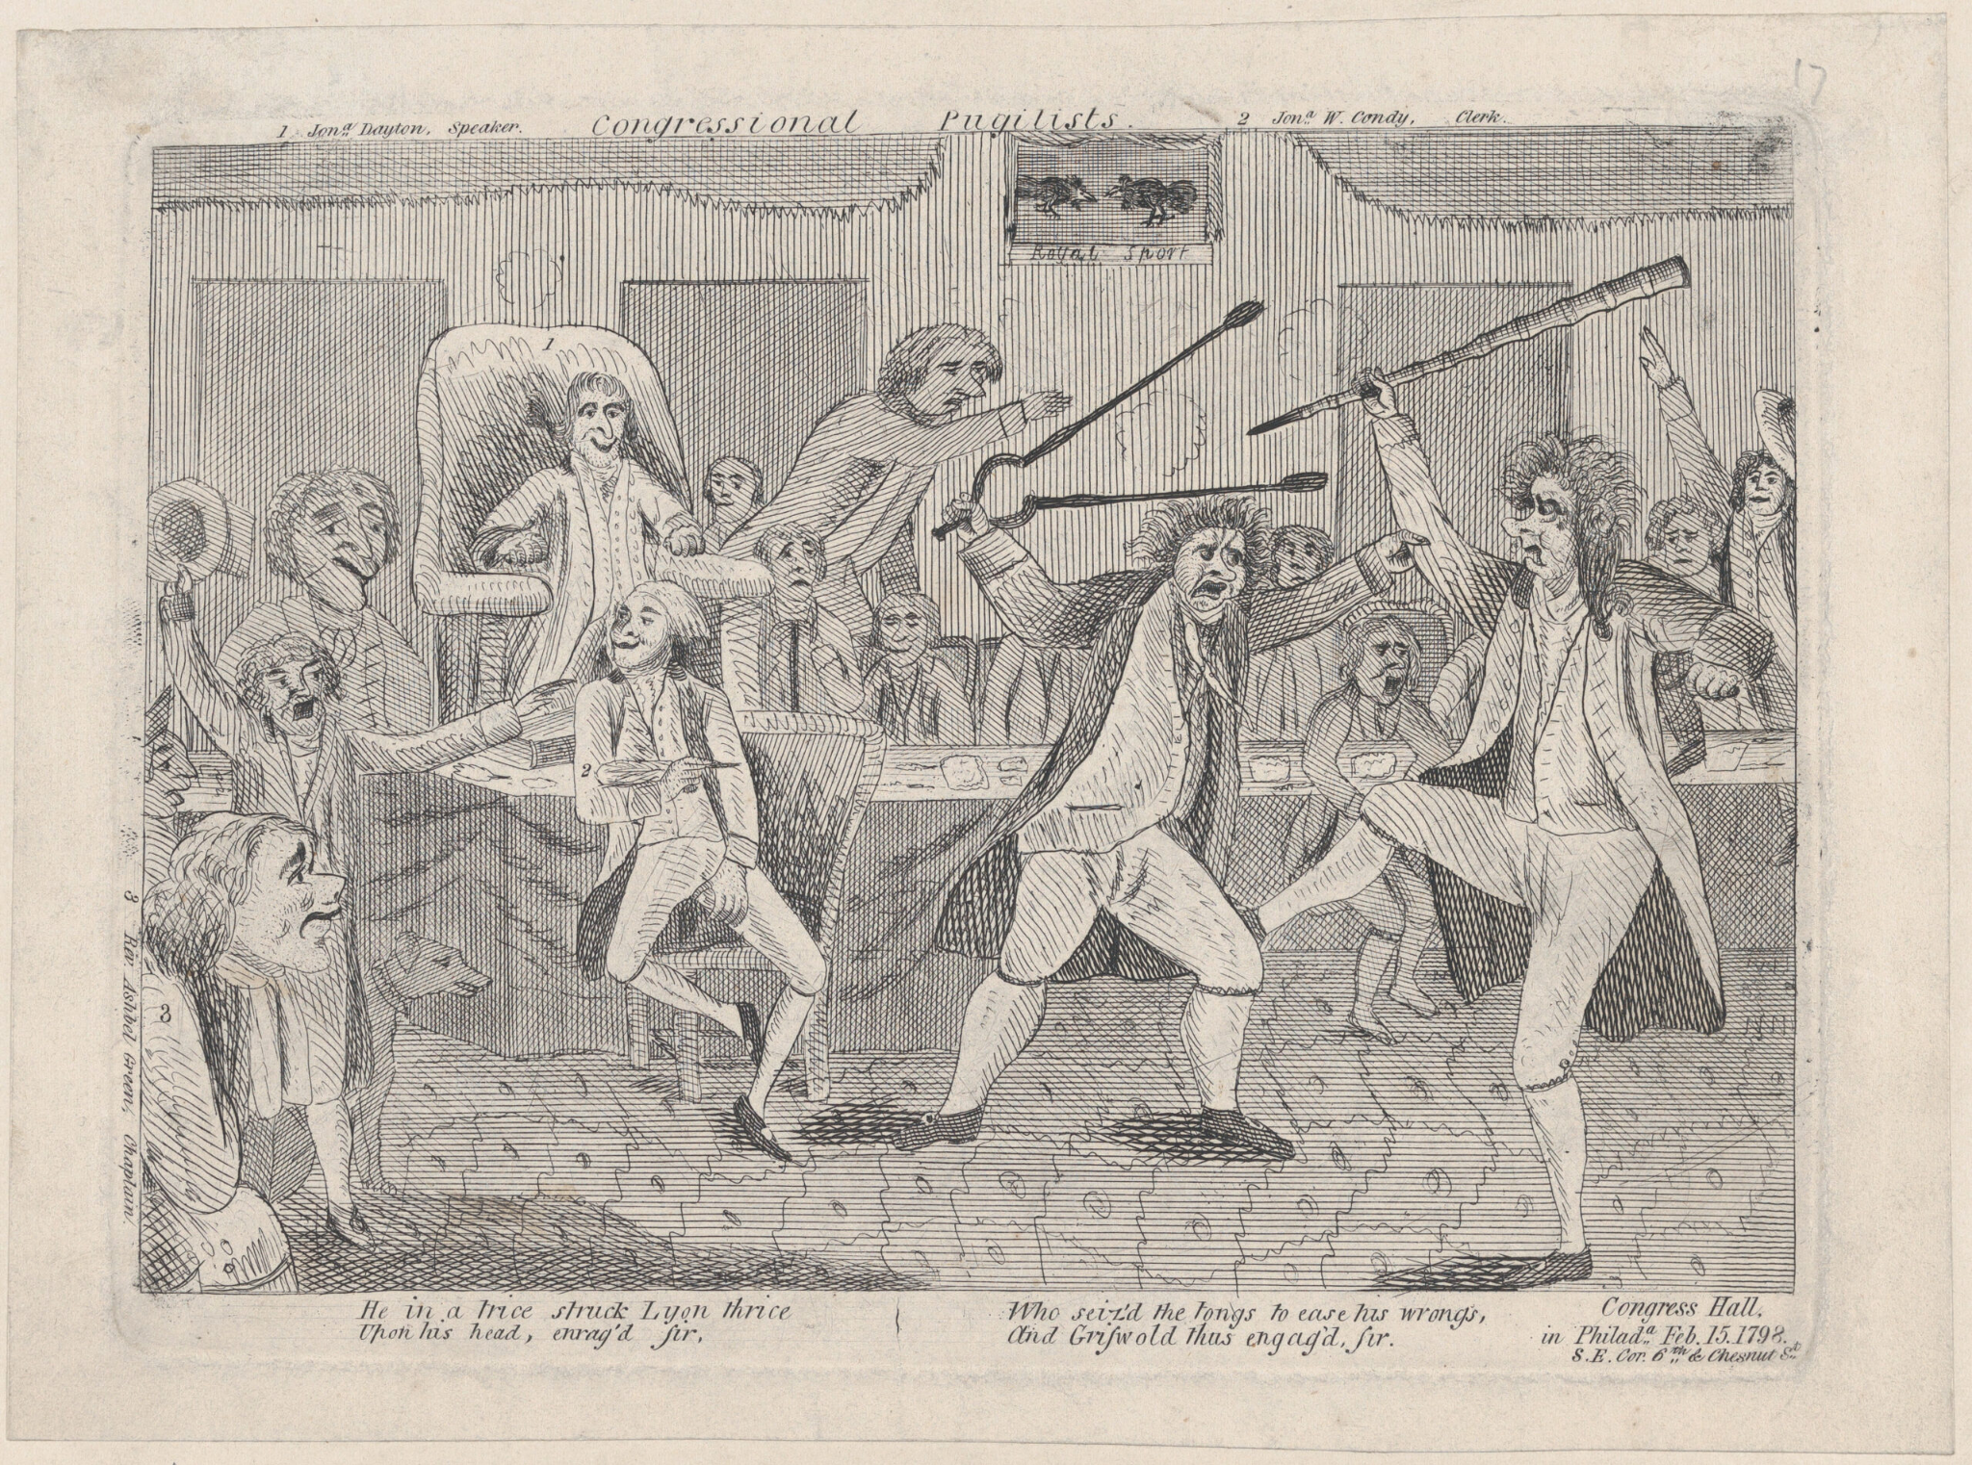
Title: Congressional Pugilists
Artist: Artist Unknown
Date: 1798
Location: Philadelphia, Pennsylvania
Framing: “This cartoon portrays a fight on the floor of Congress between Vermont Representative Matthew Lyon and Roger Griswold of Connecticut. With tensions already high due to the controversy over the 1798 Alien and Sedition Acts, the fight was ignited by an insult from Griswold to Lyon. Griswold, armed with a cane, kicks Lyon, who grasps the former’s arm and raises a pair of fireplace tongs to strike him.”

Once students have completed their evidence log, pose the following question to students:
Is polarization enduring? Cite evidence from the sources you explored in your response.

Facilitate a classroom talk session where students share their responses to the question while citing evidence from the sources. Address any misconceptions in student responses as they arise.

Using what students know about compromise and polarization from the sources they explored, have students revisit the compelling questioning through the Connect, Extend, Challenge thinking strategy:
Consider the compelling question “How does a government compromise amidst polarization?” and then ask yourself:

- How are the ideas and information connected to what you already know?
- What new ideas did you get that broadened your thinking or extended it in different directions?
- What challenges or puzzles emerge for you?

Use information from the sources in your response.

Supporting Question

8.I.Q.2 Generate supporting questions, using the disciplines of social studies, to help answer compelling questions in U.S. history between 1600-1877.

Supporting Question: How did the Missouri Compromise temporarily save the Union?

To introduce the Missouri Compromise and to support students in asking questions about this topic, have students explore McConnell’s Historical maps of the United States. The Missouri Compromise of 1820:
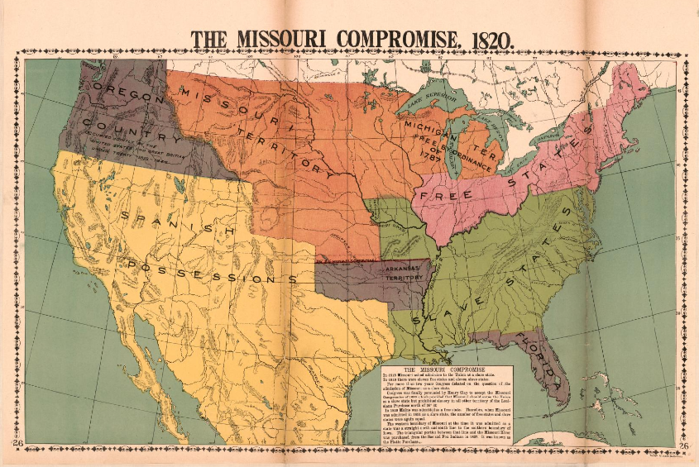
Mcconnell Map Co & McConnell, J. (1919) McConnell’s Historical maps of the United States. The Missouri Compromise of 1820. Library of Congress. https://www.loc.gov/resource/g3701sm.gct00482/?sp=25.

To encourage students “to make careful observations and thoughtful interpretations” of the map, have them engage in the See, Think, Wonder thinking strategy as a class. This routine supports students in thinking carefully about “why something looks the way it does.” Repeat the questions below as students respond to encourage new observations and inferences about what they see.

When motivating students to introduce new ideas from the map, ask:
What do you see?

When encouraging students to make interpretations of what they see, ask:
What do you think about that?

As students share what they think based on what they see, encourage them to use evidence from the map to support their statement.

When inspiring curiosity about what they see, ask:
What does it make you wonder?

As students are sharing their wonderings, record them to create a wonder wall. A wonder wall “... is a place where students can put their curious questions about things they’ve observed.” These questions can be referred to or answered throughout the lesson(s) on the Missouri Compromise.

Once students have completed their See, Think, Wonder on the McConnell’s Historical maps of the United States: The Missouri Compromise of 1820, inform students that they will now learn about the Missouri Compromise which was the law that determined the balance between free states and states that permitted the institution of slavery. The map students just explored was a visual representation of this legislation.

Investigation: Part 1
To investigate the supporting question, students will describe how the Missouri Compromise resulted from conflict surrounding the expansion of the institution of slavery. Additionally, students will learn how this compromise shaped the development of the U.S. government during this time.

8.H.CO.2 Describe the conflicts and compromises that shaped the development of the U.S. government between 1783-1877.

Have students take notes while watching the following video:

History.com Editors. (2019, September 27). Missouri Compromise. History Channel. https://www.history.com/topics/abolitionist-movement/missouri-compromise.

Students may need to watch the video twice to support their understanding of the Missouri Compromise. To guide a student’s focus while watching the video for the first time, have students complete the following:
As you watch the video for the first time, answer the following question:

“What was the Missouri Compromise?”

During the second viewing, have students take notes on what the Missouri Compromise was, why it was created and the impact of the compromise on the United States. For guidance on how to take notes while watching a video, visit Taking Notes During a Video. If students need more support in general note taking strategies, visit Taking Notes: Crash Course Study Skills #1.

At the conclusion of the video, have students engage in small group discussions about the following questions to demonstrate their understanding of the Missouri Compromise. For guidance on how to facilitate a class discussion with these questions, visit The Big List of Class Discussion Strategies and scroll down to “Conver-stations.” In “Conver-stations,” students will be placed into groups of 4-5 to complete the following steps:

“Conver-stations” Directions
- Students are then presented with a question to discuss.
- After 4-5 minutes, one or two students from each group rotate to a different group while the other group members stay where they are.
- Once students have transitions to their new group, they will discuss the next question on the prompt.
  - As students are answering the new question, they may include some of the key points from their last group’s conversation.
- Once the next question has concluded, students will rotate out of their group again. Students who have not rotated before should be the next to move to ensure that the group composition is continually revolving.

“Conver-stations” Directions

- A question will be posed to your group.
- After 4-5 minutes, one or two students from each group will rotate to a different group. The other group members will stay where you are.
- After you transition to your new group, you will discuss the next question provided.
  - As you are answering the new question, include some of the key points from their last group’s conversation.
- Repeat this process with each new question provided.

Once the new question has concluded, students will rotate out of their group again. Students who have not rotated before should be the next to move to ensure that the group composition is continually revolving.

Questions to Discuss during “Conver-stations”

- Describe attitudes toward the institution of slavery in America in 1820. How did these conflicting perspectives shape the political climate at this time?
- Explain how the Missouri Compromise appeased those who wanted to expand the institution of slavery and those who wanted it abolished.
- Why was this compromise significant?
- Was this compromise successful at resolving the conflict about the institution of slavery in America in 1820?

As you are answering these questions in your small groups, support answers by using evidence from your notes and the video.

When students have completed the “Conver-stations,” facilitate a whole group class talk where the teacher asks a question from the list above, the students respond and the teacher evaluates the students’ answers. This allows students to share their conclusions and the teacher to address any misconceptions on how the Missouri Compromise shaped the development of the United States in 1820 from the small group discussions. To encourage participants to use evidence in their responses, the teacher might ask “what makes you say that?” after a student answer. When trying to go more in depth with an answer or to hear another group’s response to the same question, the teacher might ask “would a representative from another group like to either continue our thinking on this question, or to extend our thinking in a new direction?”

Next, transition students to examine the Missouri Compromise. First, introduce students to the transcript of the Missouri Compromise so students can see the original language of the source:

National Archives (n.d.). Missouri Compromise (1820). Milestone Documents. https://www.archives.gov/milestone-documents/missouri-compromise

As students briefly look at the transcript, have them reflect on the writing of the document. For example, are there any phrases they don’t understand or unusual spellings? Inform students that they will now look at an adapted or excerpted version of the Missouri Compromise.

Provide students with an adapted version of the Missouri Compromise. For more information on how to adapt or excerpt sources, visit Module Three: Supporting Teachers When Engaging with Complex Sources. Access The Missouri Compromise, 1820 document for an example of an adapted source that is provided alongside the original source.

Inform students that to support them in completing the Analyze a Written Document tool on the Missouri Compromise, they are going to work with an adapted version of the Missouri Compromise. Share the following definitions of this term with students:
Adapting a Source | Means to simplify a source so that students may independently read the source. A source may be simplified by cutting confusing or nonessential phrases, adding clarifying phrases, replacing difficult words with easier synonyms or modifying irregular punctuation, capitalization or spelling.

Once students have been provided the adapted source along with the transcript of the original, have them complete the following prompt in small groups:
Examine the Missouri Compromise of 1820 using the Analyze a Written Document tool. Independently or in small groups, answer the questions provided.

For guidance on how to organize students into small groups, teachers may reference Using Roles in Group Work or Setting up and managing small group work. To successfully implement small group work, teachers must be mindful of organizing the small groups purposefully, clearly stating the expectations of the assignment being completed and clearly identifying student roles.

An example from a Kentucky classroom of a completed Analyze a Written Document tool can be found on the following page.

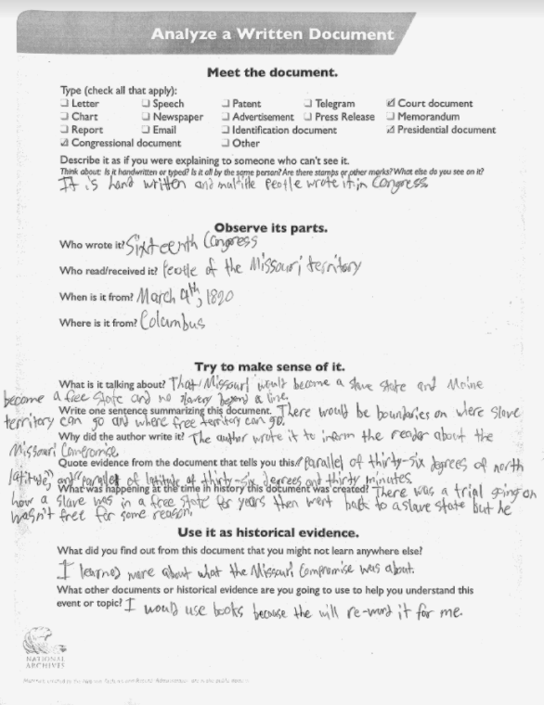

When students have completed their Analyze a Written Document tool, have students engage in small group discussions where they share the parts they observed, how they made sense of the document, and the responses they shared for using it as historical evidence by using conversation markers. Conversation markers encourage students to “use statements that promote the cohesion of ideas” (Hattie, Stern, Fisher and Frey, 2020). Sample conversation markers for small group discussion may include, but are not limited to, the following:

- “Can you tell us more about that?”
- “Can you show me where you found that information?”
- “I agree with ____ because ___.” “That is a great point.”
- “I want to add on to what ____ just said.”

As students discuss their responses to the Analyze a Written Document tool, engaging in conversation starters will promote deeper learning of their topic because students are required to engage in deep discussion that build on each other’s points. Additionally, this small group discussion will support students when engaging with Investigation: Part 3.

Prior to continuing to the next Investigation, teachers need to check for understanding of the Missouri Compromise. To do so, teachers may use funneling questions when facilitating whole group class talk after students complete their small group discussions. Funneling questions “intentionally send students down a cognitive path with a known endpoint.” Funneling questions are appropriate to use here as students are “in the surface acquisition period” of the Missouri Compromise. To check for student understanding, teachers may use some of the questions from the Analyze a Written Document tool such as:
- Who wrote The Missouri Compromise?
- Who read/received The Missouri Compromise?
- When and where is The Missouri Compromise from? Where is it from?
- What is The Missouri Compromise talking about?

As students complete the funneling questions in the whole group class talk, transition to using focusing questions to support a more in-depth conversation of the Missouri Compromise and to prepare students for Investigation: Part 3. Focusing questions “prompt more discussion.” Some questions may be drawn from the Analyze a Written Document tool, and may include, but are not limited to the following:
- Write one sentence summarizing this document.
- Why did the author write it? Quote evidence from the document that tells you this.
- What was happening at the time in history this document was created?
- How does the meaning of “compromise” apply to the Missouri Compromise?

Investigation: Part 3
8.C.KGO.1 Examine the role of Kentucky and Kentuckians within national politics between 1792-1877.

Have students read or listen to Missouri Compromise: A Win-Win for Clay:

National Public Radio. (2007, January 26). Missouri Compromise: A Win-Win for Clay [audio]. https://www.npr.org/templates/story/story.php?storyId=7043103.

As they are reading or listening to this source, have students answer the following questions:
- In Missouri Compromise: A Win-Win for Clay, Robert Remini states that compromise is achieved when “each side must feel that they have gotten something they wanted. But in order to do that, you must give up something that the other side wants so that there are no winners and no losers.” How did Henry Clay give something to both sides in the Missouri Compromise?
- Michele Norris asks “could those same tactics (of Henry Clay) be used effectively today? What is Robert Remini’s claim and what evidence does he use to support his claim?
- Why was Henry Clay considered "great" at compromising? Cite evidence from the source to support your response.

Here is an example of completed questions from a Kentucky classroom:
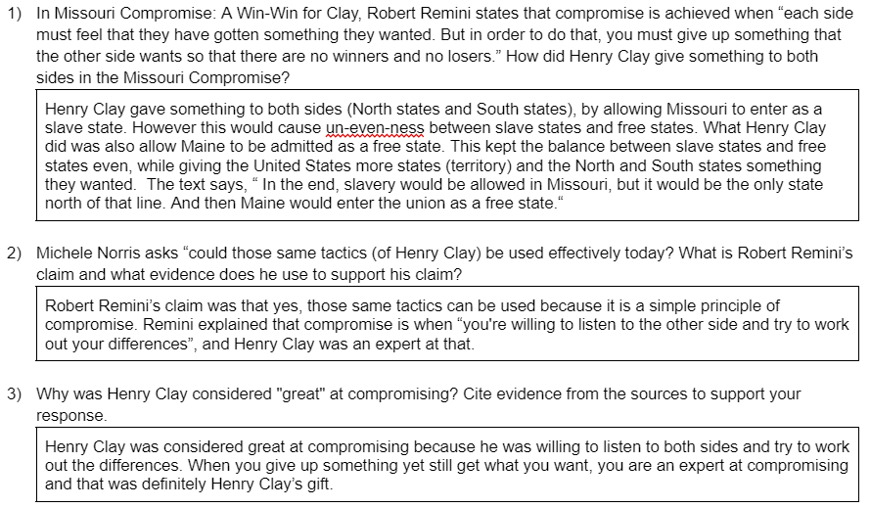

Task Aligned to the Supporting Question:
KAS for Social Studies alignment:
- 8.I.Q.2 Generate supporting questions, using the disciplines of social studies, to help answer compelling questions in U.S. history between 1600-1877.
- 8.H.CO.2 Describe the conflicts and compromises that shaped the development of the U.S. government between 1783-1877.
- 8.C.KGO.1 Examine the role of Kentucky and Kentuckians within national politics between 1792-1877.
- 8.I.UE.1 Use multiple sources to develop claims in response to compelling and supporting questions.
- 8.I.CC.3 Evaluate how individuals and groups address local, regional and global problems concerning the development of the United States.

In these assignments, students are required to synthesize information learned through engaging with the disciplinary strand standards to answer a supporting question.

Task Aligned to the Supporting Question

Construct an explanation to answer the supporting question: “How did the Missouri Compromise temporarily save the Union?”

In your response:
- Demonstrate your knowledge of the conflicts and compromises that shaped the development of the U.S. government.
- Demonstrate your knowledge of the role of Kentucky and Kentuckians within national politics.
- Evaluate how individuals and groups addressed a regional problem.
- Use multiple sources to develop a claim.

Below are examples from Kentucky classrooms.

Demonstrates strong mastery:
The Missouri Compromise temporarily saved the Union by saving the north and south from breaking out into war, keeping the balance between the amount of free and slave states there were in the United States, and giving the United States an example of how to settle disputes and debates similar to this in the future.
The first way the Missouri Compromise temporarily saved the Union was it kept the United States from breaking out into war between the North and the South. According to a Win-Win for Clay, “And perhaps his greatest work was the Missouri Compromise of 1820, bridging the gap between the North and the South over slavery. Many say it helped delay the civil war for decades.” As shown, it delayed war between the North and the South, which temporarily saved the Union.
The second way the Missouri Compromise temporarily saved the Union is it kept balance between the amount of free and slave states. According to History Channel, “This time, Speaker of the House Henry Clay proposed that Congress admit Missouri to the Union as a slave state, but at the same time admit Maine (which at the time was part of Massachusetts) as a free state.”, with A Win-Win for Clay stating, “Eleven free states, eleven slave states.” This balance saved the Union because the northerners wanted slavery abolished and the southerners accepted slavery as their culture. They thought so much of their opinions, it could’ve caused the war (earlier spoken of) to break out. As you can see, the Missouri Compromise temporarily saved the Union by keeping balance between slave and free states.
The last way that the Missouri Compromise (Henry Clay specifically) temporarily saved the Union was giving an example for the future on how to Compromise. A Win-Win for Clay explains, “NORRIS: So the tactics that Henry Clay used to bring about the Missouri Compromise, could those same tactics be used effectively today? Mr. REMINI: I think so. Why not? It's a basic principle of compromise.” This is important because the future Compromises can temporarily save the Union in the future. As you can see, the Missouri Compromise (Henry Clay) temporarily saved the Union by setting an example for the future of the Union.
In conclusion, the Missouri Compromise temporarily saved the Union in many ways. The Missouri Compromise delayed war from breaking out. The Missouri Compromise also kept balance between the slave states and the free states. Lastly, the Missouri Compromise (Henry Clay) provided an example for the future of the Union. Clearly, the Missouri Compromise saved the Union, even if it was just temporary.

Demonstrates partial mastery:
The Missouri Compromise temporarily saved the Union by hearing out both sides of the argument. The Missouri Compromise is an agreement between the North and the South that prohibits any slaves north of the 36°30 line and states that Maine is a free state and Missouri is a slave state. When Missouri wanted to be a state it would mess up the balance between the North and the South. The South wanted Missouri to be a slave state. The North wanted Missouri to be a free state. They were at a disagreement. They solved this disagreement by creating The Missouri Compromise. In a “Win-Win for Clay” it sates, “And so he, Clay, recognized that what you have to do is get the North to back off and yet achieve some kind of victory in bringing an end to the further expansion and growth of slavery, and at the same time protect what the Southerners feel is their institution. And that is what the Missouri Compromise is about. In the Louisiana territory, you draw this line at 36°30' and there is no slavery north of the 36°30'.” This proves that The Missouri Compromise took both sides into consideration and made an agreement. The agreement was all about making everything between the North and South balanced. Although the compromise was temporary it still worked. In the article “History Channel” it says, “When the Missouri Territory first applied for statehood in 1818, it was clear that many in the territory wanted to allow slavery in the new state. Part of the more than 800,000 square miles bought from France in the Louisiana Purchase in 1803, it was known as the Louisiana Territory until 1812, when it was renamed to avoid confusion with the newly admitted state of Louisiana.” This proves that half wanted to make it pro-slavery and half wanted it to make it a free state. They had to find some type of agreement and they did. In the source “History Channel” it also states, “In 1820, amid growing sectional tensions over the issue of slavery, the U.S. Congress passed a law that admitted Missouri to the Union as a slave state and Maine as a free state, while banning slavery from the remaining Louisiana Purchase lands located north of the 36º 30’ parallel.” This proves that in order to prevent any more tensions they needed to create a solution and they did by passing the law. Overall, The Missouri Compromise temporarily saved the Union by hearing out both sides of the agrument.

Demonstrates weak mastery:
The Missouri Compromise temporarily saved the Union by not making the slave states not to isolate from the Union. In “Source A: History Channel”, in paragraph 1, it states, "In 1820, amid growing sectional tensions over the issue of slavery, the U.S. Congress passed a law that admitted Missouri to the Union as a slave state and Maine as a free state, while banning slavery from the remaining Louisiana Purchase lands located north of the 36º 30’ parallel.” This proves that It saved the Union from the slave states’ separation because it stopped the slavery debate, which was were the Union wanted slave states and free states. Another piece of evidence is in “Source A: History Channel'' in paragraph 2, it states, “The Missouri Compromise, as it was known, would remain in force for just over 30 years before it was repealed by the Kansas-Nebraska Act of 1854. In 1857, the Supreme Court ruled the compromise unconstitutional in the Dred Scott case, setting the stage for the nation’s final path toward the Civil War.” This proves that the Missouri Compromise stopped the slave states from seperating because the Supreme Court ruled the Kansas-Nebraska Act unconstitutional.

Task Aligned to the Compelling Question:
KAS for Social Studies alignment:
- 8.I.Q.1 Develop compelling questions related to the development of the United States between 1600-1877.
- 8.I.UE.1 Use multiple sources to develop claims in response to compelling and supporting questions.
- 8.I.CC.3 Evaluate how individuals and groups address local, regional and global problems concerning the development of the United States.
- 8.I.CC.4 Apply a range of deliberative and democratic procedures to make decisions about ways to take action on current local, regional and global issues.

Assignments aligned to the compelling question require that students synthesize the knowledge learned from investigating supporting question(s). In this example, one supporting question is provided that is aligned to a compelling question. However, students may need to engage with more than one supporting question in order to fully engage with a compelling question. This assignment culminates with students using their historical thinking skills to confront today’s problems.

Task Aligned to the Compelling Question
How does a government compromise amidst polarization?

Based on your explanation for the supporting question, consider the following video entitled, “This 60-second animation shows how divided Congress has become over the last 60 years.”

Construct an argument to the following question: In light of the modern division within Congress, how does a government compromise amidst polarization? Draw on what you learned about Henry Clay’s civic action and additional compromises in American history to evaluate how individuals or groups might address a local, regional and/or global problem in modern society. Be prepared to share your thinking through deliberative and democratic procedures and support your argument with evidence from multiple sources.

For guidance on how to facilitate student understanding of how individuals or groups might address a local, regional and/or global problem in modern society, engage with the Circles of Action strategy. This strategy supports students to investigate ways that they can take action on an issue.

In the KAS for Social Studies, deliberative and democratic procedures are defined as follows: “a process where deliberation is central to decision making. This process also looks to generate outcomes that promote the common good through reasoning, rather than through a law-making process.” For guidance on how to facilitate deliberative and democratic procedures, visit the Guide to Classroom Deliberation for Students and Teachers for information on how to implement norms and routines for classroom deliberative and democratic processes. Additionally, access Module 4: How do we engage in civil discussion? of the Creating Collaborative Civic Spaces module series for more information, including but not limited to videos and Kentucky aligned examples that provide practical strategies and tools to help teachers create spaces where students can engage thoughtfully, respectfully, and critically with complex topics.

Hattie, J., Stern, J., Fisher, D., & Fry, N. (2020). Visible Learning for Social Studies. Corwin.
Michaels, S., O’Conner, M. C., Hall, M. W., & Resnick, L. B. (2010). Accountable Talk sourcebook: For classroom conversation that works (v. 3. 1). Pittsburgh, PA: University of Pittsburgh Institute for Learning. http://ifl.lrdc.pitt.edu
Hattie, J., Stern, J., Fisher, D., & Fry, N. (2020). Visible Learning for Social Studies. Corwin.
Hattie, J., Stern, J., Fisher, D., & Fry, N. (2020). Visible Learning for Social Studies. Corwin.
Hattie, J., Stern, J., Fisher, D., & Fry, N. (2020). Visible Learning for Social Studies. Corwin.

