Grade 8 Learning Experience Example
8.I.UE.1 and 8.H.CE.2
Introduction
The following learning experience was developed by the Frazier History Museum to demonstrate implementation examples aligned to the Kentucky Academic Standards (KAS) for Social Studies 8.I.UE.1 and 8.H.CE.2
It is important to note that the learning experience indicated through these Teacher Notes, and related resource(s) represent one example. This example is not a requirement nor a suggestion for school curriculum. While the Kentucky Department of Education (KDE) is responsible for the development of high-quality academic standards, state law assigns each local district the authority to develop the school’s curriculum and determine appropriate instructional resources based on language found in Kentucky Revised Statute (KRS) 160.345.

Kentucky Academic Standards (KAS) for Social Studies alignment:
8.I.UE.1 Use multiple sources to develop claims in response to compelling and supporting questions
8.H.CE.2 Analyze the cause and effect of Westward Expansion, the Civil War and Reconstruction on the diverse populations of the United States.
Educators may have to engage students with a standard multiple times throughout a year in order to meet the full intent of the standard. As a result, the following assignment example may not encompass the entire scope of the standards identified.

Overview:
Participants will explore and analyze a range of primary and secondary sources connected to the motivations and experiences of soldiers during the American Civil War. They will use the evidence to make a claim about why soldiers were compelled to join the fighting and how soldiers are changed when a country fights itself. It is important to note that this learning experience will be the most useful for students who already have a basic understanding of the American Civil War.
Compelling Question: How are people affected when a country fights itself?
Supporting question: What compelled a soldier to join the Civil War and how did it change them?

While this lesson is focused on the experience of soldiers during the Civil War, additional supporting questions and sources could be added that focus on other groups during the American Civil War such as, but not limited to, children, women, etc.
Teacher Notes:
Preparation:
To view a recording of this lesson being modeled with educators, access this Grade 8 History Webinar where experts from the Frazier History Museum demonstrate this learning experience. The Grade 8 History Slides include information and graphics that can be projected and shared with students.
The following resources may be used to build teachers’ background knowledge:
- What is the Frazier History Museum – overview video (6 minutes)
- A House Divided: Civil War Kentucky, American Battlefield Trust

Additionally, the following resources can be used to build background knowledge for students:
- Crash Course US History #20 – The Civil War part 1 (12 min)
- Create a word bank, as a class or in small groups, of everything that comes to mind when students consider the term “Civil War soldier”

Setting the Stage
Introduce the compelling and supporting questions to students. Explain that they could investigate these questions through a variety of diverse groups, but in this lesson, they will be focusing on Union soldiers. Remind students that Kentucky was a border state and was one of four states that allowed the institution of slavery, yet does not leave the Union.

Provide students with the following graphic organizer to record their thinking throughout the lesson:
Source | Thoughts on how it connects to the supporting question:  What compelled a soldier to join the Civil War and how did it change them?
Image of Pvt. Jesse Hopson, Company F, 108th U.S. Colored Infantry
Poem: Catch Me if You Can by Frank X Walker

Objects from Civil War era haversack

Quotes from Joseph “Kit” King Diary

The Bloedner Monument

Newspaper image of the 1855 Bloody Monday election riots, Louisville Herald, 1922

Explain to students that they will be investigating a total of three different source sets. The following sources are part of the first set:
- Image of Pvt. Jesse Hopson, Company F, 108th U.S. Colored Infantry. Carte de visite by Alfred B. Gaylord & Conrad S. Speidel
- Poem: “Catch me if You Can” by Frank X Walker

Begin by providing some background knowledge about Frank X Walker: he is an author, educator, poet and activist from Danville, Kentucky. Have students watch the video of Frank X Walker (2013 KY Poet Laureate) explaining his work in the Frazier Museum’s The Commonwealth exhibition. Ask students to pay attention to how Frank X Walker uses historical sources to write these poems as they watch.

Then, show students the following image and engage in the Question Formulation Technique (QFT), where students ask and record questions about a source:
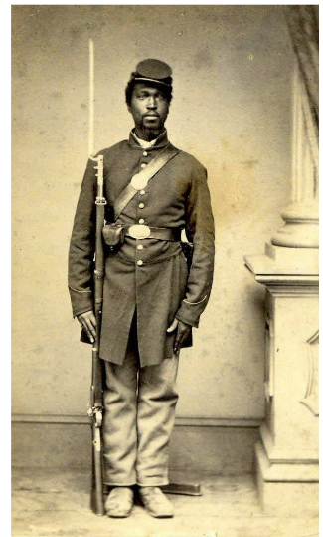

After engaging in QFT, watch the video of Frank X Walker reading his poem, “Catch Me if You Can”. The text of the poem can be found below. As they watch and listen, ask them to think about what they can learn from this poem about Jesse regarding why he joined the war and how if might have changed him.
They say that’s me, standing at attention in the picture,
imitating a tree, feed booted, married to the ground.
Look like my hat and uniform, my same fingernails and hands.

They say the face look like me, but I can’t be sure.
I was never so lucky as to own a mirror.
The is the first and onliest picture of me I have ever seen.

I’m standing so still you can’t tell how fast I really am,
but I’m a runner. Our whole company was mostly runners.
Massa Hopson chased me through the swamps for a week.

Owned a whole county in west Kentucky tucked ‘tween two rivers,
but he couldn’t catch me, not even with hounds.
Water ain’t nothing but a wet road to a born runner.

The voice behind the box said, stand there and hold still.
So, I let myself stop runnin’ long enough for the camera to catch me.
But he couldn’t know how hard that was for a man like me

to stand there, like a log, as if ol’ massa looking way way,
looking for something in the woods out a place, something
moving, something he think he own, but it’s just the wind.

-Frank X Walker

Have a whole group discussion to connect their thoughts from the image and poem to the supporting question. Ask students:
What can we learn from the image and poem about why Jesse might have joined the war or how it might have changed him?

Next, introduce the second set of sources. First is a display of objects from a Civil War haversack. Explain to students that a haversack was a bag with a single shoulder strap that soldiers used to carry items. Ask students to examine the objects in the image:
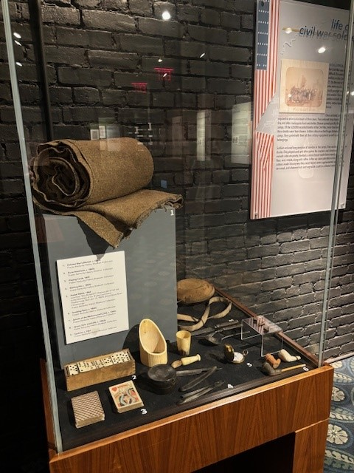

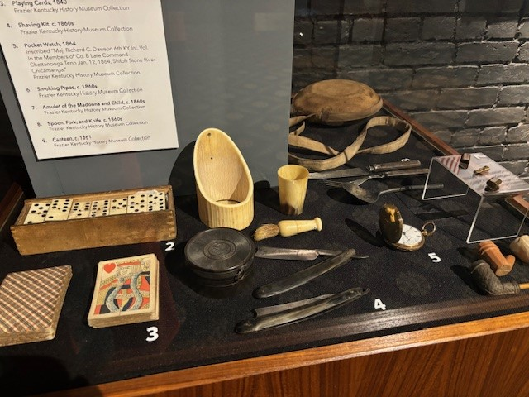

Provide students the opportunity to discuss their observations. Ask students:
- What objects do you see?
- What might they have been used for?
- What do these tell us about a soldier’s experiences during the Civil War?

Then, provide students with the close-up images below of some of the items, alongside their descriptions:
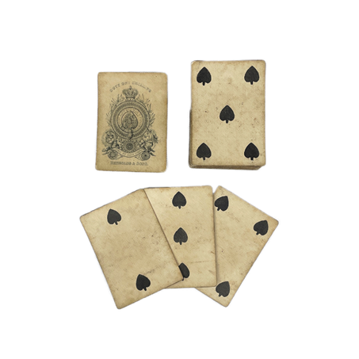
Cards and dominoes were one of the most confiscated items when soldiers were taken prisoner. They had a lot of down time between marches.
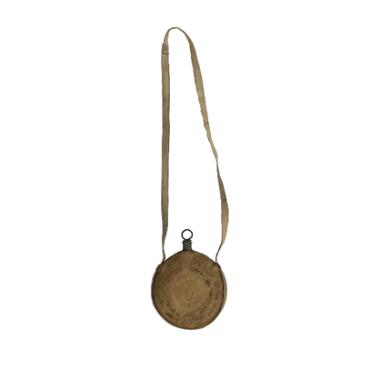
They used canteens to carry water with them because they never knew where or when they would end up.
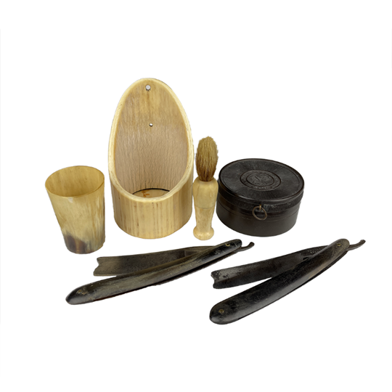
This is a full shaving kit, which shows some standards of hygiene remained for soldiers during the Civil War.

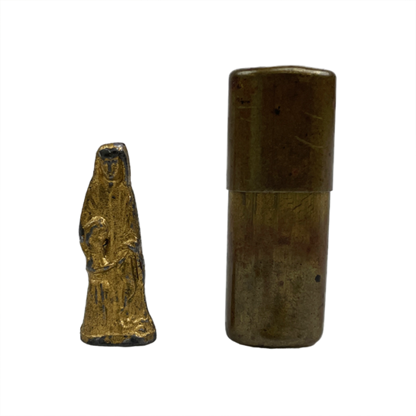
This is a very tiny (as large as your pinky finger) Madonna and child that fits into a case.

Next, inform students that they will examine Joseph “Kit” King’s diary. He was a member of the 11th Ohio Volunteer Infantry. As a member of a volunteer regiment, we know that he volunteered to join the fight. Since his first diary entry was in 1862, he likely volunteered very early on in the Civil War. Although he is from Ohio, he spent time in Kentucky and writes about this in his diary.
Show his photograph to students to observe. Explain that he was very proud of his rifle that was made by an Ohio gunmaker, and he mentions it in several diary entries.
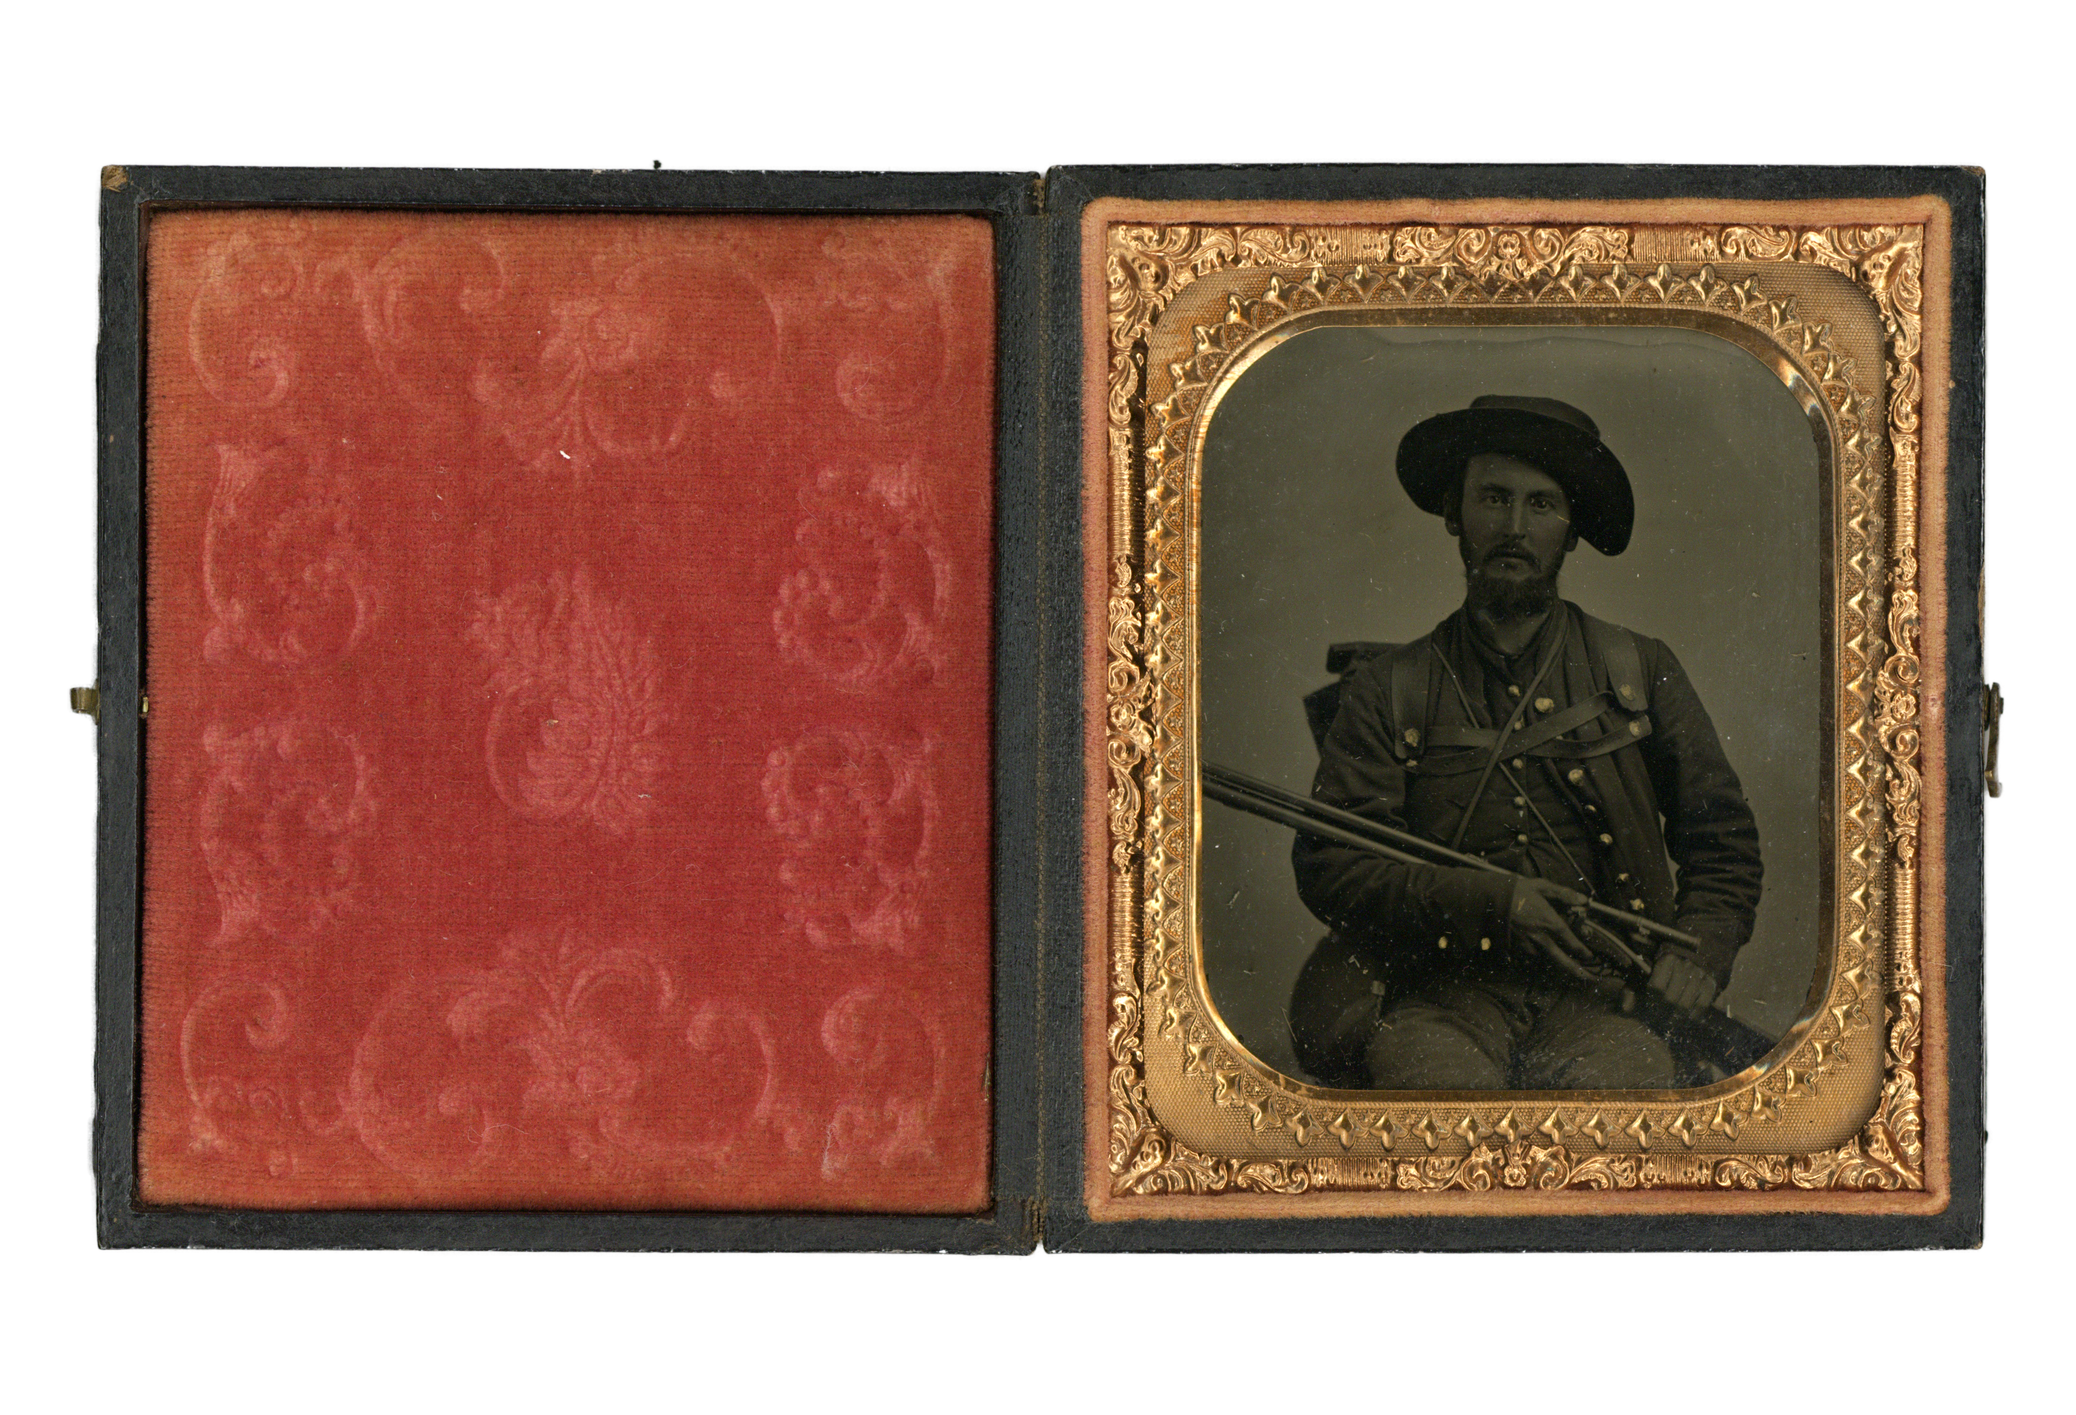

Ask students to consider the following questions:
- What do you observe about his photo?
- What are some similarities and differences to the photo of Private Jesse Hopson?

Explain to students that they will now analyze and sort a variety of quotes from Kit’s diary. Provide each student or group with 8-12 different quotes from Joseph “Kit” King’s Diary Excerpts. Ask students to read each quote and assign it to a category from the word bank that is provided on the worksheet.
After students have had the opportunity to investigate these diary entries, discuss their findings as a class. Some discussion questions include:
1. What did you learn about being a Civil War soldier from the objects and quotes?
2. What surprised you about Joseph (Kit) Kings experience?
3. Why do you think Joseph may have decided to join the Union?
4. How might Joseph’s experience during the war have changed him?

Then, explain to students that they will now investigate the third set of sources. Ask students to spend a few moments making observations of the monument below:
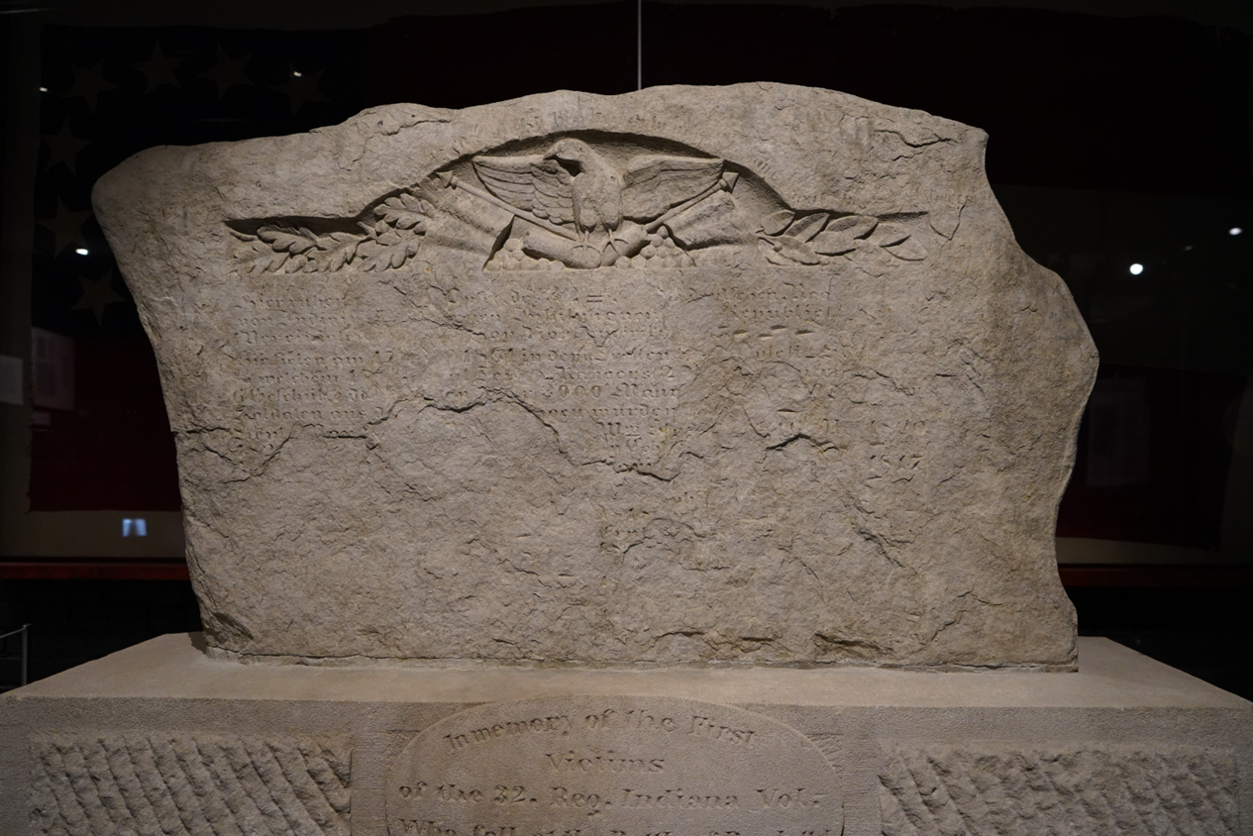

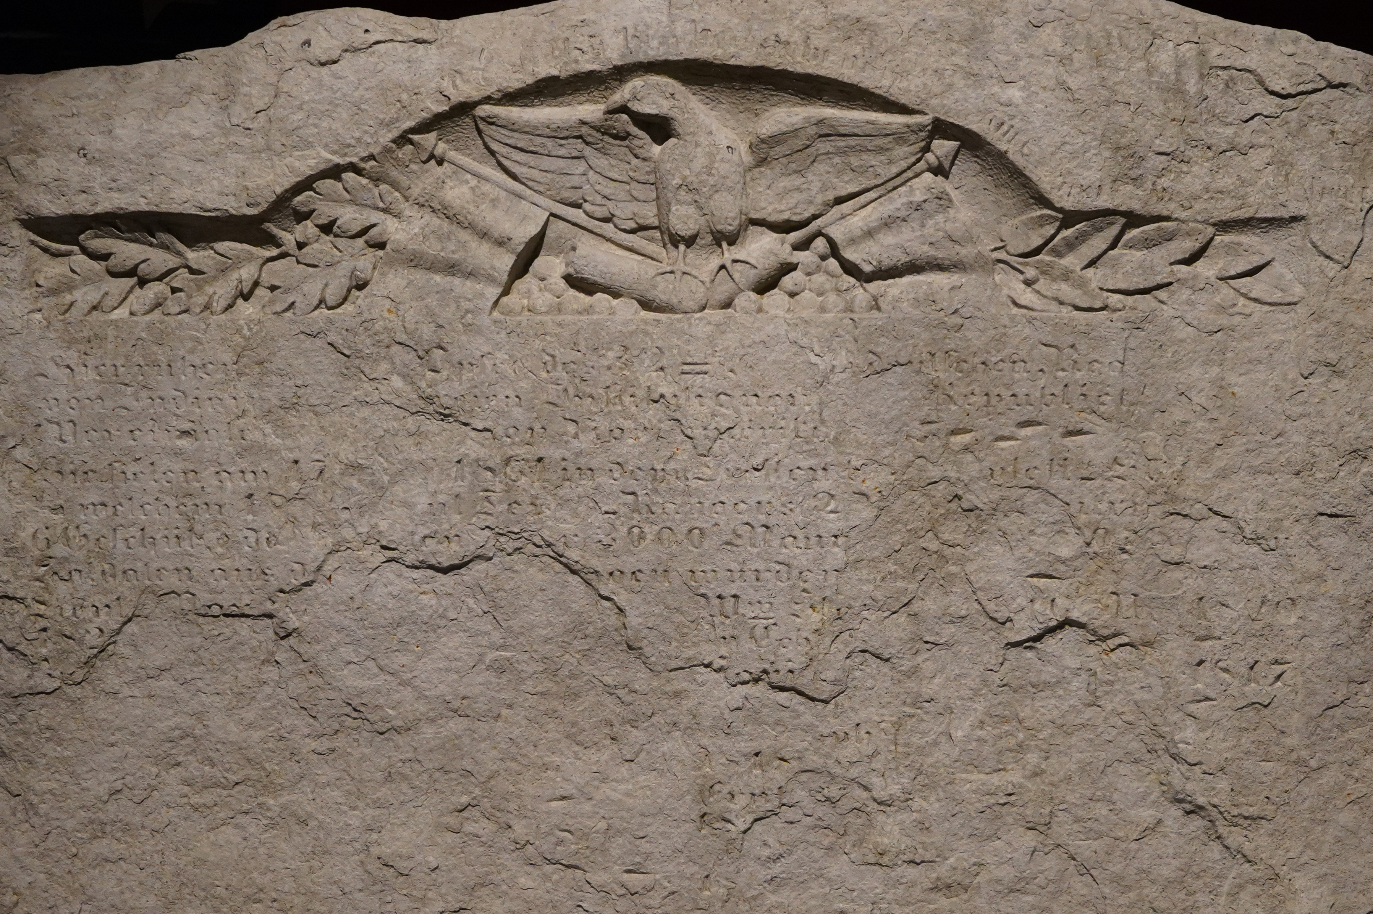

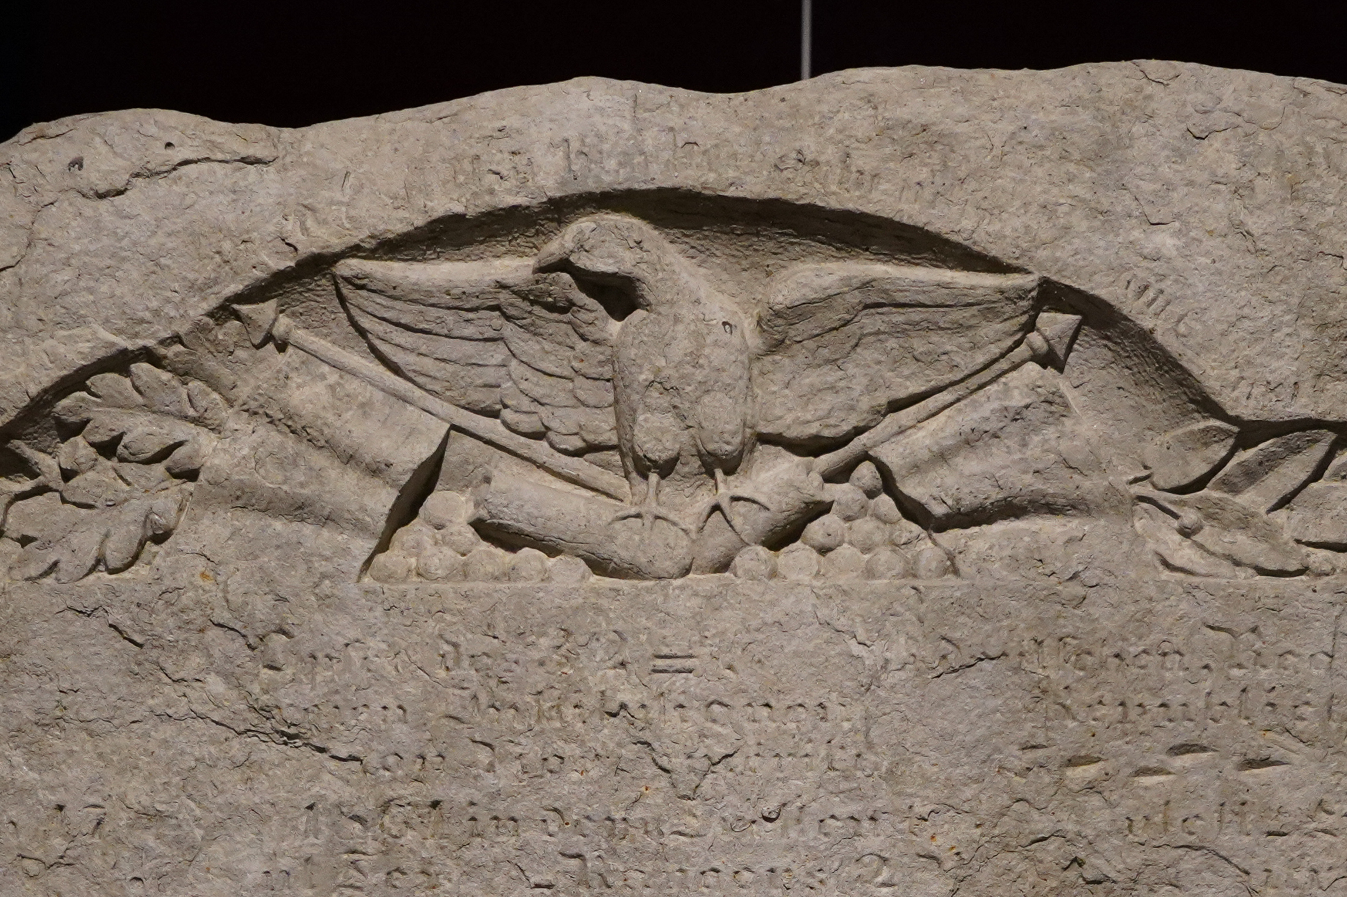

Then, use a Visual Thinking Strategy with students. Ask them to share what they notice about the monument. As they share, prompt with “What makes you say that?”, and “What more can we find?”
Explain to students that this is known as the Bloedner Monument, and it is the oldest American Civil War monument in the world. To learn more about the significance of this monument, have students watch the Bloedner Monument video. Prior to watching the video, pose the following question for them to consider as they watch:
Summarize the historical context of this monument. Why was it created and what does it commemorate?

Invite students to share their responses with the class to check for understanding and address any misconceptions students may share.
Then, repeat the Visual Thinking Strategy using the Bloody Monday newspaper image below:
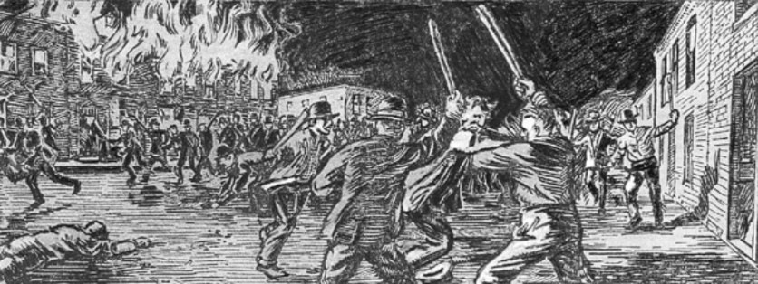

After discussion, explain that this was the election day riots of 1855, when mobs stormed the streets of Louisville in prominent immigrant parts of the city. Destruction, violence and death followed this event. Students may watch the Kentucky History Channel YouTube Video on Bloody Monday for more information about this event.
Then, have a class discussion, asking the following questions:
- What did you find most interesting about the creation of the Bloedner Monument?
- If you could ask August Bloedner one question, what would it be?
- Why might a German immigrant decide to fight for the Union during the American Civil War?
- How might August Bloedner’s experience during the Civil War have changed him?

Now that students have investigated a variety of sources to help answer the supporting question, ask them to complete the task below to assess their learning.

Task Aligned to the Supporting Question
Construct a claim to answer the supporting question, “ What compelled a Civil War soldier to join the Civil War and how did it change them?” Use evidence to support your claim.

