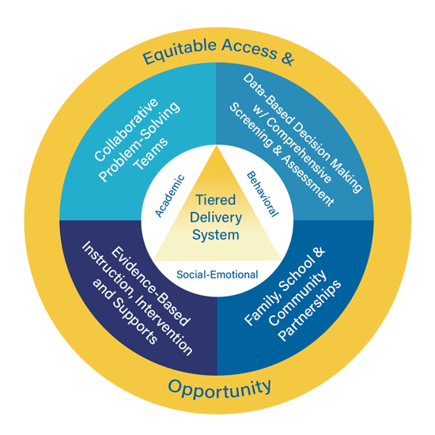
Kentucky Multi-Tiered System of Supports (KyMTSS)
Team Data Inventory

In Kentucky’s Multi-Tiered System of Supports (KyMTSS), teams systematically analyze data across academic, behavioral and social-emotional domains to achieve improved and sustainable student outcomes. Data-based decision-making guides the MTSS implementation process. Data is collected, analyzed and presented in a visual format at all levels of collaborative problem-solving teams. This template provides a structure to compile data sources and develop a plan for the comprehensive screening and assessment system, including a key concepts and considerations section at the end of the document. For further information and resources, refer to the KyMTSS Data-Based Decision-Making Essential Element page.

Academic Data

Data Sources  (universal academic screener, diagnostic assessment, progress monitoring tool, observation, performance assessment, interview, etc.) | Administered to whom?  (Use the dropdown to select the assessment group.) | Administered when?  (month, daily, weekly, frequency, etc.) | Administered by whom? | Informs what tier of the tiered delivery system?  (Use the dropdown to select the tier.) | Purpose  (screener, diagnostic, progress monitoring, required by law/regulation, other)
 | All Students | 3 times/year |  | Tier 1 | Screener
 | All Students | 3 times/year |  | Tier 1 | Screener

Questions to guide the MTSS team discussion: After compiling the data inventory for the domain, the MTSS team may use the questions below to guide a discussion for assessing the current status and planning for future action steps.

Guiding Questions | Notes to Capture the Discussion
What data provides descriptive data to help the team answer:
- What happened?
- What trends are noticed?
- What patterns emerge?
What data provides diagnostic data to help determine why something happened?
What data provides predictive data to help determine what is likely to happen in the future?
What data provides prescriptive data to help determine the best course of action for instruction, intervention and support?
For whom do we have data?
How are the data presented and reviewed by the MTSS team?
Who reviews and discusses the data?
What data protocol(s) are used to guide the discussion?
With whom are the data sets shared?
How is the data used to inform decision making in the school/district?
What additional data might be needed to inform the team’s decision-making process?
What additional data sources might be needed to effectively address the needs of tiers 1, 2 or 3?
Are there data sources that may no longer be needed or are duplicative?
What additional questions might the team have regarding academic data?

Academic Data Comments and Considerations

Behavioral Data

Data Sources  (behavior screener, office discipline referral report, attendance report, classroom tracker report, questionnaire, observation, performance assessment, interview, etc.) | Administered to whom?  (Use the dropdown to select the assessment group.) | Administered when?  (month, daily, weekly, frequency, etc.) | Administered by whom? | Informs what tier of the tiered delivery system?  (Use the dropdown to select the tier.) | Purpose  (screener, diagnostic, progress monitoring, required by law/regulation, other)
 | All Students | 3 times/year |  | Tier 1 | Screener
 | All Students | 3 times/year |  | Tier 1 | Screener

Questions to guide the MTSS team discussion: After compiling the data inventory for the domain, the MTSS team may use the questions below to guide a discussion for assessing the current status and planning for future action steps.

Guiding Questions | Notes to Capture the Discussion
What data provides descriptive data to help the team answer:
- What happened?
- What trends are noticed?
- What patterns emerge?
What data provides diagnostic data to help determine why something happened?
What data provides predictive data to help determine what is likely to happen in the future?
What data provides prescriptive data to help determine the best course of action for instruction, intervention and support?
For whom do we have data?
How are the data presented and reviewed by the MTSS team?
Who reviews and discusses the data?
What data protocol(s) are used to guide the discussion?
With whom are the data sets shared?
How is the data used to inform decision making in the school/district?
What additional data might be needed to inform the team’s decision-making process?
What additional data sources might be needed to effectively address the needs of tiers 1, 2 or 3?
Are there data sources that may no longer be needed or are duplicative?
What additional questions might the team have regarding behavioral data?

Behavioral Data Comments and Considerations

Social-Emotional Data

Data Sources  (SEL screener, questionnaire, observation, performance assessment, report, interview, etc.) | Administered to whom?  (Use the dropdown to select the assessment group.) | Administered when?  (month, daily, weekly, frequency, etc.) | Administered by whom? | Informs what tier of the tiered delivery system?  (Use the dropdown to select the tier.) | Purpose  (screener, diagnostic, progress monitoring, required by law/regulation, other)
 | All Students | 3 times/year |  | Tier 1 | Screener
 | All Students | 3 times/year |  | Tier 1 | Screener

Questions to guide the MTSS team discussion: After compiling the data inventory for the domain, the MTSS team may use the questions below to guide a discussion for assessing the current status and planning for future action steps.

Guiding Questions | Notes to Capture the Discussion
What data provides descriptive data to help the team answer:
- What happened?
- What trends are noticed?
- What patterns emerge?
What data provides diagnostic data to help determine why something happened?
What data provides predictive data to help determine what is likely to happen in the future?
What data provides prescriptive data to help determine the best course of action for instruction, intervention and support?
For whom do we have data?
How are the data presented and reviewed by the MTSS team?
Who reviews and discusses the data?
What data protocol(s) are used to guide the discussion?
With whom are the data sets shared?
How is the data used to inform decision making in the school/district?
What additional data might be needed to inform the team’s decision-making process?
What additional data sources might be needed to effectively address the needs of tiers 1, 2 or 3?
Are there data sources that may no longer be needed or are duplicative?
What additional questions might the team have regarding social emotional data?

Social-Emotional Data Comments and Considerations

Next Steps: After compiling the data inventory and discussing the questions for each domain, the MTSS team may consider next steps in the collaborative problem-solving data-based decision-making process..

Action Steps | Action Step Lead | Timeline | Notes

Data Key Concepts | Considerations
Annual Assessment Calendar  Washington County Assessment Calendar | - Organizes the assessment data throughout the calendar year.  - Relies on high-quality, valid and reliable assessments and measures.  - Informs instructional and programmatic decisions.  - Operates at the district, school, classroom and student levels.  - Encompasses the academic, social-emotional and behavioral domains.  - Includes a variety of assessments to inform instruction, intervention and support.  - Universal screeners  - Diagnostic assessments  - Progress monitoring tools  - Formative and summative assessments
Consistent and Valid Problem-Solving Process  Data Analysis Protocol | - Establishes and communicates practices, procedures and protocols for data-based decision-making to collect and analyze data at all tiers and across all levels (district, school, classroom, content area and individual student).
Coordinated System Development  Selecting an MTSS Data System | Center on Multi-Tiered Systems of Support | - Relies on high-quality, valid and reliable assessments and measures.  - Informs instructional, programmatic and logistical decisions.  - Operates at the district, school, classroom, content area and student levels.
Data Literacy Skills  Essential Elements of Comprehensive Data Literacy | - Ensures team members have the knowledge and skills to select, interpret and use multiple sources of data within a systematic collaborative problem-solving process.
Data Systems  Selecting an MTSS Data System | - Selects and uses valid and reliable assessments, while also collecting, analyzing, and leveraging data to monitor implementation fidelity and student outcomes over time.
Multiple Data Sources  Assessment Practices Within a Multi-Tiered System of Supports (ufl.edu) | - Supports an integrated data system that may include:  - Needs assessment;  - Academic and behavior universal screenings;  - Diagnostic data;  - Formative assessment data;  - Progress monitoring data;  - Demographic data;  - Early warning indicators;  - Student/family/staff survey data; and/or  - Relevant community data.
Practices and Protocol  Protocols – School Reform Initiative  Assessment Practices Within a Multi-Tiered System of Supports | The CEEDAR Center | - Occurs at all levels and tiers within KyMTSS.  - Matches instruction, intervention and support to the needs of all learners.  - Evaluates the effectiveness and health of the multi-tiered system of supports.  - Utilizes fidelity measures and decision rules.
Written Decision Rules  Data-based Decision Making | Center on Multi-Tiered Systems of Support | - Creates a systematic means to determine:  - Overall health and effectiveness of universal tier 1 instruction, intervention and support;  - Students in need of an intervention or extension;  - How frequently to progress monitor;  - When to review progress monitoring data;  - Whether to continue, intensify or exit a student from an intervention; or  - When to refer a student for a special education evaluation (in accordance with state law and district policies and procedures).

