Grade 1 Learning Experience Example: 1.H.KH.1

Introduction
The following learning experience was developed by the Kentucky Historical Society to demonstrate an implementation example aligned to the Kentucky Academic Standards (KAS) for Social Studies 1.H.KH.1.
It is important to note that the assignment(s), indicated throughout these Teacher Notes, and related resource(s) represent one example. This example is not a requirement nor a suggestion for school curriculum. While the Kentucky Department of Education (KDE) is responsible for the development of high-quality academic standards, state law assigns each local district the authority to develop the school’s curriculum and determine appropriate instructional resources based on language found in Kentucky Revised Statute (KRS) 160.345. It is under the discretion of the superintendent to determine the local curriculum, including the evaluation and selection of instructional resources. The KDE does not adopt, select or recommend specific curricula for coursework. Per KRS 160.345(g), “the local superintendent shall determine which curriculum, textbooks, instructional materials, and student support services shall be provided in the school after consulting with the local board of education, the school principal, and the school council and after a reasonable review and response period for stakeholders in accordance with local board of education policy.”

Kentucky Academic Standards (KAS) for Social Studies alignment:
1.H.KH.1 compare life in Kentucky in the past to life in Kentucky today.
Educators may have to engage students with a standard multiple times throughout a year in order to meet the full intent of the standard. As a result, the following assignment example may not encompass the entire scope of the standards identified.

Overview:
Students will investigate how Kentucky’s communities have changed by analyzing how homes and objects in homes are similar and different to their homes today.

Compelling Question: How is life at home in my community today different than it was in the past?

Supporting Question: How have homes and the objects in them changed over time?

Teacher Notes
Introduce the supporting question to students. Explain that they will be examining different types of homes in Kentucky in the past and comparing them to our homes today to determine how the home and objects within it (i.e. cookware, furniture, decorations and items for leisure activities) have changed over time.

Have students draw an image of what their home is like (bedroom, kitchen, bathroom, etc.). Use one or more of the following house pictures and/or videos to look at home life through history and how things have changed:

Archaic Home (ca. 3000BCE-1000BCE)
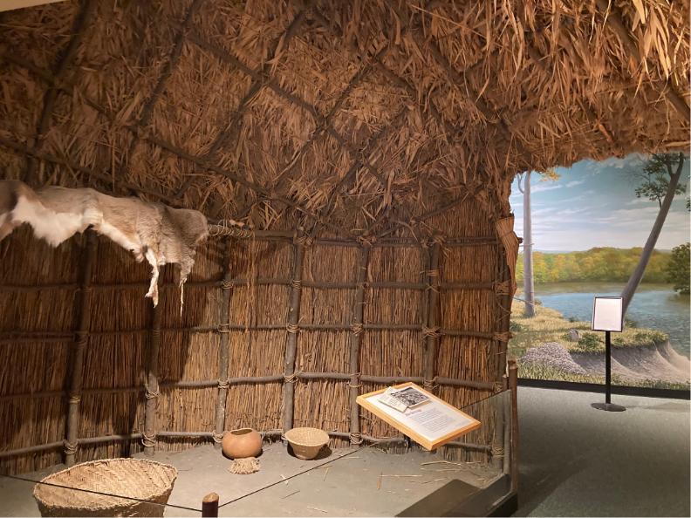
Description: Between 5,000-3,000 years ago, people lived in houses like this. These might have been long term housing or temporary camps used while men hunted and women gathered nuts and other edible plants. This structure made of cattail mats lashed to a bent sapling frame is a reconstruction of an Archaic house. It provided a place for a family to eat, sleep, and live all year.
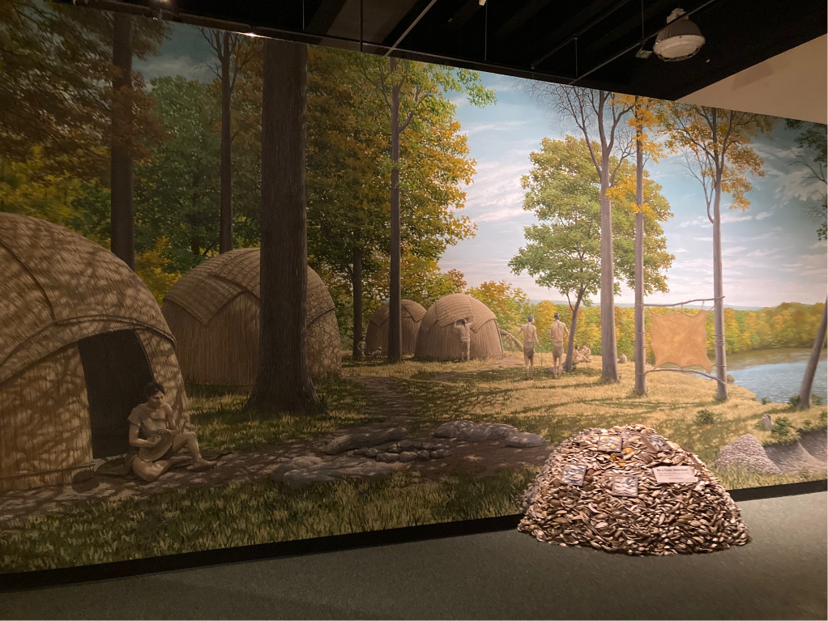
Below are additional closeup pictures of images from inside the house:

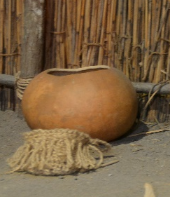  Hollowed Gourd | 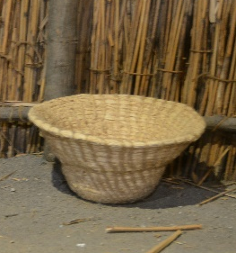  Woven Basket
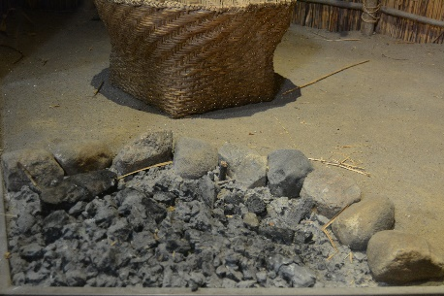  Fire Pit | 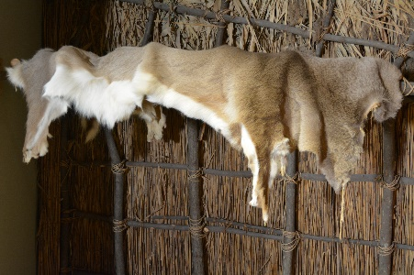  Animal Fur

Additional Discussion Questions:
- What is this house made out of?
- What objects do you see inside?
- Do you think every Native American tribe and nation had the same house?
What questions do you have about this house?

Victorian Parlor (ca. 1900)
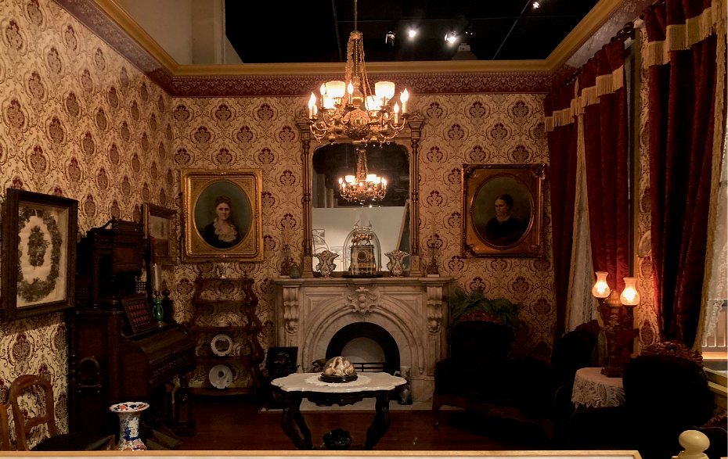
Description: A well-furnished parlor was the center of the home during the Victorian time. Here families gathered to talk, read, and entertain guests. Basic furniture was machine-made instead of hand made. Art, books and other decorations showed off the family’s style, education and culture. Easy access to stores, schools, and cultural activities made for a comfortable lifestyle for those who could afford it.
Middle- and upper-class Kentuckians living the state’s larger towns and cities often embraced the Victorian lifestyle. However, in most of the commonwealth, people still lived a simpler life on farms.

Related image from KHS Collection: Four women in Victorian parlor next to piano. - Ohio River Portrait Project - Kentucky Historical Society Digital Collections (kyhistory.com)

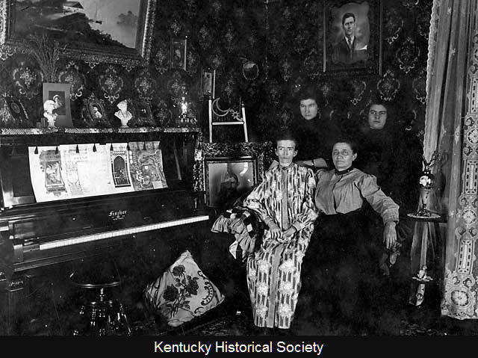
Below are additional closeup pictures of images from inside the house:

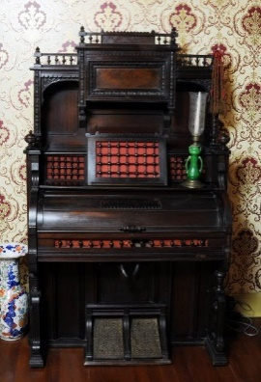  Parlor Organ | 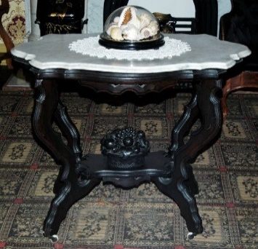  Table
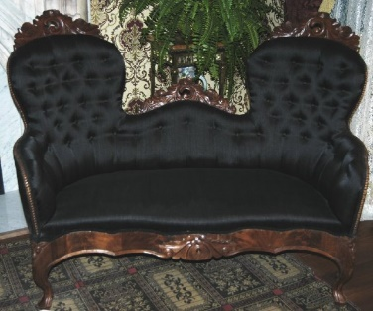  Sofa | 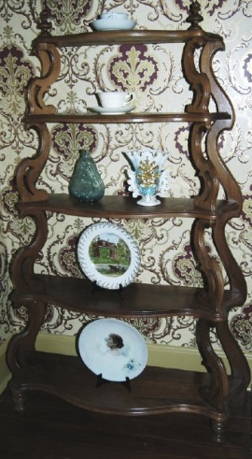  Shelving Unit
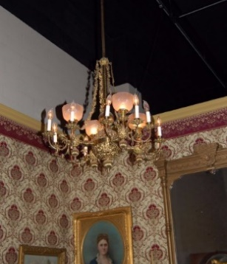  Chandelier | 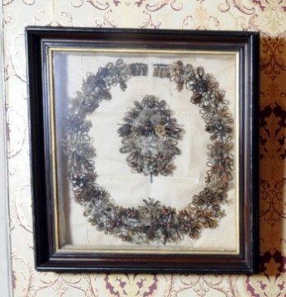  Hairwork Wreath

Additional Discussion Questions:
- Have you heard the word Parlor before? What do you think it means? Do you have a living room or a family room in your home?
- What objects do you see inside this parlor?
- How is it similar and different to your living room or family room?
- What questions do you have about this room?

Log Cabin (ca. 1800)
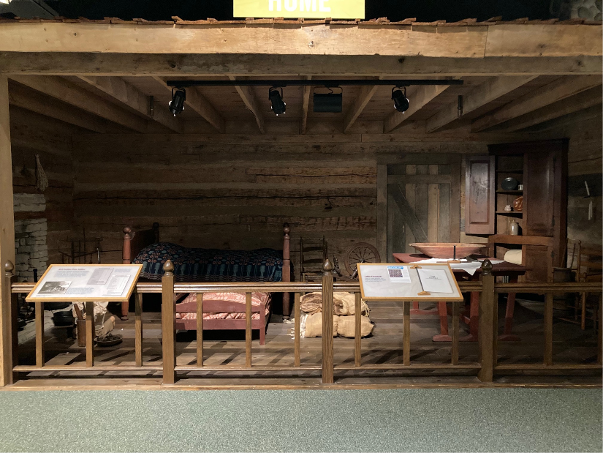
Description: European Americans traveled to this area before it became the state of Kentucky seeking land and opportunity. It was hard to bring a lot of stuff on the journey, and many people had to build their home and belongings from scratch to survive. Though small and crude, log cabins offered essential shelter to pioneers. Most settlers built a simple cabin and improved it as time and resources allowed. In some parts of the state, people built log cabins until World War I.

Related image from KHS Collection: Family on porch of log cabin in Boyle County, 1885
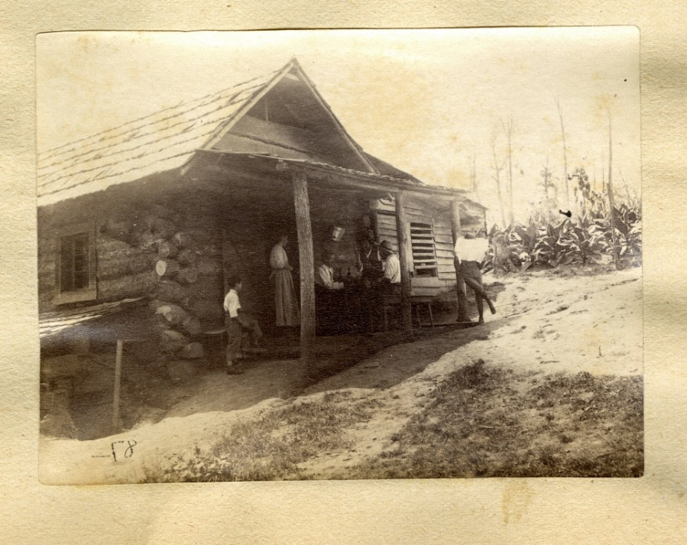
Below are additional closeup pictures of images from inside the house:

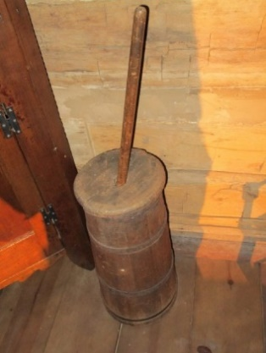  Churn | 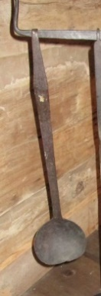  Kitchen Ladle
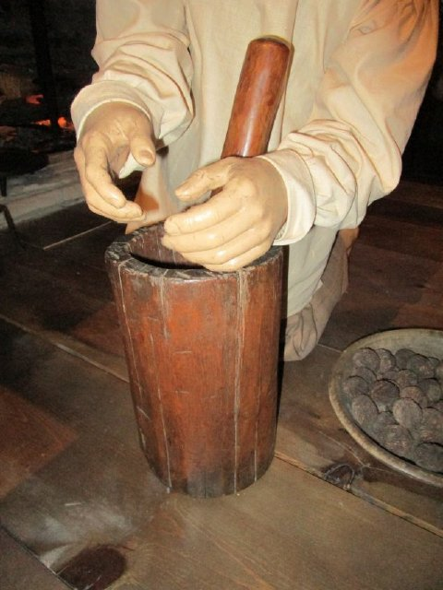  Mortar and Pestle | 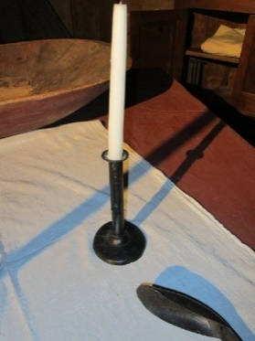  Candlestick
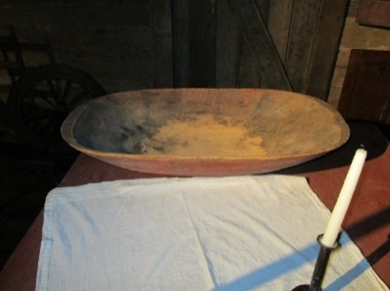  Bowl | 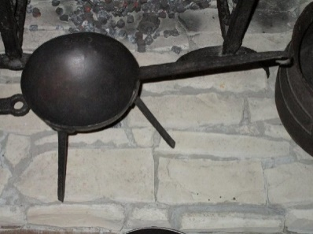  Spider
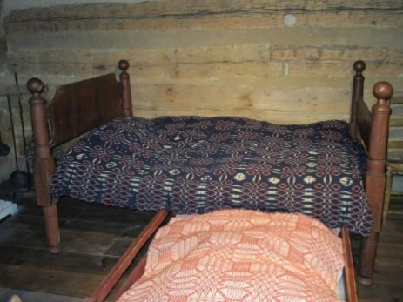  Bed | 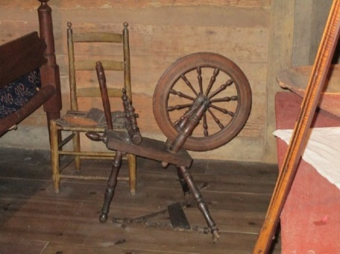  Spinning Wheel
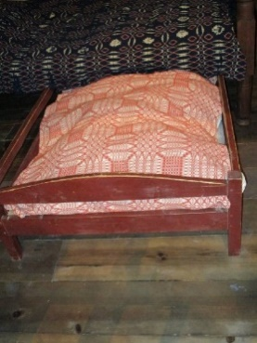  Trundle | 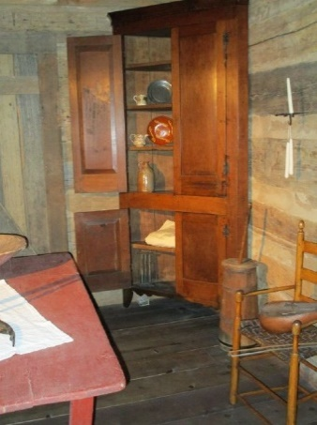  Corner Cupboard

Additional Discussion Questions:
- What is this house made out of?
- What objects do you see inside?
- How is it similar and different from the archaic house used by Kentucky’s early people?
- What questions do you have about this house?

1930s Kitchen (ca. 1930)
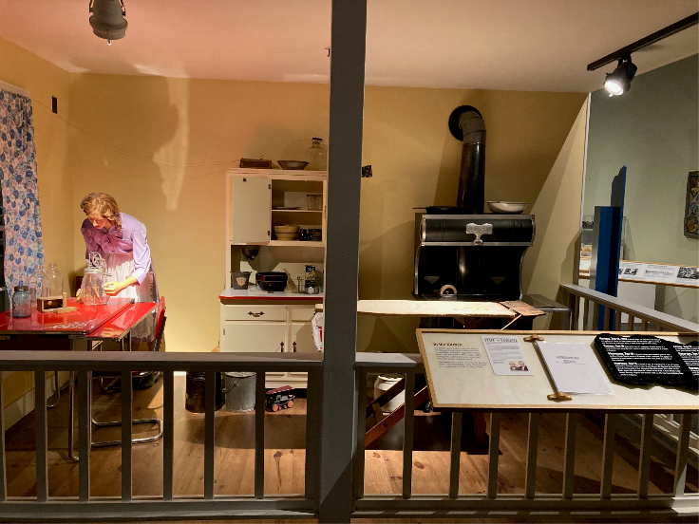

Description: The kitchen was a center of activity for the farm family. This 1930s kitchen shows how some old items (wood burning stove, hand crank butter churner) and now products (radio) existed side-by-side in many homes.
Related image from KHS Collection: Kitchen made by Paul Young for Kentucky Unities Company in Nov 1934, from Winchester, Kentucky. - William B. Ogden Studio Negatives - Kentucky Historical Society Digital Collections (kyhistory.com)
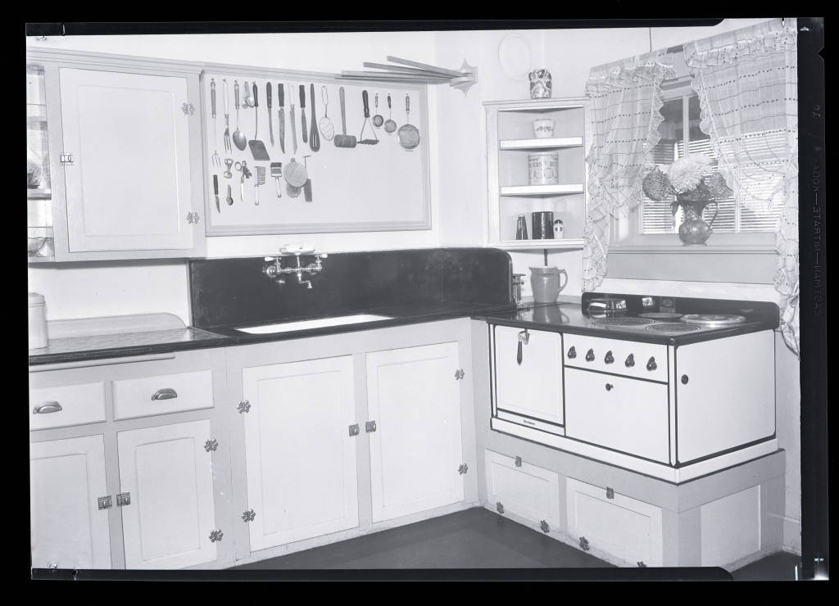

Below are additional closeup pictures of images from inside the house:

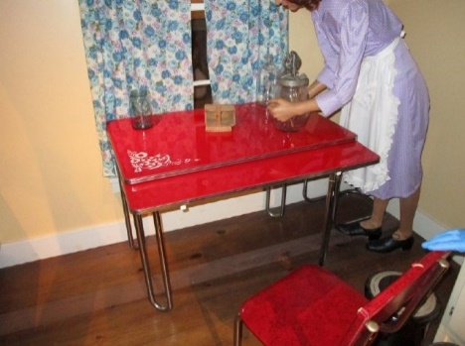  Table | 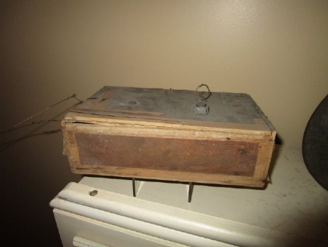  Radio
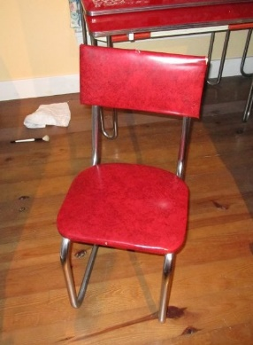  Chair | 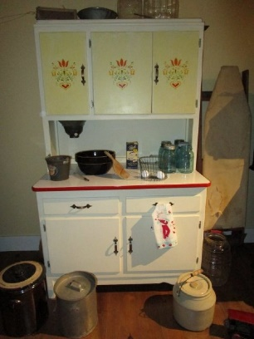  Cupboard
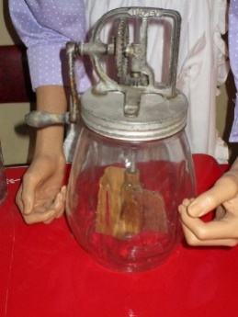  Churn | 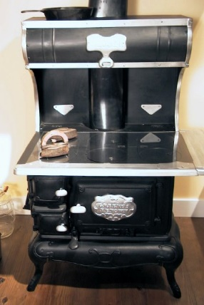  Wood heating stove

Additional Discussion Questions:
- What objects do you see inside the kitchen?
- Do any of these items look anything like items that you have in your kitchen?
- How are the images of the 1930s farmhouse kitchen and the 1934 Kentucky Utilities Company kitchen different?
- What questions do you have about this kitchen?

1960s Kitchen (ca. 1960)
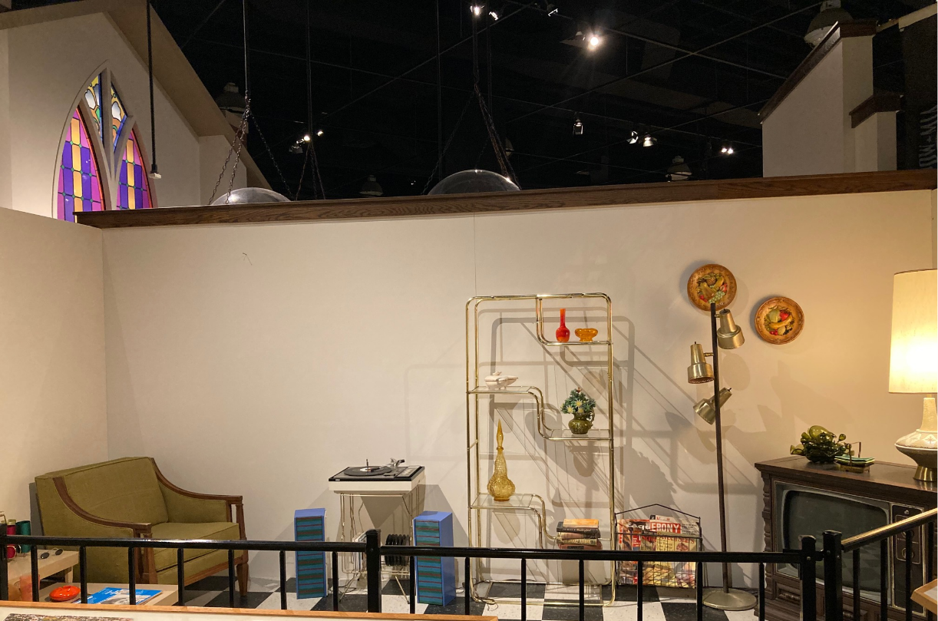
Description: Like much of the nation, Kentucky’s people started moving off farms and into cities during the decades after World War II. Suburbs grew around bigger cities, and Kentuckians moved into neighborhoods with houses, shopping areas, and fast food restaurants.

Below are additional closeup pictures of images from inside the house:

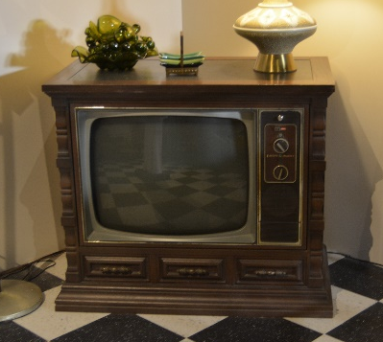  Television | 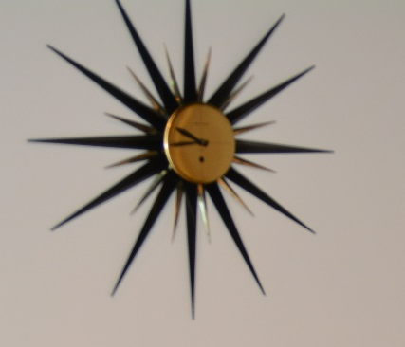  Clock
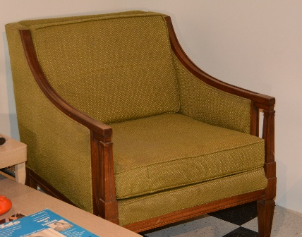  Chair | 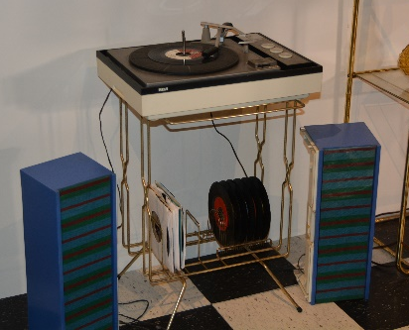  Record Player and Speakers
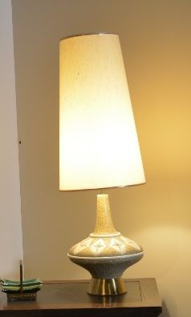  Lamp | Additional Discussion Questions:  - What objects do you see inside the living room?  - How is this room similar and different to the Victorian Parlor?  - How is it similar and different to your living room or family room?  - What questions do you have about this living room?

Below is a handout that can be used for analyzing the objects found within the different homes they explore through the sources:

1. What do you think the object is? | 6. Who used this object?
2. How do you use the object? | 7. When was the object created? A date?
3. Does this object work well for its purpose? | 8. What material is it made of? Why?
4. What other objects would complement or go with this object? | 9. Are there any marks or designs you notice?
5. How could this object or its design be improved for today’s use? | 10. List 2 different uses for the object. What would you do with it?

As a class, use a Venn diagram to organize what is similar and different between homes and household objects today and historic homes seen in the image(s) you’ve shown. You can look at one or two homes/living spaces below or explore a different one each day of the week.
Both
Your Home
Historic Home

Supplemental Information
Virtual Tour of Archaic Period Home: Historic Homes Tour | Prehistoric (youtube.com)
Virtual Tour of Log Cabin: Historic Homes Tour | Frontier (youtube.com)

Task Aligned to the Supporting Question
Answer the supporting question: How have homes and the objects in them changed over time? In your response, compare life in Kentucky from the past to life in Kentucky today.

You may use writing and drawing in your explanation.

Extension Activity
Which home came first?
- Looking at all the house pictures, can you put the houses in order from oldest to newest?
- What clues do you see in the pictures that help you choose that order?

