Session 4: Shared Learning
Planning for Instruction
Content Standard(s): Does the lesson/task focus on one or more grade-appropriate mathematics standards?
What standard(s) does this lesson/task address?

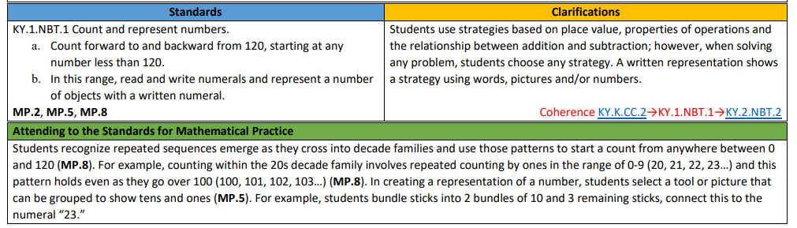

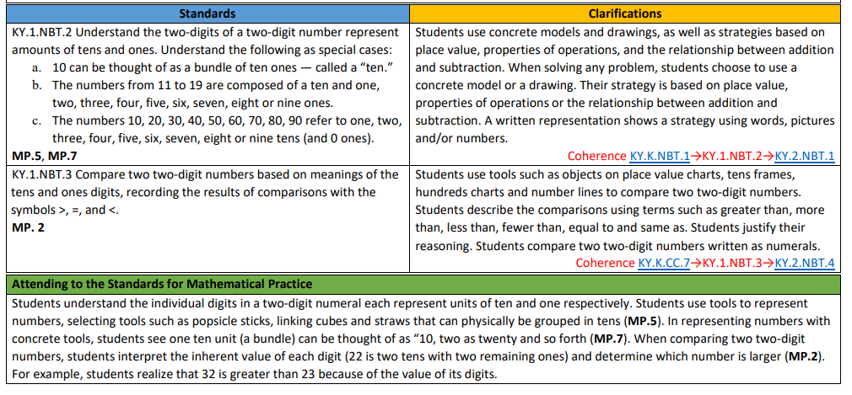

What standards (within or across grade-level coherence) does the lesson/task rely upon or support?

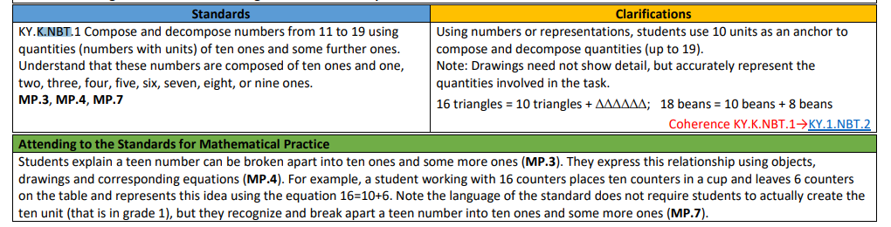

Learning Plan: Script out the key lesson components.
(e.g. Do Now, Activating Prior Knowledge, New Learning, Guided Practice, Independent Practice, Closing, etc)
N/A - We are creating an exemplar student response for a given task, not planning a lesson.
Do the Math: Select a given task or tasks from the lesson.
Solve the task by creating an exemplar student response.
Without counting each individual dot, what number do you see? How did you see it? Explain using words or a number sentence.
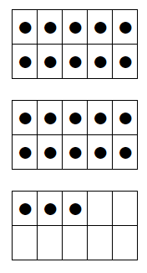

Predict incorrect solution strategies (e.g., misconceptions, procedural errors). How will you proactively address these misconceptions?

Target of the Standard: How does the lesson/task engage students in reaching the target of the standard?
Conceptual Understanding  If the target of the standard is conceptual understanding, what do students have to know in order to demonstrate mastery on this task?  This task is built around developing conceptual understanding.  Conceptual understanding refers to understanding mathematical concepts, operations and relations. Conceptual understanding is more than knowing isolated facts and methods; students should be able to make sense of why a mathematical idea is important and the kinds of contexts in which it is useful. Conceptual understanding allows students to connect prior knowledge to new ideas and concepts.  **Note to teachers: Determine the  specific representations/strategies that students will use to build conceptual understanding during this task. Use the clarifications for the standard (and supporting standards) on page 36-37 to guide this thinking. | Procedural Skill/Fluency  If the target of the standard is procedural skill/fluency, what do students have to be able to do/show in order to demonstrate mastery on this task? How are students asked to connect procedures back to underlying conceptual ideas? | Application  If the target of the standard is application, what opportunities exist for students to apply their learning to solve problems in a relevant and meaningful way?
Standards for Mathematical Practices: Which mathematical practices will you explicitly teach and/or ask students to engage with during this lesson/task? Teachers are encouraged to visit the KAS for Mathematics documents for support integrating the practice standards with the content standards.
How might SMP 1 support students in demonstrating mastery on this task? What other SMPs support student mastery of the content standards present in this task?

Video: Inside Mathematics: Liz O’Neill, Grade 1 - Lesson 1 (min 2:08 - 6:20)
Observation Notes
Teacher Instructional Moves | Impact on Student Learning

- What planning steps can we infer were taken to explicitly connect the lesson’s objectives to SMP 1?

Connecting back to our “Why”: Equity
- How might explicitly teaching SMP 1 support both mathematical understanding and productive struggle for students, especially our most vulnerable students?

Criteria for Success
Teacher Planning and Practice Look-Fors | Student Look-Fors
The teacher look-fors below come from the Effective Mathematics Teaching Practices (MTPs) put forth by the National Council of Teachers of Mathematics. | The student look-fors below come from Standards for Mathematical Practice (SMPs) found in the KAS for Mathematics.
- Look-For 1: Teacher implements tasks that promote reasoning and problem solving (MTP 2).  - Look-For 2: Teacher poses purposeful questions (MTP 5).  - Look-For 3: Teacher supports productive struggle in learning mathematics (MTP 7).  - Look-For 4: Teacher elicits and uses evidence of student thinking (MTP 8). | - Look-For 1: Students make sense of problems and persevere in solving them (SMP 1).
Additions: | Additions:
While implementing these look-fors, teachers will reflect on patterns between their planning and practice and student outcomes, with attention to outcomes for subgroups of students considering race, gender, language, learning needs, and socioeconomic status, in the service of all students meeting the student goals.

- Teachers are encouraged to keep this Reflection and Looking Ahead page to refer back to their goals and selected student subgroups in upcoming sessions.
- This page may also be shared with facilitators as an artifact for individual coaching sessions.

Teacher Name:
Facilitator Name:
Session Date:

Reflection
- How has today’s seminar deepened your thinking around SMP 1? What specific applications of SMP 1 resonated most for you?
- Which of the Look-Fors do you consider strengths? In what ways are you already implementing these look-fors in your classroom?
- Which of the Look-Fors do you consider areas for growth? What might effective support and resources in these areas look like?

Looking Ahead
- In thinking ahead to our Planning & Practice session, what new learnings from this session will you apply to an upcoming lesson within your curriculum? What teacher and student artifacts would you use to measure your success in incorporating SMP 1 into student learning?
- In thinking ahead to our Student Progress session, which students and/or subgroups of students will you assess to ensure shared learning from our session creates equitable learning opportunities and outcomes for all students?

Adapted from National Research Council. (2001). Adding it up: Helping children learn mathematics. J. Kilpatrick, J. Swafford and B.Findell (Eds.). Mathematics Learning Study Committee, Center for Education, Division of Behavioral and Social Sciences and Education. Washington, DC: National Academy Press.
For additional support, see Effective Mathematics Teaching Practices found in the BCML Appendix folder.
For additional support, see the KAS for Mathematics and the KAS for Mathematics Professional Learning Modules.

