Kindergarten Reading and Writing Assignment
This assignment is partially aligned to the standards.

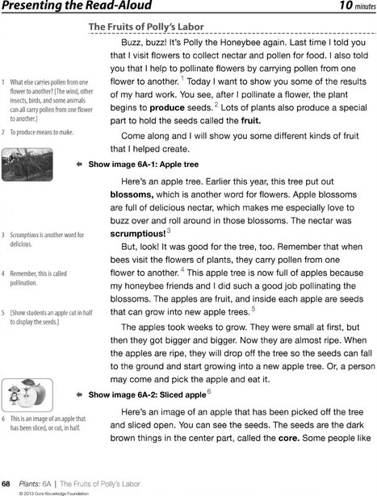
My Favorite Fruit
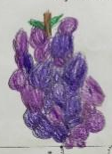
The part of a plant that holds the seeds is called the (fruit). My favorite fruit is (purple/color of fruit). It is scrumptious. It is (grapes/name of fruit).
*The italicized print represents the parts of the sentences students are supposed to trace. The parenthetical phrases represent places where students fill in the blanks, with prompting and support.

Overview
Kindergarten students listen to their teacher read a story, then trace sentences, filling in the blanks to indicate the special part some plants produce to hold the seeds is called the fruit, their favorite fruit and the color of that fruit. This assignment is partially aligned to the standards because the text is appropriate but the task is weak. Students do not need to focus on enough important elements of the text to answer the question.
About the Text
Title and Author | "The Fruits of Polly’s Labor"
What is the Lexile Level of this text? | 600L-700L
Based on Lexile, which grades is this text intended for? | 2-3
Is the text qualitatively complex enough for the grade? | Yes
Is this text fiction or non-fiction? | Non-Fiction
Is this text authentic or was it written for educational purposes? | Written for educational purposes
Does the text provide sufficient detail to build knowledge of a worthwhile topic and/or is it worth reading closely and re-reading? | Yes

Related Standards
RI.K.1: With prompting and support, ask and answer explicit questions about key ideas and details, and make logical inferences to construct meaning from the text.
The assignment is partially aligned to this standard because while the task has students write about their favorite fruit – which is the topic of text – students only have to identify information explicitly from the text once and are not prompted to make an inference.

RI.K.4: With prompting and support, ask and answer questions about unknown words in a text.
The assignment is strongly aligned to this standard because students are asked to determine which word from the text correctly fits in the first blank.

RI.K.10: With prompting and support, flexibly use a variety of comprehension strategies (i.e., questioning, monitoring, visualizing, inferencing, summarizing, using prior knowledge, determining importance) to make sense of grade-level appropriate, complex literary texts.
The assignment is partially aligned to this standard because while students engage in reading grade-appropriate text, they are not prompted to use comprehension strategies and the task doesn't require students to demonstrate understanding of textual elements beyond one vocabulary word.

L.K.1.A: When writing or speaking, demonstrate appropriate use of common nouns and verbs.
The assignment is weakly aligned to this standard because students trace words rather than generating the words themselves, with the exception of the fruit name and color.

L.K.2: When writing: a. Capitalize the first word in a sentence and the pronoun I; b. Recognize and name end
Punctuation; c. Write a letter or letters for most consonant and short vowel sounds; d. Spell simple words phonetically, drawing on knowledge of sound-letter relationships.
This assignment is weakly aligned to this standard because students are tracing, though this particular student does include end punctuation in sentence 1 and 3.

L.K.4: Determine or clarify the meaning of unknown and multiple-meaning words and phrases based on kindergarten reading and content.
This assignment is strongly aligned to this standard because the task includes the word “scrumptious” from the text. Using the word scrumptious in the context of their favorite food may help students to clarify the meaning of the word.

Why is this assignment Partially aligned?
This assignment is partially aligned because the text is strong, but the task missed opportunities to more fully align to grade level standards:
The texts are grade-appropriate. The task is based on a read-aloud that uses a text full of rich vocabulary and builds knowledge about how fruit grows. Read-aloud texts should be 2-3 grade levels above students expected independent reading level; this text, The Fruits of Polly’s Labor, is in the 2-3 grade band making it appropriate for read-aloud in kindergarten.
Minimal understanding of the text is necessary for students to fill in the blanks. Students only write about one key idea in the text. The prompt would be stronger if students were required to answer more text-dependent and text-specific questions. Filling in the blanks for favorite fruit and the color of the fruit is neither.
The question lets students practice their language skills through writing, but includes words inappropriate for decoding in kindergarten. Handwriting practice is important for students in kindergarten. However, if a task is intended to be a handwriting/encoding practice activity it should only include words that are decodable in kindergarten (i.e., not scrumptious).
When kindergarten activities are intended to be a response to text, the prompt should focus on the key ideas in the text (in this case: seeds are beginning of new plants, some plants produce fruit to hold seeds, etc.) This task focuses on writing about a favorite fruit, which students could do without reading the text, and one of the key ideas in the text. The opportunity to have students write about more key details is missed.

