8th Grade Reading and Writing Assignment
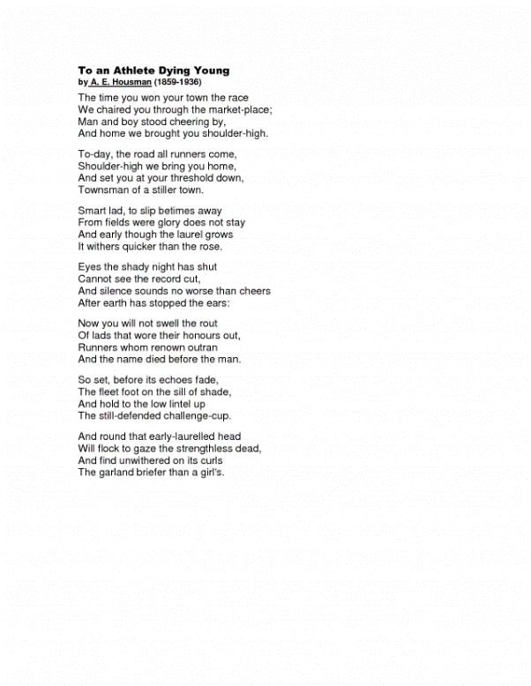
This assignment is strongly aligned to the standards.
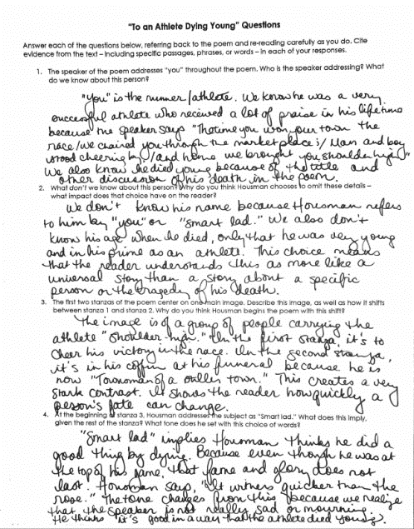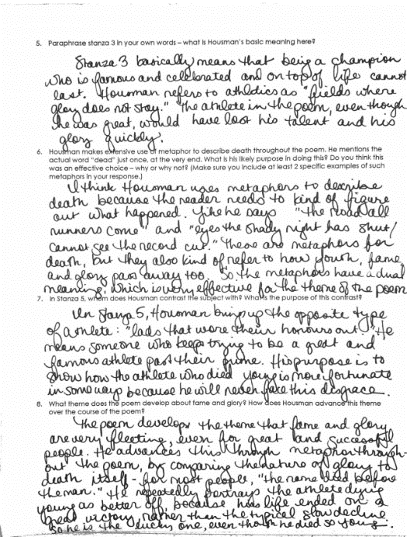

Overview
Eighth-grade students read “To an Athlete Dying Young,” a poem by A.E. Housman. The text is grade-appropriate and worthwhile, and introduces students to complex literary elements, such as the use of imagery and metaphor. The questions are purposefully sequenced to build students’ understanding, beginning with basic comprehension (e.g., “Who is the speaker addressing? What do we know about this person?”) and moving ultimately to deeper meaning (“What theme does the poem develop about fame and glory?”). Students are expected to support their responses with evidence from the text.

About the Text

Title and Author | “To an Athlete Dying Young” by A.E. Housman
What is the Lexile Level of this text? | As a “non-prose” (NP) text, the poem does not have a Lexile Level.
Based on Lexile, which grades is this text intended for? | N/A
Is the text qualitatively complex enough for the grade? | Yes
Is this text fiction or non-fiction? | N/A (poetry)
Is this text authentic or was it written for educational purposes? | Authentic
Does the text provide sufficient detail to build knowledge of a worthwhile topic and/or is it worth reading closely and re-reading? | Yes

Related Standards
RL.8.1: Cite relevant textual evidence to support analysis of what the text says explicitly as well as inferences drawn from the text.
The assignment is strongly aligned to this standard. Task directions require students to cite textual evidence, including specific language from the poem, to support their responses to each question.
RL.8.2: Determine themes of a text, and analyze how they are developed through relationships of characters, setting and plot, citing textual evidence, paraphrasing or summarizing.
The assignment is strongly aligned to this standard. The final question asks students to describe the theme, as well as to analyze how the poet develops it throughout the text. The sequence of questions progressively builds to this cumulative understanding of theme/central idea in the poem.
RL.8.4: Determine the meaning of words and phrases as they are used in a text, including figurative and connotative meanings; analyze the impact of specific word choices on meaning and tone, including but not limited to analogies or allusions to other texts.
The assignment is strongly aligned to this standard. Several questions (question 4, for example) direct students to analyze the impact of specific word choice on meaning and tone. Questions (question 6, for example) also help students unpack the author’s use of figurative language.
RL.8.10: By the end of the year, flexibly use a variety of comprehension strategies (i.e., questioning, monitoring, visualizing, inferencing, summarizing, synthesizing, using prior knowledge, determining importance) to read, comprehend, and analyze grade-level appropriate, complex literary texts independently and proficiently.
The assignment is strongly aligned to this standard. Questions 1-3 require students to demonstrate comprehension and inferencing.
L.8.5: Students have multiple opportunities to demonstrate their understanding of figurative language in context of a grade appropriate text.
The assignment is strongly aligned to this standard. Students interpret imagery in question 3, tone in question 4, and metaphor in question 6.
Why is this assignment strongly aligned?
The assignment allows students to engage with a worthwhile, complex poem. The text exhibits exceptional literary craft, using imagery, metaphor, and irony to develop a theme about the fleeting nature of fame and glory.
The questions require students to read carefully and focus on key details. Students are required to examine and explain specific stanzas, word choice, and literary devices.
The questions allow students to articulate their ideas about the text in writing. Students are required to support those ideas with specific, relevant details from the poem.
Students practice formal, academic writing. In their written responses, students are expected to demonstrate command of language conventions.

