5th Grade Reading & Writing Assignment
This assignment is partially aligned to the standards.

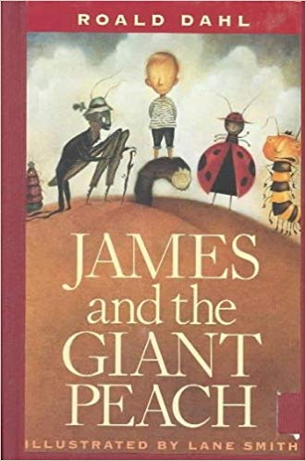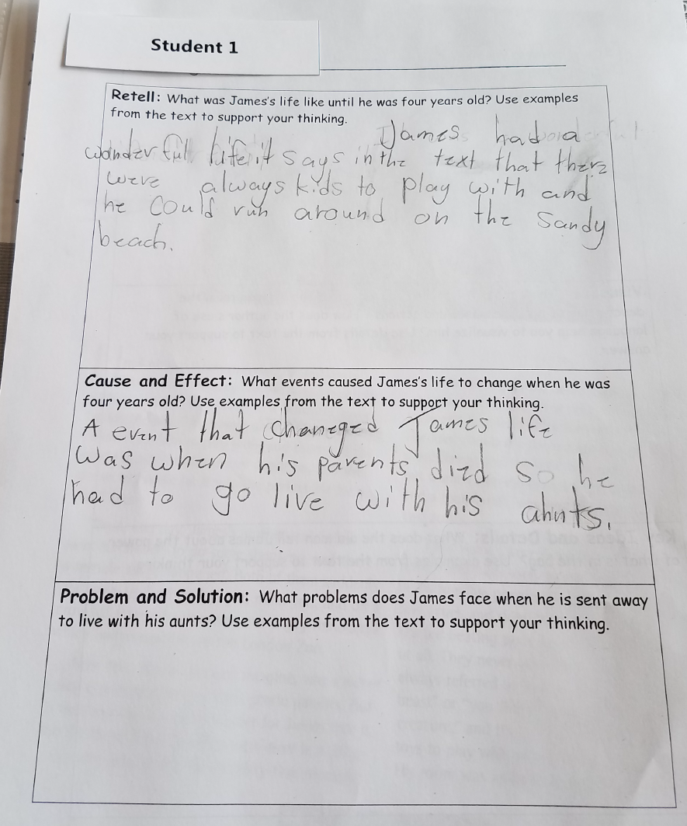
Overview
Fifth-grade students read from the Roald Dahl novel James and the Giant Peach, then answer three short-answer questions about the text. The assignment is partially aligned to the standards because the text is appropriate for fifth grade, but the accompanying questions are minimally aligned to fifth grades standards.

About the Text

Title and Author | "James and the Giant Peach" by Roald Dahl
What is the Lexile Level of this text? | 870
Based on Lexile, which grades is this text intended for? | 4-5
Is the text qualitatively complex enough for the grade? | Yes
Is this text fiction or non-fiction? | Fiction
Is this text authentic or was it written for educational purposes? | Authentic
Does the text provide sufficient detail to build knowledge of a worthwhile topic and/or is it worth reading closely and re-reading? | Yes

Related Standards
RL.5.1: Quote accurately from a text when explaining what the text says explicitly and when drawing inferences from the text.
The assignment in partially aligned to this standard. The task calls for students to “use examples from the text to support your thinking”. To fully meet the demands of this standard, the task would need require students to “quote accurately” from the text.
RL.5.2: Analyze how the theme is reflected in the text, including but not limited to poems, stories and dramas, and cite relevant implicit and explicit evidence to support thinking.
The assignment is weakly aligned to this standard. While the questions probe about events and challenges experienced by the main character, they do not prompt students to determine a theme based on these details, which is the main substance of this standard.
RL.5.3: Compare/contrast characters, settings or events in a story or drama, using specific details to analyze their interaction over the course of the text.
The assignment is weakly aligned to this standard. Students are asked to describe the experience of the main character and how he interacts with his aunts and to support their explanation with details from the text. To fully align to this standard, the prompt would need to focus more specifically on comparing and contrasting each character’s experience.
RL.5.10: By the end of the year, flexibly use a variety of comprehension strategies (i.e., questioning, monitoring, visualizing, inferencing, summarizing, synthesizing, using prior knowledge, determining importance) to read, comprehend and analyze grade level appropriate, complex informational texts independently and proficiently.
The assignment is strongly aligned to this standard. Students do need to comprehend the information presented in an adequately complex and worthwhile text to complete this task.

Why is this assignment PARTIALLy aligned?
This assignment is partially aligned because although the text is strong, but the task quality is mixed:
The text is grade-appropriate. The task is based on a fantasy novel written by the acclaimed author Roald Dahl. It is appropriately challenging in terms of structure, vocabulary, and meaning, and builds students’ cultural knowledge.
The accompanying questions require analysis of the grade level text, but do not focus students on the full level of analysis required by fifth grade standards. The questions prompt students to recount events and details from the text, including the impact of events on the main character. In fifth grade, students should go beyond re-tell to explain what the text says and draw inferences from the text. They should be asked to determine a theme, and to assess how an event impacts different characters in both similar and different ways.
Students are not required to quote the text—a critical component of fifth-grade standards. Though students are asked to use examples from the text to support their thinking, they are not prompted to quote the text in their responses, which is a core shift from 4th to 5th grade standards.

