Grade 2 Learning Experience Example: 2.E.KE.1

Introduction
The following learning experience was developed by the Kentucky Historical Society to demonstrate an implementation example aligned to the Kentucky Academic Standards (KAS) for Social Studies 2.E.KE.1.

Kentucky Academic Standards (KAS) for Social Studies alignment:
2.E.KE.1 Provide examples of each of the factors of production in Kentucky.
Educators may have to engage students with a standard multiple times throughout a year in order to meet the full intent of the standard. As a result, the following assignment example may not encompass the entire scope of the standards identified.

Overview:
Students will learn about the factors of production of coal in Kentucky, with a focus on land, labor, and capital, through analyzing artifacts.

Compelling Question: How are the factors of production used in Kentucky to produce goods and services?

Supporting Question: What are the factors of production used in coal mining in the past and today?

Teacher Notes

Visual Thinking Strategies (VTS): Opening with an Image to Build Context
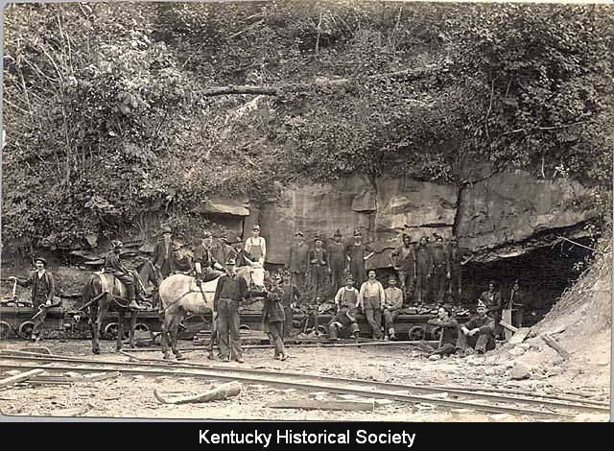  Coal miners at entrance to a Kentucky mine (ca. 1918) | Guiding Questions for VTS:  What's going on in this picture?  What do you see that makes you say that?  What more can we find?

Present the photograph above featuring Kentucky coal miners. Employ Visual Thinking Strategies (VTS) to enrich students' visual literacy, historical understanding, and critical thinking abilities concerning KAS 2.E.KE.1. Following the VTS session, explain that the photograph is from the past (ca. 1918) and shows coal miners outside a mine entrance in Kentucky.

Introduce coal mining to students by completing the first two columns of a KWL chart as a whole group. Begin by asking students “What do you know about coal mining?” Record any responses students may share while addressing any inaccuracies or misconceptions that may be shared. Next, have students complete the second column by asking them “What do they wonder about coal mining?” As students share their wonderings, record them in the chart. Students will complete this chart at the end of the learning experience.

Next, inform students that they are going to learn more about the coal industry by watching the following video:

Britannica. (n.d.). Discover the challenges faced by coal miners and the changes to the industry between 1917 and 2017. https://www.britannica.com/video/213108/Workers-challenges-Midwestern-coal-industry

As students are watching the clip, have them answer the following questions:
- Who mined coal in the past?
- What were some of the difficulties with coal mining?
- Who mines coal today?
- How has coal mining changed from the past to today?

Once students have watched the video, review the questions with the whole group and check for student understanding.

Now that students have a basic understanding of coal mining to set the context for this investigation, review the definitions of factors of production while providing examples from the video. This learning experience necessitates prior exposure to the factors of production in Kentucky. It goes beyond mere definitions, emphasizing the identification of these factors specifically within the realm of coal mining. Inform students that the factors of production are land, labor, capital and entrepreneurial skills. Define these terms with students while providing examples from the video:

Term | Definition | Example from video
Land | Natural resources used to produce goods and services, such as water and forests. | Coal
Labor | People who produce or provide goods and services | Coal miners
Capital | Machinery, tools, money used for investment. | Mining machines, dynamite, hard hats, lanterns, pickaxes
Entrepreneurial Skills | The qualities of a person who combines the other factors of production to make a profit. | The coal companies
Next, have students learn more about the factors of production in mining coal in Kentucky. Show students the interactive map found below:

Kentucky Mine Mapping Information System. (n.d.). Kentucky Coal Mine Maps. https://eppcgis.ky.gov/minemapping

This map provides different information that can be toggled on and off, including the Kentucky county boundaries, mined out areas and available mining areas. Explore this map with students to provide context for where in Kentucky coal mining takes place.

Next, inform students that they will be examining artifacts to learn more about the factors of production in mining coal in Kentucky. Introduce this new vocabulary word to support student learning and understanding for the upcoming segment of the learning experience.

Artifact- an object from the past that helps us learn about how people lived, worked, and played many years ago.

After introducing the new vocabulary, explain to students that they will be exploring photographs of artifacts used in the past.

Artifact List:

1. Pick (1997.21)
2. Miner’s Cap (1989.7.16)
3. Bird Cage (2004.45.1)
4. Carbide Lamp (1989.7.19)
5. Coal Car (IL8-2000.1)
6. Knee Pad (1989.7.9ab)
7. Coal Ball (2016.00.346)

As a whole group, model how to analyze an artifact or more from below using the Artifact Analysis Chart provided in the Kentucky Historical Society (KHS) document. The remaining artifacts can be analyzed in a small group or continued as a whole group. Use both the images and the descriptions provided in the links to support your analysis.

A Coal Miner’s Essentials
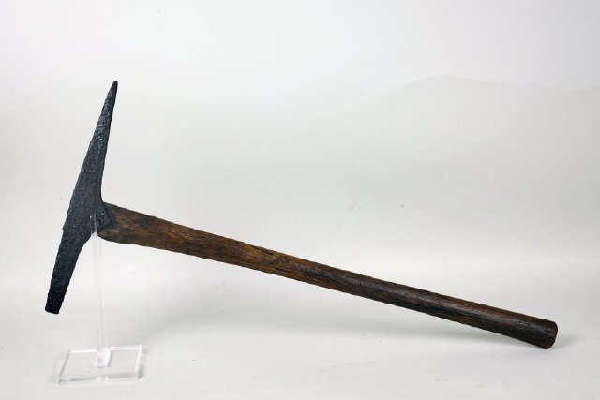
Pick (ca. 1920)

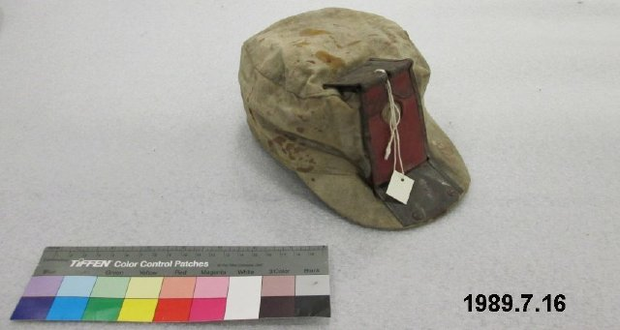
Miner’s Cap (ca. 1920-1950)

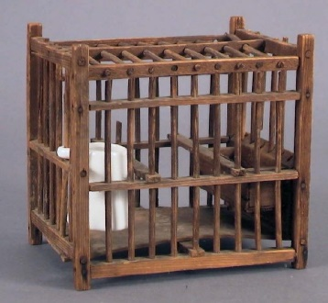
Bird Cage (ca. 1900)

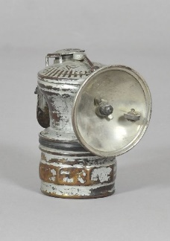
Carbide Lamp (ca. 1940)

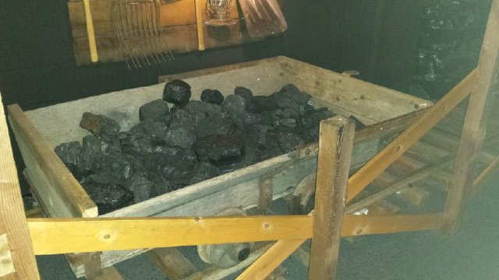
Coal Car (ca. unknown)

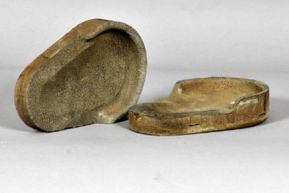
Knee Pads (ca. 1930)

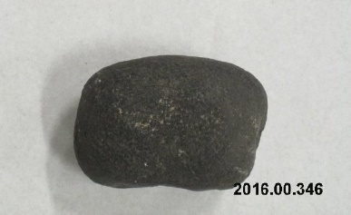
Coal Ball (ca. unkown)

After completing the Artifact Analysis Chart, discuss the following questions using the Think-Pair-Share strategy:

Discussion Questions:
- What do the artifacts tell us about the time when it was made and used?
- Do we still use these artifacts today? If so, how are they different?

Formative Assessment
What are the factors of production of coal mining used in the image below?

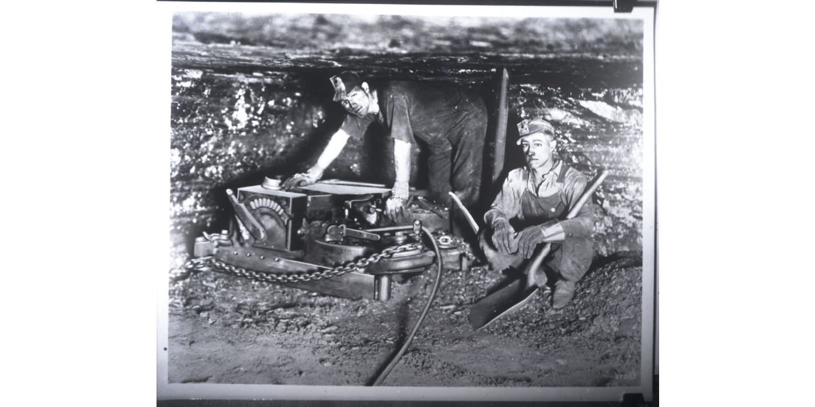
Coal mining (ca. 1920-1940)

Circle or label land, labor, and capital in this photograph of two Kentucky coal miners. These differentiated exit tickets can help assess comprehension of the material taught and identify adjustments needed to meet student needs when continuing to work with KAS 2.E.KE.1.

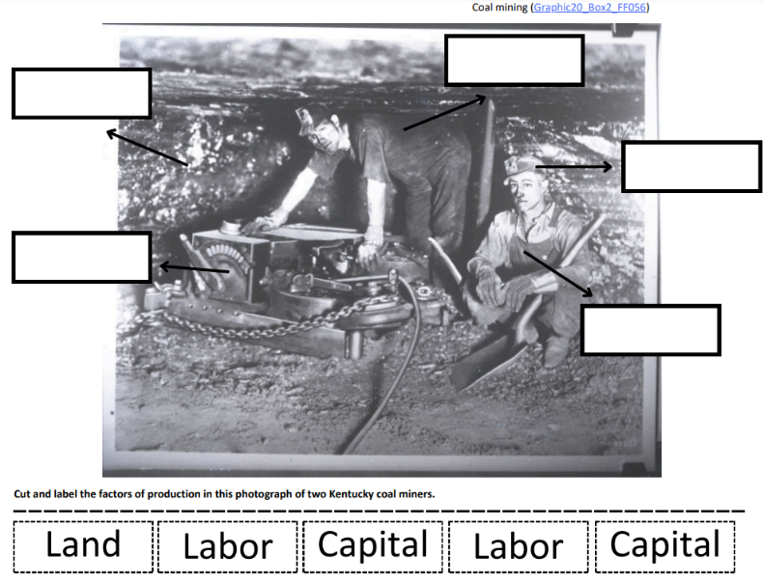 | 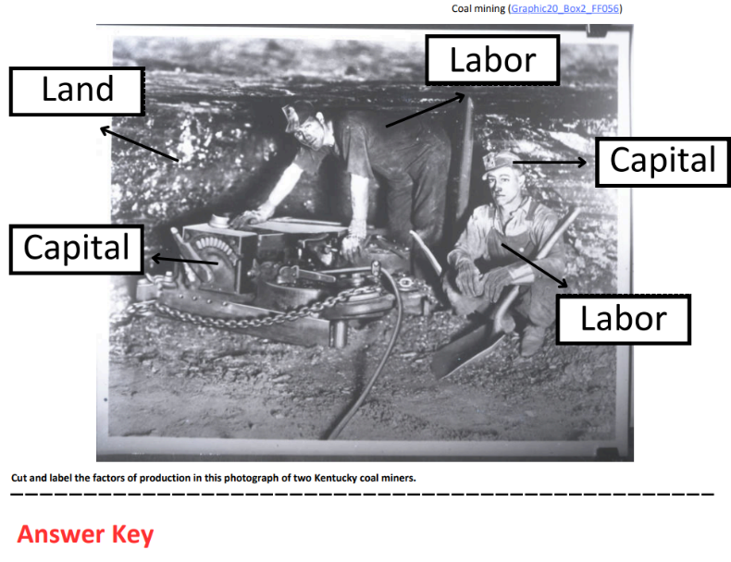
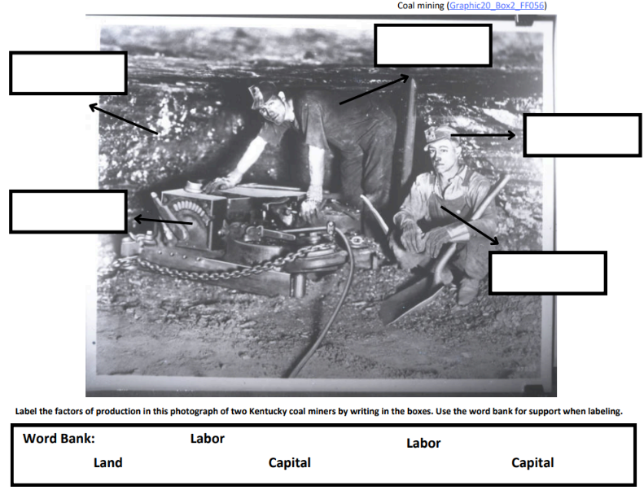 | 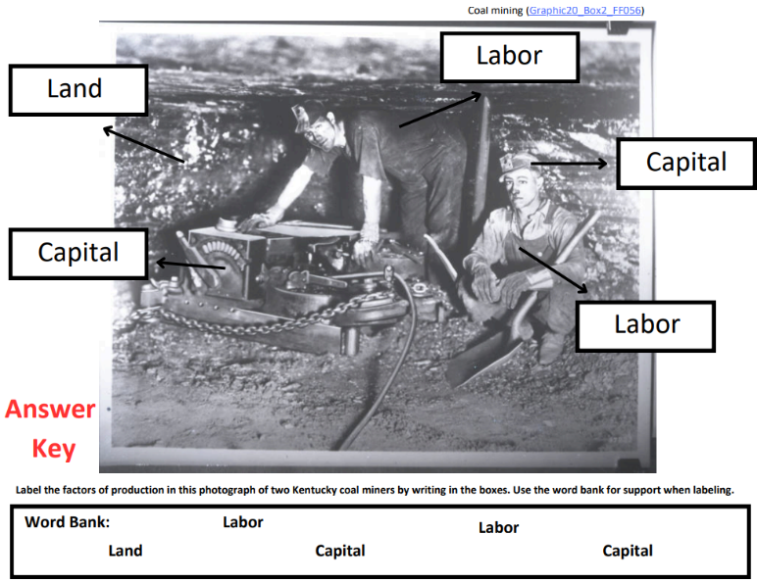
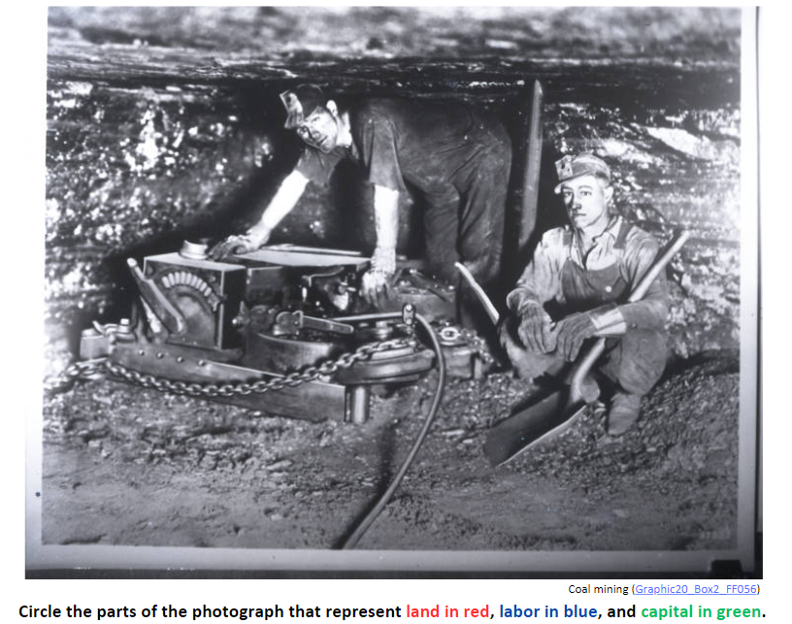 | 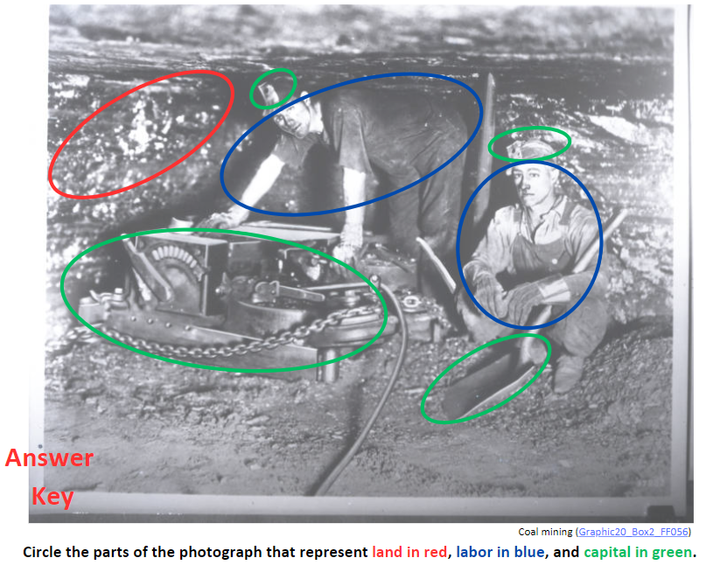

Task Aligned to the Supporting Question
Answer the supporting question: What are the factors of production used in coal mining in the past and today?
Complete this graphic organizer using the sources you looked at in this lesson. Write or draw example(s) of the factors of production used in coal mining in Kentucky.

 | Past | Today
Land
Labor
Capital
Entrepreneurial Skills

An example of a completed graphic organizer is below:
 | Past | Today
Land | Coalfields in Kentucky | Coalfields in Kentucky (with some areas mined out)
Labor | Coal miners (men only) | Coal miners (men and women)
Capital | Pickaxes, miner’s cap, lanterns, etc. | Hard hats, machinery
Entrepreneurial Skills | Coal companies | Coal companies

