[All Grades] Building a Culture of Math Learning Session 8 Facilitator’s Guide

Summary
Effective teaching of mathematics requires cultivating a culture of math learning within the classroom - this culture encourages students to take academic risks, to persevere when content becomes challenging, to utilize a myriad of mathematical tools and models to approach new problems, to share their own thinking, and to offer feedback on the thinking of others. To cultivate this kind of culture, teachers must model through words and actions the importance of grappling with content to build a deep understanding; they must equip students with the content knowledge and problem solving tools to find multiple pathways to a given solution; and they must facilitate regular opportunities for students to engage in the practices of mathematics, including analyzing their own misconceptions and refining their approaches as part of the learning process.

Throughout this content cycle, teachers will explore these instructional moves and connect them directly to the mathematical content and standards for mathematical practices within the Kentucky Academic Standards (KAS) for Mathematics. While this content cycle will do a deep dive of the 3 Standards for Mathematical Practice indicated below, the KAS for Mathematics require teachers to implement all 8 Standards for Mathematical Practice. To support teachers in elevating different SMPs during their instruction, the KAS for Mathematics tag relevant MPs to every content standard. The inclusion of those tagged MPs does NOT mean those are the only ways students can engage in the practices while learning that content. The inclusion of tagged MPs also doesn’t mean that those practices automatically happen throughout instruction on that content standard. How instruction is designed will determine how students engage with the content. This content cycle will support educators in purposefully planning and designing instruction to provide students with opportunities to engage in the practice standards while engaging with the content standards.

This content cycle focuses specifically on:
- SMP1. Make sense of problems and persevere in solving them
- SMP4. Model with mathematics
- SMP3. Construct viable arguments and critique the reasoning of others

See the Mathematics Professional Learning Modules for additional learning around the Standards for Mathematical Practice or for guidance/support with implementing the KAS for Mathematics.

Essential Questions
- How do the Standards of Mathematical Practice support teachers in creating and sustaining a culture of learning in math classrooms?
- How can teachers explicitly introduce and authentically incorporate the Standards of Mathematical Practice within their instruction?
- How can teachers create a “culture of error” where students feel comfortable taking academic risks, struggling through high-quality tasks and discussing their misconceptions to advance their own learning?
- Specifically, how can an emphasis on problem-solving (SMP 1), modeling to understand “concepts before procedures” (SMP 4) and justification of answers (SMP 3) create an environment where students are encouraged to own their own learning?

Enduring Understandings
- Teachers should communicate that perseverance, which requires a willingness to take risks and make mistakes, is a critical part of the learning process.
- In order for students to own their own learning, teachers intentionally design instruction which places equal value on the development of mathematical content and mathematical practices.
- True conceptual understanding of math comes from connecting multiple representations (concrete, representational/pictorial, and abstract).
- To build deep and enduring understanding of math, teachers must place emphasis on the “how” and “why” and push students to justify their answers,
- Meaningful teacher and peer feedback allow for students to monitor their progress toward learning outcomes and provides students with opportunities to reflect on their own learning.

Key Components of Cycle
The Learning Cycle includes the following components to support shifts in instruction:
- Shared Learning: Learning sessions where teachers learn new knowledge and skills aligned to the topic of the content cycle. This might be designed in a variety of ways, including reading and discussing an article, studying a classroom video or doing some group practice of a particular planning component.
- Planning & Practice: Opportunities for teachers to apply the content they are learning within this content cycle to review/revise classroom instruction. This could include analyzing units/lessons using tools to evaluate alignment to the KAS for Mathematics, rehearsing lessons, watching and reflecting on videos of their classroom practice, etc.
- Student Progress Monitoring: This is an opportunity for teachers to examine student progress aligned to the topic of the cycle. This can include formative student work analysis, end of unit assessments, culminating tasks, etc.

Over the course of this 12-week learning cycle, teachers will:
- Examine instructional materials and tasks using the KAS for Mathematics and supporting resources;
- Consider the implications of these materials as they relate to changes in both teacher planning and practice;
- Engage in lesson study, practice in content delivery and peer-feedback, and reflect on progress by regularly revisiting goals and analyzing student data

Note that these components do not necessarily happen in a perfect rhythm. For example, depending on the content, there may be several shared learning sessions before a planning & practice, or there may be several cycles of shared learning and planning & practice before student progress monitoring.

Session | Type of Learning | Objective(s) | Supporting KAS Resources | Assessment of Learning
Session 8 | Planning & Practice | - Apply learning to instructional planning and practice  - Give and receive feedback from colleagues in order to revise plans and refine practices | - KAS for Mathematics  - Engaging the SMPs: Look fors and Question Stems  - Breaking Down a Mathematics Standard resource  - Mathematics Assignment Review Protocol | - Session tasks: Analyze and annotate unit/lesson to leverage the given Standard(s) of Mathematical Practice

Preparation:
This Facilitator’s Guide is designed to accompany
- [All Grades] BCML Session 8 PowerPoint
Participants should be given access to the following documents to engage in the learning for this session:
- [All Grades] BCML Session 8 Handout 1
- [All Grades] BCML Session 8 Handout 2

Session Agenda Time (75-90 min)
- Slides 1 - 5: Welcome, norms, objectives & agenda (10 min)
- Slides 6 - 9: Prepare for the Planning & Practice Protocol, complete planning portion (20 min)
- Slides 10 - 11: Connecting practice to equity, complete practice rounds (16 min)
- Slide 12 - 13: Revising portion (17 min)
- Slide 14 - 15: Reflection and closing whip around (10 min)

Facilitator Notes | Accompanying Slide
Slide 1:  (1 min): Welcome  Session Summary: In this planning and practice session, teachers will apply learning of the Standard(s) for Mathematical Practice studied in the previous new learning session. As teachers plan, they will focus on the Planning and Instructional Look-Fors that will support them in meeting goals set in the previous session. Teachers will practice with a colleague, eliciting specific feedback to aid in effective instructional implementation. After collaborating with colleagues and giving/receiving feedback, teachers will modify their approach and complete or refine their instructional plans. | 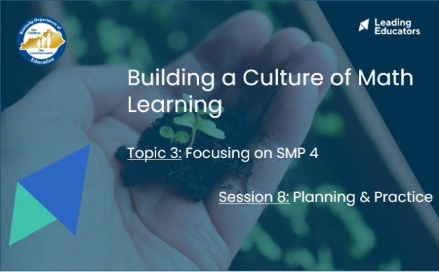
Slide 2:  (2 min) Facilitator says:  - “Let’s revisit our 12-week arc of learning to take stock of where we are now. First, let’s ground ourselves in this content cycle’s guiding principle in the yellow box. Can someone please read that out loud?”  - “In green, you’ll see our four major topics of learning. For each topic of learning, we’ll engage in a three-week learning cycle that will include a shared learning session, a planning and practice session, and a student progress session. Our first topic of learning will include an overview of all 8 Standards for Mathematical Practice, so we can get a big picture idea of what excellence in math learning should look like for students. In the next 3 topics, we’ll narrow our focus to cover just one SMP so we can better internalize and apply our learning. As you’ll see, the three SMPs we will focus on are:  - Standard for Mathematical Practice 1: Make sense of problems and persevere in solving them.  - Standard for Mathematical Practice 4: Model with mathematics.  - Standard for Mathematical Practice 3: Construct viable arguments and critique the reasoning of others.”  - “While this content cycle will do a deep dive of 3 Standards for Mathematical Practice, the KAS for Mathematics require teachers to implement all 8 Standards for Mathematical Practices. To support teachers in elevating different SMPs during their instruction, the KAS for Mathematics highlights connections between content standards and SMPs. The inclusion of those SMPs does NOT mean those are the only ways students can engage in the practices while learning that content. It also doesn’t mean that throughout instruction on that content standard those practices automatically happen. How instruction is designed will determine how students engage with the content. See the KY Standards Mathematics Professional Learning Modules for guidance.”  - [Click to play animation] “During this Planning & Practice session, we’ll take our shared learning and apply it to an upcoming lesson to ensure our shared learning transfers to teacher practice and improved outcomes for students.” | 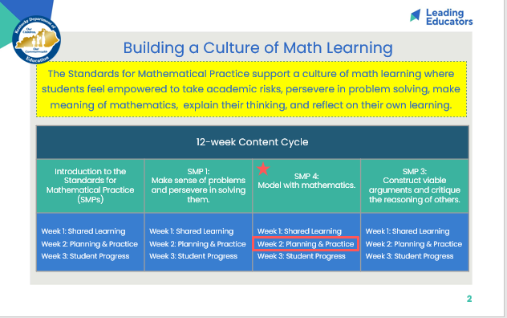
Slide 3:  (4 min) Review team norms and/or facilitate a quick team connector/icebreaker. | 
Slide 4:  (2 min) Facilitator says:  - “Please think back to the Reflection and Looking Ahead document you completed during the shared learning portion of this content cycle. Take a couple of minutes to reflect on the progress you’ve seen in your practice and in your students over the past week. What are some ways you want to continue to grow?” Capture your thoughts on Handout 1.  *Note:  - Facilitators may have chosen to collect this artifact at the end of the shared learning session. If so, facilitators should plan to return the artifact to teachers to hold onto for this Planning and Practice session and the upcoming Student Progress session occurring next week. | 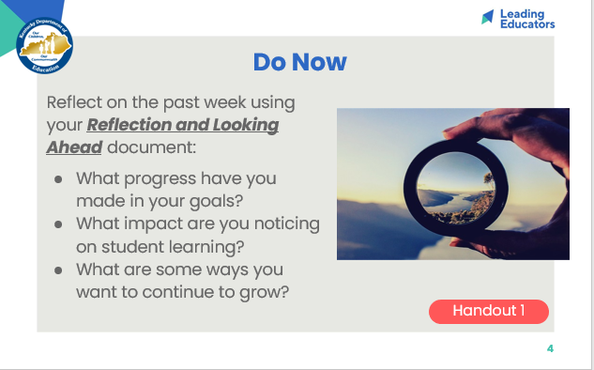
Slide 5:  (1 min) Ask teachers to popcorn out the objectives and agenda.  (1 min) Facilitator says:  - “This week, we’ll engage in a planning protocol in which we plan and receive feedback on strategic ways that we can leverage our learning from last week as we work toward the goals and look-fors of this cycle. Just like musicians rehearsing, we are tuning and refining our practice off-stage before performing for our audience of students.”  - “Before we dig in, take a moment to share with a partner the reflections you noted during the Do Now. Additionally, discuss the instructional evidence you intend to include in your plan today that will reflect the growth identified in your Reflection and Looking Ahead sheet. Revisiting our goals prior to planning will help to narrow our focus on the portions of our lesson that we want to receive feedback on today.” | 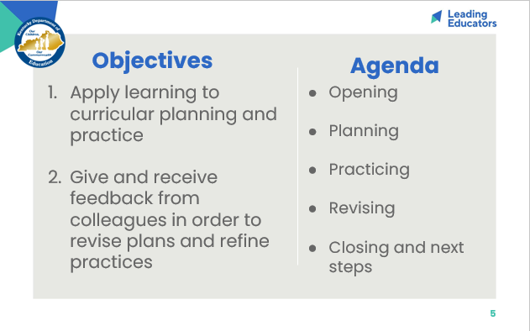
Slide 6:  Preparing for the Protocol  (2 mins) Facilitator says:  - “In our previous session, we discussed the importance of the Standards for Mathematical Practice as the building blocks for creating a culture of math learning. Today, we’re going to plan and practice implementing our shared learning. Please make sure you have the following materials pulled up:  - [Click for animation] “The KAS for Mathematics, which is available in PDF version in the BCML appendix folder.”  - [Click for animation] “Your curriculum - unit overviews, lesson plans, materials, etc - and/or other resources.”*  - [Click for animation] “Any lesson internalization, planning, or review tools - for example, lesson internalization guides, planning templates, review protocols. In the Appendix folder, you’ll find the KAS for Mathematics Assignment Review Protocol, which has guiding questions that will support you in evaluating current materials to gauge alignment to the KAS for Mathematics.”  - “If you haven’t planned out your lesson yet, [click to play animation] handout 2 provides a lesson planning tool where you can utilize the guiding questions from the ARP to begin your lesson design.”**  “Remember, as we engage with the new KAS for Mathematics, we may need to do additional work to break down the standard before we dive into lesson planning and creating an exemplar student response to an aligned task. Teachers are encouraged to use the Breaking Down a Mathematics Standard tool (also found in the BCML Appendix) to continue to deepen their understanding of content standards.”  *Note:  - *If applicable, facilitator may ask teachers to bring other curricular planning resources based on school/district context.  - **Teachers may choose to bring already completed lesson plans and/or other lesson planning templates to use during this time. | 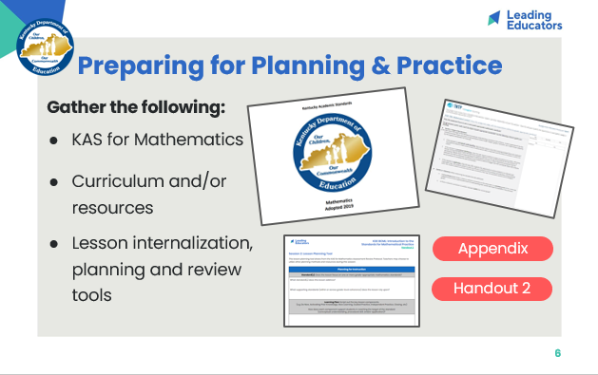
Slide 7:  Starting with Intended Student Learning  (1 min) Facilitator says:  - “As we prepare to plan, identify a partner to work with. With that partner, discuss the intended student learning for lesson you’ll be scripting or analyzing today. Knowing the intended student outcome for a given lesson is essential so that you can provide each other with specific and targeted feedback during our practice today.”  (2 min) Teachers explain the lesson objective and intended student outcomes for the lesson they are planning and/or analyzing. | 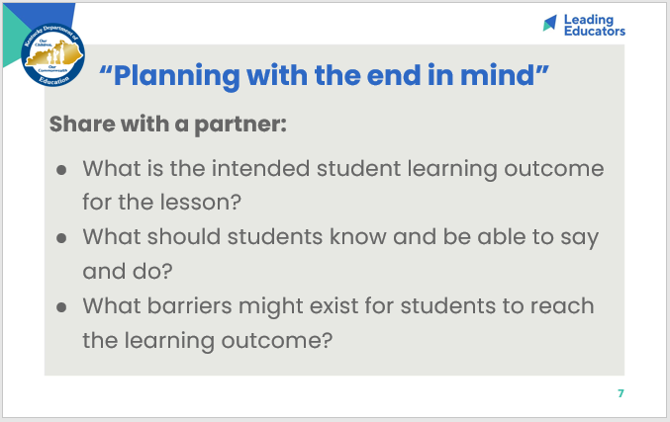
Slide 8:  Planning  (1 min) Facilitator says:  - “Today we’ll be working like musicians who annotate their scores before they perform these masterpieces on stage. We have a wealth of different curricular resources at our disposal, so it’s important to 1) design lessons that utilize high quality resources to reach the targets of the KAS for Mathematics and 2) analyze our lessons against criteria for success. It’s our analysis and adaptation of the materials that will allow us to implement them masterfully with our students. In our first phase of planning today, we’ll hone in on the portion of your lesson that best aligns with the look-fors from our shared learning last week. As you take into consideration the student outcomes for this part of the lesson, plan your instructional approach and/or analyze the segment of the lesson that will enable you to receive targeted feedback aligned to last week’s shared learning and your goals.”  Note: Before releasing teachers to plan, walk through the following slide (Slide 9) to provide teachers with resources/guiding questions to use during this planning segment of the session. | 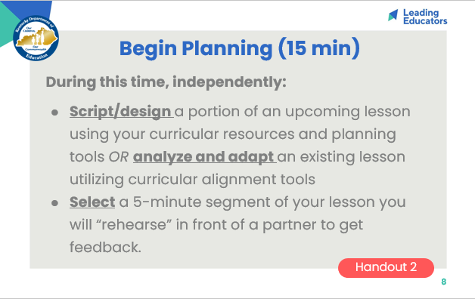
Slide 9:  Planning  (14 min) Individually or in co-teaching teams, have teachers plan and/or analyze a portion of their lesson that will elevate achievement for all students. Teachers should also plan for effective implementation (i.e. oral instructions, visuals, relevant routines, etc.) of the instructional approach. When planning, teachers should consider how implementation aligns to the intended student learning and how it will impact and support the diverse needs of students.  *Facilitator Notes:  - During the planning process, display this slide (Slide 9) to help teachers consider if their lessons need revision and provide guiding questions to support their revision process.  - Based on where teachers are in the planning process for an upcoming lesson, this “planning” time may look different from individual to individual. Some teachers may be in the initial planning phase where they are curating curricular resources and drafting a lesson plan. Handout 2 provides a lesson planning template aligned to key indicators from the KAS for Mathematics Assignment Review Protocol.  - Alternatively, teachers may already have a completed lesson plan pulled from their existing curriculum. Encourage teachers to use the Assignment Review Protocol to evaluate tasks within their existing curriculum to ensure alignment to the KAS before using those tasks with students.  - In utilizing this planning time, teachers should think ahead to what segment of their lesson they will “rehearse” with their feedback partner. Teachers are encouraged to select a segment of their lesson where they are actively implementing shared learning from this content cycle. Some possible segments may be:  - 5 minutes of an introduction to new material where the teacher is introducing SMP 1 to students.  - 5 minutes of a guided practice example where the teacher is explicitly connecting a conceptual idea or procedural skill to an SMP.  - 5 minutes of an end of class debrief where the teacher poses open ended questions for students to reflect on their use of SMPs in the given lesson | 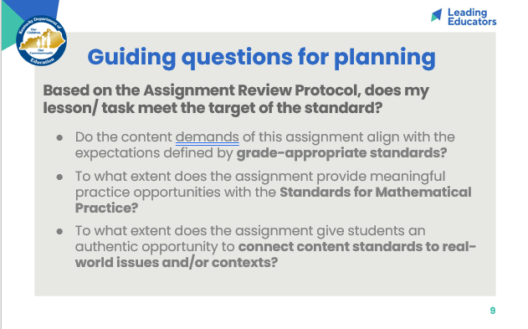
Slide 10:  (2 min) Facilitator says:  - “We are going to deliver a portion of our lesson in order to receive feedback from a colleague. Just like musicians, the first time we “perform” shouldn’t be in front of our real audience (our students). Authentic practice means we actually put on our “teacher hat” and deliver the lesson to our feedback partner as though they were our student. This might feel silly at first, but it provides an authentic opportunity to identify sticking points before we are in front of students. Push yourself to actually deliver the lesson segment. DO NOT just explain the lesson or “talk through” the lesson with your colleague; actually deliver the learning as you would in front of your class.”  - “Before we begin our ‘off-stage practice’ let’s reflect: Why is lesson rehearsal important? How does it connect to equity?”  *Note: Listen for and reinforce these key ideas...  - Lesson rehearsal allows us to work out sticking points “off-stage” before we’re in front of students. By practicing delivery beforehand, we can see what parts of the lesson flow well, what areas we may need to revise to improve clarity, etc...  - Many professions practice: Musicians rehearse, doctors' practice surgical procedures before they do them on living people, athletes go to practice. Teachers have one of the highest stakes' audiences of all - and we should practice too!  - Lesson rehearsal is connected to equity for students because it helps teachers refine their instruction before bringing it to students. This way all kids get their teacher’s very best.  - Lesson rehearsal is connected to equity for teachers because we all vary in terms of our current knowledge and experience. Practice gives us a chance to prepare for our students in an environment where can get feedback and support from others. | 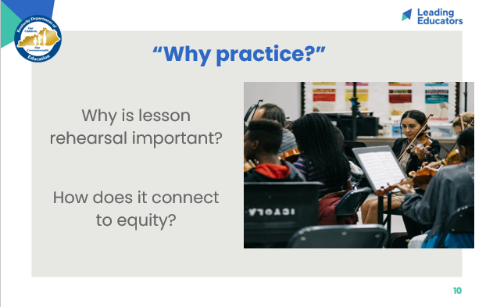
Slide 11:  Practicing  (14 min total) Have teachers follow the practice/feedback loop rounds outlined below.  - Practice/Feedback Loop Round 1 (7 min): Partner 1 delivers lesson segment. Partner 2 provides feedback for Partner 1 to record in their Handout capture table. Partners may consider the following questions when providing feedback:  - Does the lesson work?  - What modification would strengthen this lesson component for all students?  - Does this lesson component/instructional approach align to and/or support the intended student learning?  - Practice/Feedback Loop Round 2 (7 min): Repeats with Partner 2 delivering their lesson segment. | 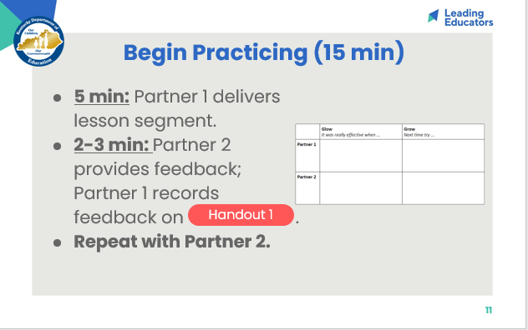
Slide 12:  (2 min) Facilitator says:  - “As we prepare to revise our plans, take a minute to jot down next steps based on your partner’s feedback on Handout 1. We’ll then take a minute to share out whole group and see what trends exist.” | 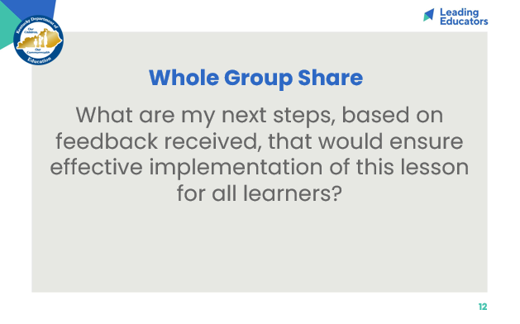
Slide 13:  Revising  (15 min) Using the feedback provided, support teachers in revising their instructional approach and continued planning. | 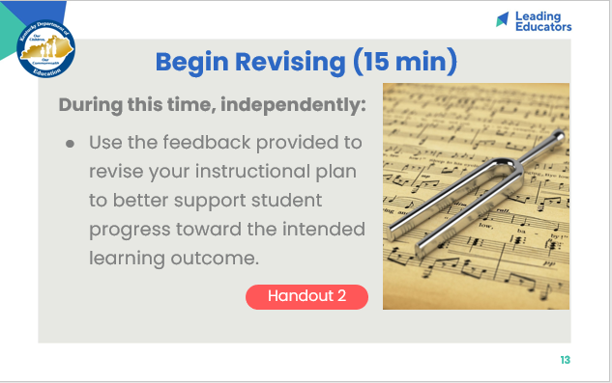
Slide 14:  Closing the Protocol  (7 min total) Have teachers follow the “closing the protocol” debrief process listed below.  - Partner Debrief (3 min): Teachers return to their original partner and share instructional plans and modifications/adaptations made in response to the feedback received. A guiding question to facilitate this discussion might be: How did you apply your partner’s practice feedback into your revised lesson?  - Whole Group Debrief (2 min):  - What did you learn from engaging in the Practice and Feedback loop with your colleague?  - How has this process pushed your thinking/helped you consider the diverse needs of students in your class? | 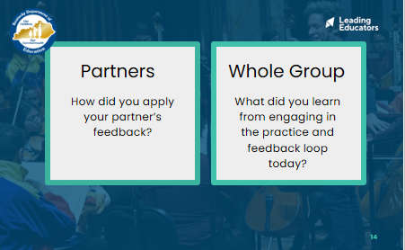
Slide 15:  (3 min) Facilitator previews next session and reminds teachers of any pre-work/action items to be completed before the next meeting.  - Example Pre-Work: Teachers should do the following:  - Create and bring an exemplar response to the assignment that will be analyzed.  - Bring a rubric/checklist to support analysis. Checklists for this analysis can be grounded in the Student Look-Fors from the shared learning session.  - Collect identified task for sub-group of students (identified on the Reflection and Looking Ahead document) to be analyzed to determine students’ growth toward the intended learning outcomes.  - Teachers may also choose to bring an entire class set of work. | 