Session 10: Shared Learning
Planning for Instruction
Content Standard(s): Does the lesson/task focus on one or more grade-appropriate mathematics standards?
What standard(s) does this lesson/task address?

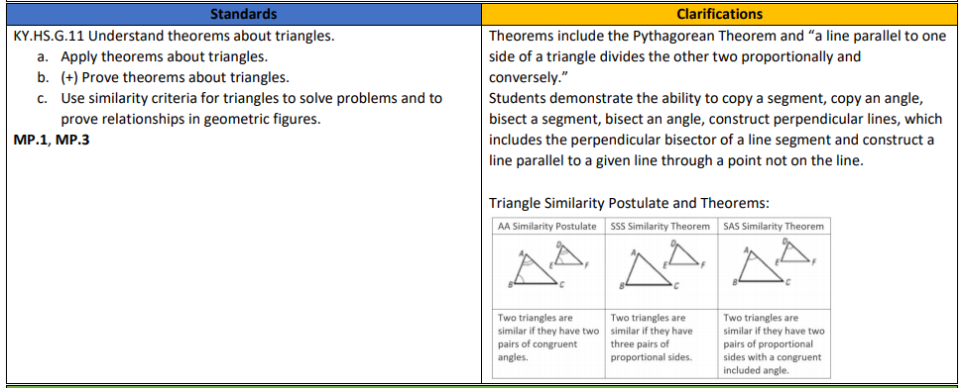

What standards (within or across grade-level coherence) does the lesson/task rely upon or support?

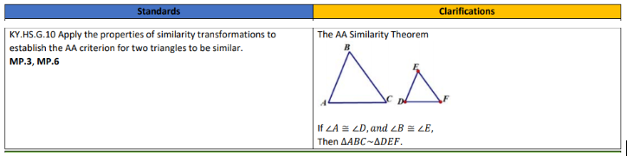

Learning Plan: Script out the key lesson components.
(e.g. Do Now, Activating Prior Knowledge, New Learning, Guided Practice, Independent Practice, Closing, etc.)
N/A - We are creating an exemplar student response for a given task, not planning a lesson.

Do the Math: Select a given task or tasks from the lesson.
Solve the task by creating an exemplar student response.

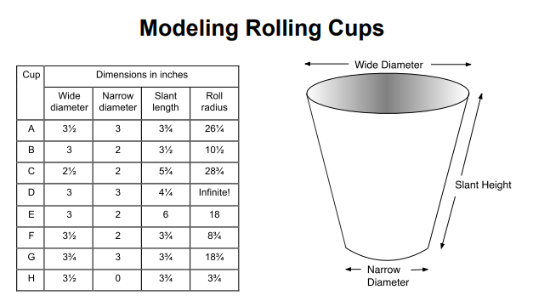

- Describe how each of the 3 lengths on the picture affect the roll radius.

- Show how you can use math to predict the radius of the circle rolled by any size cup. Show all your reasoning including any diagrams and calculations.

Predict incorrect solution strategies (e.g., misconceptions, procedural errors). How will you proactively address these misconceptions?

Target of the Standard: How does the lesson/task engage students in reaching the target of the standard?
Conceptual Understanding  If the target of the standard is conceptual understanding, what do students have to know in order to demonstrate mastery on this task? | Procedural Skill/Fluency  If the target of the standard is procedural skill/fluency, what do students have to be able to do/show in order to demonstrate mastery on this task? How are students asked to connect procedures back to underlying conceptual ideas? | Application  If the target of the standard is application, what opportunities exist for students to apply their learning to solve problems in a relevant and meaningful way?  This part of the standard targets pplication.  Application provides a valuable context for learning and the opportunity to solve problems in a relevant and a meaningful way. It is through real-world application that students learn to select an efficient method to find a solution, determine whether the solution(s) makes sense  by reasoning and develop critical thinking skills.
Standards for Mathematical Practices: Which mathematical practices will you explicitly teach and/or ask students to engage with during this lesson/task? Teachers are encouraged to visit the KAS for Mathematics documents for support integrating the practice standards with the content standards.
How might SMP 3 support students in demonstrating mastery on this task? What other SMPs support student mastery of the content standards present in this task?

Video: Inside Mathematics Video, Molly McNinch, Geometry - Lesson 1B (min 0:00-6:25)

Observation Notes
Teacher Instructional Moves | Impact on Student Learning

- What planning steps can we infer were taken to explicitly connect the lesson’s objectives to SMP 3?

Connecting back to our “Why”: Equity
- How might explicitly teaching SMP 3 support both mathematical understanding and productive struggle for students, especially our most vulnerable students?

Criteria for Success
Teacher Planning and Practice Look-Fors | Student Look-Fors
The teacher look-fors below come from the Effective Mathematics Teaching Practices (MTPs) put forth by the National Council of Teachers of Mathematics. | The student look-fors below come from Standards for Mathematical Practice (SMPs) found in the KAS for Mathematics.
- Look-For 1: Teacher implements tasks that promote reasoning and problem solving (MTP 2).  - Look-For 2: Teacher uses and connects mathematical representations (MTP 3).  - Look-For 3: Teacher facilitates meaningful mathematical discourse (MTP 4).  - Look-For 4: Teacher poses purposeful questions (MTP 5).  - Look-For 5: Teacher elicits and uses evidence of student thinking (MTP 8). | - Look-For 1: Students make sense of problems and persevere in solving them (SMP 1).  - Look-For 2: Students construct viable arguments and critique the reasoning of others (SMP 3).  - Look-For 3: Students model with mathematics (SMP 4).
Additions: | Additions:
While implementing these look-fors, teachers will reflect on patterns between their planning and practice and student outcomes, with attention to outcomes for subgroups of students considering race, gender, language, learning needs, and socioeconomic status, in the service of all students meeting the student goals.
- Teachers are encouraged to keep this Reflection and Looking Ahead page to refer back to their goals and selected student subgroups in upcoming sessions.
- This page may also be shared with facilitators as an artifact for individual coaching sessions.

Teacher Name:
Facilitator Name:
Session Date:

Reflection
- How has today’s seminar deepened your thinking around SMP 3? What specific applications of SMP 3 resonated most for you?
- Which of the Look-Fors do you consider strengths? In what ways are you already implementing these look-fors in your classroom?
- Which of the Look-Fors do you consider areas for growth? What might effective support and resources in these areas look like?

Looking Ahead
- In thinking ahead to our Planning & Practice session, what new learnings from this session will you apply to an upcoming lesson within your curriculum? What teacher and student artifacts would you use to measure your success in incorporating SMP 3 into student learning?
- In thinking ahead to our Student Progress session, which students and/or subgroups of students will you assess to ensure shared learning from our session creates equitable learning opportunities and outcomes for all students?

For additional support, see Effective Mathematics Teaching Practices found in the BCML Appendix folder.
For additional support, see the KAS for Mathematics and the KAS for Mathematics Professional Learning Modules.

