Session 7: Shared Learning
GRAPHS
G1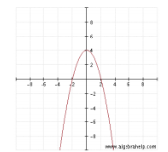 | G2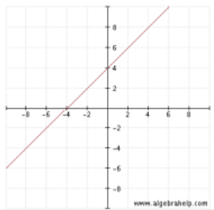
G3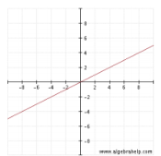 | G4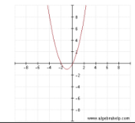
G5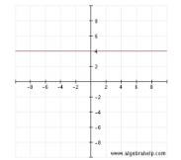 | G6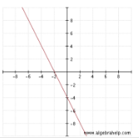
G7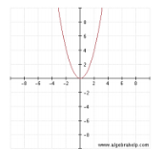 | Create a matching graph here  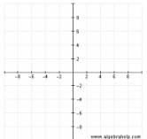
Create a matching graph here | Create a matching graph here

EQUATIONS
E1  y = x² +2x | E2  y = $\frac{1}{2}$x
E3  y = x + 4 | E4  y = -x + 4
E5  y = x - 4 | E6  y = -2x
E7  y = x² | E8  y = -x² + 4
Create a matching equation here | Create a matching equation here

TABLES
T1 | T2
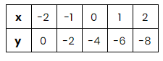 | 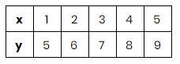
T3 | T4
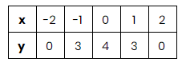 | 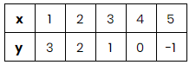
T5 | Create a matching table here
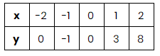 | 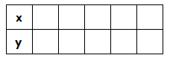
Create a matching table here | Create a matching table here
Create a matching table here | Create a matching table here

REAL WORLD PROBLEMS
R1 | R2
Andrew, Ben, and Jonathan are competing to see who can sell the most chocolate bars. Ben says he will sell 2 more bars than whatever Andrew sells. Jonathan says his sales will match whatever Andrew sells multiplied by what Ben sells. | Stephany is 4 years older than Erica. What equation would show Erica’s age (y) in terms of Stephany’s age (x)?
R3 | R4
Marissa borrows $2 from her sister every month. What equation would show how much debt, y, Marissa will have after x months. | The Office of Parks and Recreation is building a square swimming pool. What equation could model the area of the pool, y, where each side, x, is of equal length?

R5 | R6
Beauty Cuts, the local hair salon, has 3 employees - Frank has worked at the salon for 8 years; Shelly has worked at the salon for 1 year; Marcus has worked at the salon for 2 years. As a policy, Beauty Cuts gives all employees 4 sick days per year regardless of the number of years they have worked at the salon. What equation would show the number of sick days per employee, y, as a function of the number of years worked by the employee, x? | Roman is playing “Monkey in the Middle” with his two friends: His two friends must try to pass the ball back and forth over Roman’s head so that Roman cannot catch it. One of Roman’s friends stays 2 meters to Roman’s left; the other friend stands 2 meters to Roman’s right. Both friends start by picking the ball off the floor and then throwing it so that it reaches its highest point at 4 meters above Roman’s head before falling back down to the floor.
Create a matching real world problem here | Create a matching real world problem here
Create a matching real world problem here | Create a matching real world problem here

