Instructions for Completing the School-based Health Services Annual Application

- Go to https://gmap.education.ky.gov/
(Note: The districts GMAP User Access Administrator must setup your GMAP access and assign the role of District Medicaid Application Update. A list of district User Access Administrators is located in GMAP under KDE Resources.)

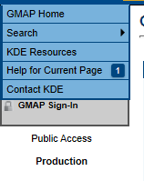
- Select GMAP Sign-In on the left Main Menu.
- Sign in with email address and password. 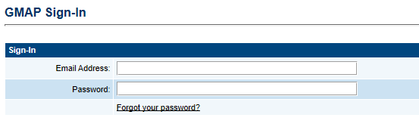
- Click on District Document Library and select 2024 then click on Search Folders.

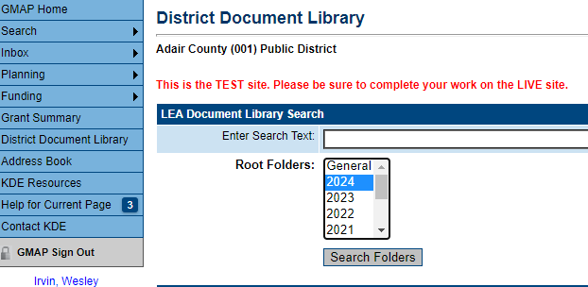

- Click on 2024 then locate the Medicaid Application folder.
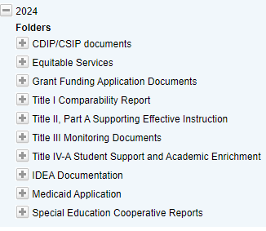
- Click on Medicaid Application. To download the School-Based Health Services Annual Application template click Edit Documents.
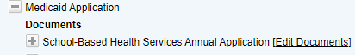
- Click on the SBHS Certification Application document template.
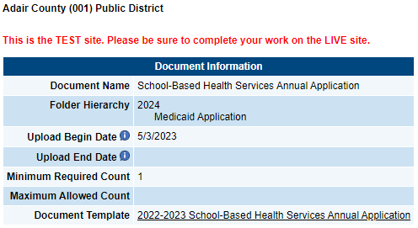

- Save and name the document to a folder on your computer. To upload completed SBHS Certification Application click Upload Document then click Select and locate the document saved on your computer from the template. Enter a Document Name and Document Description and click Save.
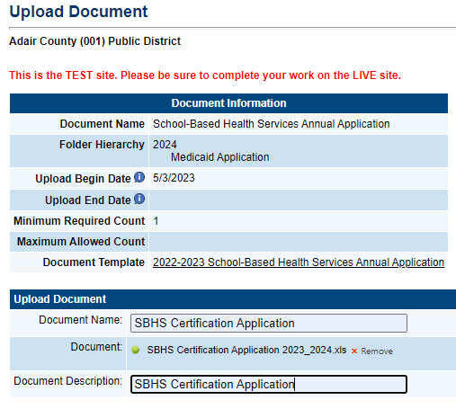
- To verify a successful upload, Click Return to District Document Library. Click on School-Based Health Services Annual Application. Under Document History, you will see the uploaded file along with the date and time stamp.

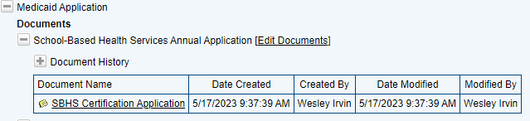

- To upload Certification/Licensure file. Click Edit Dcouements under Certification/Licensure.
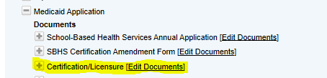

- To upload completed Certification/Licensure click Upload Document then click Select and locate the document saved on your computer. Enter a Document Name and Document Description and click Save.
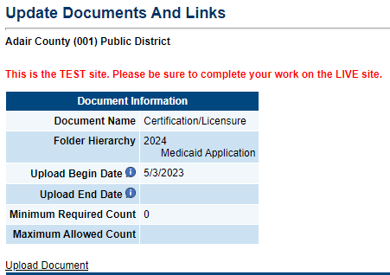

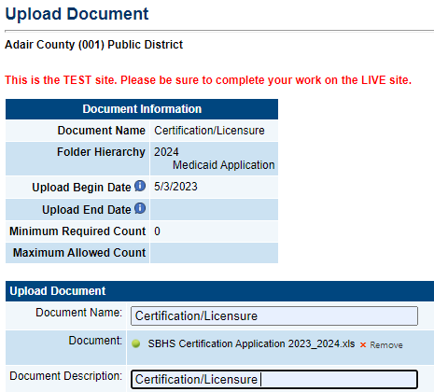
- To verify a successful upload, Click Return to District Document Library. Click on Certification/Licensure. Under Document History, you will see the uploaded file along with the date and time stamp.

